Tag Free Kiwi

Years 9–10 Focus area 3
This section of the Tag Free Kiwi programme contains one of the following focus areas for students at years 9–10 (ages 13–14):
- A history of expression
- Graffiti – what does the word mean?
- Consequences of graffiti vandalism
- Is it art?
- Making a difference
- Pride in your community
- Being creative

Focus area 3: Consequences of graffiti vandalism

Contents
Focus area 3: Consequences of graffiti vandalism 3
Curriculum links 3
Resources 3
Learning outcomes 3
Learning experience 1: Consequences 4
Activities 4
Assessment 5
Copysheet: Victims 6
Copysheet: Offences (a) 7
Copysheet: Offences (b) 8
Copysheet: Offences (c) 9
Copysheet: Offences (d) 10
Copysheet: Offences (e) 11
Copysheet: Match the Crime 12
Copysheet: Victim Impact Statement POL 392 13

Focus area 3: Consequences of graffiti vandalism

Curriculum links
Key Competencies: Thinking; Relating to others; Participating and contributing
Learning areas: Social Sciences

Resources
Copysheet: Victims
Copysheet: Offences (copy each to A3, colour and laminate)
Copysheet: Match the Crime
Copysheet: Victim Impact Statement
School Community Officer or Community Constable

Learning outcomes
At the end of this learning experience students will be able to:
- explain that graffiti vandalism has consequences for all
- match a graffiti-related offence with an associated penalty.

Learning experience 1: Consequences

Activities

1. The victims
Working in pairs or small groups, students write the word “Consequences” on a piece of paper, using their own art style. These are displayed on the wall.
Divide the class into five groups. Allocate one of the victims from Copysheet: Victims to each group. The group works together to complete a cause-and-effect diagram like the one below to show some of the consequences of the graffiti vandalism for the victims.
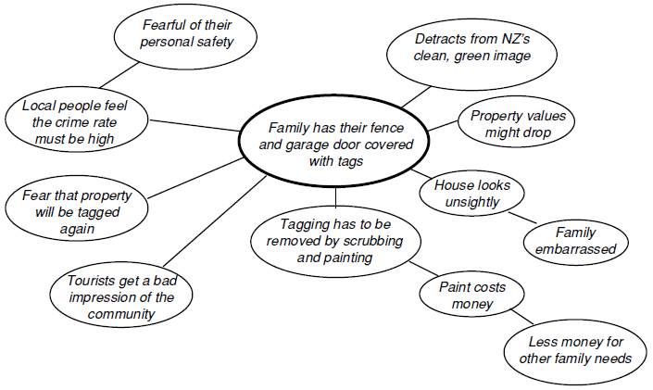
Either display completed diagrams around the “Consequences” display and invite students to skim and scan the other groups’ work or ask each group to report back their findings.

2. Offences and penalties
Set up a Bus Stop activity using A3 versions of each of the cartoons from Copysheet: Offences. Working individually or in pairs, students go to each bus stop in turn and decide and record in their books what they think the offence is and what the penalty should be.
Give out Copysheet: Match the Crime so that students can check the accuracy of their ideas. The Police Officer will be able to answer students’ questions relating to the law.
Ask: Were you surprised that any of these things were offences? Why, or why not?
Were your penalties more or less severe than the real penalties?
Do you think these penalties would stop someone from tagging? Why, or why not?
Would it stop you?

3. Victim impact statement
Show or read the Victim Impact Statement to the class. In pairs, students write down four questions they would like to ask each of the following:
- the principal of Taukimo School
- one of the taggers
- the parents of one of the taggers.
Each pair shares their questions with another pair.

Assessment
View the students’ completed cause-and-effect diagrams.

Copysheet: Victims

Victim 1: The Joseph Family
The Josephs are a family without much money. There are four children in the family aged from 7 through to 15. Mum works hard at the local supermarket. Dad has been working as a fitter, but is now unable to work because of a back injury. The family is very proud of their house, which they own, and just recently they have all worked together to paint their front fence. It was looking really good. It was difficult to afford the paint, but they managed to scrape together enough to buy it.
They come out one morning to discover that the fence and the letter box are covered in tags.

Victim 2: City Council
The council is proud of this community and has spent a lot of money on facilities and beautification. It works closely with a local Beautification Trust and tries to remove graffiti vandalism as soon as it appears. This is a losing battle and is costing the council about $1.4 million a year.
The council gets a report that taggers have broken into the local swimming pool overnight and bombed everywhere.

Victim 3: Mrs Sa’anga
Mrs Sa’anga lives in a retirement flat. She is 75 years old and her husband died 10 years ago. She lives on her own. Her health is not good, especially her heart, and she is very frightened by reports of violence and petty crime in the area. Her family is very supportive, but they have recently moved out of the area. She is on a pension.
She is dismayed to find tags across her front door and on the outside walls of her flat. The vandals must have come right on to her property.

Victim 4: Mrs Haumaha
Mrs Haumaha is principal of a large primary school. The school is not particularly well off, but uses its funds wisely and maintains the school property well. There has been tagging at the school, but the property manager keeps it under control and removes it as quickly as possible. Mrs Haumaha thinks that it is kids from the nearby secondary school who do most of the damage.
She is very concerned when she comes to school over the weekend and finds that there is etching over lots of the windows. This is expensive damage. Worse still, she finds etching equipment stashed under one of the prefabs. This makes her wonder if the offenders are students from her school.

Victim 5: Mr and Mrs Patel
The Patels own their own grocery shop and work long hours to keep the shop open as much as possible. They are very proud of their immaculate premises and are well known and liked in the community. They send money home to the family in Fiji. They have two small children, aged 4 and 6.
They come out of the shop in the afternoon and find that taggers have been busy. The shop window and the outside display stand have been tagged and some of the produce has paint splatter as well. They had not seen it happening.

Copysheet: Offences (a)

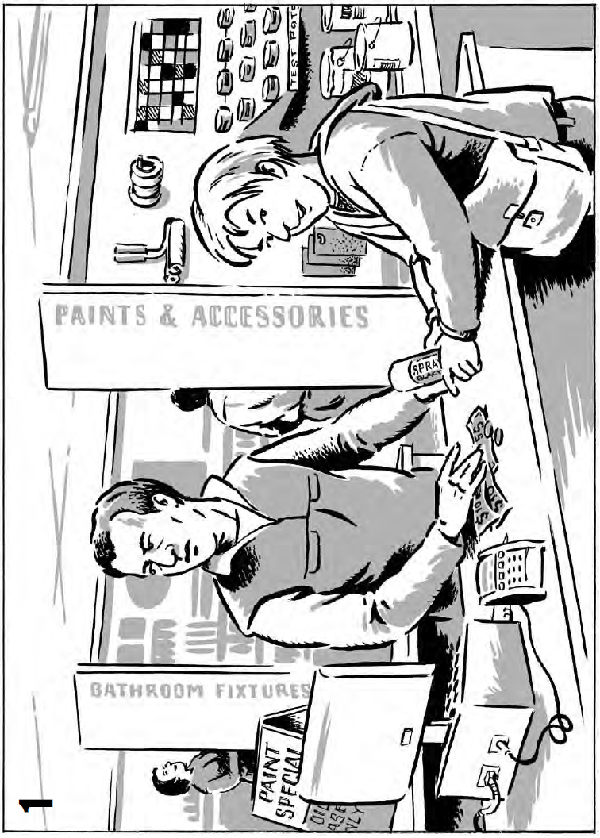

Copysheet: Offences (b)

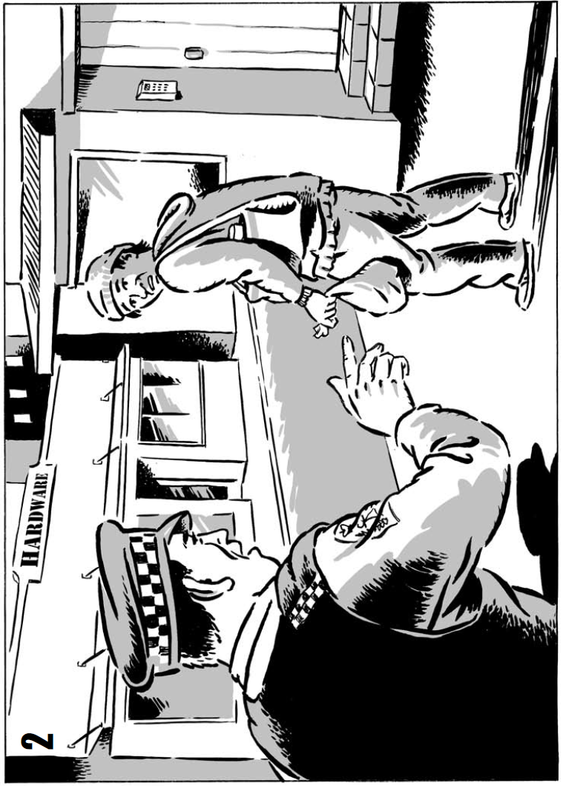

Copysheet: Offences (c)

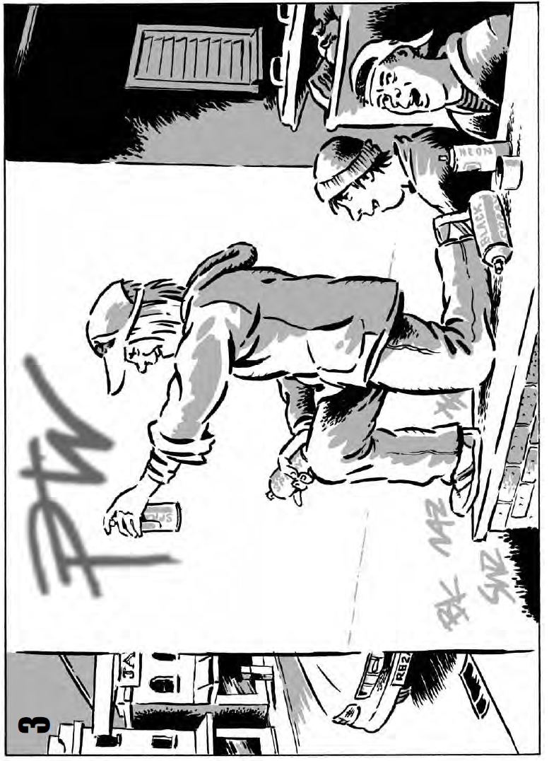

Copysheet: Offences (d)

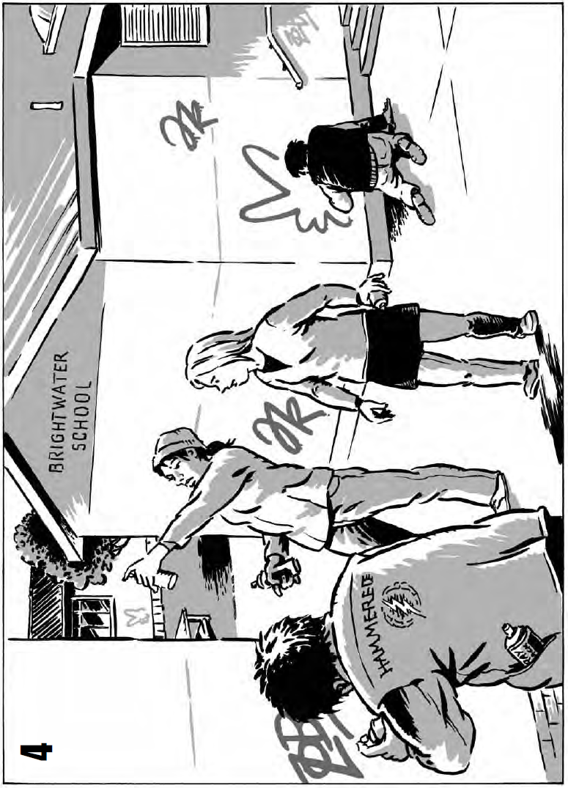

Copysheet: Offences (e)

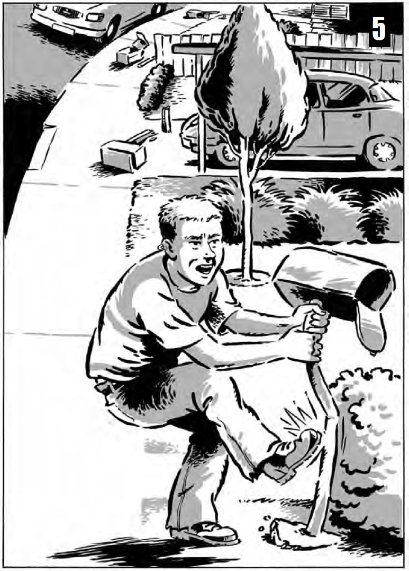

Copysheet: Match the Crime

Offence | Penalty
Scenario 1  Selling a spray can to a person under the age of 18 | Summary Offences Act, section 14A (though there are some defences)  Penalty: Fine not exceeding $1,500
Scenario 2  In possession of graffiti implements without a reasonable excuse | Summary Offences Act, section 11B  Penalty: Community work or a fine not exceeding $500 or both
Scenario 3  Young person spraying a tag on a wall | Summary Offences Act, section 11A  Penalty: a community based sentence or a fine up to $2000 or both
Scenario 4  Group of 15-year-olds tags the whole school | Crimes Act, section 269 – intentional damage  Penalty: 7 years in jail  or Summary Offences Act, section 11A  Penalty: a community based sentence or a fine up to $2000 or both
Scenario 5  Young person damaging a letter box by kicking it | Summary Offences Act, section 11 – wilful damage.  Penalty: Imprisonment for a term not exceeding three months or a fine not exceeding $2,000

Copysheet: Victim Impact Statement

