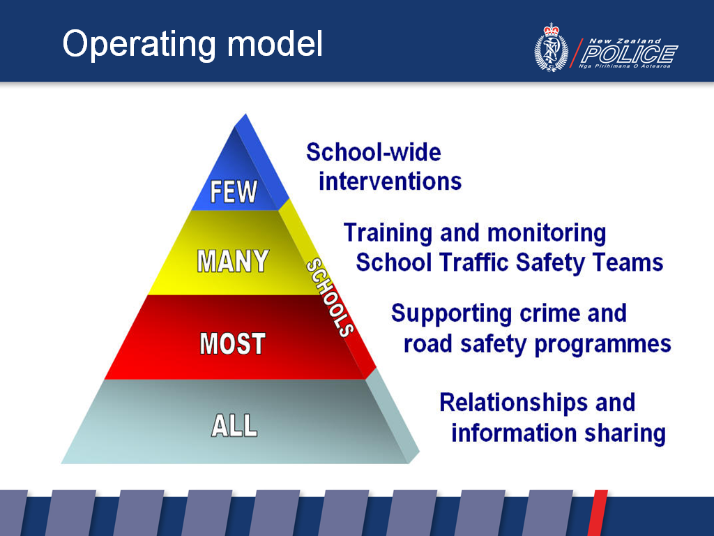

A priority schools, selected through an evidence-based process, are supported to develop and implement school-wide interventions to address crime and/or road safety issues through a problem-solving process. School-wide interventions are based on an explicit whole school approach (see ‘School-wide Interventions’ on page 3).

schools run a School Traffic Safety Team (eg School Patrols, Bus Wardens). School Community Officers will continue to train these STSTs. Police will monitor their operation to ensure consistency across New Zealand.

schools run various Police programmes (eg Kia Kaha, Keeping Ourselves Safe, drug education, road safety education) either in their entirety or elements of the programme. School Community Officers support schools with developing and implementing these programmes.

This support to schools may include:
- accessing the resources for these programmes, or identifying where the resources can be obtained via the Police's online School Portal schools.police.govt.nz (see 'School Portal' on page 4)
- co-teaching parts of the curriculum programme - especially parts related to the law or sensitive components
- participating in staff, parent and/or community meetings.

schools will be encouraged to have an ongoing relationship with a Lead Police Contact (see ‘Engagement Model’ on page 2). The relationship will be based around information sharing:
- from the Police about crime and road trauma concerns in the student catchment area of the school
- from the schools about behaviours from students/families/ whānau that are negatively impacting on students' educational potential.
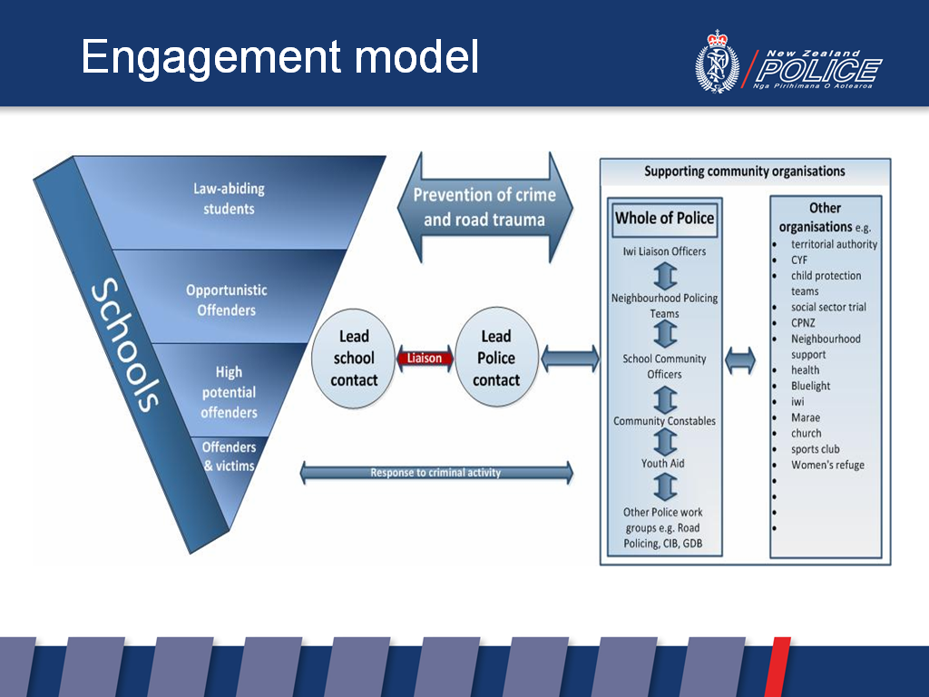

schools will be encouraged to have an ongoing relationship with Police.

The relationship will be based around information sharing:
- from the Police about crime and road trauma concerns in the student catchment area of the school
- from the schools about behaviours from students/families/ whānau that are negatively impacting on students' educational potential.

To formalise the partnership between Police and schools, ideally:
- Police will have a dedicated liaison person for each school (Lead Police Contact)
- each school will have a dedicated liaison person with Police (Lead School Contact).

The role of these lead contacts is to share information and agree on:
- prevention activities
- any relevant response procedures.

Ideally the Lead Police Contact should be the School Community Officer. In some school communities the Lead Police Contact may be a Youth Aid Officer, Community Constable, Iwi Liaison Officer, member of Neighbourhood Policing Team, or a rural Constable.

The Lead Police Contact will interface with the range of relevant police roles who engage with school communities.
Police also maintain connections with a range of supporting community organisations. Information on each organisation should include contacts details and clearly describe the organisation's relevance, capacity and capability to support schools.
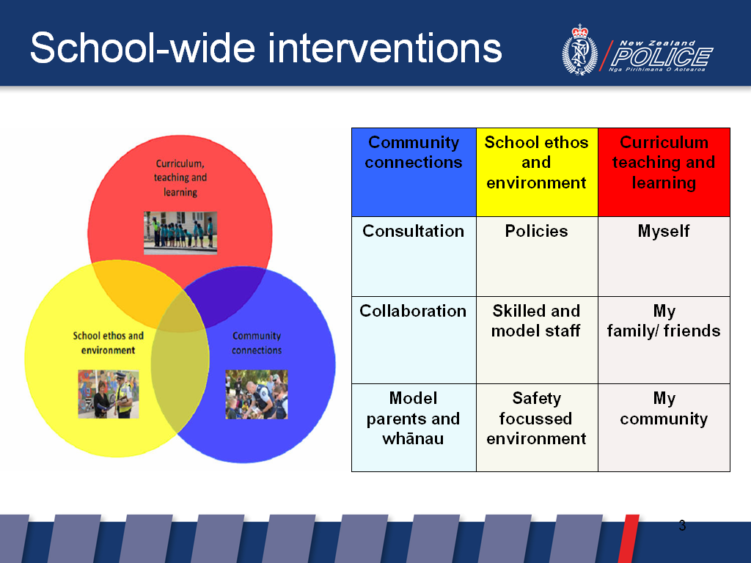

A priority schools, selected through an evidence-based process, are supported to develop and implement school-wide interventions to address crime and/or road safety issues through a problem-solving process (see 'Operating Model' on page 1).

School-wide interventions are based on an explicit ‘whole school approach’, composed of three interconnected components, each with three parts:

Community connections:
- Consultation – all community members opinions are valued and encouraged.
- Collaboration – all people and organisations work together to achieve safety for children and young people.
- Model parents and whānau – parents and whānau positively influence their children to behave safely.

School ethos and environment:
- Policies – policies, procedures, and resourcing focused on student safety are developed and regularly reviewed.
- Skilled and model staff – teaching staff can confidently facilitate relevant and authentic safety education.
- Safety focussed environment – improvements are made to the environment to increase safety.

Curriculum teaching and learning:
- Myself – students take action to look after themselves in unsafe situations.
- My family/friends – students take action to create safe situations when with people they know.
- My community – students take actions that lead to a safer community or place.

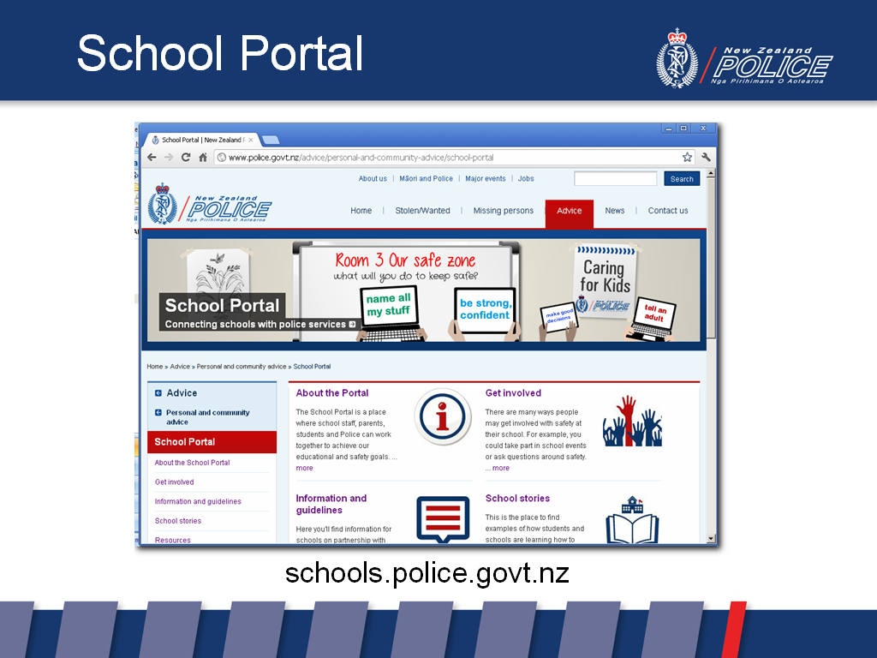

The School Portal assists Police and school communities to work together to achieve both Police's prevention goals and schools' safety and educational goals.

It contains a wealth of information for both schools and Police, including:
- models on how Police partner with schools around both prevention and response
- processes and templates for school planning
- good practice guidelines, eg road safety, drug education and child protection
- qualities under which Police would endorse or support programmes delivered by other agencies
- links to partners and collaborators who work in schools
- teaching and learning resources
- information for parents and students.

The School Portal includes the ability for Police, schools and students to share work they have done to address crime and crash issues. This knowledge bank of peer-reviewed narratives and other material will provide a range of effective strategies to deal with similar issues.

schools.police.govt.nz

