Serving School Communities
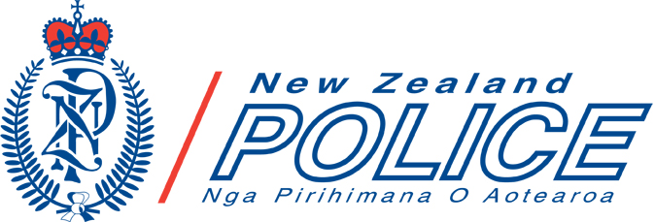

Purpose
The shared goals, principles and values of New Zealand Police in partnership with schools is to ensure all New Zealand children and young people live and learn free from harm from crime and crashes.
Serving School Communities is the overarching document to define how New Zealand Police will work toward these, and provide prevention services for school communities.

Vision
The New Zealand Police’s motto is to build “safer communities together”.

Mission
The mission of Police’s National Prevention Centre services to school communities is "all New Zealand children and young people living and learning free from harm from crime and crashes".

The Prevention First operating strategy places prevention at the forefront of our organisation and people at the very centre.

Principles
The New Zealand Police has five principles to provide direction towards partnering with school communities:

- Future focused – all prevention activities should include short- and long-term goals, which are ideally incorporated into school plans/charters.
- Treaty of Waitangi – promoting partnership, protection and participation with iwi.
- Evidence-based – activities are planned based on robust evidence and monitored for impact to measure effectiveness.
- Community engagement – prevention activities operate within a whole school approach.
- Inclusion – the actions of this partnership will be culturally responsive and recognise different social, economic, physical and ethnic factors.

Values
When school communities provide a safe physical and emotional environment for their students, and seek preventative support from the New Zealand Police, the following values will be applied:

- Student-centred – learning experiences use inquiry and curiosity so that students develop empathy, resilience, integrity, equity and respect for self and others.
- Targeted participation – school communities implement prevention activities to address identified issues.
- Sustainability – a Police-school partnership supports a sustainable culture of safety.
- Collaborative and inclusive – effective prevention activities use partnerships and networks in a whole school approach.

Goals
The two goals of Serving School Communities are:

- Goal 1 – Supporting safer school communities
School communities (staff, BOT, parents/whānau) will access sufficient knowledge, resources, support and connections so that students feel safe and are safe

- Goal 2 – Students receiving effective safety education
Students will gain the knowledge, confidence and connectedness to influence their environment so that so that they feel safe and are safe.

Outcomes
To achieve these goals New Zealand Police has identified five outcomes aligned with the Ottawa Charter for Health Promotion.
Mission
All New Zealand children and young people living and learning free from harm from crime and crashes.
Goal 1 Supporting safer school communities
School communities (staff, BOT, parents/whānau) access sufficient knowledge, resources, support, and connections so that students feel safe and are safe.

Goal 2 Students receive effective safety education
Students will gain the knowledge, confidence and connectedness to influence their environment so that so that they feel safe and are safe.

Outcome Area 1 – Public Policy
School communities maintain policies and procedures to ensure children and young people learn free from harm from crime and crashes.
Outcome Area 3 – Develop Personal Skills
Interventions involve students taking action to prevent harm from crime and crashes. This requires skill development for students and possibly school staff, parents/whānau and community groups.
Outcome Area 4 – Orienting Services and Resources
School communities will be assisted to address prioritised crime and crash issues that affect their students' learning, through prioritised deployment of resources and infrastructural support.
Outcome Area 2 – Create Supportive School Community Environments
A safety culture is valued and implemented within school communities, using a whole school approach.
Outcome Area 5 – Strengthen Community Action
Effective, aligned and sustained working relationships operate between school communities and community providers (including the New Zealand Police).
Police tactics to achieve outcomes

Outcome area 1 – Public policy
School communities maintain policies and procedures to ensure children and young people learn free from harm from crime and crashes.

Tactics
- Ensure Police (e.g. School Community Officers) work with schools through the Police Schools Engagement Cycle.
- Ensure each intervention links to a school policy with clearly described procedures.
- Ensure policies include defined procedures on how to:
  - prevent the issue, and
  - respond to occurrences of the issue.

Outcome area 2 – Create supportive school community environments
A safety culture is valued and implemented within school communities, using a whole school approach.

Tactics
- Follow a problem solving process (SARA) for each intervention, which:
- clarifies the problem based on valid data
- establishes clear short-term and long-term goals for the intervention
- implements prevention activities that include each of the nine components of the whole school approach as described in the Intervention Planning Tool
  - assesses the intervention against the short term goal.
- Support the school to ideally incorporate the intervention’s goals into their annual plan/charter.

Outcome area 3 – Develop personal skills
Interventions involve students taking action to prevent harm from crime and crashes. This requires skill development for students and possibly school staff, parents/whānau and community groups.

Personal skill development occurs in the:
- curriculum, teaching and learning component of the whole school approach, where students take action for the safety for themselves, others and their community
- skilled and model staff section of the School Ethos and Environment component of the whole school approach
- model parents and whānau section of the Community Connections component of the whole school approach.

Tactics
Consider skill development for:
- children, through curriculum sessions
- school staff, through professional learning and development (PLD)
- parents/whānau, through communication via their children or directly from the school.

Police-Schools Operating Model
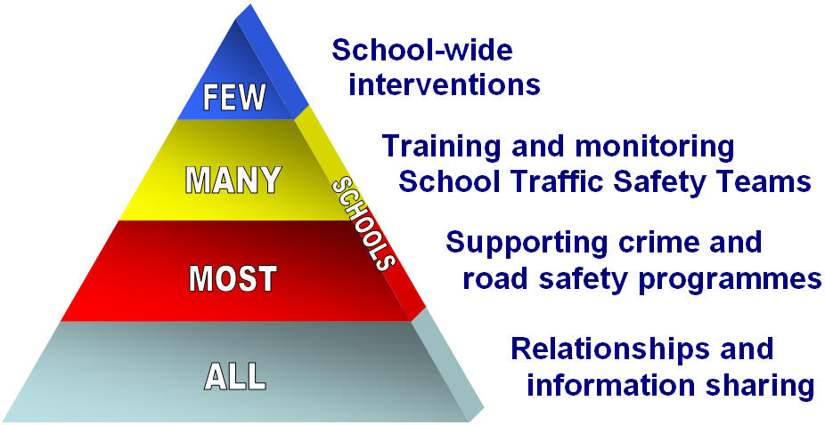
Outcome area 4 – Orienting services and resources
School communities will be assisted to address prioritised crime and crash issues that affect their students' learning, through prioritised deployment of resources and infrastructural support.

The emphasis of deployment will be prevention through the Police-Schools Operating Model.

Tactics
Encourage all schools to have an ongoing relationship with a Lead Police Contact, as described in the Police-Schools Engagement Model. The relationship will be based around information sharing:
- from the Police about crime and crash concerns in the student catchment area
- from the school about behaviour from students/families/whanāu that are negatively impacting on students' educational potential.

Police-Schools Engagement Model
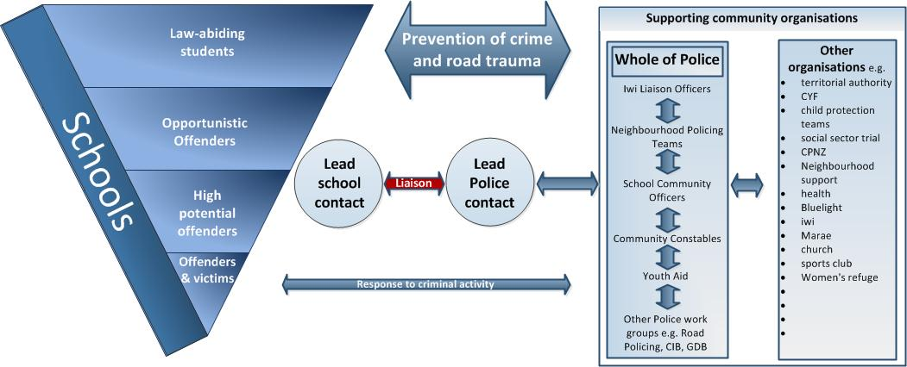

Support most schools to run Police programmes (e.g. Kia Kaha, Keeping Ourselves Safe, Choice, Road Safe), either in their entirety or part thereof. Police (e.g. School Community Officers) support schools with developing and implementing these programmes. This support may include:
- accessing resources for programmes, e.g. Police's School Portal (schools.police.govt.nz)
- co-teaching parts of the programme - especially law or sensitive components
- participating in parent and/or community gatherings.

Support the many schools that run a School Traffic Safety Team (e.g. School Patrols, Bus Wardens). Police (e.g. School Community Officers) will train STSTs and monitor their operation to ensure consistency.

Identify a few priority schools through an evidence-based process. Through deployment in RIOD and by agreement with the school, School Community Officers will partner with these schools to implement school-wide intervention(s) by:
- fully applying the Police Schools Engagement Cycle
- using a whole school approach as defined in the Intervention Planning Tool.

Undertake a response function for criminal activity that occurs on school grounds, by identified students, or directly affecting identified students.

Outcome area 5 – Strengthen community action
Effective, aligned and sustained working relationships operate between school communities and community providers (including the New Zealand Police).

Tactics
- Maintain an up-to-date database of community organisation. The information on each provider should include contact details and clearly describe the organisation's relevance, capacity and capability to support schools.
- Approach relevant community organisations to collaborate with the school community to address issues. Organisations may include, but are not limited to: CYF, principal clusters, territorial authorities, Neighbourhood Support, Community Patrols, MoE regional offices, iwi groups, Blue Light, health agencies, churches, sports clubs, bus companies and local businesses.

