Supporting school issues through a whole-school approach
Travelling Safely
Police district | School name | School demographics | Submitted by
Northland | Kamo Intermediate | Decile range 5 | Senior Constable Ian Anderson School Community Officer

Summary | Personal safety of students using a pedestrian crossing.
Issue | Community consultation identified that traffic flows and pedestrian safety near the school were becoming an issue.  This was compounded by the large number of nearby schools (two primary, one secondary) and early childhood facilities, and an increase in building and population shift towards this area.  As well as an increased traffic volume, the pedestrian crossing was found to have incomplete road markings, and there were issues with buses parked nearby restricting visibility for the school patrollers and the adult supervisors.  One of the school patroller signs was found to be significantly longer than the other, which made handling this sign a challenge.  There was also only one protective bay at the crossing, which made it more difficult for the school patrollers when they were on patrol.  Two bus bays in the area also made it difficult for the school patrollers to operate due to limited visibility and to buses crossing next to them.
Identification and prioritisation | These issues were initially identified by the school and School Community Officer in late 2013, along with a number of other similar problems at school crossings within the Whangarei area.  Further issues were identified after consulting with students and teaching staff from this area.  The issue was prioritised by the school, the SCO and the local council who incorporated it into their roading plan.
Short-term goal | - To assess the existing pedestrian crossing and update the road markings.  - To conduct a review of bus parking in the area and see if there were safer options.  - To modify the school patrol signs so that both signs are the same length.  - To speak to bus drivers using the nearby bus stop to eliminate pickups while the patrol is operating.  - To review and replace school patrol uniforms to ensure better visibility.
Long-term goal | - That the pedestrian crossing and bus-stops are safer.
Prevention activities | Activities that occurred within a whole-school approach included:  School ethos and environment (policies; skilled staff; safe environment)  - All school patrol members were trained and informed of the problems with the pedestrian crossing, and ideas sought from them on how to make the pedestrian crossing safer and more user friendly.  - The local roading authority painted new road markings to ensure the pedestrian crossing was more visible, and modified the road markings to ensure they meet regulations.  - Police increased their presence after school to ensure drivers drove correctly and safely during this transition period.  Community connections (consultation; collaboration; model parents)  - Students’ ideas were given to the local roading engineer.  - The engineer and roading maintenance members came out to the crossing to witness the problems firsthand.  - Police prepared a PowerPoint presentation for local council engineers outlining the problems at this and other crossings, so that planning could be carried out across the region to ensure all crossings were of a high standard.  - Local bus drivers were consulted on possible alternative locations to pick up passengers when the patrol was operating.  - Articles about the safety of school crossings in the Whangarei area appeared in local and national media.  - A presentation was made to a School Community Officer training course outlining the problem and steps to rectify them, as an example for new SCOs.  - Draft modified crossing plans showing the proposed new crossing design were circulated to Police and Kamo Intermediate to review and give their opinion around the proposed design.  - After feedback from Police, staff and patrollers, a revised plan was recirculated and adopted as the new design.  - The local roading controlling authority modified the signs so that they fitted with the new crossing design and were of equal size.  - Local roading personal assisted school patrollers during the change of crossing design phase, manning ‘stop go’ signs when road markings were disrupted.  - A new crossing was installed at the location, incorporating all of the modifications outlined in the new plan.  - A formal traffic management plan was agreed, which enabled the use of a cone to make the crossing more visible.  Curriculum teaching and learning (taking action for: myself; my friends; my community)  - Staff and students were trained to use a whistle and calls to ensure safer crossing procedures.  - School Traffic Safety Team badges were developed and distributed to newly trained school patrollers as a means of identifying school patrollers within the school environment, and as a means of promoting the school patrollers’ role within this and other schools.
Impact | The short-term goals were all achieved.  As a result of this intervention, the safety for the school patrollers, students and teaching staff has increased.  The pedestrian crossing was moved further down the road to ensure a safer route into the bus bay, and two safety islands were installed.  The alterations to the signs greatly improved the students’ ability to carry them to and from the crossing safely, and also made them easier to use, particularly on windy days.  With alterations to procedures and with the new layout, the crossing is now working more smoothly, and is safer for all those who use it.  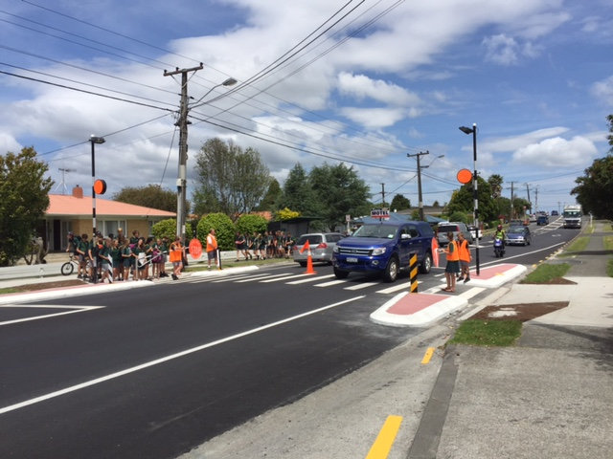
Next steps | The next step to enable the long-term goal to be achieved is an extension to the 40km speed zone within this area to incorporate the school patrol crossing. Discussions have been held with the local district council, with a view of having this completed in the next financial period.
Obstacles | Because of the cost associated with modifications to this and other crossings, it was necessary to prioritise this school’s changes in amongst those of other schools.
Improvements | Over time, improvements with process and procedures between all parties around modifying the crossings have ensured that this intervention worked smoothly, and we believe it was successful. However, if before starting the intervention we had gathered specific data on the number and type of incidents on the crossing, we could then more clearly measure the success by seeing if there was an actual decrease in those incidents after the intervention.
Conclusion | Although this process took a reasonable time to complete because of the obstacle mentioned above, the end result has been very pleasing for the school, the local council and the Police. We can all be proud of the outcome that we have achieved.

