Supporting school issues through a whole-school approach
Responsible Citizens
Police district | School name | School demographics | Submitted by
Bay of Plenty | Tahatai Coast School | Full primary urban  Decile 7 | S/Const S.McKenzie  School Community Officer

Summary | School playground area was being disrespected outside school hours.
Issue | The school playground area was being disrespected outside of school hours with debris and damage left behind. This resulted in an unsafe place for the students. Similar damage to community playgrounds discouraged children from play.  The school wished to develop students’ social responsibility to take collective responsibility for their community, and to foster partnerships to increase community connections and shared responsibility for the school’s playground area so that it would be a safe place for both the students and the community to enjoy.
Identification and prioritisation | The principal reported a 50% increase in incidences of damage to the school playground each week due to out-of-hours use.  Police identified a similar problem at the community playground.
Short-term goal | To involve the school in caring for the community playground by building relationships with community members and being good citizens.
Long-term goal | A collective community responsibility using Crime Prevention Through Environmental Design (CPTED) principles to look after the central area of the school, keeping it safe and well cared for, for the enjoyment of the wider community.
Prevention activities | Activities that occurred within a whole-school approach included:  School ethos and environment (policies; skilled staff; safe environment)  - Developing and communicating reporting procedures for unsafe practices, so as to encourage students and staff to report incidents.  - Immediate attendance by caretaker to any remedial work.  - A review of sensor security lighting and surveillance cameras.  Community connections (consultation; collaboration; model parents)  - Police, school, and local Council collaborated on a community action plan.  - Established relationships with local Community Patrol and Neighbourhood Support groups to keep an eye on both community and school facilities.  - The school PTA discussed and approved funding for art panels to display around the school playground area.  - Community members, parents and students attended a formal unveiling of art panels at both the community and school playgrounds.  Curriculum teaching and learning (taking action for: myself; my friends; my community)  - A school-wide art project with contributions from every student, depicting their whānau and native birds, for display on art panels at the local community playground and the school playground, creating a link between both areas (see photos in Appendix).  - An inquiry based learning approach to what makes a good citizen, and the effects of taking action that reflected the school-wide theme of ‘Making Waves’.
Impact | Students are now using the community playground facilities.  The number of damage-related reported incidences to Police has dropped significantly to less than one incident per month – a reduction within the community of at least 75%.  The art panels remain intact and have been effective deterrents to graffiti and general abuse of these facilities.  A significant reduction in tagging across the whole community.  After-hours use of the school playground is resulting in fewer issues requiring remedial action.
Next steps | Ideally, the next step would be to focus the learning from the student inquiry specifically at the local community, rather than taking a global view of citizenship. In doing so, they will be able to develop relationships and become more connected with their own community, supporting collective responsibility for school facilities.  Consult with parents to identify parents and whānau who may be further involved in growing community connections.
Obstacles | The biggest obstacle has been a change in key personnel involved, as this impacted on continuity and sustainability of the intervention. This highlighted the need for shared ownership from the outset to ensure that changes in personnel would not impact on the ‘response’ phase of the intervention plan.
Improvements | Parent consultation could be improved to make the community engagement more effective, as their input was largely untapped and limited the extent of community ‘buy in’ at grass roots level.  Additionally, ensuring that any changes in key personnel would have minimal impact on the continuation of the intervention.  There is now a national CPTED-based resource called Safer Schools that could be used in any similar intervention.
Conclusion | The short term goal was reached successfully, with the students very proud of their art panels on display in the community playground. This has been effective in reducing damage and encouraging students to use the playground. The installation of art panels within the school, and learning about citizenship, have also been effective to help students take care of their own playground and school facilities.  Whilst this is part of their long term goal, stronger community connections need to be encouraged to ensure the wider community feels and takes ownership for looking after the school, and students develop genuine citizenship in the community.

APPENDICES: Photographs and intervention plan

Community Playground
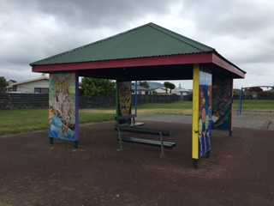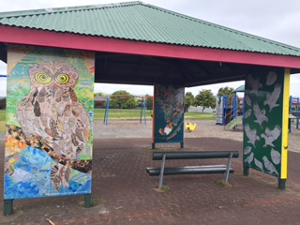
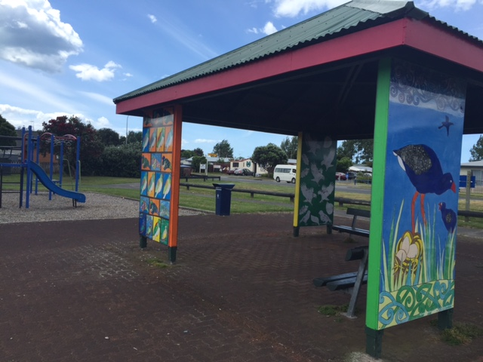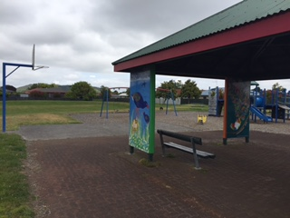

School Playground
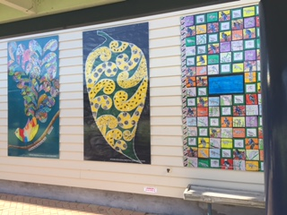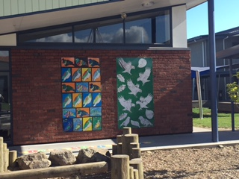
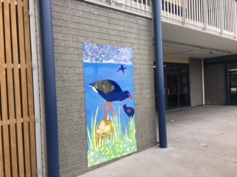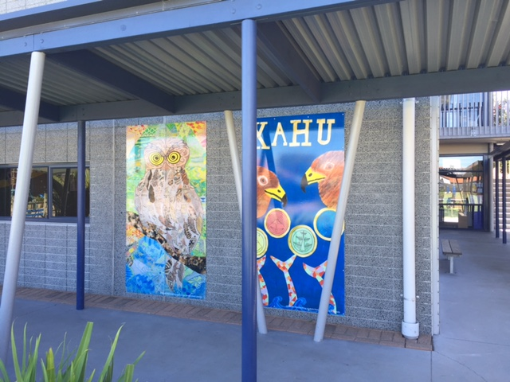

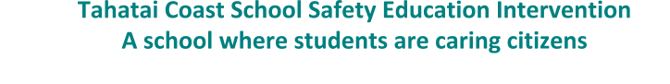
Our vision for a safe physical and emotional environment is ...
School and Community relationships and partnerships are fostered to develop citizenship through our Living and Learning behaviours
Our short-term goal for this intervention is …
To involve the school in caring for the community playground by building relationships with community members and being good citizens.
Our longer-term goal for this intervention is ...
We want a collective community responsibility for looking after the central area of the school, keeping it safe and also well cared for, for the enjoyment of the wider community.
Our planning and reporting target that will be most influenced by undertaking this intervention is …
Encouraging partnerships between the school and outside personnel to create as many opportunities for students as possible, as we believe this will improve care for our community as responsible citizens

The data sources and consultations we are using to help identify this issue and review this plan are …
- Keeping in regular contact between the Police and the school to consider how things are going and share information (This may be Principals and Lead Police Contact).
- School caretaker reporting to the Principal a 50% increase of incidents and evidence found at the school on a monthly basis
- Police reporting to the school relevant community incidents and activities.
- A record being kept of joint action in the community for a ‘project’ or activity.
- School CCTV evidence
- Comments made by parents around improving community connections through annual consultation
- Comments made by students to staff around condition of central playground area and any other areas within the school grounds

School community safety education intervention plan template
Intervention focus | Scan - gathering data and assessing needs (Step 1) | Analyse  (Step 2) |  | Respond  (Step 3) | Assess the impact  (Step 4)
Community responsibility for the care of central playground area within school | What does data and other evidence say about current practice?  Records show that opportunities for community engagement with school, and vice versa, are rare.  Incidents requiring remedial work by caretaker following out of hours use of playground have increased.  This has also been identified as a problem in community playground facilities situated in the wider community  Police believe that establishing community connections within the Papamoa area will reflect greater pride in the community and likely reduce other property crime in the area | What does our data suggest are the next step goals for this aspect?  Explore opportunities to improve mutual community engagement by consulting with local partners including Police  Immediately repair any remedial work on playground within school  Review current policies/procedures (eg) security and lock us, five year property plan  Prevent it from occurring within school so that there are no reports of damage, and there is a reduction of reported incidents of community damage to Police  Identify with Police who else may be able to help within school and the local community | What activities, programmes or strategies are we going to use to action these goals?  - Prioritise caretaker in remedial action around playground  - Develop a teaching and learning programme at all class levels that encompasses care for community and collective responsibility  - Provide information to parents about what we are doing  - Include sensor lighting around the school playground area  - Meet with school neighbours to increase observation  - Increase observation by Community Patrol group  - Encourage support of Junior Neighbourhood Support group in school  - Establish relationship with Tauranga City Council and Hartford Ave/Papamoa Community Centre | - Who is leading the activities, and who else is involved?  - Are resources allocated?  - What is the timeframe?  BOT will lead the policy and resourcing  Deputy Principal will lead the teaching and learning using content from Police programmes Doing the Right Thing, Tag Free and Bryan & Bobby  The Principal will lead collaboration and parental communications  The Police will  - provide investigative support around crime within school and the wider community  - support the teaching programme  - respond promptly when requested by Community Patrols  - support Junior Neighbourhood Support in school  - provide opportunities to establish links with other community stakeholders (eg) TCC, NS, JNS, CPNZ, etc | - What criteria or data will we use to show us we have met our goals?  - When will we assess this?  Reports of damage and associated costs will be provided at each BOT meeting  This plan will be reviewed in May 2016, and will include feedback from:  - teachers on their preparation and delivery of a teaching programme  - students about the value of the actions they took  - parents/whānau on impact around the school and wider community  - local community members about the level of shared ownership, pride and responsibility for school and community facilities  Reports of damage made to Police both within school and in the wider community

School ethos and environment
 | Scan - gathering data and assessing needs (Step 1) | Analyse  (Step 2) |  | Respond  (Step 3) | Assess the impact  (Step 4)
Policies | When asked students didn’t know who to tell if they saw some unsafe practices happening outside of school hours | Develop a policy around the playground that supports safety and care that can be incorporated into the security policy, safe environment policy, five year property plan | A draft and revised policy will be provided for consultation with BOT  The key points of the revised policy will be communicated to students, staff and parents | The BOT will sign off on a revised policy at August BOT meeting.  Principal will lead the communication to staff and parents | The BOT will review the effectiveness of the policy during Term 2, 2016
Skilled and model staff | School staff need to embrace the project concept as they currently do not view this as their role.  Staff are not sure of what support is available to help bridge classroom learning with collective responsibility for the school grounds and wider community | Principal and Senior Leadership Team meet to discuss opportunities for engagement with community partners  Teachers confidently provide interesting and relevant classroom programmes around caring for personal, school and wider community property that embraces citizenship | SLT involves BOT and rest of staff around identified opportunities for community engagement  Police SCO provides examples of teaching resources around Doing the Right Thing, Tag Free and Bryan & Bobby, which teachers may adapt to classroom programme | Senior leadership (SLT) and middle leadership teams (MLT) to lead planning for the teaching programme - Tahatai - caring for our community | Teachers across the school will be asked how well they felt prepared to run  Tahatai - caring for our community programme
Safety focussed environment | Teens and youth frequent the school, out of hours, littering, breaking glass and congregating  Students did not think it was their job to keep an eye on activity within the school grounds out of hours and were reluctant to report evidence of this happening | Build an awareness of surveillance cameras on site amongst the wider community  Develop a ‘caring community’ approach where students take responsibility for keeping the school and wider community tidy and safe | Appropriate signage considered by BOT and suitable locations for erection within school grounds identified  Awareness created through communcation to whānau and the wider community  Students take action and responsibility as part of the teaching programme  Students utilise the Junior Neighbourhood Support programme to empower community responsibility | BOT will agree on signage and appropriate locations at August meeting  Principal to send newsletter to whānau keeping everyone informed and SCO to utilise Papamoa Neighbourhood Support network communications  In Term 4, teachers will survey students to determine whether they felt that the Tahatai - caring for our community programme contributed to improving safety of the school playground and wider community facilities | Students will be surveyed about whether they believed their actions have helped contribute to a safer school playground and wider community where everyone takes collective responsibility
Community connections
 | Scan - gathering data and assessing needs (Step 1) | Analyse  (Step 2) |  | Respond  (Step 3) | Assess the impact  (Step 4)
Consultation | Parents and whānau hadn’t previously been consulted around what they want for the school to be a community facility and how we can take  collective responsibility for looking after our school and the wider community  Approaches have been made from Tauranga City Council and Police around opportunities to involve school in wider community issues | In Term 3 we will ask parents to attend a whānau hui about our central playground and ask what they would like for the school to be a community facility and how we can keep it safe and well cared for  Further communication with Council and Police with a willingness to be involved in relevant identified community-based projects | Whānau hui run by Police talking about the issues of property damage in the community and the role the school has in taking pride in their own environment as well as the wider community  Three way meeting to be scheduled involving Police, SLT and TCC to identify projects the school may wish to take on in the community | Principal and SCO share responsibility for inviting parents to a consultation hui and co-facilitate discussion  Principal to send newsletter to whānau keeping everyone informed and SCO to utilise Papamoa Neighbourhood Support network communications  SCO to coordinate meeting with stakeholders to identify opportunities and establish level of school involvement in community projects | By the end of Term 2, 2016 the school will provide feedback to parents and other stakeholders about the impact of the in-school programmes and community projects that support the development of collective community responsibility in both domains
Collaboration | In the past the school felt solely responsible for looking after their buildings and playgrounds and that they were the only ones who cared about them  In the past the school has not considered how it could be involved in caring for community facilities believing that to be a Council or Police issue | Identify other interested parties who may be able to help  Develop the idea of community responsibility within the school staff  Work with Police and TCC on an identified community-based issue  Explore funding opportunities for signage and installation of sensor lighting for after hours use | As well as working with Police SCO & TCC we will meet with  Community Groups such as:  - Community Patrols  - Neighbourhood Support  - Junior Neighbourhood Support  - Hartford Ave/Papamoa Community Centre  Agree to collaborate with Police & TCC around providing artwork for Hartford Ave Community Playground  Review five year property plan to increase sensor lighting and review environmental design | Police SCO will connect with local leaders of Community Patrols & Neighbourhood Support to increase observations of both school & community areas.  Principal & SLT commit to initiating design and develop artwork to go on playground panels involving the school children who are local residents as much as possible  Associated costs identified and agreed to amongst Principal, TCC & Police  Local Police staff to support JNS within the school by attending assemblies to promote and encourage student involvement  BOT to consider allocating additional resourcing to sensor lighting at August meeting | By the end of Term 2, 2016 the school will provide feedback to parents and other stakeholders about the impact of the in-school programmes and community projects that support the development of collective community responsibility in both domains
Model parents and whānau | Current home-school partnerships are based around learning programmes for national standards, rather than looking at social programmes | Work with parents/whānau to share the new approaches the school is using to develop students’ social strategies & consciences  Ask for whānau input into the Tahatai - caring for our community programme | Use the school newsletter and website to share information about the Tahatai - caring for our community programme, with related tips and suggestions for home/community  Design a homework task for students and parents to identify effects of abuse of school and community facilities  Run a whānau session that promotes family involvement and participation | Deputy Principal and SCO share responsibility for the home school partnership  MLT to take responsibility for designing age appropriate homework task for students  Deputy Principal to Identify parents and community members wanting and willing to be involved | By the end of Term 2, 2016 the school will provide feedback to parents and other stakeholders about the impact of the in-school programmes and community projects that support the development of collective community responsibility in both domains  By the end of Term 4, we will have completed the Tahatai - caring for our community programme and sought feedback from students  By the end of Term 2, 2016 we will provide feedback to parents about the impact of the programme on vandalism and damage within the school and local community

Teaching and learning
 | Scan - gathering data and assessing needs (Step 1) | Analyse  (Step 2) |  | Respond  (Step 3) | Assess the impact  (Step 4)
Students looking after themselves | Students said that they knew that damaging property was a bad thing | Using a PLD process, classroom teachers will develop a set of teaching strategies to focus on caring for property | Term 3  MLT will explore strategies to teach caring for things and share these with teachers using content as appropriate from Doing the Right Thing, Tag Free and Bryan & Bobby | Term 4  All teachers will use the practised teaching strategies in a programme called Tahatai - caring for our community, which will include content from Doing the Right Thing, Tag Free and Bryan & Bobby | After the programme students will be asked what they will do now to look after their own property
Students looking after friends/ family | Many students said that they didn’t think about the playground being unsafe for others even though they had seen damage from after hours use | We will review the school curriculum plan to ensure all students are provided with opportunities to learn about property damage |  | The SCO will support the teachers with information about the law and consequences of being caught damaging property | After the programme students will be asked what changes they have made to make sure other people’s property is looked after
Students looking after the community | Students said that it was the caretaker’s job to take care of the school and not their responsibility. They didn’t realise that they could share responsibility for not only the school but community facilities as well | We will use student goal-setting and students taking action so they will look after their own property, other people’s and the school environment and wider community |  | Students will come up with and carry out actions to make the school and wider community a safe place for everyone to play | After the programme students will be asked what happened as a result of actions they took to make their school and community playgrounds safe places to play

Reviewing your plan: reflection questions:
- BALANCE: Does the plan contain a range of actions that cover the identified safety issue? NOTE: An effective plan is multifaceted.
- Build shared LEADERSHIP and a sense of OWNERSHIP: Are all stakeholders involved in the process (school leaders, staff, students, parents and whānau, and professional partners)? Are different people given opportunities to lead? Are key school leaders involved?
- RESOURCES: Are adequate resources allocated and professional learning opportunities planned for all (staff, students, parents and whānau)?
- SUSTAINABILITY: If key people were to leave, are there other team members involved in each action? Are the goals and planned actions realistic and do-able in the timeframes suggested?

