Supporting school issues through a whole-school approach
Successful relationships
Police district | School name | School demographics | Submitted by
Bay of Plenty | Unnamed | Kura Kaupapa Urban  Decile band 1–3 | Const D. Bidois  School Community Officer
Summary | Dealing with bullying within a Māori world view.
Issue | Bullying and other incidents such as fighting and smoking.
Identification and prioritisation | The principal and two senior teachers met with Police regarding student behavior at the kura. Police data showed issues within the community (such as drug and alcohol abuse, and family violence) that the kura acknowledged were having a detrimental effect on the well-being and learning capabilities of students. The top priority was to deal with bullying. Teachers’ observation and kura data provided information about the type and frequency of the bullying, which students were involved, and the severity of the incidents.
Short-term goal | - An immediate reduction in the number and frequency of bullying incidents; bullying would be monitored over the rest of the term.
Long-term goal | - There will be no bullying at the kura.
Prevention activities | Activities that occurred within a whole-school approach included:  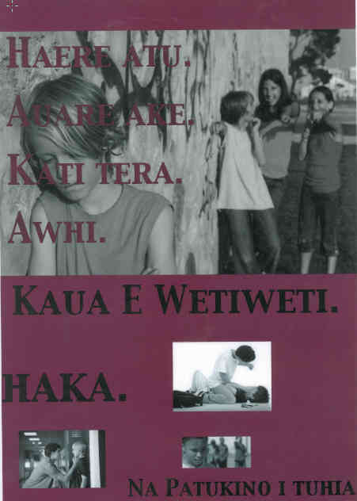  School ethos and environment  - Kura Uara (values) were identified early on. These were reinforced by referring back to these Uara during the lesson delivery of the programmes – e.g,. Manaakitanga, Awhitanga, etc.  - The senior students created a process for students to deal with bullying they called HAKA: Haere atu (Walk away), Auare ake (Whatever), Kati tera (Stop that), and Awhiawhi (Seek help).  Community connections  - Parents/whānau were encouraged to participate in all lessons.  - Students were set homework in which they had to speak with their parents about bullying experiences.  - The kura took part in an unconnected Blue Light trolley day for all schools, which involved some fathers (including gang members) and their children.  - Police ran a police dog demonstration and spoke about how the Kura’s Uara and the Police values were very similar, thus supporting the Kura, and the community connection with Police.  Curriculum teaching and learning  - Senior students were taught how to respond to students who came to them and asked for assistance to deal with bullying.  - Intermediate students created laminated posters of HAKA, to put up around the kura in classrooms, and plan to complete a video demonstrating the use of the process.  - Junior students were taught the HAKA process and composed a waiata (song), with actions, to help remember it.  - The programme also included some Keeping Ourselves Safe learning intentions regarding bullying behaviours that students might witness or experience in their homes and wider local community.
Impact | Students, especially the young ones, immediately started to use the HAKA process. Bullying incidents have decreased.  Police had been initially called in to assist with a specific problem, bullying, from a punishment perspective. But the mere presence of a police officer in the school all day (teaching, having lunch with the kids, playing, talking and laughing with them, meeting their parents) had a huge influence on breaking down barriers between the teachers, students, the Māori community and the Police.
Next steps | The next steps for this intervention are to:  - improve current processes (which are compliant with Ministry of Education guidelines) for dealing with the bully, the incident, and the victim, within a Māori world view, including the processes for reporting and dealing with serious incidents  - improve the internal process using Tikanga and Kawa for dealing with minor incidents in the early stages of bullying.  - reduce the barriers to community engagement with Police.
Obstacles | The main obstacles were:  - the requirement to use Te Reo at all times. Teachers and students encouraged and assisted the SCO to use Te Reo  - the depth and emotive content of the issue created some difficulties in matching Māori answers to bullying with processes that met Ministry of Education guidelines. This was overcome to a certain extent by making use of the tuakana/teina philosophy of the Māori world view  - teachers’ and students’ doubts that Police could do anything other than shoot people and take Dad away to jail. Changing this perception is ongoing task with no quick fix  - the lack of Police Māori rauemi (resources). This was overcome by utilising kura resources such as Pakiwaitara and Whakatauki, inventiveness and teacher expertise.
Improvements | The intervention would be improved by:  - including more parents/whānau and people from community groups  - including more Police staff, so Police and the community see each other in a positive light  - repeating the intervention at other kura would create an opportunity for improvement and increased effectiveness, and would ensure consistency as students progress through the different levels of the kura  - encouraging flexibility in meeting kura needs, inventiveness in using whatever resources are available, and assisting Kura in improving their processes.
Conclusion | The kura is proud of the creation of the HAKA process as a whole-kura effort. This has reinforced their Uara, created learning opportunities for teachers and students, and has potential to spread throughout the community.

