Supporting school issues through a whole-school approach
Travelling Safely
Police district | School name | School demographics | Submitted by
Bay of Plenty | Unnamed | Co-ed primary school Decile 2 | Constable M Bicknell

Summary | Increase safety of students crossing the road after school.
Issue | 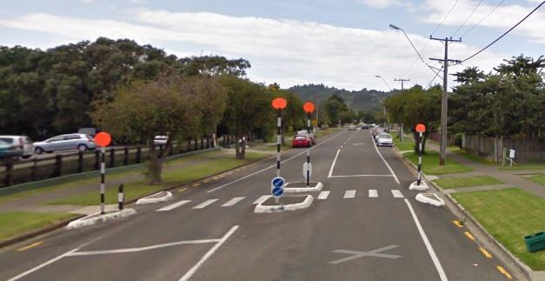  Potential of injury to students after school, as they leave from two schools that are situated almost opposite each other on the same street.  The pedestrian crossing is used by students from both primary and intermediate schools.  A school patrol operating on the pedestrian crossing is manned by primary students. The primary school ends at 2.40pm and patrollers finish patrolling this crossing at 3.00pm. Intermediate school ends at 3.00pm. Many of their students use this crossing without any patrollers present.  The issues include:  - vehicles parking illegally on yellow lines, making it difficult for patrollers to get a clear view of the traffic coming  - drivers appearing to travel over 50km  - drivers not focusing on the road or their driving whilst travelling back and forth past the school looking for their children to pick up  - vehicles stopping for the pedestrian crossing, causing traffic to build up  - some students cutting between stopped cars instead of using the crossing.
Identification and prioritisation | The issue was identified and prioritised by the primary school’s teacher in charge of the School Patrols, the School Community Officer, and parents viewing some near misses of students being hit by vehicles. This has occurred on the crossing, and also 50 meters away from the pedestrian crossing.
Short-term goal | To analyse the dynamics of the environment outside the primary and intermediate schools, so as to be able to implement changes to enhance student safety.
Long-term goal | - To reduce the volume of intermediate students using the northern school exit opposite the primary school.  - To improve student behaviour on and around the road.  - To raise awareness amongst parents and caregivers about safe road practice when uplifting students after school.  - To improve the safety of the area by the addition of structural safety measures.
Prevention activities | Activities that occurred within a whole-school approach included:  School ethos and environment (policies; skilled staff; safe environment)  - The primary and intermediate Principals met to refresh the policy that intermediate students should use the further exit from primary school unless their direct route home is past the primary school.  - Staff from both schools were informed about this policy and implications.  - Students’ ideas to improve road safety were sought, inclduing repainting the road markings as it is hard to see where the yellow no-park lines started; installing a “kiss and go” drop off-pick up parking area; and installing an electronic school zone and 40 kmph speed restriction sign.  Community connections (consultation; collaboration; model parents)  - Students wrote a letter to the District Council to inform them of the results of their observations, and made recommendations to help improve students’ safety.  - Parents and caregivers were made aware of the project, and saw the students working on data-gathering before and after school. This had an effect on improving driver behaviour and speeds.  - Students put a message into the school newsletter informing parents of their concerns regarding driving behaviour and practices that made it unsafe for students.  - Parents were spoken to by the SCO outside the school to inform them of safety issues such as parking illegally, and travelling back and forth looking for students.  - SCO assisted students with gathering data on the speed of vehicles travelling past the schools, by using a laser detection device.  - Neighbourhood Support Co-ordinator, SCO and primary Principal undertook the first steps to implement a Walking School Bus from the primary school. Unfortunately this did not get up and running due to lack of interest and support from the parents and caregivers.  Curriculum teaching and learning (taking action for: myself; my friends; my community)  - Primary school GATE teacher facilitated 20 students to analyse the dynamics of the environment outside their school, and problem-solve some initiatives to improve student safety.  - Over five days the students recorded the behaviours of drivers, students and pedestrians before school, at lunchtime, and after school. They observed driver distraction, number and speed of vehicles, students crossing without using the pedestrian crossing, and other student behaviour. They noted the general condition and layout of the road area. This data was analysed, graphed, summarised and included in a letter to the District Council.  - All students were informed of the concerns for their safety, and that they must use pedestrian crossing and manage their behaviour on and around the road.  - Local council parking wardens continued to monitor this area to educate and enforce safe parking practice near school entrances.  - The SCO provided road safety education for the primary school, including safe use of the pedestrian crossing after school.
Impact | The Whakatane District Council have agreed to assess the area and will look to implement some changes suggested by the students to enhance safety in the area. Changes will be finalised and implemented in 2017.  There is more compliance by students around the exits of both schools, and students are using the crossing instead of cutting across the road.  There are less intermediate students using the northern school exit, reducing the pedestrian crossing’s effect on the traffic flow.
Next steps | Follow-up in 2017 with District Council about the changes to be implemented.  Refresh safety guidelines with the 2017 students in both schools.  Engage with parents and caregivers on alternative sites to pick up their children, e.g. get students to walk to the next block and meet them there.  Provide incentives for students, e.g. a school ‘doing the right thing’ card.  Continue to provide road safety education to students.
Obstacles | Parental engagement has been difficult in terms of effective modelling of safe practices. There are some differences in understanding around what safe practice actually looks like.  The Walking School Bus did not have the support to be implemented.  Some drivers were critical of using students to gather data.
Improvements | More effective communication and consultation with parents and caregivers to help identity and address their views, and get their compliance.  Include the intermediate school more in assessing the issues, and share responsibility for traffic congestion, driver behaviour, and student behaviour.  Promote ways of encouraging parents to avoid the main school entrance as their preferred pick-up point for students.
Conclusion | The students’ behaviour has improved in relation to them using the pedestrian crossing.  There is need for continual education and enforcement of safe walking practices when leaving school at the end of the day.  There is still work to be done on changing drivers’ behaviour around safe practices for picking up students.  The improvements to be undertaken by the Council will increase the impact and results of this intervention.

