Supporting school issues through a whole-school approach
Theme: Safe Journeys
Police district | School name | School demographics | Submitted by
Auckland City | Royal Oak Primary | Urban co-ed school. Decile 8. | Senior Constable Doug Jamieson

Summary | Safety of students when using the pedestrian crossing on Pah Road.
Issue | 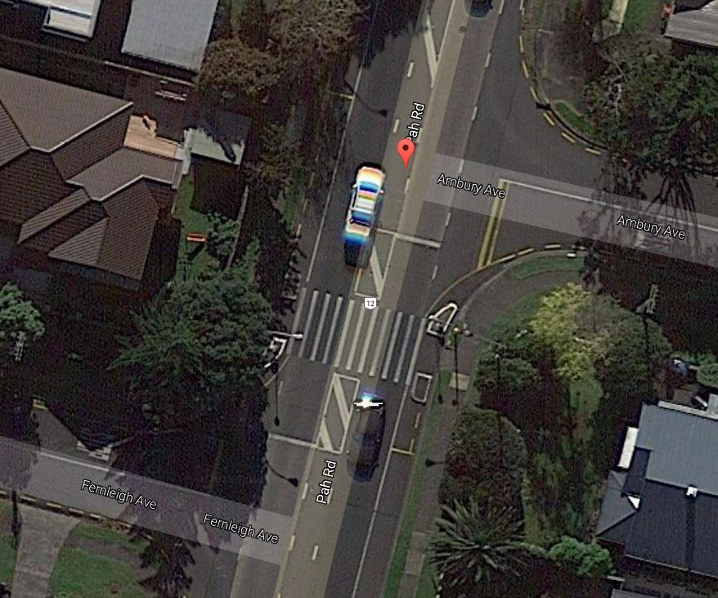  Vehicles not giving way to pedestrians on the pedestrian crossing, which is poorly located on a busy main arterial route between two adjacent side roads, made worse by vehicles turning left out of one side road while waiting to turn right into the opposite side road, thus blocking visibility on the crossing.
Identification and prioritisation | Over several years there has been a history of incidents reported by school staff, local residents and parents, of pedestrians (including school children) being nearly hit by vehicles while using the crossing. These incidents had been growing in frequency, making this a priority issue.
Short-term goal | Increase the safety of students when they are using the crossing before and after school.
Long-term goal | - Incorporate improved safety modifications into the design of the existing pedestrian crossing  - Eventually replace the pedestrian crossing with a traffic light controlled crossing situated in a more suitable location.
Prevention activities | Activities that occurred within a whole-school approach included:  School ethos and environment (policies; skilled staff; safe environment)  - The school advised parents to accompany their children when using the crossing.  - The school promoted increased use of the “Walking School Bus”.  - Police SCO made regular attendance at the crossing a priority, in order to create a higher profile Police presence to increase driver awareness, improve driver behaviour, and to inform and educate pedestrians using the crossing of the need to take extra care.  Community connections (consultation; collaboration; model parents)  - Road Policing Units increased patrols of the area.  - Letters were sent to parents to recruit adult supervisors to supervise the crossing during peak student crossing times, which a number of parents agreed to. Teachers and principal also took turns in assisting with this.  - Engineering improvements were added at various stages by Auckland Transport, including the installation of coloured, high-friction seal on the approach to the crossing, repositioning the poles displaying the orange flouro disks, and installing warning signs with flashing lights. In September 2016 the pedestrian crossing was finally removed, and a new traffic light crossing was installed further up Pah Road in a more suitable location.  Curriculum teaching and learning (taking action for: myself; my friends; my community)  - Road safety lessons for junior school classes using Police’s Travelling Safely resources. This included safe use of pedestrian crossings and the need for students to ensure they can see that all drivers are actually stopping before walking over the crossing.  - A special lesson was conducted by the Police SCO with a particular group of approximately 60 students who usually walk to school via the Pah Road crossing.
Impact | Student safety immediately improved once adult supervisors began supervising the crossing. However incidents still occurred regularly of vehicles not giving way to pedestrians on the crossing.  In the three months since the new crossing was installed, no incidents have been reported.
Next steps | Review the situation next year, and in the meantime continue to have an adult supervising the crossing to encourage safe crossing behaviour and ensure students are not trying to cross after the green cross signal has gone off (which was occurring when the crossing was first installed).
Obstacles | There was a good response from parents when asked to volunteer their time to supervise at the crossing, but there were not enough to cover the complete weekly timetable. So school staff had to be made available to fill several gaps in the duty roster.  The financial cost involved in making engineering design improvements to the crossing meant they had to be made in a partial and gradual manner. The considerable cost of installing a new traffic light crossing meant an extended time delay before the budget became available to carry out this work.  During the changeover period between the pedestrian crossing being removed and the new traffic light crossing being commissioned, there was a period of two weeks where pedestrians were left without a proper crossing to use. The Police SCO had to attend most mornings and afternoons during this period to support parents and teachers assisting the students to cross safely, until the new crossing was operational.
Improvements | An improvement would be that the pedestrian lights on the new crossing be upgraded to the countdown timer type that display how many seconds remain before the lights change and traffic starts to drive again.  Opportunities could be provided for student-led action to promote the safe use of the new crossing by their school and their local community.
Conclusion | Steps taken by the Police SCO, the school community and Auckland Transport have achieved a successful conclusion by enabling students walking to and from school to now cross Pah Road in far greater safety.

