Supporting school issues through a whole-school approach

Responsible citizens
Police district | School name | School demographics | Submitted by
Auckland City | Edendale School | Contributing  Urban, multicultural  Decile band 4–6 | Snr Const. J. Taylor  School Community Officer

Summary | Increasing the safety of students when using a local reserve.
Issue | Edendale Reserve, on Sandringham Road, Auckland, is a shared space owned jointly by Auckland Council and Edendale School. These two locations also have pizza, noodle and alcohol shops next to them.  After each weekend in February 2015 there was broken glass and rubbish on the field at Edendale Reserve.  This reserve is used by Edendale School for sports and for play during break times. The broken glass and rubbish were a danger to the students.
Identification and prioritisation | 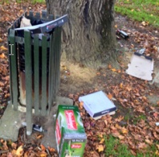  The school caretaker gathered data on the amount, type, and location of rubbish in the reserve each Monday. On one occasion the amount of broken glass and rubbish retrieved by the caretaker was enough to fill a big wheelie bin. The glass was mainly alcohol bottles and the rubbish was pizza boxes.  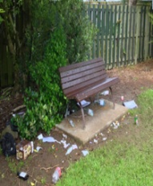  The principal raised concerns because building construction in  the school meant that more students would use the walkway through Edendale Reserve for one year.  Edendale Reserve is set off Sandringham Road, a main route into Auckland City CBD. The reserve includes mature, tall trees that create hidden places for people to congregate. There are three park benches in the reserve and one rubbish bin. Edendale Reserve currently has an evening liquor ban.  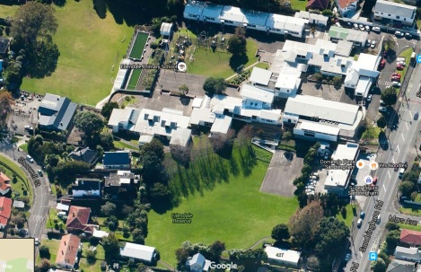  During a lesson of safe walking with year 1–2 students through Edendale Reserve, the SCO observed two men who were sitting on a park bench and drinking alcohol. The two men were still there during the lunch break while students played on the field.  The principal contacted Police about a man who was sniffing out of a plastic bag on the field of Edendale Reserve. This prevented a sports lesson being taken by a class teacher. The SCO located and dealt with the man.
Short-term goal | To create a system to help the school deal with the broken glass and rubbish, and to decrease the number of incidents of littering and other unlawful uses of the reserve.
Long-term goals | To reduce the amount of broken glass and rubbish left in Edendale Reserve.  To reduce the number of issues reported by the school.  To engage with the wider school community (such as local shops, residents, local businesses, Auckland Council, families, Community Police) to encourage their assistance with helping reduce this issue by the end of the 2015–2016 summer.
Prevention activities | Activities that occurred within a whole-school approach included:  School ethos and environment  - The caretaker walked through Edendale Reserve each day to assess dangerous litter.  - There is an overnight liquor ban currently in place to deter people from consuming alcohol in the reserve at night.  - The SCO supported staff with safe walking lessons that included walking through the reserve and informing students about the potential dangers (for example, glass on the footpaths) and to avoid people they did not know.  - Four students completed an enquiry unit on the issue. The students wrote a letter to Auckland Council expressing their concerns and provided ideas on how to reduce the problem. The council replied with an outline of its plans for the reserve.  - The students designed a pamphlet and a letterbox drop to inform local residents and shop owners about the issues and ask them to be on the lookout and to report any offenders to police.  - The students asked the three nearby businesses to display the pamphlets to increase community awareness.  - Police were deployed to conduct foot patrols through the reserve when they were able to do so.  - The SCO completed a CPTED report that identified all the issues summarised in this narrative.  Community connections  - Discussions about ways of dealing with the issues included the principal, school staff, the school caretaker, Auckland Council, Police and the SCO, and local businesses.  - The principal, school staff, caretaker, Auckland Council, Police and SCO collaborated to educate students on safety when walking or using the reserve.  - The council agreed to:  - provide table seating on Sandringham Road at a location near to the pizza shop to reduce the number of people who eat their pizzas in the reserve  - increase the liquor ban to 24 hours  - increase the frequency of inspections and litter pick-ups, especially Monday mornings  - provide a small budget for landscaping within the reserve, including putting in an extra litter bin, trimming back vegetation around one of the seats to increase visibility, and replanting with low-growing vegetation.  - The principal and the SCO have both written articles for the school newsletter outlining the concerns when students are walking through the reserve. The pamphlet created by the students was also published in the school newsletter.  Curriculum teaching and learning  - The key messages of the safe walking programme were for the students to be responsible and not approach anyone they do not know in the reserve, and to avoid the rubbish and broken glass.  - A group of four students completed an enquiry in which they analysed the issues, wrote to the local council outlining their concerns, and designed a pamphlet for local residents. This initiative aimed to encourage the students to be aware of issues within their play area, and to promote a safer environment for them.
Impact | Short-term goal  The principal, the SCO and the local council worked together to ensure that council contractors organised regular cleaning of the reserve, rather than the school caretaker doing it.  Long-term goal  By Term 4 the principal had noticed an improvement with the reserve, and there were no reports of broken glass and rubbish left in the reserve.
Next steps | Police will enforce the revised alcohol ban and conduct patrols through the reserve.  The local council will put its recommendations into practice as budget allows.  Contractors for Auckland Council will clean the reserve each week and empty rubbish bins before they get overfull.  The school will monitor and report any further incidents.  The school will continue to hold safe walking lessons that include safety from rubbish and personal safety.  Installing flood lights in the reserve and CCTV cameras will be considered as a deterrent.  The school will use local print media if the issues continue.
Obstacles | The main obstacle was that neither the school nor the council appeared to have communicated with each other on what they use the reserve for, and who should have use of it.  One business, which contributes to most of the rubbish, was reluctant to help.  The third obstacle was the lack of monitoring and guardianship in the reserve to keep it safe. This can be overcome by applying CPTED principles.
Improvements | The intervention would be improved by:  - identifying and contacting other users of Edendale Reserve to ensure that they are supporting safety within the reserve  - creating different ways for the parents and members of the public to be contacted, and gaining their support with keeping the reserve safe for the students.
Conclusion | This intervention has raised awareness at Edendale School – incidents are being reported promptly so that they can be dealt with quickly. The school is pleased that there has been a reduction in dangerous litter and that the collaboration involved in this intervention has had a positive effect.

