Supporting school issues through a whole-school approach

Responsible citizens
Police district | School name | School demographics | Submitted by
Auckland | Te Papapa School | Contributing school  Urban  Decile band 1–3 | Carol Leota, Associate Principal  Snr Const. D. Jamieson  School Community Officer

Summary | Promoting positive school values and developing social skills.
Issue | Police intel showed that statistically Te Papapa School was located in the centre of crime in the Auckland Police District. The school had been involved in PB4L School-Wide since 2010, and was considering the implementation of the second tier of the initiative with interventions to support at-risk learners to develop social skills.
Identification and prioritisation | A team that included the SCO, RTLB, the principal and the associate principal reviewed the behaviour referral data for learners who were at risk of developing embedded antisocial behaviours.  The data clearly identified boys from the senior school who were demonstrating at-risk behaviours such as defiance, non-compliance, disrespect, verbal and physical aggression, and damage to school property. Some students were involved in property damage and theft of sirens in the community.  The school’s PB4L-based approach to developing the desired social skills in the students included data analysis, planning, teaching, modelling behaviour, and using practice to reinforce learning.  The team decided to target the group, include some role models, put in place a lot of highly engaging activities that support the focus on social skills, and ask the learners to name the group. The boys called their group the Police Squad.
Short-term goal | The targeted boys will:  - develop social and coping skills  - understand how these skills are used in real life jobs (for example, Police officer, professional athlete)  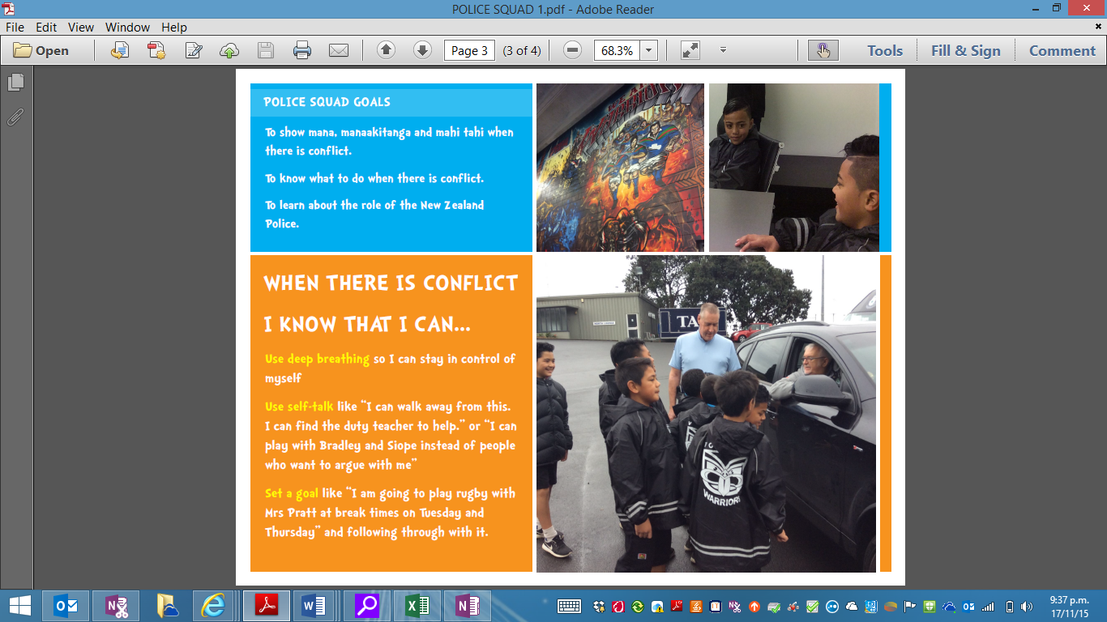  - develop positive relationships with the Police.
Long-term goal | Targeted boys will exemplify the school values of mana, manaakitanga and mahi tahi, and be role models who know what to do if there is conflict in the playground.
Prevention activities | Activities that occurred within a whole-school approach included:  School ethos and environment  Te Papapa School is a PB4L School-Wide school that believes all students can learn to demonstrate the positive school values. Social skills are taught weekly. In PB4L School-Wide tier two, a group of students has the opportunity to re-learn the social skills and positive values of the school.  Community connections  - The intervention included collaboration between the school, Police and the Vodafone Warriors.  - The boys met a range of Police officers from School Community Services, Armed Offenders Squad, Police Dog Team and Highway Patrol. Police shared their roles, why they became Police officers, and reinforced the teaching and learning of the intervention by describing how they cope with conflict in their roles.  - The boys went to Mt Smart Stadium and met Sir Peter Leitch, who reinforced the strong values of the Vodafone Warriors. Jerome Ropati, the Vodafone Warriors’ ambassador, led a group tour and made clear links between the values of the Vodafone Warriors and the values of the school. Jerome reinforced the teaching and learning of the intervention by describing how players on the field deal with conflict and what the Police Squad members can do when they are involved in conflict.  Curriculum teaching and learning  - Individual behaviour referral data was used to create plans with each referred student about what they could do differently next time.  - The school used rewards to reinforce the desired behaviours, and each week the SCO rewarded the Police Squad student of the week (based on referral data and teacher voice) who had exemplified Police Squad goals and school values. Rewards included Vodafone Warriors posters, Police Dog merchandise and New Zealand Police resources.

Impact | 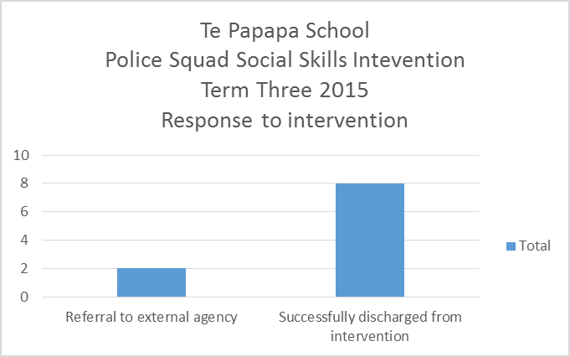  The table below shows referrals by members of the Police Squad for target behaviour and the result of the intervention. The ethnicity and year level of each student is given. All the targeted students were male.  The student population sees the Police Squad as a group with mana who demonstrate the school values and access community opportunities to practise and reinforce their social skills.

Student | Referrals for target behaviour in the term before the intervention | Referrals for target behaviour during the term of the intervention | Outcome
Māori, year 5 | 4 | 0 | Successfully discontinued
Pasifika, year 6 | 3 | 0 | Referred to other agency
Pasifika, year 6 | 5 | 0 | Referred to other agency
Māori, year 4 | 10 | 4 | Successfully discontinued
Pasifika, year 4 | 10 | 5 | Successfully discontinued
Pasifika, year 4 | 5 | 0 | Successfully discontinued
Pasifika, year 6 | 0 | 0 | Successfully discontinued
Māori , year 6 | 0 | 0 | Successfully discontinued
Pasifika , year 6 | 0 | 0 | Successfully discontinued
Pasifika , year 6 | 4 | 2 | Successfully discontinued
Total | 41 | 11 | Decrease by 73%

Next steps | The intervention has been successful. The group has a high profile and students are requesting to be included in future. Referral data is reviewed each term to determine the next target group. In Term 3 it was year 4–6 students, and in Term 4 it was year 3–4 students.  The intervention provided an example of how expected behaviours can be explicitly taught, individual and group goals can be developed, and desired behaviour rewarded, leading to improved student behaviours.
Obstacles | The values and beliefs of the wider community don’t always match up with the positive social skills, values and beliefs of the group at the school. As a result, although Police Squad members were demonstrating improved social skills in the school, incidents of concern involving students still took place out of school. The obstacle was overcome by careful and focused mentoring of the individual student by the SCO, the school and external agencies supporting the family.
Improvements | The intervention would be improved by better communication with the wider school staff about its purpose and impact and the range of community opportunities available through it (for example, a V8 Supercar experience).
Conclusion | Te Papapa School is proud of how this intervention has improved students behaviours in the school, the high regard in which Police are now held, and the support from the wider school community. The school appreciates the support of Police officers and the Vodafone Warriors for the intervention.

