
School Community Safety Education Planning Process

Schools and police partnering in school-wide interventions to prevent crime and crashes

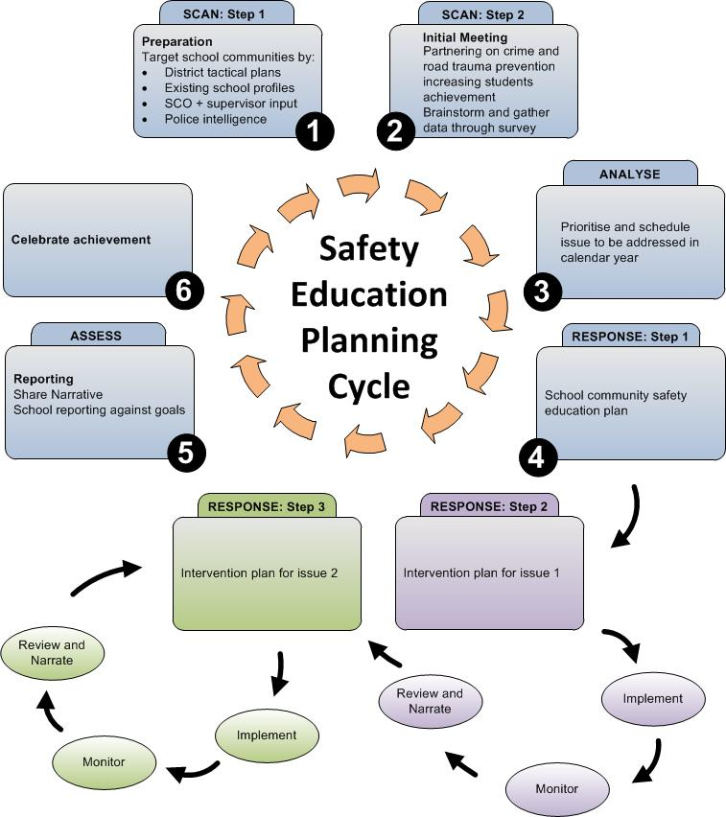
Note: While this diagram shows two Responses to two issues, the Safety Education Planning Cycle may have have less or more Responses, depending on how many issues have been prioritised to be addressed.

Goal | The goals of partnering in a school-wide intervention are to:  - prevent crime or crashes in the school community  - increase the safety and well-being of students  - improve the educational achievement of students.  These goals are to be achieved through interventions owned by prioritised school communities, and delivered within a whole school approach.

SCAN
Step 1  Preparation and prioritising  (suggested in August to fit with school charter) | Read the:  - New Zealand Police Prevention First strategy  - planning tools on the School Portal schools.police.govt.nz  - National Education Guidelines, including National Education Goals (NEGs) and National Achievement Guidelines (NAGs).  Prioritise schools for partnership through a range of intelligence sources, e.g.:  - national and district intelligence  - data from the Ministry of Education e.g. Education Counts  - school data and information  - knowledge from existing SCOs and other Police.
Gather information about the prioritised school | Review:  - previous School Profiles for the school  - the school's most recent ERO review  - the school's charter (the purpose of a school charter is to establish the mission, aims, objectives, directions, and targets of the Board).
Step 2  Initial meeting with school principal  (suggested in Sept/Oct to fit with school charter) | Discuss with the principal what the school will gain from working in partnership with Police. Examples may include:  - the students increasing their educational achievement by feeling safer  - the school becoming the most desirable school in the community with an expanding student roll  - the school having an ally in Police to access more resources to achieve their building programme (e.g. through CPTED)  - school staff having more time to be creative teachers, and to be more involved in preventing undesirable student behaviour rather than having to spend time on discipline.  Consider asking questions about the school related to their school charter, e.g.:  - What is the school's mission?  - what will the achievement of this mission look like in four years?  - how does this mission align with preventing crime and crashes?  - What are the school's values?  - how do these values align with preventing crime and crashes?  - how are these values demonstrated in the school environment and lessons?  Discuss ways that various forms of crime and crashes may impact on the ability of the school to fulfil its mission.  Discuss with the principal their thoughts on the role that a safe school community has on academic results of students.  Consider completing a Partnership Agreement.
Brainstorm crime prevention and road safety issues to be addressed | Encourage the principal to identify factors that affect student safety (from being a victim of crime or a crash), and that they identify as a problem in their school  Consider updating the School Profile.  Provide information about issues identified through Police intelligence products, which are currently most problematic for students in their school.  Discuss examples of how schools have worked in partnership with the Police to address problems.
Complete school community survey | If necessary, encourage the principal to gather further data to confirm the factors that affect student safety, e.g. survey children, teachers and the community.

ANALYSE
Step 3  Prioritise issues to be addressed in calendar year  (suggested in Oct/Nov to fit with school charter) | Prioritise with the principal an issue (or issues) that will be the focus of an intervention(s) for the coming year.  Prioritisation considers all the issues identified through the survey, those identified by the principal, and those that Police intelligence products have identified.

RESPONSE
Step 4  Safety Education Annual Plan | Place prioritised issues into a one-page School Community Safety Education Plan.  Encourage the school to transfer goal(s) from the Safety Education Plan into the school's Annual Plan as part of the charter they submit to MOE by 1st March.
School community intervention plan | Begin planning to implement a school-wide intervention to address the issue(s).  The intervention should consider all nine components of the whole school approach as described in the intervention planning tool, and should follow a problem solving process e.g. SARA.  Place the content of the discussion into a planning template. The school may have their own template, or they may use the Police intervention planning template.
Implementing the intervention plan | Schedule police (e.g. SCO) time through tasking and coordination to contribute to the actions identified in the plan.
Review the implementation | Review the impact of the intervention(s) as compared to the short term goals in the implementation plan.

ASSESS
Step 5  Reporting on the intervention | Produce a narrative at the completion of each intervention, which describes:  - what the intervention was trying to achieve (goals)  - what actions took place across the three themes of the whole school approach  - what impact the intervention has had compared to the goal(s)  Based on the school's wishes, the narrative may not mention the school's name or other means of identification.  Police have a narrative template on the school stories page on the School Portal.
Sharing your learning with the district | Share the narrative with your colleagues.  Have a colleague in the district peer-review the narrative.
Sharing learning from the intervention | Provide opportunities for the school and other district staff to review the narrative.  Forward the narrative to Police National HQ for final review and editing, to be placed on the School Portal.
Reporting to MOE | Where schools have placed goal(s) from the safety education plan into the school's Annual Plan, they report the results of the intervention in the school's Annual Report (due to be submitted to MOE by 31st March in the following year).

Celebrate achievements
Step 6  (suggested in Nov/Dec) | School – seek ways to acknowledge the students and other school community members who have contributed to the intervention that has resulted in a safer school community.  Local police – seek ways to acknowledge schools who have achieved a safer school community, e.g. media release, information to parents, presentation to school staff or student assembly.  PNHQ – seek ways to acknowledge the most effective interventions (where identified goals have been quantified and achieved) that a school and Police have facilitated together.

