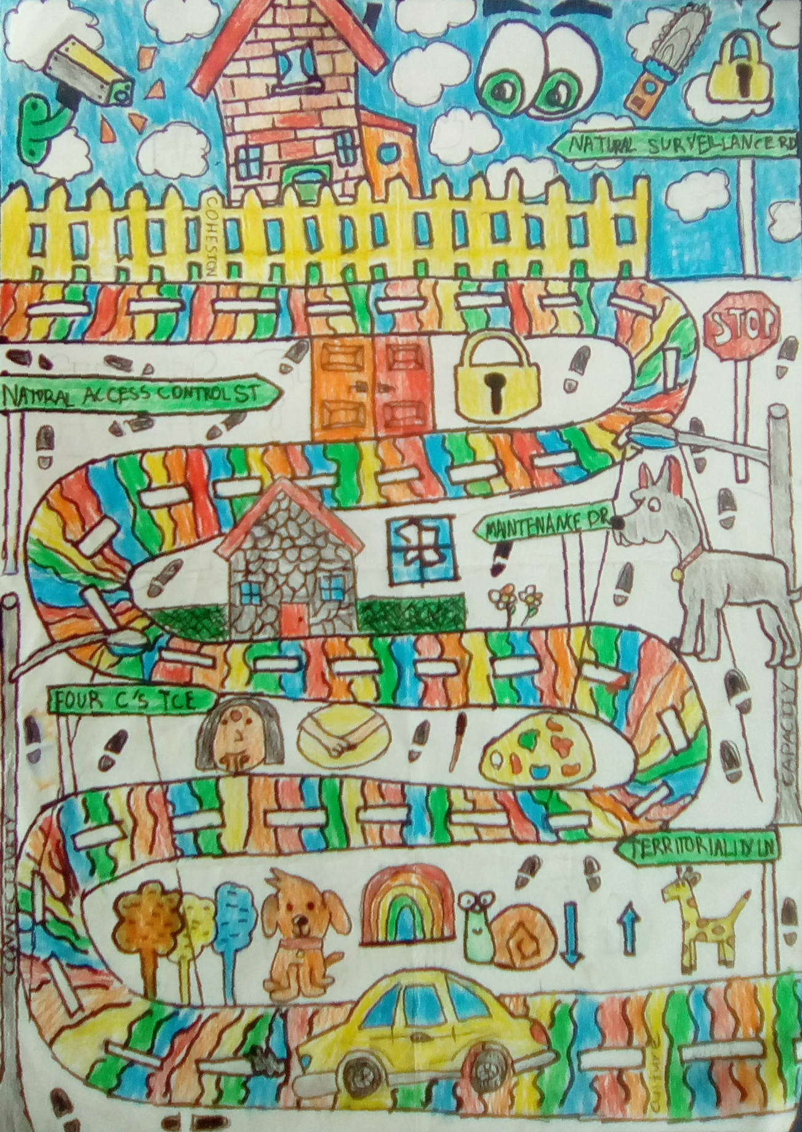
Safer Schools

Foreword 3
Acknowledgements 4
Introduction 5
Focus area 1: What makes us safe? 8
Learning experience 1: Natural Surveillance 10
Learning experience 2: Access Management 13
Learning experience 3: Territorial Reinforcement 14
Learning experience 4: Quality Environments 15
Focus area 2: How safe are we? 16
Learning experience 1: Preparing to audit our school 17
Learning experience 2: The audit 18
Focus area 3: So what did we find? 20
Learning experience 1: Evaluating the audit 22
Learning experience 2: Writing up the audit 23
Focus area 4: Sharing our understanding 26
Learning experience 1: Storyboard 27
Learning experience 2: Presentation practice 28
Learning experience 3: Presentation 29

Foreword
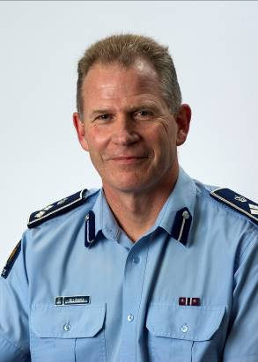
I am pleased to support Safer Schools on behalf of the New Zealand Police. Schools are at the heart of our communities, and play a vital part in crime prevention. We are committed to supporting schools so that students have the best environment for learning, and that everyone in the school community is safe and feels safe.

Safer Schools has been developed as a joint Police and schools initiative to work together to prevent crime, road trauma and harm in our communities.

It draws on the principles of Crime Prevention Through Environmental Design (CPTED), with the aim of preventing crime by designing a physical environment that influences positive human behaviour.

While these principles have been around for some time, Safer Schools provides a structured series of learning activities involving students, the school and Police, culminating in student-led recommendations and actions to improve the school environment.

Safer Schools aligns with The New Zealand Curriculum while incorporating expectations for both schools and Police. It is designed to enhance the connections between schools and the communities that surround them.

Bill Searle
Assistant Commissioner: Prevention
Police National Headquarters

Acknowledgements

We would like to particularly acknowledge Fleur Knight from Murrays Bay Intermediate School and Sergeant Deane McEntee from Auckland City Police’s School Community Service for their hard work and dedication to initiate Safer Schools.

We would also like to acknowledge the following people who have contributed their time, thoughts and ideas to Safer Schools:
- Colin Dale – Principal of Murrays Bay Intermediate School
- Amelia Wilson – student at Murrays Bay Intermediate School (cover artwork)
- Kyle Brewerton – Principal of Remuera Intermediate School
- Julie Miller – Teacher at Remuera Intermediate School
- Robyn Curry – Principal of Te Papapa Primary School
- Sergeant Scott Svendsen – Scene of Crime Team Leader with Auckland City Police
- Senior Sergeant Jason Edwards – Youth and Community Coordinator with Auckland City Police
- Lawrie Stewart and Roly Hermans – National Prevention Centre, Police National HQ

Introduction

Overview
Safer Schools has been designed for members of the school community to identify and prioritise action that will enhance the school environment to make it safer. It is anticipated that after completing the lessons, the school can look to further extend Safer Schools through the community to identify and solve common issues and to form better connections with the school.

Rationale
Schools in New Zealand face many issues that put the school, their students and staff at risk. One issue that schools face is that they are often targeted by people who commit burglaries or property damage. The cost of this crime in terms of property replacement and repair amounts to millions of dollars; however the cost in lost educational opportunities is immeasurable.
Safer Schools is not limited to property crime; it can be adapted to address any issue affecting students in schools throughout New Zealand, such as road safety, bullying, or drug abuse. The ability to adapt Safer Schools to any relevant issue makes this an ideal tool for schools to use to improve the safety of all connected with their school.
The benefits of implementing Safer Schools are that students who feel safer are more likely to:
- have higher educational achievement
- behave positively
- extend themselves both physically and socially by being able to mitigate and manage risk situations
- develop closer connections with the school
- be more actively engaged with the school community.
Safer Schools is based on the principles of Crime Prevention Through Environmental Design (CPTED). These principles assist in reviewing and modifying the design and effective use of the environments. From here on in, CPTED principles will be referred to as Safer Schools principles.
Safer Schools uses a problem solving method called SARA (Scan, Analyse, Respond, Assess). This method is used extensively by Police.

Role of the teacher and the school
The role of the teacher in Safer Schools is to teach the students the Safer Schools principles, in partnership with the School Community Officer.

To achieve this the students will:
- define the Safer Schools principles using real-life examples of crime prevention and crime response
- identify examples in their school environment of the four Safer Schools physical principles of Natural Surveillance, Access Management, Territorial Reinforcement and Quality Environments, and justify whether these are good or poor examples
- complete a safety audit of the school using the four Safer Schools physical principles
- identify and justify unsafe areas, grading them 0-3
- write up the safety audit using the template provided
- create a presentation with findings and images to explain areas in the school that are safe, marginal and/or unsafe
- present findings, as recommendations, to school management and staff, School Community Officer and Board of Trustees
- act on the recommendations made in the audit
- involve the wider community in the improvement of safety in schools.

Role of the police officer
The role of the police officer (often the School Community Officer [SCO], but could also come from other Police groups) is to support the school in the delivery of Safer Schools. The police officer will be able to assist by:
- providing real-life examples of crime prevention and crime response
- reinforcing the value of partnering with Police to have safer communities together
- drawing on the experience of other trained Police personnel such as Crime Scene Attendants (CSAs) and detectives (CIB).
The learning experiences that will benefit most from the police officer’s involvement are highlighted in the Safer Schools timeline landscape under the heading ‘SCO role’.

Safer Schools timeline
- Timeline landscape [DOCX]
- Sequence of lessons [PPTX]

Where to afterwards?
On the conclusion of Safer Schools, you could consider:
- introducing the four additional social ‘soft principles’ of CPTED essential for social action to be effective, namely cohesion, connectivity, culture and capacity (the four ‘C’s)
- doing a community audit, for example in neighbouring streets around school
- initiating community murals
- coming up with ideas for curriculum integration and community engagement following the audit.

See Applying Safer Schools to home, school, community [DOCX] for more details.

Focus area 1: What makes us safe?

This section contains one of the following Focus areas from Safer Schools for students at years 7-8:
- What makes us safe?
- How safe are we?
- So what did we find?
- Sharing our understanding

Explanation
In this focus area students will be introduced to the four physical principles of Safer Schools. These four principles establish an understanding of the target areas for auditing the security of the school in Focus area 2. Students who have an understanding of these principles will be able to differentiate between safe areas, and areas that require attention to reduce the risk to the particular environment, as well as those who use that environment.

Curriculum links
Key competencies: Participating and contributing; Thinking; Managing self.
Learning area: Level 3 Health and Physical Education – Personal health and physical development: Safety management. Students are able use the principles of environmental safety at their school and explain how the principles improve safety at their school.

Resources
- Safer Schools workbook [DOCX]
- Slideshow: Natural Surveillance [PPTX]
- Slideshow: Access Management [PPTX]
- Slideshow: Territorial Reinforcement [PPTX]
- Slideshow: Quality Environments [PPTX]
- Natural Surveillance checklist [DOC]
- Access Management checklist [DOC]
- Territorial Reinforcement checklist [DOC]
- Quality Environments checklist [DOC]
- Police officer (often a School Community Officer, but may also come from another Police group)

Success criteria
Students will be able to:
- apply knowledge of the four physical principles during a walk around the school.

Learning experience 1: Natural Surveillance

Learning intentions
Students will be able to:
- identify examples of the principle of Natural Surveillance within their school environment
- explain how they can use the principle of Natural Surveillance to improve safety at their school.

Notes for the teacher
Natural Surveillance deters crime because people do not want to be seen committing offences. Natural surveillance can be improved by using materials that people can see through, designing environments where people have clear sightlines and encouraging people to use the environment so there are more people seeing what is happening in that environment.
This Natural Surveillance checklist [DOC] provides more detailed information.

Notes for the police officer
The police officer (usually the School Community Officer, but can be from another Police group) may introduce an example from their own experience where Natural Surveillance features in a crime scene. This may be a burglary that the officer attended, or a car crash where reduced visibility played a part in the crash.
The officer will identify how the lack of Natural Surveillance contributed to the event, and then discuss recommendations that could have reduced the chance of this event happening.

Resources
- Slideshow: Natural Surveillance [PPTX]
- School Community Officer

Activities

1. What is Natural Surveillance?
Teacher introduces the physical principle of Natural Surveillance, using the slideshow presentation Natural Surveillance [PPTX].
Definition: People are present and can see what is going on. People can see and be seen.

2. Natural Surveillance at a school
Apply the principle of Natural Surveillance to the photos of a burglary in a school, found in the slideshow presentation Natural Surveillance [PPTX].
Discussion questions:
What has happened in the photos?
Where has this happened?
How has the offender gained entry into the room?
What has helped the offender enter this room?
What features enabled the offender to commit the crime?
What could have prevented this crime?
What features would have helped to prevent this crime?

3. Natural Surveillance in our school
Identify ways in which a burglar could enter your classroom after hours.
What items in our classroom could be valuable to an offender?
Why could they be valuable?
How are these items protected during and after hours?

Walk around the school and identify elements of Natural Surveillance. Photograph evidence of:
- open lines of sight around the school, for example see-through fences and windbreaks
- foliage that doesn’t provide hiding places, for example cut off lower branches of trees
- lighting, for example sensor lighting.
- internal glass walls
- neighbours who watch and report suspicious behaviour
- community groups who use school facilities after hours, for example exercise classes
- community safety organisations, for example community patrol checks, Neighbourhood Support, security company patrols
- passing vehicular and foot traffic to report suspicious behavior.

4. Natural Surveillance in the community
The police officer talks with the class about a real-life example from their own experience in the Police.

Possible extension activities
Discuss areas in your classroom where there is good Natural Surveillance, and where there is poor Natural Surveillance. Identify what items are kept in each of these areas.
Test the visibility of valuables inside the classroom.
What can people see from outside the classroom looking in?
How could you limit visibility into your classroom after school hours?

Learning experience 2: Access Management

Learning intentions
Students will be able to:
- identify examples of access management (how do you get there?) within their school
- explain how knowing where to go and how to get there, improves safety at their school.

Notes for the teacher
Access Management focuses on clear, direct walkways and clear signage. Access management deters crime because it reduces the possibility of offenders making excuses for being where they shouldn’t be. At times issues that are identified will relate to more than one principle. For example, vegetation growing over pathways can be both an Access Management and a Natural Surveillance issue.
This Access Management checklist [DOC] provides more detailed information.

Resources
- Slideshow: Access Management [PPTX]
- Safer Schools workbook [DOCX]

Activities

1. What is Access Management?
Teacher revises Natural Surveillance, then introduces Access Management, using the slideshow presentation Access Management [PPTX].

Definition: Access Management focuses on clear, direct walkways and clear signage. Access management deters crime because it reduces the possibility of offenders making excuses for being where they shouldn’t be.

2. Access Management in our school
Students discuss Access Management in their school.
Ask:
How easy it is for people to find their way to the front office of the school, the dental clinic, and individual classrooms.
Where do the pathways lead?
Is the signage clear/easy to read/written in languages relevant to our area?

Students work with the Safer Schools workbook [DOCX] to identify access management in their school by walking around the school and taking photographs.

Learning experience 3: Territorial Reinforcement

Learning intentions
Students will be able to:
- identify examples of Territorial Reinforcement (who should be here?) within their school
- explain how knowing who should be in different areas, improves safety at their school.

Notes for the teacher
Territorial Reinforcement focuses on defining private, semi-private and public areas. Clear definition of private, semi-public and public spaces reduces excuses for people to be in the wrong place at the wrong time, doing the wrong thing.
This Territorial Reinforcement checklist [DOC] provides more detailed information.

Resources
- Slideshow: Territorial Reinforcement [PPTX]
- Safer Schools workbook [DOCX]

Activities

1. What is Territorial Reinforcement?
Teacher revises Natural Surveillance and Access Management, then introduces Territorial Reinforcement, using the slideshow presentation Territorial Reinforcement [PPTX].

2. Territorial Reinforcement in our school
Students discuss the principle of Territorial Reinforcement as it applies to their school.
Ask:
How do lines control what we do?
What is the effect of the lines on our netball court? On the road?
How do lines keep us safe?
What other materials are used to define different areas in our school?
How are the areas for staff and students defined in our school?
How are out of bounds areas defined?
How are parking places defined?

Students work with the Safer Schools workbook [DOCX] to identify territorial reinforcement in their school by walking around the school and taking photographs.

Learning experience 4: Quality Environments

Learning intentions
Students will be able to:
- identify examples of Quality Environments (who looks after this place?) in their school
- explain how knowing who looks after this place improves safety at their school.

Notes for the teacher
Quality Environments focuses on maintenance, caring for the environment, being present. Clear definition of Quality Environments gives people the message that this place is cared for, looked after and crime will not be tolerated.
This Quality Environments checklist [DOC] provides more detailed information.

Resources
- Slideshow: Quality Environments [PPTX]
- Safer Schools workbook [DOCX]

Activities

1. What are Quality Environments?
Teacher revises Natural Surveillance, Access Management and Territorial Reinforcement. Then introduce Quality Environments, using the slideshow presentation Quality Environments [PPTX].

2. Quality Environments in our school
Students discuss the principle of Quality Environments as it applies to their school.

Ask:
What is maintenance?
What evidence is there that our school environment is maintained?
How does a maintained school affect how you feel about our school?
What areas need better maintenance and why?

Students work with the Safer Schools workbook [DOCX] to identify quality environments in their school by walking around the school and taking photographs.

Focus area 2: How safe are we?
This section contains one of the following Focus areas from Safer Schools for students at years 7-8:
- What makes us safe?
- How safe are we?
- So what did we find?
- Sharing our understanding

Explanation
In this focus area students work together in groups to audit the school environment by applying the four physical principles of Safer Schools. They will grade aspects of the school environment as safe, marginal or unsafe. In later focus areas students will need to explain why they have made this assessment, as well as explain the mechanics of the audit itself.

Curriculum links
Key competencies: Participating and contributing; Thinking; Managing self.
Learning areas:
- Level 3 Health and Physical Education: Healthy communities and environment: Plan and implement a programme to enhance an identified social or physical aspect of the school.
- Level 4 Social Sciences: understand how exploration and innovation create opportunities and challenges for people, places and environments.
- Level 3 Technology: Brief development - describe the nature of the intended outcome and explain how it addresses a need.

Resources
- Enlarged A3 size digital map of the school (cut into eight pieces)
- Blank sheets of paper (A1 - A3)
- Coloured pencils or crayons (red, orange and green)
- School Community Officer

Success criteria
Students will be able to:
- complete an audit of the school environment by applying the four physical principles of Safer Schools.
- record their findings on a hand drawn map that they have prepared beforehand.

Learning experience 1: Preparing to audit our school

Learning intentions
Students will be able to:
- enlarge a sitemap of their school by hand.

Notes for the teacher
Students enlarge the digital site map by hand without using rulers. Maps do not need to be drawn precisely to scale. Fold the A4 map four times. Fold a sheet of A3 paper four times.
Students enlarge the school site map from A4 to A3 by copying the folded squares. Hand-drawing the enlarged map, rather than doing so with a photocopier, will help students gain familiarity with the area they are auditing.
Classrooms and areas on the map need to be labeled using felt/crayon. Students use three colours to shade in areas that are safe (green), marginal (orange), unsafe/dangerous (red).
Students walk around their designated area to get a feel for that environment.

Resources
- Enlarged A3 size digital map of the school (cut into eight pieces)
- Blank sheets of paper (A1 - A3)
- Coloured pens or crayons

Activities

1. Preparing our maps
Divide the class into eight groups.
Fold a digital map of the school into eight equal parts.
Give each group a part of the map to enlarge.
Students then enlarge their area of the map by hand to A3 size.

Learning experience 2: The audit

Learning intentions
Students will be able to:
- work within a group to conduct a safety audit of their assigned area in the school
- apply the four physical principles of Safer Schools to a safety audit of their school
- identify areas in their school that are safe, needing improvement or unsafe.

Notes for the teacher
While walking around the school students will colour-code their map, take photographs, and make specific notes about the identified areas.

Notes for the School Community Officer
The School Community Officer (SCO) assists the students in identifying areas that are safe, needing improvement, or unsafe as defined by the four physical principles of Safer Schools. As this practical experience of undertaking a safety audit will be unique for the students, having the experience of the SCO to support the learning will be of great benefit.
To prepare themselves for this role, the SCO should ask themselves:
- What am I trying to achieve?
- What can I do to help achieve this?
The SCO could seek the assistance of a Crime Scene Attendant (CSA), forensics officer or a detective (CIB) to further draw on their experience to assist the students in the audit.

Resources
- Coloured pencils or crayons (red, orange and green)
- Hand-drawn maps from previous learning experience
- School Community Officer

Activities

1. Doing the audit
Teacher explains the colour-coding (green = ‘safe’; orange = ‘needs improvements’; red = ‘unsafe and needs urgent attention’).
Explain that during the audit students will walk around their assigned area of the school and colour in their map according to the above coding.
Students audit the specific area of school assigned to them. They label each part and colour-code the map.

Ask:
What areas have you identified as safe (coloured green)? Why?
What areas need improvements (coloured orange)? Why?
What areas have you identified as being unsafe (coloured red)? What makes this area unsafe? Who can be affected by this unsafe area?

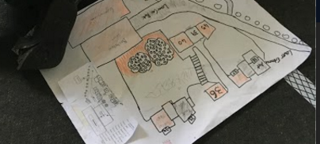

Focus area 3: So what did we find?
This section contains one of the following Focus areas from Safer Schools for students at years 7-8:
- What makes us safe?
- How safe are we?
- So what did we find?
- Sharing our understanding

Explanation
Students justify why they have rated areas unsafe, safe or needing improvement. They grade unsafe areas with a 0-3 scale to determine areas of priority that need urgent attention. Students then write these findings as an audit that will be shared with school management/board, as per this sample student audit [DOCX].

Curriculum links
Key competencies: Participating and contributing; Thinking; Managing self.
Learning areas:
- Level 3 Health and Physical Education: Healthy communities and environments - Plan and implement a programme to enhance an identified aspect of the school.
- Level 4 Social Sciences: Understand how exploration and innovation create opportunities and challenges for people, places and environments.
- Level 4 English: Speaking, Writing and Presenting
- Construct texts that show an awareness of purpose and audience through deliberate choice of content, language and text form.
- Conduct and write up a safety audit of their school by integrating the CPTED principles into an audit and using the template to write the audit for presentation to school management/board.
Safer Schools Assessment Rubric [DOCX]

Resources
- Colour-coded maps produced in Focus area 2.
- Three sheets of A1 chart paper
- Marker pens in red, orange and green.
- Copysheet 1: Audit template
- aSStle writing assessment rubric

Success criteria
Students will be able to:
- identify ways to improve the safety of their school
- provide reasons for undertaking these improvements
- identify the people who will need to be involved in making these improvements.

Learning experience 1: Evaluating the audit

Learning intentions
Students will be able to:
- explain how the principles improve the safety of their school
- make recommendations on how to improve the safety of their school
- prioritise their recommendations to identify the most urgent needs.

Notes for the teacher
Students transfer their green, orange and red areas onto large sheets of paper for the whole class to see.
When all red areas are recorded, they are graded on a 0-3 scale. A grade of ‘3’ is most urgent.
All the red areas graded with the number 3 become recommendations for action in the audit.

Resources
- Colour-coded maps produced in Focus area 2.
- Three sheets of A1 chart paper
- Marker pens in red, orange and green.

Activities

1. Prioritising the unsafe areas
Students record findings made from the maps they produced during Focus area 2 onto large sheets of paper labeled: safe (green); needing improvement (orange); and unsafe (red).
Teacher works with the whole class to review the items on the RED chart. These are prioritised with numbers:
- ‘0’ means it won’t be addressed.
- ‘1’ means it’s not that important to fix it.
- ‘2’ means it’s important to fix it, but it’s not urgent.
- ‘3’ means you need to fix it straight away.

Learning experience 2: Writing up the audit

Learning intentions
Students will be able to:
- transfer their learning into a written assessment of the audit
- Identify how these improvements can be made.

Notes for the teacher
See this sample student audit [DOCX].
This is to be used as a writing assessment. Students individually write up the first part of the audit as defined in the template. This is an overview of what they did and why they did it.
Three students type up the information collected from the green, orange and red sheets.
This information can then be shared electronically with the other students who will cut and paste this into their own audits.

Resources
- Copysheet 1: Audit template
- Safe School assessment rubric [DOCX]
- asTTle writing assessment rubric [DOCX]

Activities

1. Writing up our audit
Use Copysheet: Audit template to write up the audit.
All students complete paragraphs 2, 3 and 4:
- Paragraph 2 - students write definitions and give examples of the four physical principles of Safer Schools.
- Paragraph 3 - students answer in full, who carried out the audit, when it was carried out and why it was carried out.
- Paragraph 4 - students explain how the audit was carried out:
- map enlargement by hand
- colours used, what they mean, and how the colours were applied to the maps.

One student completes paragraph 5 and shares it with the class. One student copies all of the safe areas in the school that each group has identified.
One student completes paragraph 6 and shares it with the class. One student copies down all of the areas needing improvement in the school as identified by each group.
One student completes paragraph 7 and shares it with the class. One student copies down all of the unsafe areas identified by each group.
One student completes paragraph 8 and shares it with the class. One student copies down all of the recommendations made by the class that need actioning immediately, and why.

Assessment
See:
- Safe School assessment rubric [DOCX]
- asTTle witing assessment rubric [DOCX]

Copysheet 1: Audit template
1. Safety audit for ____________________________________
2. What are the four physical principles of safer schools?
- ____________________________________
- ____________________________________
- ____________________________________
- ____________________________________
3. Who carried out the audit? When? Why?
4. What steps were used in completing a safety audit?
For example:
- map of school-digital-cut up into sections
- create hand drawn map labeling buildings
- colours used in the audit
- explanation of the colours used

- Which areas in the school are identified as safe and why are they safe?

- Which areas in the school are identified as needing improvement and why is this so?

- Which areas in the school are identified as unsafe and why are they unsafe? Grade these as 0-3 (least to most urgent).

- Recommendations: The most urgent identified unsafe areas (‘3’) become the recommendations in the audit.

Focus area 4: Sharing our understanding
This section contains one of the following Focus areas from Safer Schools for students at years 7-8:
- What makes us safe?
- How safe are we?
- So what did we find?
- Sharing our understanding

Explanation
In this final focus area, the students transfer their knowledge of safety concerns discovered in the audit by delivering a presentation.
The audience for this presentation will ideally be made up of relevant concerned parties such as senior school management, parents, local police and councillors, as well as local businesses which could also benefit from being involved in implementing these changes within the school.

Curriculum links
Key competencies: Participating and contributing; Thinking; Managing self.
Learning areas: Level 4 English: Speaking, Writing and Presenting
- Students will integrate sources of information, processing and strategies to identify, inform and influence.
- Use oral, written and visual language to create meaning and engage interest.

Resources
● Post-it notes
● Slideshow software
● Computer and data projector
● Screen

Success criteria
Students will be able to:
- transfer their knowledge through an oral presentation to an audience.

Learning experience 1: Storyboard

Learning intentions
Students will be able to:
- share their understanding with their peers.

Notes for the teacher
During the storyboard process, each student chooses one part of the auditing process that they want to explain as part of a presentation. They import a photo or image into the slideshow presentation to match their script.

Resources
- Post-it notes
- Slideshow (or other presentation software)
- Computer and data projector
- Screen

Activities

1. Preparing the presentation
Divide the audit into parts. Each student (or pair of students) prepares a presentation about a part of the audit.
Students write their own presentation (approximately 30 seconds to one minute long). The presentations will tell the story of the audit, including defining the physical principles. Stick Post-it notes with an outline of each part of the presentation onto a chart to show the class presentation in a chronological order.
Students design a slideshow that enhances each part in the presentation. Each student writes and illustrates their own slide(s) for the parts they are responsible for.

Learning experience 2: Presentation practice

Learning intentions
Students will be able to:
- Explain how they carried out the audit, and share the results of the audit to an audience.

Notes for the teacher
Students practice delivering their speech in front of the class.

Resources
- Written presentations
- Digital slideshow presentation equipment

Activities

1. Practicing our presentations
Students practice what they are going to say in the presentation by reading their script a number of times so they are confident. Some might even transfer their script onto cue cards.
Students practice their scripts so they know who is speaking before them and after them.
Students practice their scripts with the slideshow behind them, so the slides match their presentations.

Learning experience 3: Presentation

Learning intentions
Students will be able to:
● confidently convey their findings in an oral presentation to an audience
● provide reasons for implementing their recommendations on safety improvements within the school.

Notes for the teacher
Students deliver their presentations to a relevant audience.

Notes for the police officer
The police officer (usually the School Community Officer, but could be from another group) could consider inviting relevant Police management and media to be part of this audience.

Ideally a representative from the attending police management can provide verbal feedback to the students at the conclusion of their presentation. This would underline the relevance of undertaking Safer Schools, not just from the perspective of improving the safety of the school, but by emphasising the partnership of Police and the community working together to prevent crime.

Resources
- Digital slideshow presentation equipment
- Police officer

Activities

1. Delivering our presentations
Students deliver their presentation (with accompanying slideshow) to an audience, who could include:
- school management
- community representatives (including invited members of Police)
- local businesses
- another class in the school
- parents of the students.

Assessment
You can use this presentation assessment rubric [DOCX].

