Road Safe

Years 7–8 Focus area 5
This section of the Road Safe programme contains one of the following focus areas for students at years 7–8 (ages 11–12):
- Safety checks
- Out and about in traffic
- Out and about responsibly
- Cycling out and about
- Out and about socially
Note: Research suggests that an effective programme should include learning experiences from each of the focus areas.

Focus area 5: Out and about socially

Contents
Focus area 5: Out and about socially 2
Focus question 2
Explanation 2
Curriculum links 2
Resources 2
Success criteria 3
Learning experience 1: Helping out 4
Learning intentions 4
Skills 4
Activities 4
Copysheet: Help Cards 6
Learning experience 2: Fun but safe 7
Learning intention 7
Skills 7
Activities 7
Optional learning experiences 7
Learning experience 3: Going further out 9
Learning intention 9
Skills 9
Activities 9
Copysheet: Can you come with us? 11

Focus area 5: Out and about socially

Focus question
How can I interact with others in safe ways?

Explanation
In this focus area, students consider the part that roads play in social activities. This could be sporting activities such as road running, or planning and undertaking a trip to another part of the country. They consider the requirements for doing these safely.
As they use the road, they may become aware of others who need help – for example, a younger person who is lost or has fallen over. They develop skills to help in these situations.

Curriculum links
Key Competencies: Thinking (thinking about actions as a road user); Managing self (taking responsibility for keeping safe); Relating to others (being aware of their responsibilities as road users); Using language, symbols and texts (traffic signs and symbols)
Learning areas: Level 4 Health and Physical Education: Strand A – Safety management; Strand B –Positive attitudes; Strand D – Community resources, Rights, responsibilities and laws

Resources
Copysheet: Help Cards
Resource people with specialist knowledge to talk to students
Materials for simulated crash scene (optional)
T-shirts (old and light coloured)
Video camera
Fluorescent fabric paints
Pictures of leisure activities (brought by students)
Glue, paper and scissors
Maps of New Zealand
Transport timetables
Telephones and Internet
Cycles (if appropriate)
Parent help
Copysheet: Can You Come with Us?

Success criteria
At the end of this focus area students will be able to:
- act responsibly when others need help on the road
- demonstrate basic first aid skills and knowledge
- explain how emergency services work
- describe how to carry out safely a leisure activity on or near the road
- plan and cost trips within New Zealand that use different forms of transport.

Learning experience 1: Helping out

Learning intentions
By the end of this learning experience students will be able to:
- act responsibly when others need help on the road
- demonstrate basic first aid skills and knowledge
- explain how emergency services work.

Competencies developed in this learning experience
Role playing
Problem solving
Identifying learning needs
Gathering information
Interviewing
Processing information
Practising basic first aid

Activities

1. Analysing help situations
Divide the students into groups. Give each group one of the cards from Copysheet: Help Cards. Choose ones that are relevant to your students, or make up more appropriate ones.
For each card students must decide:
What help is needed?
Can I give this help?
What sequence should the help be carried out in?
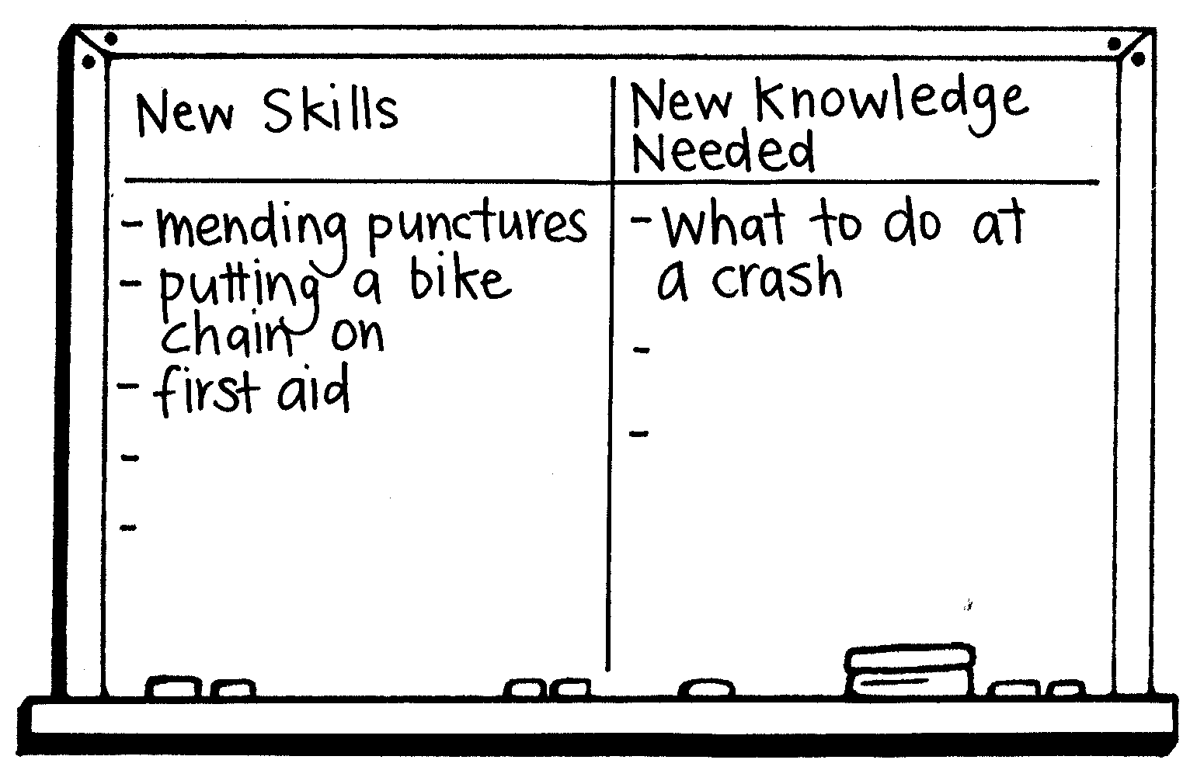
Would it be safe for me to help?
If not, what should happen instead?
What new skills or information might I need?
Bring groups back together and share the answers. If students have suggested helping strategies that are unsafe or not sensible, these should be discussed.
Build up on the board a list of new skills and knowledge that students have identified they need.
Some of the Help Cards describe problems of a serious nature, such as power lines being down. It is very important that students understand that at times like these it is not safe for them to approach. They should go for adult assistance.

2. Role-play
Allocate each group a Help Card that they have not worked with. They prepare a short role-play in which they offer safe and sensible help.
Each group demonstrates their role-play to the rest of the class. They rate it using the following criteria:
Have they helped the person in need?
Was the helper safe?
Was the help offered sensible?

3. New skills and knowledge
Arrange for students to gain the new skills and knowledge that they have identified as needing. This could include such things as:
- basic first aid
Arrange for a resource person (St Johns, Red Cross, local doctor or nurse, school nurse) to come and take the class through basic first aid training.
- handling emergency situations
Arrange for a speaker from Fire Service, Police or Ambulance Service to give students information about what to do if they are first on the scene of a crash.
- cycle repairs
Arrange for a resource person such as a cycle shop owner to give students practical help at fixing cycle punctures and basic cycle repairs.
If desired, the role-plays could be repeated, with students using the new skills and knowledge they have acquired.

Copysheet: Help Cards

You see a young person fall off their bike. They lie on the road, crying.  What can you do to help? | Your little brother is trying to put on his seat belt, which is all tangled up.  What can you do to help?
You are going home in the school bus. The driver swerves to miss a sheep and runs off the road into the ditch.  What can you do to help? | You are walking home after the school bus has dropped you off. You see a farmer who has fallen off their farm bike.  What can you do to help?
You come across a younger child standing by their bike. The chain has come off.  What can you do to help? | You come across a young person looking very upset. They tell you that they have missed the bus home.  What can you do to help?
You are walking along the road when you come across a car that has hit a power pole. You can see the driver still in the car. There is no one else there.  What can you do to help? | A parent has let someone from the junior school out of the car on the side of the road opposite the school. She is trying to cross the road, further down from the crossing.  What can you do to help?
Your friend is having trouble fixing a puncture on their bike.  What could you do to help? | A lot of students at the school patrol are giving the school patrol warden a hard time.  What can you do to help?
There is an old lady carrying her shopping at the pedestrian crossing. She drops her walking stick.  What could you do to help? | Your father is driving your family to swimming. The young ones are squabbling and making a lot of noise. Dad is getting cross.  What can you do to help?

Learning experience 2: Fun but safe

Learning intention
By the end of this learning experience students will be able to describe how to carry out safely a leisure activity on or near the road.

Competencies developed in this learning experience
Recording
Designing and making
Planning
Presenting
Communicating

Activities

1. Defining leisure
Working in small groups, students use the pictures they have brought to make a leisure collage. Underneath they write a definition of leisure.

2. Leisure activities on or near the road
Build up a list of leisure activities that the class are involved in. Identify those that are carried out on or near the road, such as cycling or road running. Mark these with an asterisk (*). Talk about how, in these activities, students are sharing the road with other road users, such as motorists, other cyclists and pedestrians. As well as making sure that they behave safely, they have to be wary of these other road users, who may behave in unpredictable ways.
Working in groups, students select one of the activities marked *. They make a list of the minimum safety requirements needed for this activity. This should cover such things as clothing, visibility, times for activity, safety equipment and location. Students present this information in a visual form for reporting back.
Ask: Do you think people always follow these minimum safety requirements? If not, why not?
Whose job is it to see that minimum safety requirements are followed?
Why should road users always be observant of other road users?

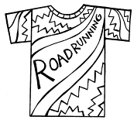
Optional learning experiences
Students could do one or all of the following:
- Turn an old T-shirt into a visible garment for a road runner, using design techniques and fluorescent fabric paints.
- Design safety equipment (such as knee or elbow pads) that is more acceptable to young people.
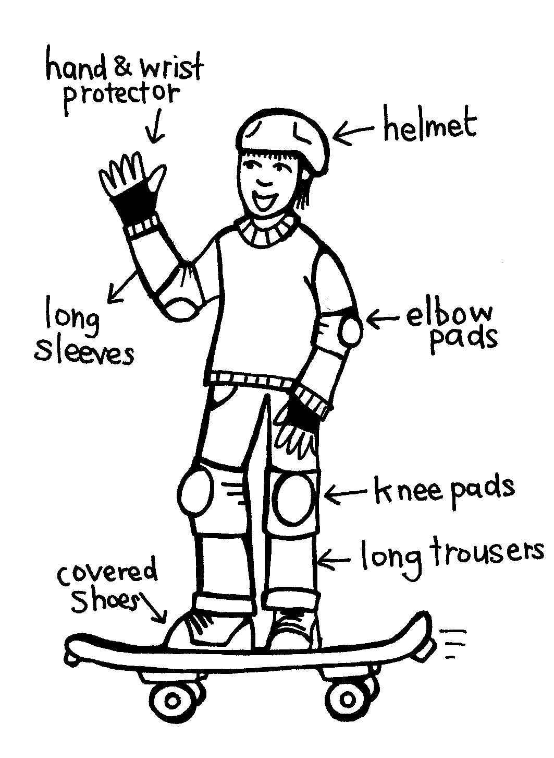
- Design an advertising campaign for any of the new products from above. The campaign could be through video, radio, TV or print.

Learning experience 3: Going further out

Learning intention
By the end of this learning experience students will be able to plan and cost trips within New Zealand that use different forms of transport.

Competencies developed in this learning experience
Map reading
Using scales
Doing research
Reading timetables
Gathering information from a range of sources
Communicating
Peer assessment
Decision making
Presenting

Activities

Option 1

Planning where and how to go
Divide students into groups. Each group chooses a destination in New Zealand to which they would like to make a hypothetical trip. Examples might be:
To see the whales off Kaikoura
To go to a marae in Gisborne
To go for a holiday to the beach at Tauranga
A trip to Wellington to see Te Papa
School camp or field trip
They must produce a plan to show how they are going to get there, using at least three different forms of transport.
If students plan to use cycles as one form of transport, the maximum distance travelled by this method should be no more than 15 km per day.
The plan should include:
- total distance
- travel time
- rest stops
- overnight stays
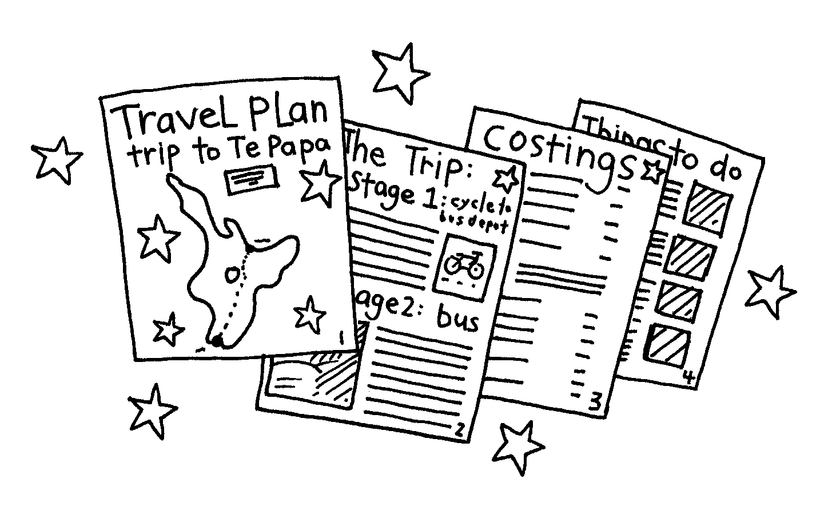
- costings for each leg of the trip
- total costings.
Groups will need to use a range of resources to prepare the plan, such as maps, telephone directories, timetables for ferries and trains, and the Internet.
Each group presents their travel plan to the whole class, as a display, which is assessed by their peers.

Option 2

Plan a trip
Choose a realistic destination for a class trip. This could be to the zoo, a local marae, a country/city school not too far away or a restaurant in a neighbouring town. Work with the class to plan the trip, including the following:
- means of transport
- cost
- length of journey
- stopping places, if appropriate
- parent helpers
- equipment to take (first aid kits, puncture repair kits).
The class will need a range of resources to plan the trip, including public transport timetables, telephone directories, and maps. If parent drivers are included in the plan, use Copysheet: Can You Come with Us?
Carry out the trip.
Note
If cycles are used, both they and the cycle helmets will need to be checked before departure. The length of the trip to be cycled should not be more than 15 km.
Do some What if ... situations before the trip to cover possible hazards.

Evaluation
After the trip, ask:
What did we get right in our planning?
What problems did we experience?
What would we do differently next time?
What have we learnt about choosing and costing methods of transport?

Copysheet: Can you come with us?

Dear Parents or Caregivers

Our class has been planning an outing. The students have planned and costed the trip and worked out suitable means of transport. The details are:

Place: __________________________
Date: __________________________
Time: __________________________
Cost: __________________________

Equipment your child will need to bring:

We would like parents to come with us, to help with transport and supervision, and to have fun. Please complete the tear-off strip.

Thank you for your help.

__________________________ __________________________
Teacher School Community Officer

Name: Phone No:
I can come on the trip YES NO
Number of adults coming
I can transport children in my car YES NO
If YES, complete the following checklist:
Car has a current WOF, and registration
Driver has a current full Driver’s Licence
Number of seatbelts in the car (excluding driver)

