Road Safe

Years 7–8 Focus area 4
This section of the Road Safe programme contains one of the following focus areas for students at years 7–8 (ages 11–12):
- Safety checks
- Out and about in traffic
- Out and about responsibly
- Cycling out and about
- Out and about socially
Note: Research suggests that an effective Road Safe programme should include learning experiences from each of the focus areas.

Focus area 4: Cycling out and about

Contents
Focus area 4: Cycling out and about 3
Focus question 3
Explanation 3
Curriculum links 3
Resources 3
Success criteria 4
Learning experience 1: Negotiating intersections 5
Learning intentions 5
Skills 5
Activities 5
Copysheet: Cycle Safety Quiz 8
Learning experience 2: I’m a future driver 9
Learning intention 9
Skills 9
Preparation 9
Activities 9
Copysheet: Five Intersections 11
Learning experience 3: Advanced cycling course 12
Learning intention 12
Skills 12
Preparation 12
Activities 13
Copysheet: Advanced Cycling Course 14
Copysheet: Students’ Cycling Competence Checklist 15
Copysheet: Students’ Cycling Competence Checklist for Road Cycling 18
Copysheet: Letter to Parents 19

Focus area 4: Cycling out and about

Focus question
How can I keep safe when I am riding out and about, sharing the road with others?

Explanation
In this focus area, students are introduced to traffic law, especially as it relates to them as new cyclists. They practise the skills of negotiating intersections and giving hand signals. They revise and practise cycling skills, taking these to an advanced level. This is done first on cycling courses set up in the school grounds and then, with the permission of parents, on the road.

Notes for the teacher
You may choose to use a cyclist training organisation, if you have one in your area.

Curriculum links
Key Competencies: Thinking (thinking about actions as a road user); Managing self (taking responsibility for keeping safe); Relating to others (being aware of their responsibilities as road users); Using language, symbols and texts (traffic signs and symbols)
Learning areas: Level 4 Health and Physical Education: Strand A – Safety management, Regular physical activity; Strand B – Movement skills, Positive attitudes; Strand D – Rights, responsibilities and laws

Resources
Copysheet: Cycle Safety Quiz
The Official New Zealand Code for Cyclists for reference (available at www.nzta.govt.nz/resources/roadcode/cyclist-code/ )
Road Tiles (available from your School Community Officer)
Toy vehicles
Musical instruments for rap
Physical education gear
Copysheet: Five Intersections
Equipment for marking out intersections on tennis court or field, such as signs, fire hoses, half tennis balls, cones, set of road signs, traffic lights
Numbered vests, netball bibs or numbers for each rider to wear
Students’ own cycles and cycle helmets, checked for safety before the activity
Parent helpers, who have been carefully briefed
School Community Officer
Parked car with driver
Stopwatch
Copysheet: Advanced Cycling Course
Copysheet: Students’ Cycling Competence Checklist
Back-up vehicle and trailer
First aid kit
Cell phone
Parental permission slips
Video camera/camera (optional)
Copysheet: Students’ Cycling Competence Checklist for Road Cycling
Copysheet: Letter to Parents

Success criteria
At the end of this focus area students will be able to:
- explain how to negotiate an uncontrolled intersection
- demonstrate correct hand signals to use when cycling
- negotiate intersections on their cycles
- demonstrate advanced cycling skills
- demonstrate safe cycling practices on the road.

Learning experience 1: Negotiating intersections

Learning intentions
By the end of this learning experience students will be able to:
- explain how to negotiate an uncontrolled intersection
- demonstrate correct hand signals to use when cycling.

Competencies developed in this learning experience
Loco-motor skills, such as hand signals
Sign writing
Co-operating with others
Art – painting, use of colours
Timing
Enlarging
Drawing shapes, composing words and music
Rapping

Activities

1. Introduction
Explain to students that in this focus area they will build on their knowledge of traffic law and will be given the opportunity to develop advanced cycling skills. Hand out Copysheet: Cycle Safety Quiz. When students have completed the quiz, locate The Official New Zealand Code for Cyclists on the computer to check their answers. The School Community Officer can clarify points as necessary.
Answers to Cycle Safety Quiz
1 red 11 left
2 rear 12 hand signals
3 cycle helmet 13 walk
4 can 14 slow down, stop
5 must 15 behind
6 white 16 lock
7 reflectorised 17 carrier
8 tread 18 do
9 oiled 19 pedal
10 rider 20 cycle

2. Hand signals
Introduce the Hand Signal Jive to students. Follow these steps.
- Show students the six hand positions.
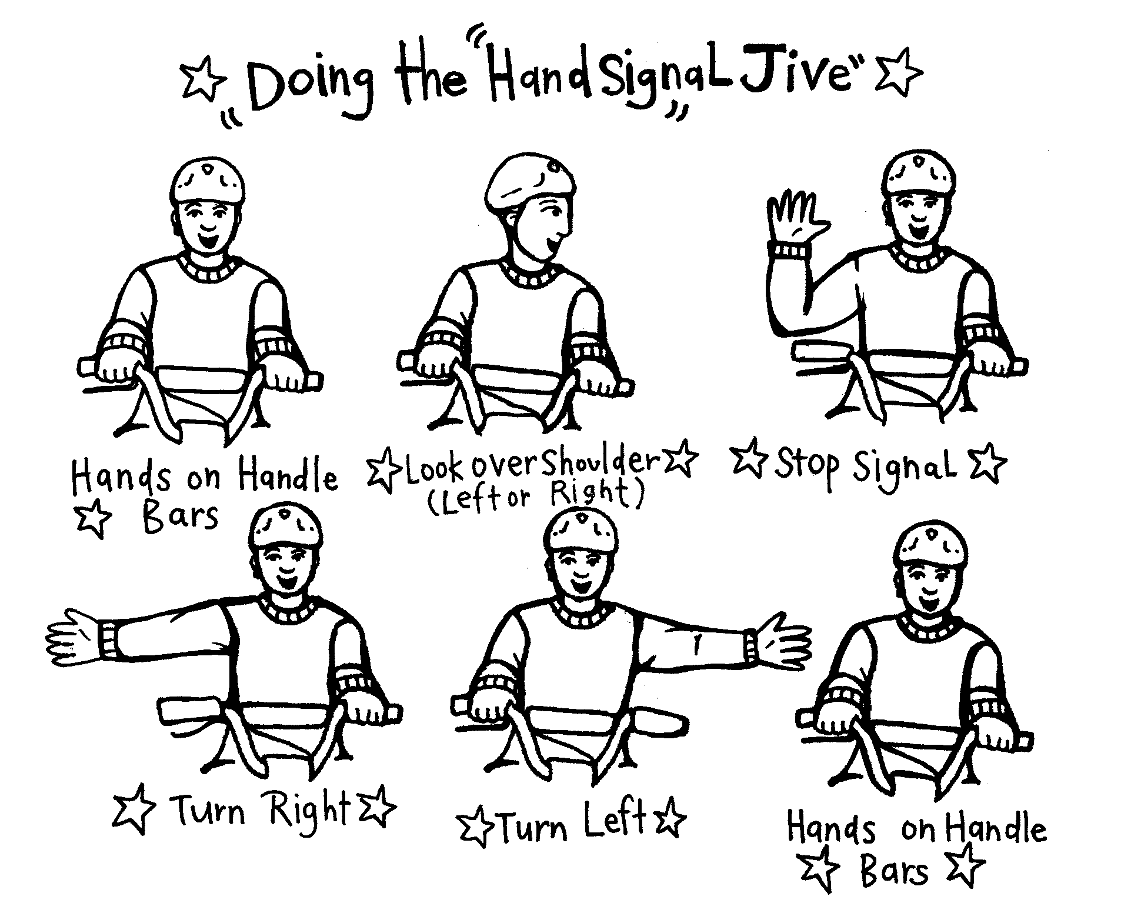

- Explain that you will call out the numbers 1–6 and students must make the correct hand and/or head movement. Those who are incorrect must sit down.
- Have a trial run, calling the numbers slowly and in order.
- Speed up the calling.
- Begin calling in a different order.
- Call numbers in Te Reo.
Students can make up a rap song about the six hand positions. This can be performed with actions and musical accompaniment. Both the rap and the game can be used at intervals during the term to reinforce the skills of giving hand signals.

3. Controlled and uncontrolled intersections
The School Community Officer discusses the difference between controlled intersections, in particular signs, traffic lights and road markings, and uncontrolled intersections. Explain that the class is going to learn how to negotiate uncontrolled intersections. Draw an intersection on the board and explain the correct procedure for cyclists to negotiate it. This can be reinforced using the road tiles.
Students can use toy vehicles to practise negotiating the intersection.
Make that students are familiar with the give way rules.
Point out to students that cyclists cannot, however, assume that cars will give way to them, so they must always be alert.
The desks could be moved to create an intersection. Students can practise negotiating this on foot, using the appropriate hand signals.
Ask: How easy was it to negotiate the intersection?
Were there any difficulties with hand signals?
Would it be more difficult if you were on a bike? Give a reason.
Would it be more difficult on the road? Give a reason.

Copysheet: Cycle Safety Quiz

Fill in the missing words.

1. A STOP sign is coloured white and _____________ .
2. The law requires every bicycle to have a red or yellow _____________ reflector.
3. The law requires every cyclist to wear a _____________ _____________ .
4. A cyclist _____________ carry a passenger on a special safety seat, fitted with footrests.
5. A cyclist _____________ comply with the road rules.
6. If riding at night, your cycle must have a _____________ light that faces forward,.
7. When you ride at night, wear _____________ clothing.
8. Bicycle tyres must be fully inflated and have good _____________.
9. A bicycle chain must be tightly adjusted, clean and well _____________.
10. A bicycle seat should be adjusted to suit the size of the _____________.
11. When making a right turn you should move to the _____________ of the centre line.
12. Cyclists let other motorists know what they are doing by using _____________
_____________ .
13. Cyclists riding through a pedestrian crossing must _____________
14. When approaching a STOP sign a cyclist must _____________ and _____________.
15 A cyclist should look _____________ when moving out in traffic.
16 A cyclist should always _____________ their bicycle when leaving it unattended.
17 To carry goods on a bicycle, cyclists should use a _____________.
18 When turning left you _____________ have to use hand signals.
19 Bicycles must have yellow _____________ reflectors.
20 A cycle lane is marked by a white _____________ outline drawn on the road.

Learning experience 2: I’m a future driver

Learning intention
By the end of this learning experience students will be able to negotiate intersections on their cycles.

Competencies developed in this learning experience
Demonstrating
Recalling
Revisiting
Observing
Explaining
Recognising
Negotiating other cyclists
Negotiating intersections
Giving hand signals
Reacting to traffic signs

Preparation
Prepare for the learning experience by marking out the five intersection course shown on Copysheet: Five Intersections on the playing field. Non-riding students can assist with this and some will be stationed around the course. They can be used to direct traffic at any of the intersections, as required. Non-riders could also take the role of traffic observers and could inform the teacher of very skilled riders or those who need some extra help.
Cycles and cycle helmets should be checked before the learning experience.

Activities

1. Negotiating the course
Explain the course to everyone.
Students all start at the same point and proceed to the centre, where they are directed by the traffic lights. After this they can ride the course, making their own decisions about which way to go, unless they come to traffic lights, traffic signs or a person on point duty.
Establish the following rules:
- no overtaking
- no wheel stands
- no skidding on back wheels.
They will practise give way rules, using their classmates as other traffic. The teacher will sit in the police car and use the public address system to caution riders or to call riders in. There is a designated Rest Spot by the car. This should be used for:
- riders who get tired
- riders who demonstrate poor technique
- riders who misbehave.
The teacher can review learning intentions and techniques with these riders.
As an alternative, the class could be divided into two groups, one half on the course and one in the Rest Spot observing.

3. Review rules and try again
After 5–7 minutes, call all cyclists in and review the rules for give ways and negotiating intersections. Any inappropriate behaviour can be corrected at this point. Remind students of the seriousness of the exercise before sending them back on the course.
After the exercise:
Ask: What was the best thing about riding the five-intersection course?
What was the hardest thing?
What was one thing you learned?
What is one thing that you will need to practise?
Each student can draw themselves, or a cyclist they observed, cycling safely around the intersection course.

Copysheet: Five Intersections
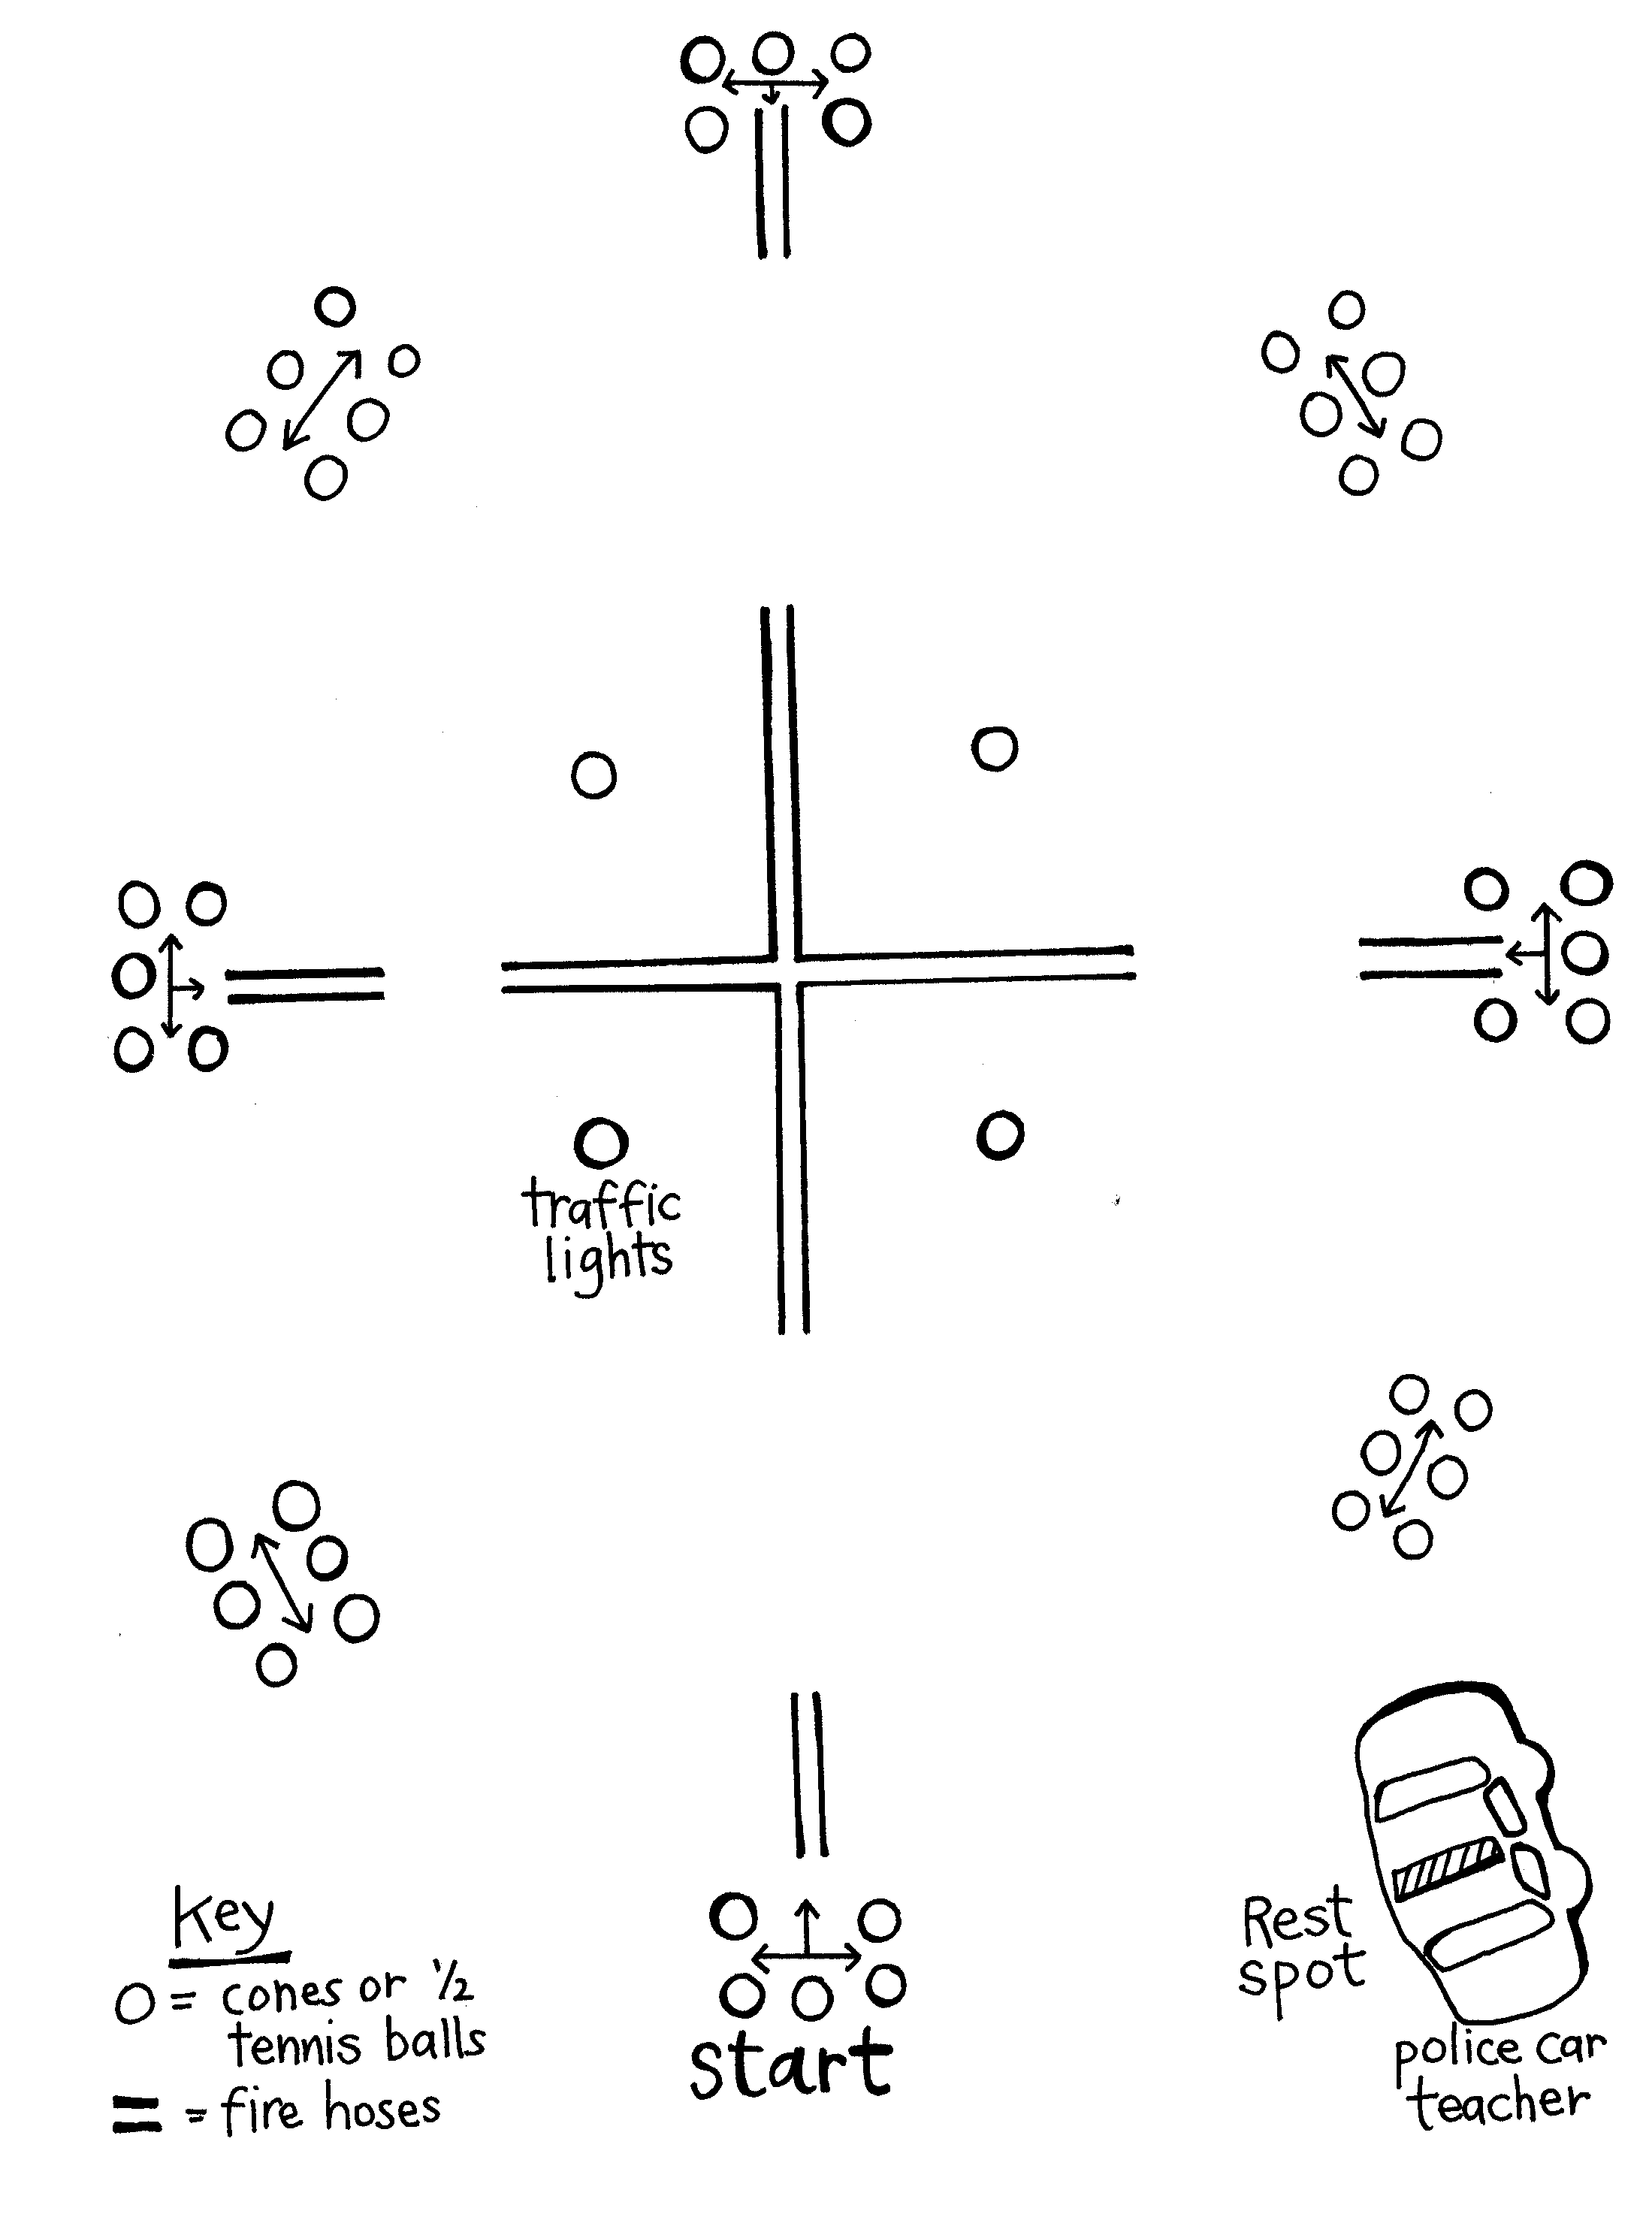

Learning experience 3: Advanced cycling course

Learning intention
By the end of this learning experience students will be able to demonstrate advanced cycling skills.

Competencies developed in this learning experience
Demonstrating
Practising
Recalling
Observing
Cycling skills:
- emergency braking
- weaving
- doing tight turns
- riding slowly
- checking car behavior

Preparation
The advanced cycling course, shown on the Copysheet, should be set up before this activity on a large asphalt area or playing field. The course has five parts.
1. Straight riding track with parked car | Students ride the straight line, without wobbling, with hands on the handlebars and an upright posture. They must scan for hazards, which could be placed on the track. A person in the parked car should, at intervals, open the driver’s door, put on its indicators and rev the engine. Riders must take appropriate evasive action. A non-rider could be seated in the back of the vehicle and throw obstacles, such as tennis balls, onto the track.
2. U-turn boxes | Cyclists negotiate each box in turn, practising controlled turning, without falling off or putting a foot on the ground.
3. Slow riding track | Cyclists ride the 3-metre track as slowly as they can, maintaining control and the correct cycling position.
4. Figure of eight | Cyclists ride the figure-of-eight track in a controlled way, practising give way rules and cornering. They should maintain a safe speed and scan for other traffic.
5. Emergency braking | Cyclists are lined along a line, equally spaced. They ride in a straight line at a controlled speed, keeping a safe distance from the next rider. The command "Stop!" is given through a megaphone. The cyclists must react quickly, stopping by using both brakes and putting a foot down for stability.
There should be a parent helper and some non-riders posted at each activity. They use the relevant part of Copysheet: Students’ Cycling Competence Checklist to assess riders’ performances

Activities
Gather riders at the advanced cycling course and ensure that they are familiar with it. Check all cycles and helmets. Allocate tasks to non-riders and to any riders whose cycles are deemed to be unsafe. Explain that cyclists will spend 15 minutes (vary time to suit) at each activity in turn.
Divide riders into five groups, one for each activity. Each group will spend 15 minutes at that activity, before they move on to the next. This should allow sufficient time for them to practise the required skills.
After riders have completed all activities:
Ask: Which was the hardest activity? Why?
Which was the easiest activity? Why?
At which activity did you learn the most?
What is one new skill that you have developed?
What is one skill that you think you need to work on?
This activity could be repeated over two sessions, to give students sufficient time to practise new skills. It could be repeated again later, so that students’ improvement can be monitored.

Copysheet: Advanced Cycling Course
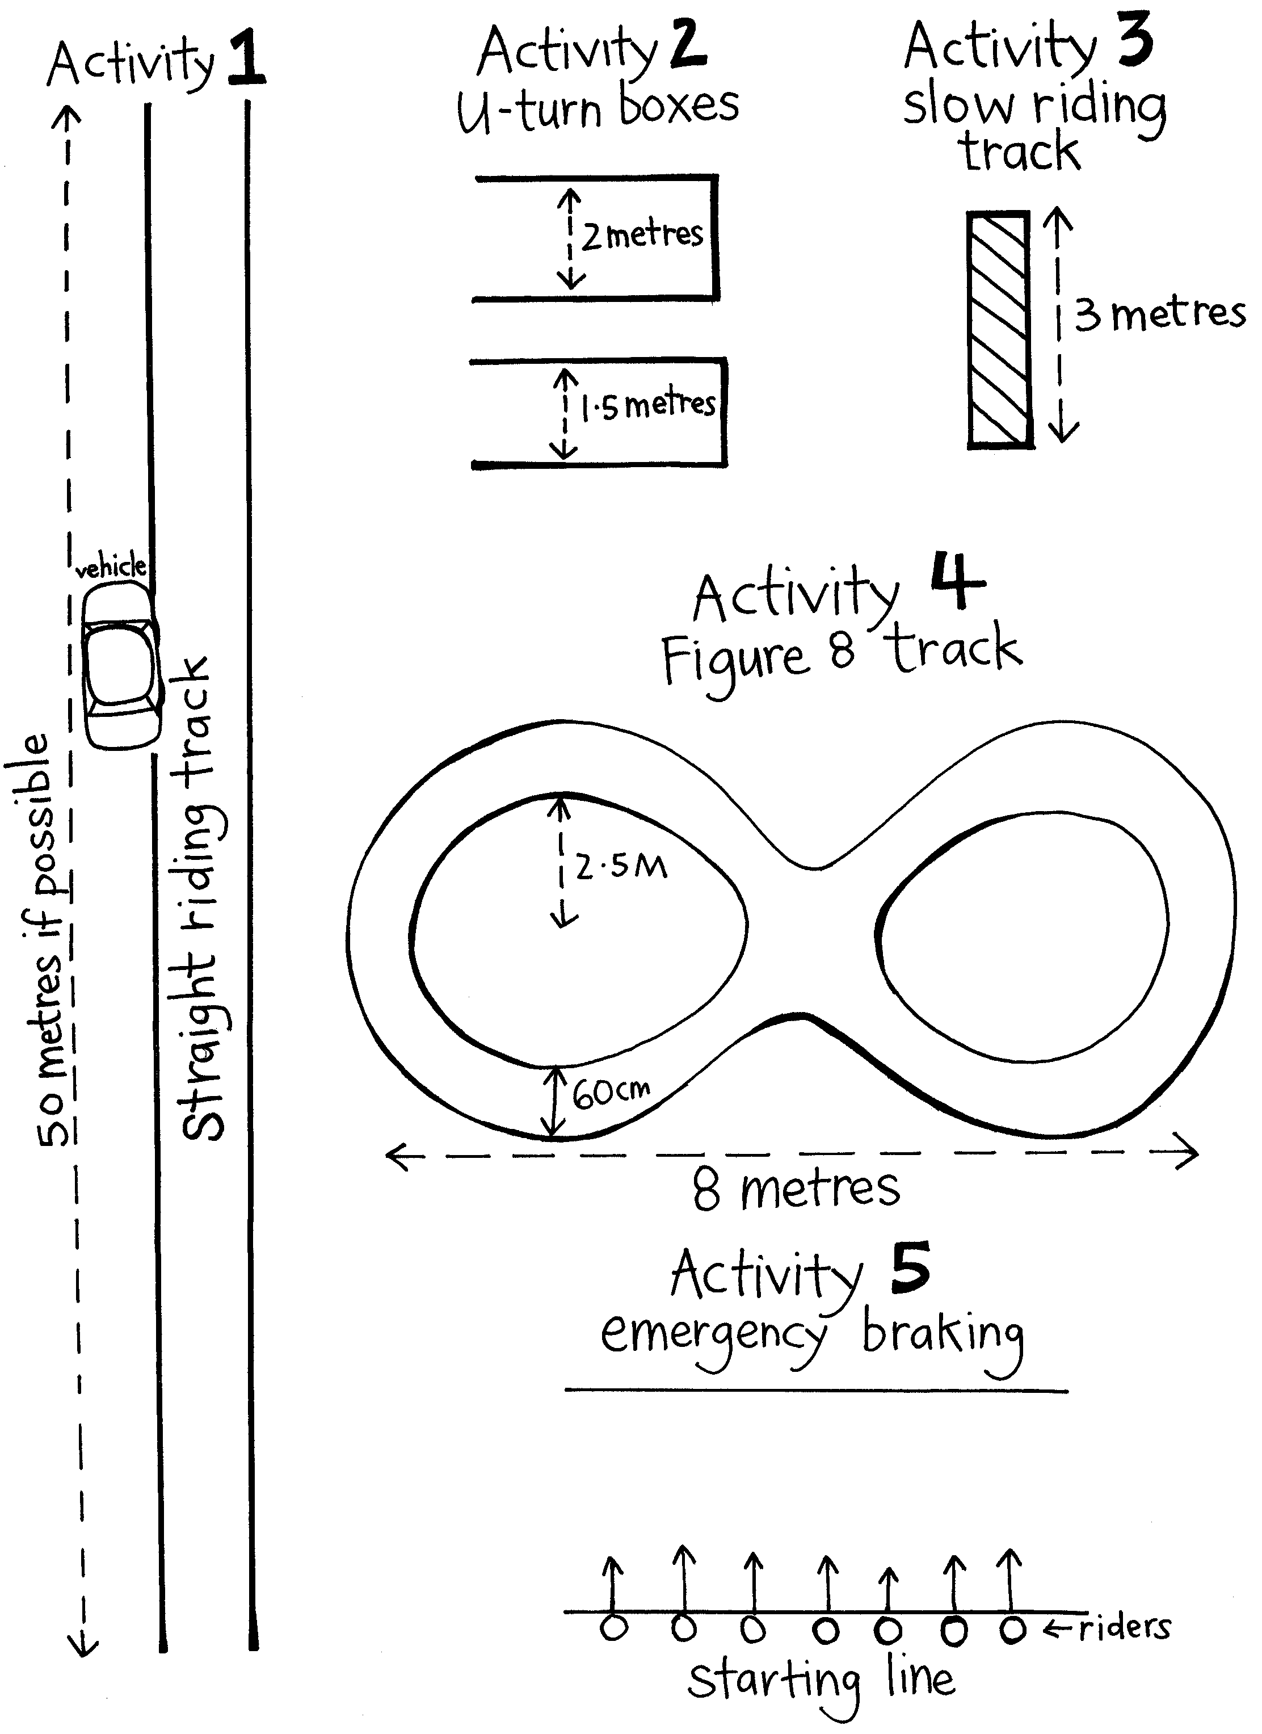

Copysheet: Students’ Cycling Competence Checklist
This can be used by non-riders, parents and teachers to check cyclists’ competence at each of the five activities.
If desired, each student could be rated as follows: C = competent P = needs practice
1: Straight line riding | Riding in a straight line
1: Straight line riding | Not wobbling
1: Straight line riding | Both hands on the handle bars
1: Straight line riding | Upright posture
1: Straight line riding | Scanning for hazards
1: Straight line riding | Negotiating parked cars
1: Straight line riding | Reacting to hazards appropriately
2: U-turn boxes | Controlled riding
2: U-turn boxes | Competent negotiation of corners
2: U-turn boxes | Not putting feet on the ground
2: U-turn boxes | Scanning for other traffic
2: U-turn boxes | Staying on the bike while cornering
3: Slow riding | Controlled riding
3: Slow riding | Keeping feet off the ground
3: Slow riding | Riding in a straight line
3: Slow riding | Keeping bottom on the saddle
3: Slow riding | Staying on the bike
3: Slow riding | Both hands on the handle bars
4: Figure of eight | Controlled riding
4: Figure of eight | Cornering without putting feet down
4: Figure of eight | Maintaining a safe speed
4: Figure of eight | Scanning for other traffic
5: Emergency braking | Cycling abreast of others
5: Emergency braking | Keeping a safe distance from other riders
5: Emergency braking | Riding in a straight line
5: Emergency braking | Listening to instructions
5: Emergency braking | Reacting quickly to STOP command
5: Emergency braking | Using both brakes
5: Emergency braking | Putting foot down for stability

Learning experience 4: Riding on the road

Learning intention
Students will demonstrate safe cycling practices on the road.

Skills
- observing
- communicating
- practising
- cycling skills:
- giving hand signals
- negotiating roundabouts
- responding to traffic signs
- obeying traffic rules

Resources
- School Community Officer
- Parent helpers, who have been carefully briefed.
- Students’ own cycles and cycle helmets, checked for safety
- Numbered vests or netball bibs for riders
- Back-up vehicle and trailer
- First aid kit
- Cell phone
- Parental permission slips
- Video camera/camera -optional
- Copysheet: Students’ Cycling Competency Checklist for Road Cycling
- Copysheet: Letter to Parents

Preparation
The teacher and School Community Officer need to have pre-planned a suitable route on a not too busy stretch of road, with some or all of the following six stations, where cycling behaviour will be evaluated:
- an intersection
- roundabout
- traffic lights
- Stop sign
- Give Way sign
- stretch of straight road
- parked cars.

Parent helpers need to be located at each station to evaluate students. The teacher and School Community Officer are roving the course. A back-up vehicle and first aid kit should be available if any students need attention.

Before the outdoor practical activity, have students take home Copysheet: Letter to Parents and return the signed permission slip. They should have checked their cycles and cycle helmets. Give students an outline of the cycling course and go over it with them, so that they know what to expect.

Note: On-road riding must be treated seriously. Every precaution must be taken to ensure that riders are safe, with a full risk analysis and management process undertaken according to the school's risk management policy. In addition to this, students must be assessed carefully, in order to receive an advanced cycling certificate.

Activities
Assemble cyclists, each wearing a numbered vest. Locate parent helpers and non-cyclists at the station points, with Copysheet: Student cycling competency checklist for road cycling. Get students to ride the test route in small groups at least once, to familiarise themselves. Then let each cyclist start the route, at about 2-3 minute intervals. As they pass the station checkpoints they are assessed by the parent helper. The non-riders can assist by calling out the rider’s number.

After the session gather all riders and non-riders. Ask each parent helper to comment on the cyclists’ performance at their station checkpoint.

Ask: Which part of the course did you find hardest to negotiate? Why?
Which part of the course did you find easiest? Why?
What would you do differently next time?
What cycling skill do you want to improve?

Note: Cyclists are assessed at each of the checkpoints, using Copysheet:Student cycling competency checklist for road cycling . They may be graded C = competent or P = needs practise. The results of each checkpoint assessment can be collated, to determine whether or not students can be awarded a school's road safety advanced cycling certificate. To receive this, they should score C in all criteria. Students who do not receive a certificate should be given the opportunity to practise their skills and resit the test.

Copysheet: Students’ Cycling Competence Checklist for Road Cycling
To be used by parents and teachers at specific checkpoints, to assess the performance of cyclists.
C = competent P = needs practice NA = not applicable
Names | Looks behind | Correct posture | Negotiates hazards | Checks parker cars | Looks for other traffic | Keeps both hands on handlebars | Uses hand signals correctly | Scans for traffic and hazards | Follows traffic lights and signs | Rides single file. or two abreast

Copysheet: Letter to Parents

Dear Parent or Caregiver
As part of the school’s road safety programme your child has been practising advanced safety skills for cycling on the road, using a course set up in the school grounds. These skills have included giving correct hand signals, negotiating intersections, responding to traffic signals and obeying traffic laws.
The class is now ready to practise these skills on a real road. This will be happening on:

Could you please complete and return the permission slip below. We would also like parent helpers for this occasion. Please indicate if you are able to help in this way.
We look forward to a safe and enjoyable cycling experience.
Yours faithfully

________________________
Teacher

I give/do not give permission for _______________________ to take part in the cycling on-road training.

I can/cannot come to assist.

_________________________
Parent

