Road Safe

Years 7–8 Focus area 3
This section of the Road Safe programme contains one of the following focus areas for students at years 7–8 (ages 11–12):
- Safety checks
- Out and about in traffic
- Out and about responsibly
- Cycling out and about
- Out and about socially
Note: Research suggests that an effective programme should include learning experiences from each of the focus areas.

Focus area 3: Out and about responsibly

Contents
Focus area 3: Out and about responsibly 3
Focus question 3
Explanation 3
Notes for the teacher 3
Curriculum links 3
Resources 3
Success criteria 3
Learning experience 1: What do I already know? 5
Learning intentions 5
Skills 5
Activities 5
Copysheet: Road Safety Quiz 6
Copysheet: Road Safety Quiz Answer Sheet 10
Copysheet: Offence and Penalty Cards 11
Learning experience 2: Role models 12
Learning intention 12
Skills 12
Activities 12
Optional learning experiences 13
Learning experience 3: Changing things for the better 14
Learning intentions 14
Skills 14
Activities 14

Focus area 3: Out and about responsibly

Focus question
How can I be a responsible road user?

Explanation
In this focus area, students appreciate that they are just one road user and must consider the rights and safety of other road users as well as themselves. They consider traffic laws that affect them and penalties for breaking these laws. Students explore the way in which young children model their traffic behaviour on their parents and older children. Students clarify how their own traffic behaviour may shape that of others. They take action to solve a transport problem in their local community.

Notes for the teacher
The first part of the activity in Learning experience 2 should be done about a week before this focus area starts.

Curriculum links
Key Competencies: Thinking (thinking about actions as a road user); Managing self (taking responsibility for keeping safe); Relating to others (being aware of their responsibilities as road users); Using language, symbols and texts (traffic signs and symbols)
Learning areas: Level 4 Health and Physical Education: Strand A – Safety management; Strand D – Rights, responsibilities and laws;

Resources
Copysheet: Road Safety Quiz
Copysheet: Road Safety Quiz Answer Sheet
Copysheet: Offence and Penalty Cards (cut into sets for group work)
School Community Officer
Photopack: Role Models - photos 1–7 (available from your School Community Officer)
Motor vehicle crashes in New Zealand (available on Ministry of Transport website)
Maps of the local area (available from Google Maps or Terralink New Zealand Ltd)
Resource people, such as the local traffic engineer or Road Safety Co-ordinator

Success criteria
At the end of this focus area students will be able to:
- explain why it is important to have traffic laws
- explain why penalties are important for those who break traffic laws
- explain how behaviour can be influenced by role modelling
- identify traffic problems in the local area
- develop solutions to solve these problems and make these known to the relevant agencies.

Learning experience 1: What do I already know?

Learning intentions
By the end of this learning experience students will be able to explain why:
- it is important to have traffic laws
- penalties are important for those who break traffic laws.

Competencies developed in this learning experience
Communicating in groups
Decision making
Identifying own traffic law knowledge
Making value judgments
Matching

Activities

1. Road rules
Hand out Copysheet: Road Safety Quiz to students. Depending on the abilities of students, you may need to give some explanations first.
Explain that the quiz is designed to find out what they know about road rules. It is not a test.
Go over the answers and handle any student queries.
Ask: Why do we need to have traffic signs?
Why do we need to have traffic laws?
What could happen if road users, including you, don't obey these laws?
Why must you always watch other road users carefully?
The same quiz could be used again at the end of the programme to assess students’ new knowledge.

2. Offences and penalties
Divide students into groups. Give each group a set of offence cards and a set of penalty cards (made from Copysheet: Offence and Penalty Cards). The group must match the offence to the penalty.
Ask: Why is it important to have penalties?
Do you think these penalties are fair? Why, or why not?
Do you think penalties encourage people to obey traffic laws? Why, or why not?

Copysheet: Road Safety Quiz
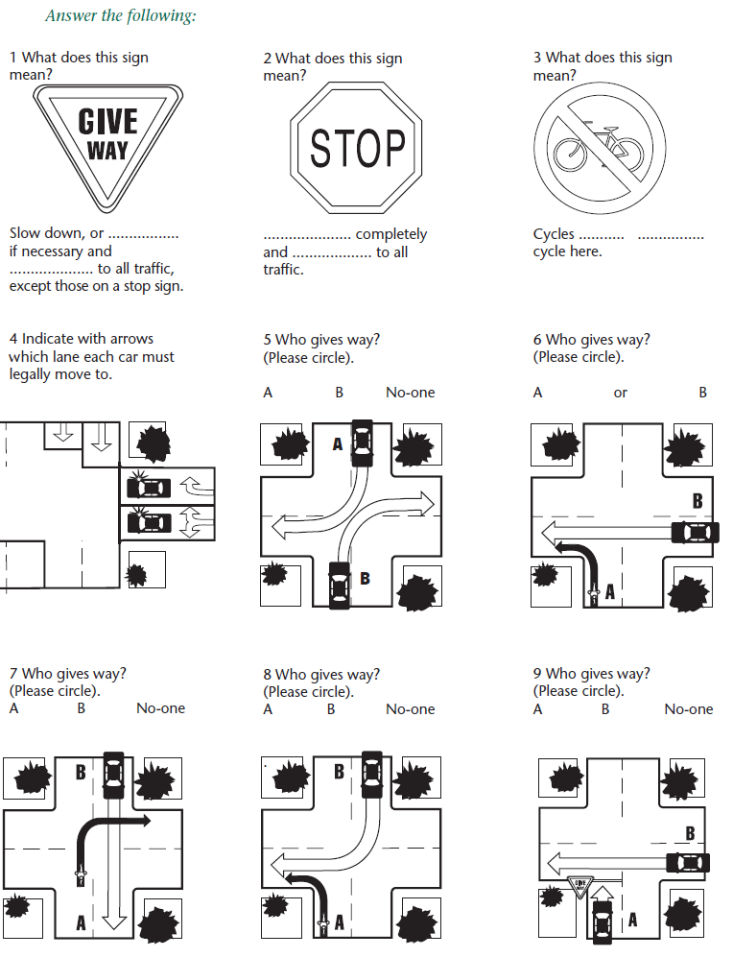

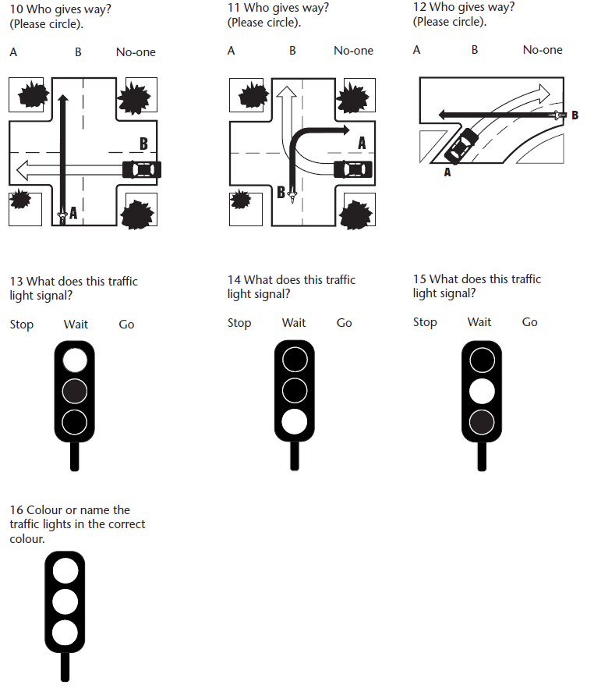

Copysheet: Road Safety Quiz Answer Sheet
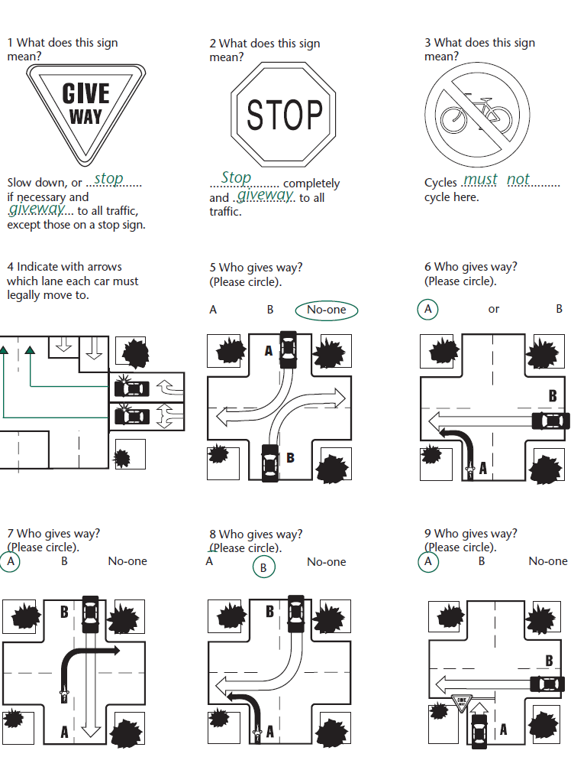
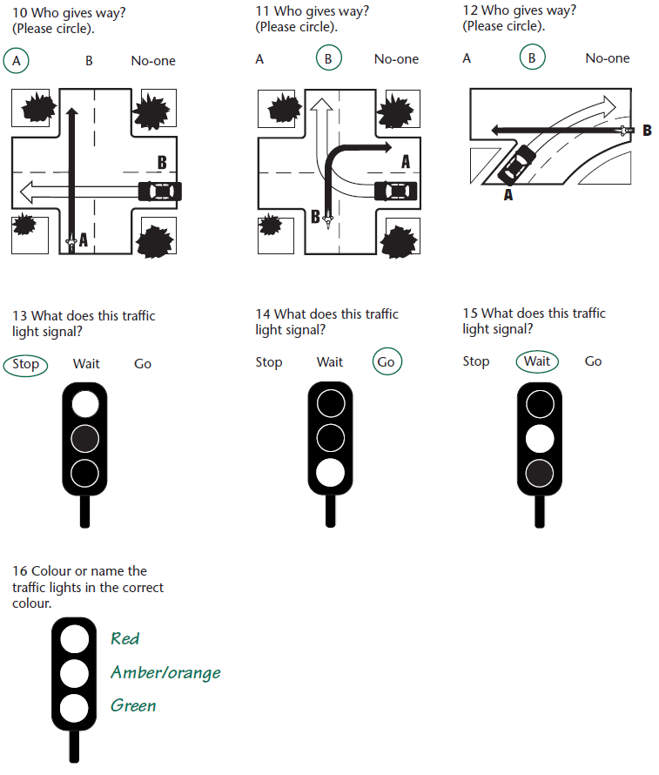

Copysheet: Offence and Penalty Cards

The penalties are correctly matched with each offence given below. Cut both Offences and Penalties up in to sets for group-work.

Offence | Penalty
Crossing the road within 20 metres of a pedestrian crossing | Traffic offence notice $35 penalty
Riding your bike without a cycle helmet. | Instant fine $55
Riding your cycle after dark with no front light. | Instant fine $55
Riding your cycle after dark with no back light. | Instant fine $55
Driver failing to stop at a School Patrol Crossing with signs extended. | Instant fine $150
You fail to wear your seat-belt when one is available. You are under the age of 14. | Instant fine to the driver of the vehicle $150
Crossing at the traffic lights when the light is showing DON’T WALK or the red person walking sign is showing. | Traffic offence notice $10 penalty
Failing to restrain a 3-year-old in a car restraint. 7.6 | Instant fine to the driver of the vehicle $150
Riding your bike over a railway crossing when the lights/bells are flashing/sounding and/or barrier arms are down. | $150 instant fine
Riding your bike on the footpath. | Instant fine $55

Learning experience 2: Role models

Learning intention
By the end of this learning experience students will be able to explain how behaviour can be influenced by role modelling.

Competencies developed in this learning experience
Observation
Graphing
Analysing
Recording
Researching

Activities

1. Experiment
Select two students – an influential student admired by others, and an observer/recorder. Explain to them that they must not talk to anyone else about this experiment.
Arrange for the first student to adopt some new and/or novel behaviour. Examples might be:
- wearing something on wrist or ankle
- wearing a new, distinctive item of clothing
- devising and using a new cool word
- introducing a new craze or game.
The influential student adopts the new behaviour for a week. During this time the observer notes the reactions of others to the new trend and the rate at which other students adopt the new behaviour.
At the end of the week, inform the class of the experiment. The observer reports back and the class can analyse the results, graph these and compare changes observed in boys and girls.
Ask: How did you feel when you observed (name) behaving in the new way?
Did you adopt the new behaviour? Why, or why not?
What does this experiment tell you about how people are influenced by others?
If (name) had been modelling something unsafe, would you still have copied him or her? Why, or why not?

2. Role modelling
Put the class into groups. Give each group one of the photographs in the Role Model Photopack. They complete the following:
Identify safe behaviour
Identify unsafe behaviour
Identify anyone who might be influenced by older people
Explain how they might be influenced
Each group reports back to the class. Work with the class to make some generalisations about role modelling. Some examples might be:
- Young people learn good and bad behaviour from people older than they are.
- Adults sometimes don’t realise that young people copy what they do.
Ask: What commitment are you prepared to make in order to be a good role model?

Optional learning experiences
Students could complete some or all of the following:
- Make observations of traffic behaviour at key locations, at different times of the day, analyse these and make comments about the role modelling presented.
- Find examples of safe and unsafe modelling in magazines or on TV.
- Video the road user behaviour of younger children before and after school and analyse it.
- Invite a local personality who is a good role model to come and talk to the class about role modelling.

Learning experience 3: Changing things for the better

Learning intentions
By the end of this learning experience students will be able to:
- identify traffic problems in the local area
- develop solutions to solve these problems and make these known to the relevant agencies.

Competencies developed in this learning experience
Identifying roading problems
Analysing crash reports
Mapping
Designing solutions
Drawing plans
Letter writing
Presenting reports
Interviewing

Activities

1. Map
Introduce a map of the local area.
Students locate the route they travel to and from school and draw their own map of this. Mapping rules should be emphasised.

2. Analysing route
Group together students who travel along the same route. Ask them to identify parts of the route that they find difficult to negotiate, or improvements they would like made. Local crash statistics could help students identify danger areas – they could do studies of traffic flows, density and speed of traffic and pedestrian crossing counts.
Examples could be:
Difficulties cycling with heavy traffic near school
Uncontrolled intersections
An unsafe park that they must walk or cycle through
Crossing a busy highway that does not have a pedestrian crossing or footbridge
’No parking‘ areas surround the school, making it hard for parents to drop students off
No areas for the school bus to pull off the road to let students on or off
School bus stop is a long way from your house
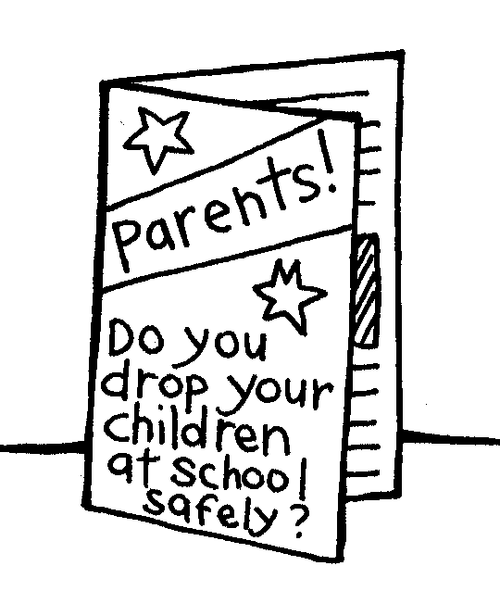
The groups then select one problem and come up with a way to solve this. The solution should be detailed and could include such things as:
- drawing proposed changed plans
- writing new policies
- carrying out a survey of public opinion
- costing out proposed changes
- organising a newspaper campaign to inform the public and change their road use behaviour
- creating and delivering pamphlets.

3. Presentations
Invite a panel of appropriate, interested parties to class, such as a local body politician, an MP, traffic engineer, chairperson of the Board of Trustees, Road Safety Co-ordinator, community constable, Ambulance and Fire Service.
The groups make presentations outlining their problem and the solution they have designed.
If feasible, assist students to bring about the proposed changes.
