Road Safe

Years 7–8 Focus area 2
This section of the Road Safe programme contains one of the following focus areas for students at years 7–8 (ages 11–12):
- Safety checks
- Out and about in traffic
- Out and about responsibly
- Cycling out and about
- Out and about socially
Note: Research suggests that an effective programme should include learning experiences from each of the focus areas.

Focus area 2: Out and about in traffic

Contents
Focus area 2: Out and about in traffic 3
Focus question 3
Explanation 3
Notes for the teacher 3
Curriculum links 3
Resources 3
Success criteria 4
Learning experience 1: I don’t want to be a statistic 5
Learning intentions 5
Skills 5
Activity 5
Optional learning experiences 6
Copysheet: My Traffic Behaviour 9
Learning experience 2: A risky business 10
Learning intentions 10
Skills 10
Activities 10
Optional learning experiences 12
Copysheet: Scenario Cards 13
Learning experience 3: Handling hazards 14
Learning intentions 14
Skills 14
Activities 14
Copysheet: Hazard Cards 16
Learning experience 4: Safe and secure 17
Learning intentions 17
Skills 17
Activities 17
Optional learning experiences 18
Copysheet: My bike Is ... 20

Focus area 2: Out and about in traffic

Focus question
What can I do to keep myself safe on the road?

Explanation
In this focus area students identify their own safe and unsafe practices and those of young people arriving at and leaving school. They will assess their own risk-taking behaviour as road users and identify things about it that they want to change. They consider hazards they may encounter on the road and look at ways of handling them.
As an introduction to the focus area on cycling, they consider ways of keeping their cycles safe.

Notes for the teacher
The video On the Move (Learning experience 1) is divided into five parts (or 'blocks'), each showing some examples of traffic behaviour, followed by a discussion break and stills of each traffic scenario that can be used as memory joggers for the students. Each part contains more examples than the last. Teachers may choose to use any number of the parts according to the ability of the class. The whole class can watch the parts, or more able students can work in groups.

Curriculum links
Key Competencies: Thinking (thinking about actions as a road user); Managing self (taking responsibility for keeping safe); Relating to others (being aware of their responsibilities as road users)
Learning areas: Level 4 Health and Physical Education: Strand A – Safety management; Strand D – Rights, responsibilities and laws

Resources
Video: On the Move (available from your School Community Officer)
Video camera
Copysheet: My Traffic Behaviour
Motor vehicle crashes in New Zealand (available on Ministry of Transport website)
Copysheet: Scenario Cards
Dictionary
Board games brought by students (optional)
Eggs (optional)
Copysheet: Hazard Cards (cut up into sets for groups)
Story: Milk Run by Steven Butcher in School Journal Story Library
Story: Paper Girl by Peter Thomson in School Journal Story Library
Copysheet: My Bike Is ...

Success criteria
At the end of this focus area students will be able to:
- identify safe and unsafe practices of pedestrians, cyclists and passengers.
- identify their own safe and unsafe road user practices
- identify risks they sometimes take in traffic
- find ways of reducing these risks
- identify traffic hazards
- suggest strategies to overcome hazards
- use safety strategies to protect their cycles
- explain what to do if they are the victim of crime.

Learning experience 1: I don’t want to be a statistic

Learning intentions
By the end of this learning experience students will be able to identify:
- safe and unsafe practices of pedestrians, cyclists and passengers.
- their own safe and unsafe road user practices.

Competencies developed in this learning experience
Visual language – viewing
Identifying and grouping
Peer and self-assessment
Goal setting
Decision making
Co-operating and working with others
Interpreting statistics
Graphing statistics
Writing reports
Filming a video (optional)

Activities

1. Introduction
Inform students that they are learning a Road Safe education programme to help them keep safe on the roads now that they are more independent and are travelling further from home.
Ask: Who can remember learning about road safety?
What are some things that you learnt?

2. Video
Explain to the students that they are going to see a video showing some examples of young people arriving and leaving school. They are going to observe safe and unsafe behaviour by pedestrians, passengers, cyclists and drivers. Show Block 1 of On The Move to the class and together discuss the road safety behaviour shown. Suggested discussion points for each block are listed at the end of this activity.
Split the class into four groups – cyclists, passengers, pedestrians and drivers. Show Block 2 of the video. Each group observes and records the safe and unsafe behaviour of their specific road user and then reports back in the discussion break. The teacher records the information on a large chart, like the one on the next page. This process can be repeated with all the blocks if desired.
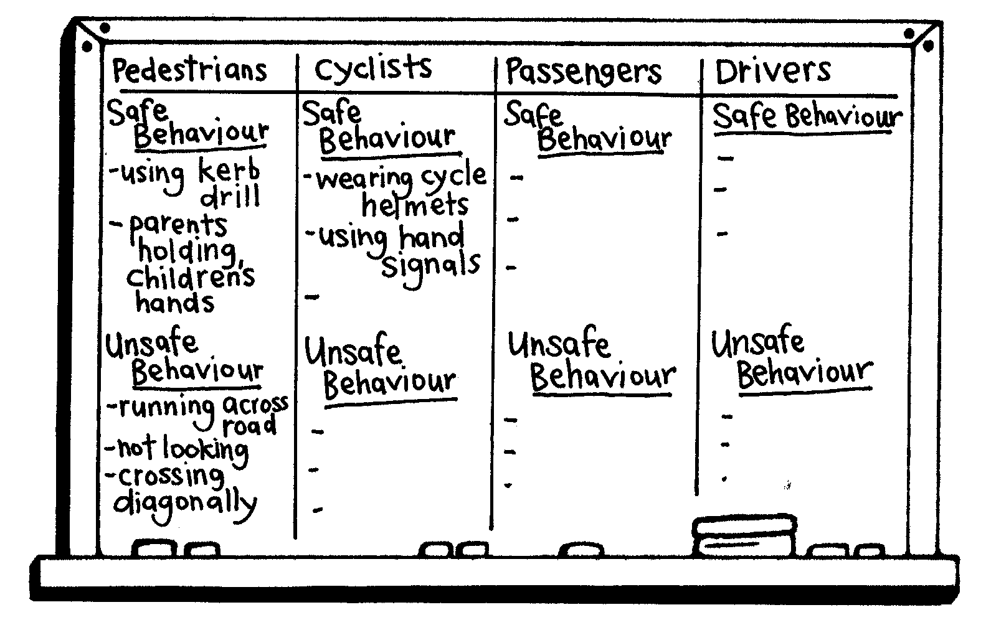
Discuss with students the items in the safe and unsafe sections of each category, to see if there is agreement. Consider the unsafe things.
Ask: Why are these things unsafe?
Why do people act in this way?
What could happen if they go on acting in unsafe ways on or near the road?
What are the advantages of acting safely on the road?
Are there any disadvantages?

3. Vehicle crash statistics
Show the class some relevant statistics about current motor vehicle crashes in New Zealand (available on the Ministry of Transport’s website), such as the percentage of road deaths and injuries by age and gender. Students could graph and interpret the statistics.
Ask: What can you do to avoid becoming a statistic?
Hand out Copysheet: My Traffic Behaviour. Working individually, students identify their own safe and unsafe behaviour. At the bottom of the sheet they indicate one specific behaviour that they want to change. It is important that the teacher supports and reinforces this goal setting. This sheet should be referred to at intervals during the year and other road safety goals set.

Optional learning experiences
Students can video their peers arriving and leaving their own school. This could be analysed in the same way as the video On the Move.
Students design and complete posters promoting safe behaviour on or near the road, particularly targeting unsafe practices they have observed in 1 above. These can be put up around the school. Students can note if they can identify any behaviour changes after the poster campaign.

Video On the Move | Discussion points
Block 1 | Cycling on the footpath  Cycle helmets worn  Parent parking on the bus stop  Running across the road  Parents stopping at appropriate and inappropriate places to let children out  Child tries to get into a moving vehicle
Block 2 | Child crosses between cars  Parent parked on bus stop  Cycle helmets worn  Child gets out of car on footpath side  Parents take children into the school  Skateboarder with no helmet and crossing the road without looking  Cyclist doesn't look when giving hand signals  Parents park off road to let children out at school  Running on footpath, with shoe lace undone  Children standing in bus  Running across road diagonally
Block 3 | Parent with small children on bikes crossing in a dangerous manner  Children crossing without looking  Parent parked on the wrong side of the road  Driver pulling out without looking  Cyclist doesn't look when turning, but does signal  Cycle helmet worn  Road bridge for cyclists to cross the road  Cars and bus parked on yellow lines  Pedestrians cross without completing kerb drill or looking in the middle of the road  Parent parked on wrong side of the road and on the bus stop  Parents stopping to talk on the road  Parent crossing correctly with boys
Block 4 | Pedestrian crossing correctly  Child put into car on the road side  Cyclist wobbles when riding across the road  Parent taking children and dog to school but doesn't check for traffic  Pedestrians not looking for traffic and running across the road  Bus stops on yellow line  Children line up to get on the bus  Children let out of car on the right side of the road , but car engine still running  Running across the road diagonally
Block 5 | Parent letting children out on the right (footpath) side of the car and crossing the road with them  Letting children out on the road side of the car  Car parked on yellow lines and on footpath  Child seated in boot, but all seats in the car are full and she has a seatbelt on  Driver indicates when pulling out  Two girls walking correctly on footpath  Boy runs on footpath and across the road without looking  Pedestrians cross without completing kerb drill or looking for traffic  Cyclist crosses without looking and rides on the footpath  Bus has correct signs; children seated on the bus  Cycle helmets worn

Copysheet: My Traffic Behaviour

Ways I behave safely as a passenger, cyclist and pedestrian:
•

•

•

Ways I behave unsafely as a passenger, cyclist and pedestrian:
•

•

•

My goals Things I want to change about my road safety behaviour are:
•

•

•

I will go about this by:
•

•

•

Learning experience 2: A risky business

Learning intentions
By the end of this learning experience students will be able to:
- identify risks they sometimes take in traffic
- find ways of reducing these risks.

Competencies developed in this learning experience
Reporting
Presenting
Recording

Activities

1. Defining risk
Working in groups, have students write a definition of risk.
Each group presents their definition and a class definition is developed. A dictionary may be used as reference.

2. Risk situations
Give students one of the situations below. Choose ones that are relevant to their experiences or make up your own. Ask students to place themselves along a continuum line, one end of which is High Risk and the other end of which is Low Risk, according to whether they consider this a high or low risk situation for them. Ask students to talk to the people close to them to see if they are in the right place on the line. Some students may then like to change position. Ask students from different points on the line to explain their position.
Repeat this process with other scenarios.
Situations
Bungy jumping off a bridge
Running across the road in front of traffic
Parachuting
Skateboarding off the top of the half pipe
Riding your bike with no hands
Doing a dive off the high diving board
Going for a ride with a drunk driver
Taking some money out of your mother’s purse without asking permission
Cycling across the train tracks when the barrier arm is down, the lights are flashing and bells are ringing
Smoking a cigarette
Cheating in your exams
Ask: What have you found out about the level of risk that you are willing to take?
What have we found out about the level of risk that our class is willing to take?
Is it good to take risks? Why, or why not?
Which of the situations were not safe risks to take? Why?
In which of these situations might the risk you take affect other people too?
Talk about how we all take risks sometimes, and this is good to extend us, as long as the risks do not put us in unsafe situations. Explain that whenever you take a risk, you must weigh up the consequences first. Put students into small groups. Allocate each group one of the most unsafe risks identified by students in the questions above. Have them list the possible consequences of taking this risk. This should be done in diagram form, as in the example below. Positive consequences should be marked +. Negative consequences should be marked –.
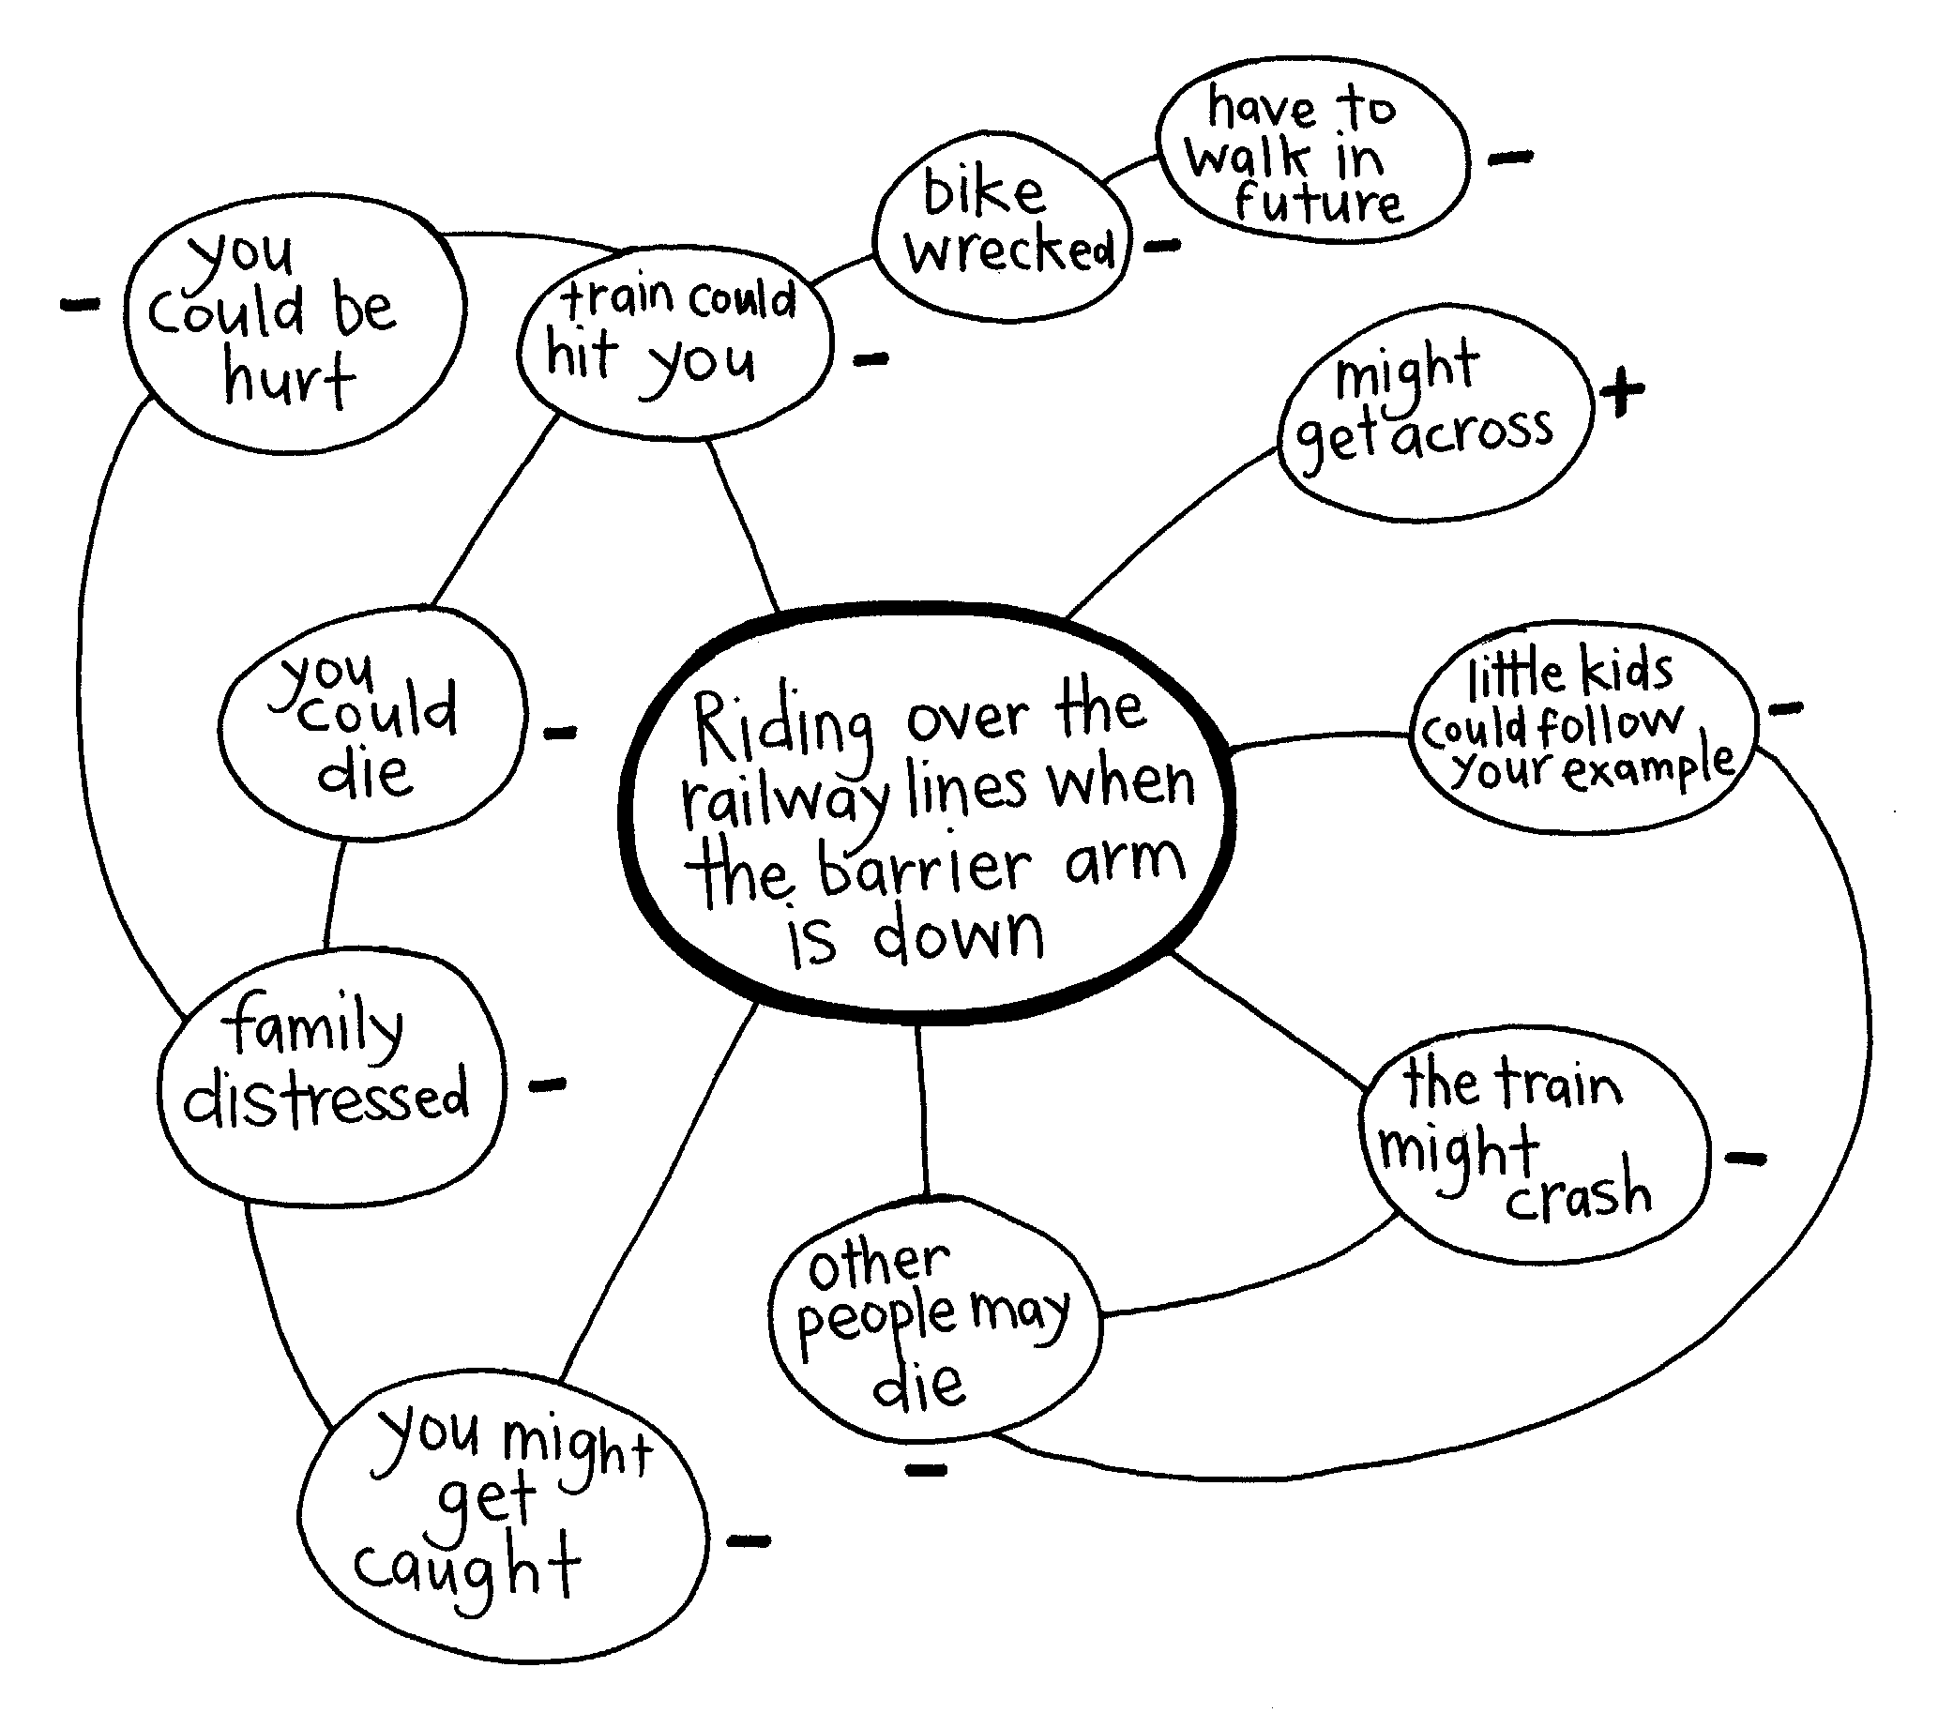
Each group reports back.

3. Scenario cards
Put students into six groups. Give each group one of the cards from Copysheet: Scenario Cards to analyse.
The analysis must include:
- What are the different options?
- What are the possible consequences of each option?
- What is the safest option for me? Why?
Ask: Why do we take risks?
Do all risks have serious, unsafe consequences?
What should you do before you take a risk?
What have we learnt about risks and traffic?

Optional learning experiences
Students could play board games which involve risk taking. Afterwards they analyse the sorts of risk they took and the results. Some suitable games could be Jenga, Operation, Monopoly, Game of Life, Risk.
Hold an egg throwing and catching competition. Put students in pairs. Give each an unboiled egg. The pair must throw and catch the egg twice without breaking it. The winner is the pair who have done this successfully, with the widest gap between them. Cautionary note: some cultures may consider it inappropriate to use food in this way.
Ask: What was the risk you took when you widened the gap?
Was it worth the risk?
Why did some people choose to stand quite close together?
Were there any advantages or disadvantages of doing this?
Involve students in cleaning up the mess!

Copysheet: Scenario Cards

An adult in your family asks you to go buy a takeaway breakfast for the family. It takes only five minutes to do the round trip on your bike and it is a lovely sunny day.
Do you wear your cycle helmet?

Your older brother or sister is allowed to take your parents’ ute to visit a friend about 3 kilometres away. You can go, too. It’s a sunny day.
Do you jump in the back or ride inside?

You are ready to leave for school and you just have time to cycle there. You remember that you noticed that the brakes on your bike were not working very well.
Do you still ride?

There is a four-lane road outside your school that you must cross to get home. The school patrol is 300 metres up the road outside another school and you are in a hurry. The school has a rule that you must use the school patrol crossing.
Do you cross outside the school or go up to the school patrol?

You are allowed to go to the local skating area to ride your scooter. On your way you see several friends riding their scooters between the cars in the supermarket car park. They call you over to join them.
What will you do?

You are biking through town on the way to school. You see your best friend walking along the footpath and stop to talk. Your friend asks you for a ride to school.
What will you do?

Learning experience 3: Managing hazards

Learning intentions
By the end of this learning experience students will be able to:
- identify traffic hazards
- suggest strategies to overcome hazards.

Competencies developed in this learning experience
Visual identification
Viewing
Decision making
Group participation

Activities

1. Introduction
Read one or both of the stories Milk Run or Paper Girl as a starter.
Ask: What traffic hazards could make their job more difficult?
Build responses up into a star diagram like the one below.
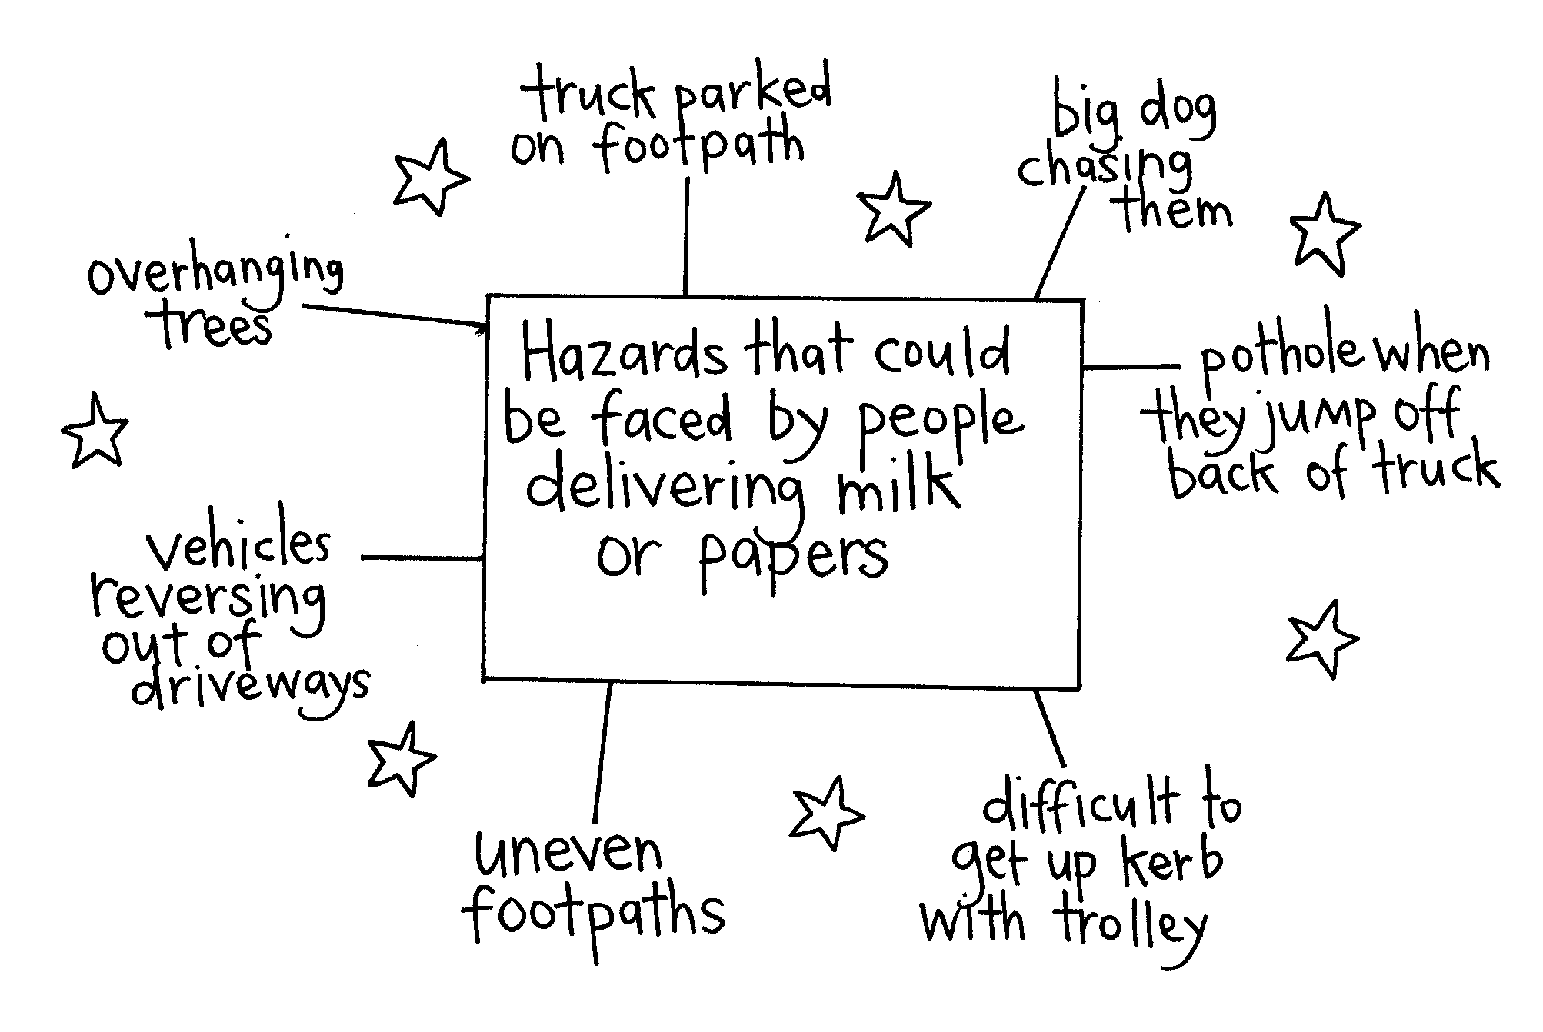
Ask: How many of you have jobs? What sort?
Do you sometimes face traffic hazards in your job? If so, what sort?

2. Hazard cards
Divide students into groups. Give each group one of the Hazard cards. For each card, they answer the following questions:
What is the hazard?
What could happen?
What could the young person(s) do to handle this?
After groups have worked on the cards:
Ask: Have any of you encountered any road hazards lately?
How did you handle them?
Do you think you will deal with them better next time? Why, or why not?

Copysheet: Hazard Cards

You are walking home from school with a group of friends. Ahead of you a big truck is parked over the footpath while it unloads. It is causing a buildup of traffic on the road.

The road is almost completely blocked by two fire engines and other emergency vehicles. There are people and fire hoses everywhere. You are approaching the scene on your bike.

A young person is biking along with a large box balanced on the handle bars that is blocking the rider’s view. There are cars directly in front.

A young person is riding a bike. Coming up behind is a car that appears to be weaving about all over the road.

You are walking home along a country road with friends. You approach a bend you can’t see around.

A farmer is feeding out from a trailer on the back of the tractor. A young child is steering the tractor and another is sitting on the wheel arch.

You are cycling along in pouring rain. A large truck goes by and sprays you with water.

You are going home in the school bus. There are bags and other gear all down the aisle.

Learning experience 4: Safe and secure

Learning intentions
By the end of this learning experience students will be able to:
- use safety strategies to protect their cycles
- explain what to do if they are the victim of crime.

Competencies developed in this learning experience
Formulating questionnaires
Surveying
Collating information
Graphing
Drawing conclusions
Gathering data

Activities

1. Bike thefts
Work with students to develop a questionnaire to gather information from fellow students about bike thefts. The questionnaire should cover such things as:
Has your bike ever been stolen?
Time of theft
Place of theft
Was the bike secured at the time?
Was the theft reported?
Was an adequate description given of the bike?
Was the bike recovered?
Decide how, and to whom, the questionnaire should be delivered.
Students can collate the information, graph it and draw conclusions. These could be written up for an article in the school or local newspaper or could be sent home to parents, to warn about the dangers of bike theft.

2. Bikes at school
Some students could be tasked with surveying bikes brought to school to find out if they are secured and if so how this was done. The group reports back to the class and their findings could be summarised for a second article to the school or local newspaper or a report to parents.
Ask: Why is it important to secure your bike?
When should you do this?
Why don’t people bother to do this all the time?
What are the best ways of securing a bike?
What is the best way of securing your bike at home?
The School Community Officer could provide this information for students, or they could do research (for example, at local cycle shops) to see what security products are available.
They could design posters and/or pamphlets to go around the school to inform other students about the results of the cycle security check and the products available for securing a bike.

3. My bike
Hand out Copysheet: My Bike Is ...
Students fill in as much information about their bike as they can. They then take the sheet home to complete any missing details. Talk about the importance of keeping this information in a safe place in case their bike is ever stolen.
The teacher gives the students the following scenario, or a similar one from their own experience:
Jonathon Hardy had a red mountain bike. It wasn’t all that new, but it was in good condition and he was very proud of it. He rode everywhere on it and used it for his paper round. One night he came home pretty tired. He was going to see a friend soon, but first he needed a drink and something to eat. He left his bike leaning on the hedge just inside the gate. The cycle helmet was on the handlebars. The bike was out of sight there. He was only inside for a few moments, but when he came out, both bike and cycle helmet were gone. He rushed out on to the footpath and looked up and down. He thought he saw someone on a red bike just going around the corner.
Ask: Was this a safe place to leave the bike?
Why do you think Jonathan didn’t put it away or lock it?
What do you think has happened to the bike?
What do you think Jonathon should do now?
What information could he give the Police?
Explain to the class what to do if their bike is stolen, describing what action the Police will take and emphasising that it is easier to keep a bike safe than to get it back after it has been stolen.

Optional learning experiences
As a research exercise, students could work out the social and economic cost to Jonathon of having his bike stolen. This would include:
- the replacement cost of the bike
- the replacement cost of the cycle helmet
- having save to buy a new cycle and helmet
- having difficulty doing his paper round
- having to take public transport, and the cost of this
- having his parents driving him to places.
Students could make themselves an identity card to carry with them at all times, so that they could be easily identified if they were in a crash or needed help. Talk about the importance of keeping this in a safe and secure place. A photograph could be included if desired.
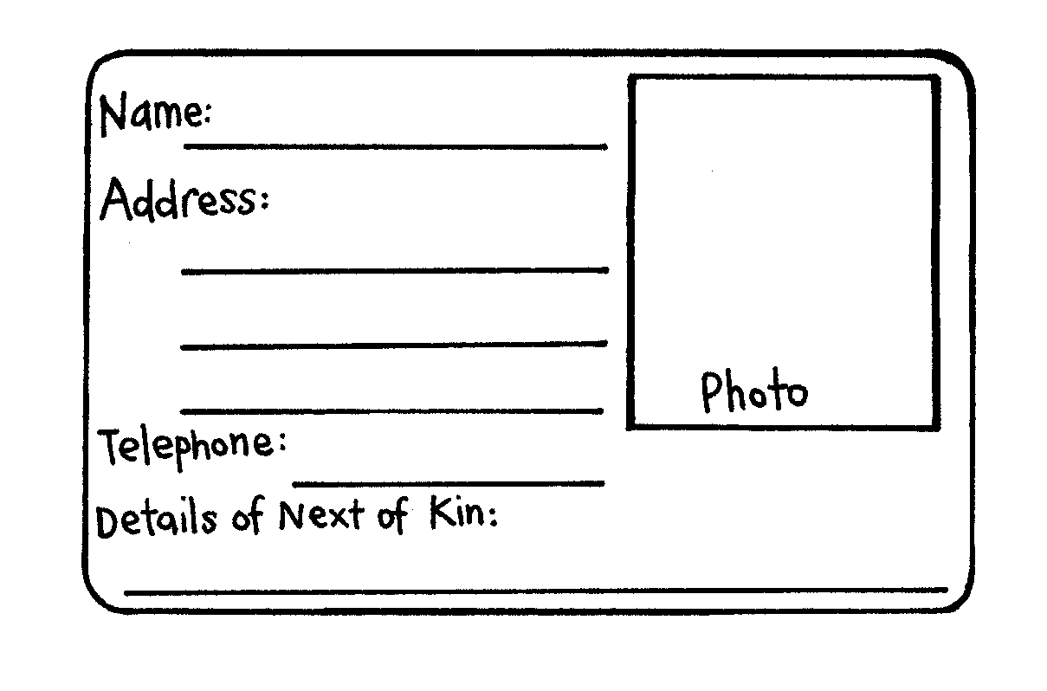

Copysheet: My bike Is ...

Fill in the following information about your bike, from memory.

Make: (as shown on the frame) ________________________________

Type: BMX / Road / Mountain / Other (circle the ones which apply)

Identification or frame number: ________________________________

Where the number is found: ________________________________

Colour: Frame: ________________________________

Forks: ________________________________

Seat: ________________________________

Distinguishing marks (scratches, dents) : ________________________________

Accessories (list lights, mudguards, lock, pedal clips etc.) :

________________________________________________________________

________________________________________________________________

If you were unable to complete any of these details, please check them tonight.

Draw a picture of your bike or insert/attach a photograph in the space below.

Note: Keep this form and ask your parents to file it with other important documents.

