Road Safe

Years 4–6 Focus area 4
This section of the Road Safe programme contains one of the following focus areas for students at years 4–6 (ages 8–10):
- Passenger and pedestrian
- Safe cycling
- Cycling with confidence
- Preparing for future on-road cycling
Note: Research suggests that an effective programme should include learning experiences from each of the focus areas.

Focus area 4: Preparing for future on-road cycling

Contents
Focus area 4: Preparing for future on-road cycling 2
Explanation 2
Notes for the teacher 2
Curriculum links 2
Resources 2
Success criteria 2
Learning experience 1: Road signs and road rules 3
Learning intentions 3
Activities 3
Optional learning experiences 4
Copysheet: Signs for Cyclists 5
Copysheet: Answers for Teachers 7
Learning experience 2: Hazards 9
Learning intentions 9
Activities 9
Optional learning experiences 9
Concluding activity 10
Copysheet: Hazard Cards 11
Copysheet: Cycle Skills Post Training Survey 13
Copysheet: Funnel Strategy 15

Focus area 4: Preparing for future on-road cycling

Explanation
In this focus area students consolidate learning about safe walking and cycling. They consider traffic laws that affect them as pedestrians and as future cyclists on the road. They become familiar with relevant traffic signs. They consider some of the hazards that they may face as future cyclists on the road and decide on strategies to handle these.

Notes for the teacher
For more information on traffic law for cyclists see the New Zealand Transport Agency’s Fact Sheet 1 Cycles: Road rules and equipment.
Additional information is available in The official New Zealand code for cyclists (also available from NZTA and on its website).

Curriculum links
Key Competencies: Thinking (thinking about actions as a road user); Using language, symbols and texts (traffic signs and symbols); Managing self (taking responsibility for keeping safe in a traffic environment)
Learning areas: Levels 2–3 Health and physical education: Strand A – Safety management; Strand D – Rights, responsibilities and laws

Resources
Copysheet: Signs for Cyclists
Copysheet: Answers for Teachers
Large sheets of paper and felt pens
School Community Officer (SCO)
Copysheet: Hazard Cards
Headings on A4 paper for: Traffic Conditions, Weather Conditions; Road Conditions; Cycle rider; Cycle
Copysheet: Cycle Skills Post Training Survey
Copysheet: Funnel Strategy

Success criteria
At the end of this focus area students will be able to:
- list some simple rules for riding cycles on the road
- identify some of the road signs that cyclists must follow
- identify potential traffic hazards for cyclists
- suggest strategies to overcome these.

Learning experience 1: Road signs and road rules

Learning intentions
By the end of this learning experience students will be able to:
- list some simple rules for riding cycles on the road
- identify some of the road signs that cyclists must follow.

Activities

1. Road rules for pedestrians
Divide students into pairs. Ask them to tell each other as many road rules for pedestrians as they can think of. Examples could be:
- crossing at a pedestrian crossing if within 20 metres
- crossing at traffic lights only when the green person is walking
- walking straight across the road and not jay walking.
Take responses from some groups and correct any inaccuracies.
Ask: Why is it necessary to have rules for pedestrians?
What could happen if you break the rules?
Why are you important as a role model?

2. Road rules for cyclists
Divide students into small groups. Tell each group that they are town planners for a new town that is going to have lots of cyclists. They are to come up with a list of rules that will help keep cyclists and other road users safe. Recording should be done on large sheets of paper in a chart like the one below.

Rules for cyclists | Reasons for the rule

Ask each group in turn to report back, without repeating any rule that has already been given. The School Community Officer validates each rule and correct ones can be recorded on the board.
At Level 1 of the Cyclist Skills Training Guidelines, students do not need to know all the rules for cyclists. The School Community Officer and teacher decide which additional rules from the following list they think are necessary at this level.
Cycling rules
Wear a safe, standards-approved cycle helmet.
Cycle must meet the legal requirements.
Cycle in the same direction as all other traffic.
Keep to the left, about one metre out from the kerb.
If you are turning, give way to all traffic that is not turning.
If you are turning right and the opposing vehicle is turning left, you must give way.
If the road you are on terminates (bottom of the T), give way to traffic on the continuing road (top of the T). This also applies at driveways.
In all other situations give way to your right.
Remember the 2-second rule.
Ride no more than two abreast if traffic conditions allow this.
Use correct hand signals when turning or stopping.
Keep to the correct lane when turning.
Ask: Why do we have traffic laws?
Why is it important for cyclists to obey traffic laws?
What might the consequences be if traffic laws are not followed?
Hand out Copysheet: Signs for Cyclists. Working in pairs, ask students to write what they think each sign means.
The correct answers are given on Copysheet: Answers for Teachers.
Additional information is available in The official New Zealand code for cyclists (NZTA).

Optional learning experiences
Take students for a walk around the school area, reminding them of safe walking skills first. Ask them to locate and draw/ photograph all the traffic signs they see. Display these on the classroom wall.
Students develop their own Cycling Behaviour Observation Sheet. This should cover safe/appropriate cycling behaviours. They use the form to monitor cyclists’ behavior and skills in a selected road. They do this from a safe location. They then record conclusions that they have made from their observations.

Copysheet: Signs for Cyclists
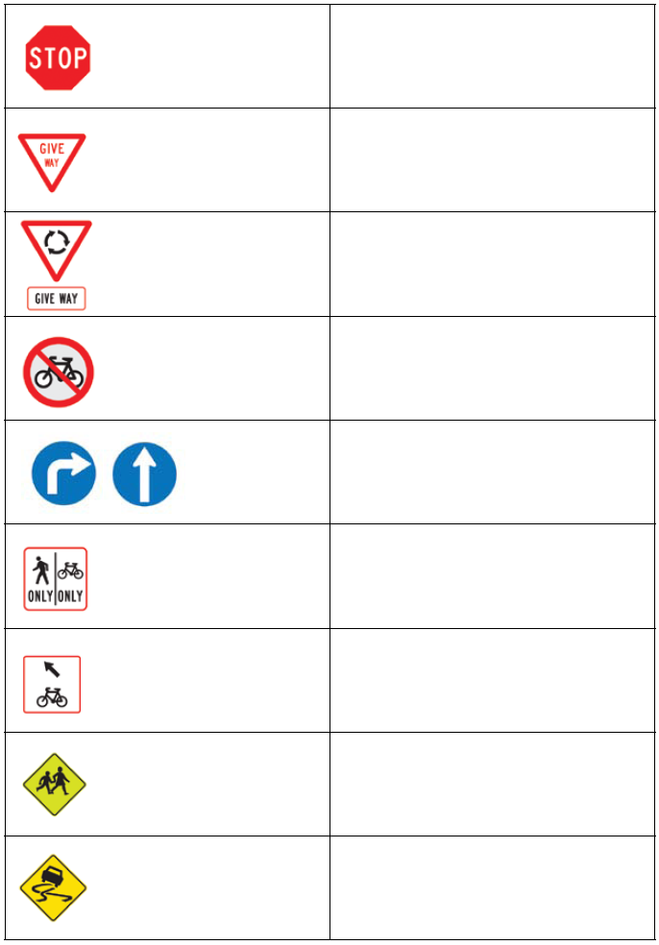
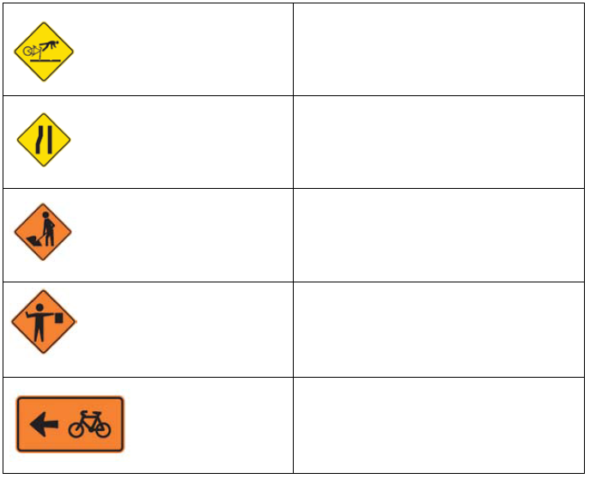

Copysheet: Answers for Teachers
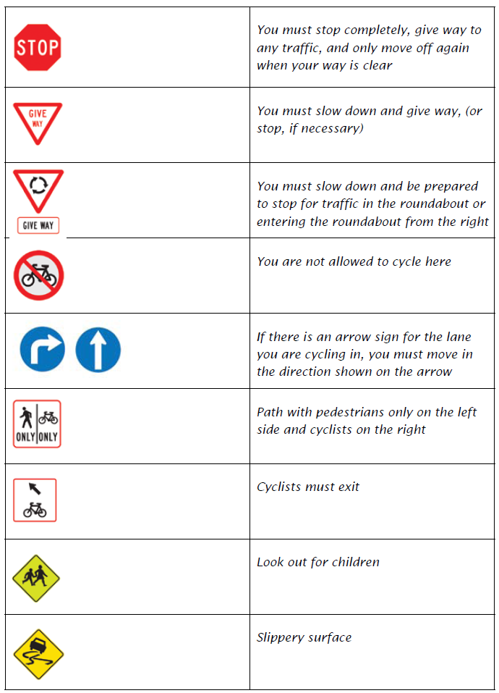
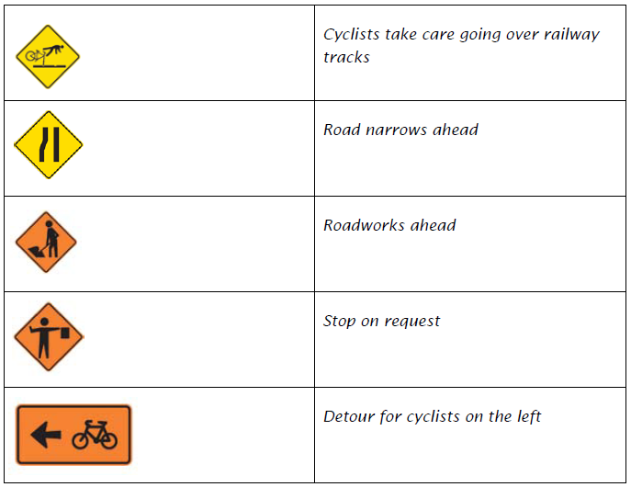

Learning experience 2: Hazards

Learning intentions
By the end of this learning experience students will be able to:
- identify potential traffic hazards for cyclists
- suggest strategies to overcome these.

Activities
For these activities, choose hazards from Copysheet: Hazard Cards, or write some of your own.
Remind students that they are not being trained to ride on the road. However, they are being introduced to the idea that there are hazards for cyclists on the road and they can begin thinking how about strategies to handle these.

1. Classifying hazards
Seat the students in a large circle. Spread the hazards from Copysheet: Hazard Cards face down on the floor. Also place out five headings on A4 paper for: Traffic Conditions, Weather Conditions; Road Conditions; Cycle rider; Cycle. In turn, each student picks up a hazard and places it under the heading where they think it best fits. Other students can agree to the placement or move it to another heading. Once you have reached a consensus, the next student picks a card.

2. Strategies for managing hazards
Seat the students in a circle. Hand the first student one of the hazards from Copysheet: Hazard Cards. They must describe the hazard and say what they would do in this situation (strategy). Ask other students for other strategies. Repeat this with the next student and so on until all students have had a turn or all the cards have been used up.

Optional learning experiences
Play What if ... with the class. For example:
What if there was lots of loose gravel on the road?
What if a car door opens as you are riding by?
What if you see an object on the road in front of you?
What if a big dog chases your bike?
Arrange students into a donut. Give a traffic hazard. Students on the inside circle must tell their partner what they would do in that situation. The outside circle moves one place to the left. Name another hazard. This time the person on the outside of the circle explains what they would do. Repeat this process as long as students stay interested.

Concluding activity
Students document what they have learnt by completing Copysheet: Cyclist Skills Post Training Survey and Copysheet: Funnel strategy.

Copysheet: Hazard Cards

You are going to ride your bike and you notice the chain is loose.

You are riding along the road when a car door opens right in front of you.

You have to cross a very busy intersection on your way home.

You find that the traffic lights are not working.

You notice that your cycle helmet has got a big dent in it. You were just going to put it on.

You are riding home from school when a big dog starts chasing you.

You and a friend are riding home when you see a car knock a pedestrian over on the pedestrian crossing in front of you.

You are riding your bike when you come to a roundabout. You are not sure what lane you should take.

You are riding on the footpath to deliver newspapers when a car backs out of a drive in front of you.

While you are riding home it suddenly starts to pour with rain. You can hardly see anything in front of you.

As you set off on your bike early one morning you realise that there is a frost.

As you approach the Intermediate school on your bike you see that there is a lot of traffic and two buses blocking the cycle lane.

You have had a bad day at school and as you cycle home you can't stop thinking about it.

You have a really bad cold and your eyes are sore. Your head starts aching when you put your cycle helmet on.

The traffic is unusually heavy as you are biking home from school one day.

You come across a group of older students cycling three abreast in front of you.

There are road works ahead blocking most of the lane you are riding in.

You have gone out for a ride and suddenly realise that your brakes aren't working properly.

Your mud guard is scraping against the front wheel as you ride along.

A drain has blocked on your cycle route home and there is a huge sheet of water across the road.

A large truck is in front of you as you are cycling to town. It is going to the dump carrying a big load and there is a lot of plaster dust blowing back right into your face.

You left your bike lying by the drive at home and when you next ride it you notice that the whole front wheel is a bit bent and very wobbly. You wonder if Dad drove over it with the car.

Copysheet: Cycle Skills Post Training Survey

1. What is your name?

2. How often do you ride your bike? (✓)
Never A few times a year About once a month
Every day At least once a week Don’t have a bike

3. How do you get to school or work on most days? (✓)
Car Bike Bus Walk Other _____________________

4. How would you like to get to school or work most days? (✓)
Car Bike Bus Walk Other _____________________

5. How confident do you feel riding your bike in parks/reserves or playgrounds? (Please circle)
1 2 3 4 5
Not confident OK Very confident

6. How confident do you feel riding your bike on the road? (Please circle)
1 2 3 4 5
Not confident OK Very confident

7. Have you ever ridden your bike on the road: (✓ one option) Yes No

8. Tick the two things that the law says you must have on your bike. (✓)
Water bottle | Red or yellow rear reflector | Brakes on the front and back wheels | Drink bottle holder

9. Tick one of these items that the law say you must wear when riding your bike. (✓)
Helmet | Hat | Gloves | Sunglasses
10. Tick the one picture that shows the right way to wear a helmet. (✓)
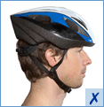  (Image source www.acc.co.nz) | 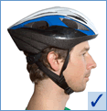 | 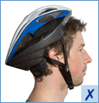 | 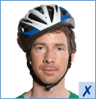

11. Which foot should you start with on the ground before riding out from the kerb on your bike? (✓)

Left foot Right foot Don’t know

12. When you ride your bike on the road, what do these signals tell other road users? (✓)
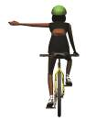 | 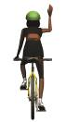 | 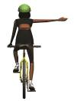
- I am stopping or  slowing down | - I am stopping or  slowing down | - I am stopping or  slowing down
- I am turning right | - I am turning right | - I am turning right
- I am turning left | - I am turning left | - I am turning left

13. How long should you signal for? (✓)
At least 3 seconds At least 5 seconds At least 10 seconds Don’t know

14. Did you enjoy the cycle training? (✓)
Not at all OK Good Excellent

15. Tell us what you enjoyed the most about the cycle training and why.

16. Is there anything that could be improved about the course for next time?

Thank you for completing the survey.

Copysheet: Funnel Strategy

Three things that I didn’t know when I started this study

1

2

3

Two things that this has made me think about

1

2

One thing I am going to do as a result

1

