Road Safe

Years 4–6 Focus area 3
This section of the Road Safe programme contains one of the following focus areas for students at years 4–6 (ages 8–10):
- Passenger and pedestrian
- Safe cycling
- Cycling with confidence
- Preparing for future on-road cycling
Note: Research suggests that an effective programme should include learning experiences from each of the focus areas.

Focus area 3: Cycling with confidence

Contents
Focus area 3: Cycling with confidence 2
Explanation 2
Notes for the teacher 2
Curriculum links 2
Resources 2
Success criteria 3
Learning experience 1: Bike control skills 4
Learning intentions 4
Activities 4
Optional learning experiences 5
Copysheet: More about bikes 6
Learning experience 2: Bike handling skills 7
Learning intentions 7
Activities 7
Optional learning experiences 9
Copysheet: Cyclist Observation Sheet 10
Copysheet: Marking Out a Cycle Course 11
Copysheet: Grade 1 Trainee Skills Assessment 12

Focus area 3: Cycling with confidence

Explanation
In this focus area, students practise Grade 1 cycling skills in a controlled and supportive environment, as opposed to a road and traffic environment. This grade teaches bike control skills, such as getting on and off a bike, and specific bike-handling skills, such as being able to manoeuvre safely to avoid objects. These new skills will promote cycling confidence and safe bike handling. Road rules and signs are also covered.

Notes for the teacher
It would be logical for both learning experience 1 and 2 to be done on the same day, to avoid children having to bring their bikes of two occasions.
For more information on teaching these bike control and handling skills, see the New Zealand Transport Agency’s Cyclist Skills Training Guide (March 2010), available from its website.
Copysheet: Marking Out a Cycling Course gives suggested mark outs to allow students to practise the cycling skills in Learning experience 2. These could all be connected to make a complete cycling course.

Curriculum links
Key Competencies: Thinking (thinking about actions as a road user); Managing self (taking responsibility for keeping safe when cycling); Relating to others (being aware of the rights and responsibilities of all traffic users)
Learning areas: Levels 2–3 Health and physical education: Strand A – Safety management; Strand Strand B – Movement skills; Strand D – Rights, responsibilities and laws

Resources
Bikes that have been checked against legal requirements
Cycle expert
Correctly fitted, standards-approved cycle helmets
Copysheet: More about Bikes
Copysheet: Cyclist Observation Sheet
Copysheet: Marking Out a Cycling Course
Copysheet: Grade 1 Trainee’s Skills Assessment
Stories: Failing Brakes, Wipeout Gulch and Red Mark in the Riding By stories (available from your School Community Officer)
Cones
Vehicle Flash Cards (available from your School Community Officer)

Success criteria
At the end of this focus area students will be able to:
- get on and off the bike without help
- get on and off from the left of the bike away from traffic
- hold the brakes while mounting and dismounting
- demonstrate the ‘pedal ready’ position with the right pedal up and the left pedal down
- start off and pedal without help
- stop quickly and with control
- steer the bike and manoeuvre safely to avoid objects
- steer the bike to the right and left with control
- manoeuvre with control around objects both at speed and slowly
- look behind without wobbling while cycling in a straight line
- demonstrate a stop, turn right and turn left signal while cycling in a straight line
- look behind and then signal
- change gears from the ‘hardest’ to the ‘easiest’ while riding.

Learning experience 1: Bike control skills

Learning intentions
By the end of this learning experience students will be able to:
- get on and off the bike without help
- get on and off from the left of the bike away from traffic
- hold the brakes while mounting and dismounting
- demonstrate the ‘pedal ready’ position with the right pedal up and the left pedal down
- start off and pedal without help
- stop quickly and with control.

Activities

1. Start off and pedal without help
Demonstrate:
- getting on and off the bike from the left, away from traffic
- the ‘pedal ready’ position with the left foot down and the right foot up
- putting the bike in a low gear and moving off by pushing down, using the balls of the feet
- slowly riding in a straight line, in a low gear.
Each cyclist now completes each of the above steps. Non-cyclists can be partnered with a student with a bike so that they can also practise these skills.
Ask: How did it feel to be in control of your bike?
Why is it important to be able to ride slowly?

2. Stop quickly and with control
Demonstrate how to use the back and front brakes together gently to come to a controlled stop. The rear brake should be applied slightly before the front brake – this will prevent the back wheel from jumping.
If there are some students whose bikes have foot brakes, demonstrate how they should brace their arms and move their weight to the back of the bike by sliding toward the rear of the seat.
Ask students to cycle in a circle. When you shout “Stop!”, they must stop quickly.
Ask students to cycle towards a line marked on the ground. When they get to the line, they must stop. Students keep practising this skill until they can stop smoothly.
Partner cyclists up with non-cyclists. The cyclists talk about what they have learnt and how confident it makes them feel.

Optional learning experiences
Read the story Failing Brakes from the Riding By stories.
Students can complete one of the tasks on Copysheet: More about Bikes.

Copysheet: More about bikes

Choose two or more of the following tasks:

- Construct a model of a bicycle out of recycled things that you have found at home.
- Design a bike using only 3 circles, 7 rectangles, 10 triangles and 1 oval.
- Write a song describing the key features a safe cycle helmet should have and how it should be worn.
- Write a poem about riding a bicycle. Present this neatly, with drawings.
- Design and make a suitable and safe cycling outfit.
- Survey friends to find out what sort of extra features (water bottles, locks ...) they would like on their bike. Graph your results.
- Design your own “For Sale” sign to sell your bike. Remember to describe all its great features.

Learning experience 2: Bike handling skills

Learning intentions
By the end of this learning experience students will be able to:
- steer the bike and manoeuvre safely to avoid objects
- steer the bike to the right and left with control
- manoeuvre with control around objects, both at speed and slowly
- look behind without wobbling while cycling in a straight line
- demonstrate a stop, turn right and turn left signal while cycling in a straight line
- look behind and then signal
- change gears from the ‘hardest’ to the ‘easiest’ while riding.

Activities
Non-cyclists can be located in a position where they can observe cyclists and complete Copysheet: Cyclist Observation Sheet.

1. Steer the bike and manoeuvre safely to avoid objects
Demonstrate how to:
- steer the bike to the right and left with control
- manoeuvre safely to avoid objects at speed
- manoeuvre safely to avoid closely placed objects (cones) at low speed.
This is preparation for the slalom activity.

2. Steering and ‘figure of 8’ exercise
Divide the students into two groups. Position one group at each corner of the same end of the course. One student from each group, at the same time, starts riding diagonally towards the centre. Both students must pass through the centre mark, adjusting their speed in order to avoid collision. Students can then ride to the other side of the course and wait in the corners to repeat the manoeuvre again from this side.

3. Slalom (manoeuvring to avoid objects)
Place markers/cones in a straight line no more than 1.5 metres apart. Have students cycle in slalom fashion between the markers, keeping both hands on the handlebars and pedalling continuously. Pedalling should be smooth and controlled (i.e., no jerking or sudden back braking). Brakes can be used with control to moderate speed.
Have students repeat this exercise, but at slow speed. Markers/cones can be placed closer together.

4. Looking behind
Demonstrate how to look behind while continuing to cycle in a straight line. Hands must remain on the handlebars, and the cyclist must lean forward and bend one arm. When turning the head to the right, bend the left arm. When turning the head to the left, bend the right arm.
Ask: When would you use this skill? (To check for traffic)
When would be an appropriate time to look behind? (When there are no hazards, such as a car crossing in front of you)
Why is it important to practise this here in the playground? (It will build up our confidence; there is no traffic; we will learn not to wobble)
Each student in turn cycles in a straight line, looking behind twice before the end.

5. Signal – stop, left and right
Demonstrate how to:
- signal ‘left’ with the left arm at 90° from the body with a flat palm (thumb pointing upwards) while continuing to cycle in a straight line
- signal ‘right’ with the right arm at 90° from the body with a flat palm (thumb pointing upwards) while continuing to cycle in a straight line
- signal ‘stop’ by lifting your right arm to a 90° position to the horizontal, and fingers pointing up;
- return both hands to the handlebars after signalling and before making any turn.
Ask: When would you use these signals? (When turning left or right, stopping or slowing down, starting an on-road journey)
How soon before taking action should you make a hand signal? (At least 3 seconds)

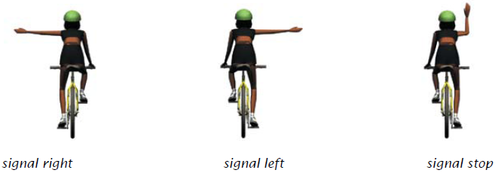

Line the students up at one end of the course.
Get the students to get on their bikes (one at a time) and cycle in a straight line. At the halfway point, get each student to look over their right shoulder for at least three seconds while keeping the bike steady and moving in a straight line. As they do this, hold up a Vehicle Flash card. The cyclist must call out the vehicle’s type and colour.
At the end of the course, have the riders make a controlled stop and dismount.
Repeat the exercise, each time practising a different skill in the middle (all signals, as well as looking over both shoulders) and using different Vehicle Flash Cards.

6. Using the gears
Demonstrate how to:
- change gears while the bike is moving
- change down to a lower gear before stopping
Have students cycle around individually or as a group, changing gears from the ‘hardest’ (high gear) to the ‘easiest’ (low gear) as they go. Once they are comfortable with this, ask them to put their bikes in a low gear and start from a stop at one end of the netball court/practice space. They should cycle to the other end, changing gears up as they go and then changing them down again so that they are in a suitable gear for starting off again by the time they come to a stop.
If desired, individual student's skills can be assessed using Copysheet: Grade trainee skills assessment

Optional learning experiences
Read the story Wipeout Gulch from the Riding By stories.
Read the story Red Mark from the Riding By stories
Set up the cycling course at a later date. Video students practising the new cycling skills. Show the video to the class and have them pick out things done well, and things not done so well.

Copysheet: Cyclist Observation Sheet

This is for use by students who are non-riders.

1 Watch all riders going around the cycle course and complete the following:
Which part of the course did riders find most difficult? Slalom Circle U turn Straight line

Which part of the course did riders find easiest? Slalom Circle U turn Straight line

2 Choose two riders and complete the following checklist for them, using the following key.
C = competent P = needs practice

Skill | Rider 1 | Rider 2
Riding between cones
Steering to safely avoid objects at speed
Making a U-turn
Riding in a circle
Riding steadily without wobbling
Giving a hand signal
Completing the course with few stops
Riding in a straight line
Looking behind

Copysheet: Marking Out a Cycle Course

Tracks which students will ride on for several lessons can be marked out permanently on an asphalted area. Suggested tracks are shown below, although the actual layout will depend on the space available. For example, the ‘intersection’ could be built around a corner of the school building to save space.
A member of your school or a parent may be able to advise on the laying out of these tracks. The local Council may agree to do the actual line marking, provided that the position of the lines has been indicated (for example, with strings and crayon).

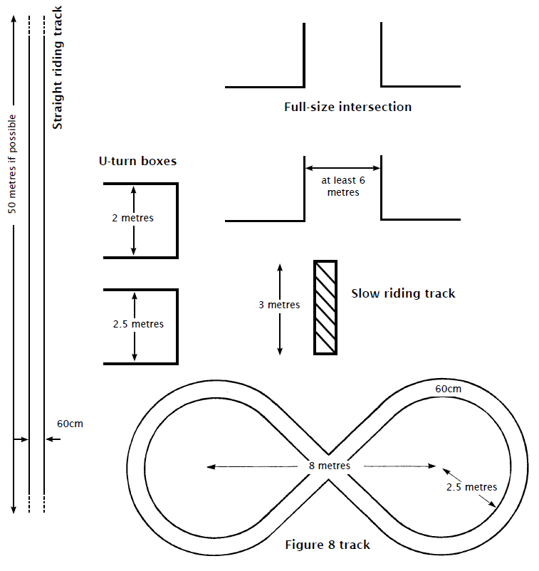

Copysheet: Grade 1 Trainee Skills Assessment
 |  |  |  |  |  |  |  |  |  |  | NUMBER
 |  |  |  |  |  |  |  |  |  |  | NAME
 |  |  |  |  |  |  |  |  |  | ✓ | Carry out a bike check
 |  |  |  |  |  |  |  |  |  |  | Carry out a helmet check
 |  |  |  |  |  |  |  |  |  |  | Explain legal requirements for bicycles and safety equipment
 |  |  |  |  |  |  |  |  |  |  | Get on and off the bike without help
 |  |  |  |  |  |  |  |  |  |  | Start off and pedal without help
 |  |  |  |  |  |  |  |  |  |  | Stop quickly with control
 |  |  |  |  |  |  |  |  |  |  | Steer the bike and manoeuvre safely to avoid objects
 |  |  |  |  |  |  |  |  |  |  | Look behind
 |  |  |  |  |  |  |  |  |  |  | Signal – stop, right and left
 |  |  |  |  |  |  |  |  |  |  | Use their gears
 |  |  |  |  |  |  |  |  |  |  | COMMENTS

Key: ✓ = yes X = no

