Road Safe

Years 4–6 Focus area 2
This section of the Road Safe programme contains one of the following focus areas for students at years 4–6 (ages 8–10):
- Passenger and pedestrian
- Safe cycling
- Cycling with confidence
- Preparing for future on-road cycling
Note: Research suggests that an effective programme should include learning experiences from each of the focus areas.

Focus area 2: Safe cycling

Contents
Focus area 2: Safe cycling 2
Explanation 2
Notes for the teacher 2
Curriculum links 3
Resources 3
Success criteria 3
Learning experience 1: Helmet check 4
Learning intentions 4
Activities 4
Optional learning experiences 5
Copysheet: Letter to Parents and Caregivers 6
Copysheet: Cycle Skills Pre Training Survey 7
Learning experience 2: Bike check 9
Learning intentions 9
Activities 9
Optional learning experiences 9
Copysheet: Helmet/Bike Safety Check 10
Copysheet: A Short History of the Bicycle 12

Focus area 2: Safe cycling

Explanation
In this focus area, students learn the basics of cycle maintenance and how to select and fit a cycle helmet. This is information that is useful to them, even if they are not yet in possession of a cycle. It is also important that parents and caregivers are given the same safety information about bike maintenance and cycle helmets, so that they can ensure that their children have safe cycle helmets and bikes.

Notes for the teacher
The New Zealand Transport Agency’s Cyclist Skills Training Guide (March 2010), available from its website, outlines how cyclist skills should be taught to prepare trainee cyclists to ride confidently on the road. It caters for a range of trainees and suits both school and adult training environments. The guide is divided into 4 levels: Complete Beginner; Grade 1 Beginner; Grade 2 Intermediate; Grade 3 Advanced.
This focus area is aligned to Grade 1 of the Cyclist Skills Training Guide. All the cycling activities included in it comply with the Cyclist Skills Training Guide.
Grade 1 teaches cycle control skills in a non-traffic environment and focuses on specific bike handling skills to promote bike confidence and safe bike handling. Road rules and signs can also be taught at this grade, but Grade 1 should be taught in a simulated road environment only. Trainees must be made aware that this level of training does not qualify them for riding on the road.
The training covers both theory and practical training. It takes approximately 3 hours. The ratio of instructor to trainees is 1:30 for the theory and 1:15 for the practical.
Core skills for Grade 1 are:
Carry out a bike check.
Carry out a helmet check.
Understand the legal requirements and safety equipment for bicycles.
Get on and off the bike without help.
Start off and pedal without help.
Stop quickly and with control.
Steer the bike and manoeuvre safely to avoid objects.
Look behind.
Signal – stop, left and right.
Use the gears.

Letter
Copysheet: Letter to Parents and Caregivers should be sent home before Focus area 2 begins. It must be made quite clear that Police and NZTA recommend that children under the age of 10 should not ride on the road unless accompanied by a responsible adult. They should therefore not bike to school on their own, so parents will need to cycle with their children, or bring the bike in a vehicle.
It should also be made quite clear to both parents and students that this programme is not training for riding on the road.

Legal requirements
Wearing an approved cycle helmet is compulsory by law in New Zealand for any person who uses the road on a bicycle or bicycle trailer. Exemptions are possible on the grounds of religious belief, physical disability or medical conditions.
For more information about legal requirements for cycles and cycle helmets, see the NZTA factsheet Cycles: Road Rules and Equipment.
The school needs to decide how they will deal with students whose bikes do not meet the legal requirements.

Curriculum links
Key Competencies: Thinking (thinking about actions as a road user); Managing self (taking responsibility for keeping safe when cycling)
Learning areas: Levels 3–4 Health and physical education: : Strand A – Safety management; Strand B – Movement skills; Strand D – Rights, responsibilities and laws

Resources
Resource person to assist with cycle helmet and bike checks, such as School Community Officer, cyclist training organisation or cycle shop staff
Safety approved cycle helmets, brought by students
Copysheet: Letter to Parents/Caregivers
Copysheet: Cycle Skills Pre Training Survey
A safe and well maintained bike – students’ bikes
Copysheet: Helmet/Bike Safety Check
Copysheet: Short History of the Bicycle
Story: Grounded from the Riding By stories (available from your School Community Officer)

Success criteria
At the end of this focus area students will be able to:
- select a safe cycle helmet and fit it correctly
- explain why they should wear a cycle helmet
- check a bike to see if it is:
- a suitable size and fit for the rider
- safe and meets the legal requirements.

Learning experience 1: Helmet check

Learning intentions
By the end of this learning experience students will be able to:
- select a safe cycle helmet and fit it correctly
- explain why they should wear a cycle helmet.

Activities
Invite students to complete Copysheet: Cycle Skills Pre Training Survey. Collect this in for marking and retain so that the results can be compared with the post training survey at the end of this Focus area.
Invite a cycle expert to class for these activities.
Divide students into pairs (or small groups if there are insufficient cycle helmets), each with a safety approved cycle helmet. Each pair checks that:
- the shell and polystyrene of the helmet is in good condition – not cracked or damaged
- the straps and buckles are in good order – not frayed or broken.
- the helmet has a standards-approved sticker – examples of the approved stickers are shown below.
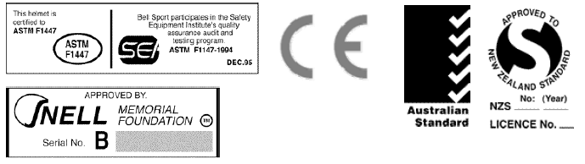
The US Consumer Product Safety Commission’s bicycle helmet safety standard is also approved.
The cycle expert demonstrates the correct fitting of the cycle helmet, checking that:
- the helmet is the correct size – with little or no wobble when fitted on the trainee’s head
- the helmet touches the head all the way around the rim
- the helmet sits flat and square on the head, with the rim of the helmet 1–1.5 cm above the eyebrows
- the helmet cannot be pulled back to expose the forehead and cannot be tilted forward, backward or sideways
- the chin and back straps run in straight lines from the rim of the helmet and meet on the jaw, below and to the front of the ear lobe
- the straps buckle up under the chin, not on the jaw. The chin strap should be firm, but not too tight.
Caps or beanies should not be worn underneath the helmet.
Each student with a cycle helmet puts it on, and has it checked by other students. The cycle expert and the teacher check them as well.
Ask: Why is it important that you wear a cycle helmet?
What might happen if your cycle helmet was in poor condition?
What does the law say about wearing cycle helmets?

Optional learning experiences
Students work in pairs to make an outline of a cycle helmet. Inside the helmet they write the features of a safe cycle helmet.
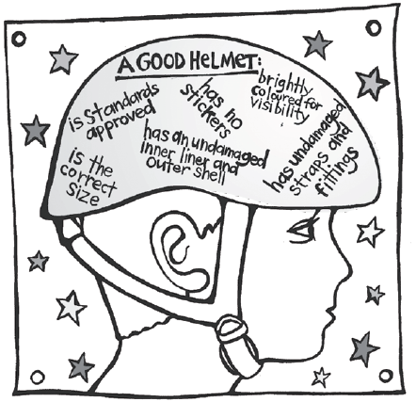
Students develop a survey that can be used to find out how well the community uses its cycle helmets. The survey could include such things as:
- helmet worn
- helmet visible but not worn
- straps done up
- helmet positioned correctly on the head
- helmet has no visible dents or marks.
After the survey the class can collate their findings and publish the results on the school website or the local newspaper.

Copysheet: Letter to Parents and Caregivers
Dear Parent/Caregiver
We are currently implementing a road safety programme in your child’s class that involves practical cycling activities. We are about to begin the section on cycling. We will be teaching:
- selecting and fitting a cycle helmet
- checking a bike to see that it meets legal requirements
- cycle skills exercises to promote confidence and safe bike handling.
These skills meet the requirements of Grade 1 of the Cyclist Skills Training Guidelines published by the NZ Transport Agency in March 2010. All of these exercises will be carried out in a non-traffic environment. Your child will not be taken out to practise these skills on the road or in traffic.
Please note that Police and the NZ Transport Agency recommend that children under 10 should not be riding on the road unless accompanied by a responsible adult on a bike.
If your child is to participate in this programme he or she will need:
- a bike in good working order. It would be helpful to do a simple bike check of things like brakes, tyre pressure, wheels spinning freely and light oil on the chain. You could use the helmet/bicycle check form from the Cyclist Skills Training Guidelines:
www.nzta.govt.nz/resources/cyclist-skills-training-guide/docs/template14-helmetbike-check.doc
- a standards-approved helmet. It should have a standards-approved sticker on the inside, as shown in The Official New Zealand Code for Cyclists published by the NZ Transport Agency:
www.nzta.govt.nz/resources/roadcode/cyclist-code/about-equipment/cycle-helmets.html
- to be able to ride a bike. Please let us know if your child is a complete beginner, or does not have a bike.

During and after the programme, encourage your child to practise and develop the skills being taught.

Thank you for your help. Please fill in the consent form below. If you have any questions, please contact me.

Yours faithfully

(teacher)
The cyclist training programme will be taught on

Your child will require a bike and cycle helmet in serviceable condition.

Please complete this consent form and return to school by

Signed: ............................................................ Print Name: ..................................................

Child’s name: ............................................................

Copysheet: Cycle Skills Pre Training Survey

1. Name of School Community Officer: | Grade of training: Level 1
2. What is your name?
3. How old are you? | 4. Are you: Male Female

5. How often do you ride your bike? (✓)
Never A few times a year About once a month
Every day At least once a week Don’t have a bike

6. How do you get to school or work on most days? (✓)
Car Bike Bus Walk Other _____________________

7. How would you like to get to school or work most days? (✓)
Car Bike Bus Walk Other _____________________

8. How confident do you feel riding your bike in parks/reserves or playgrounds? (Please circle)
1 2 3 4 5
Not confident OK Very confident

9. How confident do you feel riding your bike on the road? (Please circle)
1 2 3 4 5
Not confident OK Very confident

10. Have you ever ridden your bike on the road: (✓ one option) Yes No

11. Tick the two things that the law says you must have on your bike. (✓)
Water bottle | Red or yellow rear reflector | Brakes on the front and back wheels | Drink bottle holder

12. Tick one of these items that the law say you must wear when riding your bike. (✓)
Helmet | Hat | Gloves | Sunglasses
13. Tick the one picture that shows the right way to wear a helmet. (✓)
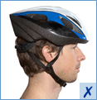  (Image source www.acc.co.nz) | 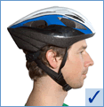 | 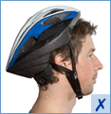 | 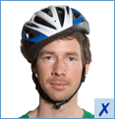
14. Which foot should you start with on the ground before riding out from the kerb on your bike? (✓)

Left foot Right foot Don’t know

15. When you ride your bike on the road, what do these signals tell other road users? (✓)
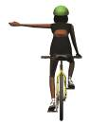 | 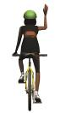 | 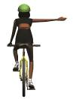
- I am stopping or  slowing down | - I am stopping or  slowing down | - I am stopping or  slowing down
- I am turning right | - I am turning right | - I am turning right
- I am turning left | - I am turning left | - I am turning left

16. How long should you signal for? (✓)
At least 3 seconds At least 5 seconds At least 10 seconds Don’t know

Thank you for completing the survey.

Learning experience 2: Bike check

Learning intentions
By the end of this learning experience students will be able to:
- check a bike to see if it:
- is a suitable size and fit for the rider
- is safe and meets the legal requirements.

Activities
The cycle expert uses the cycle to demonstrate all the equipment that a bike must have by law and discusses correct bike maintenance and storage of bikes.
Hand out Copysheet: Helmet/Bike Safety Check.
Students who have brought bikes use this to check their own bikes. Buddy them up with non-riding students.

Optional learning experiences
Read the story Grounded from the Riding By stories.
Students draw their idea for a bike for 2030, labeling the features that it has.
Students read Copysheet: Short History of the Bicycle. They carry out online research to document changes in bikes since the 1870s. They then make a summary of improvements in safety and speed.

Copysheet: Helmet/Bike Safety Check

Name of owner:
Type of bike (circle): BMX Road Mountain Child Other
Colour: Frame ID number:
Name of cycle training organisation:

The purpose of this helmet and bicycle check is to examine their condition before starting training. Major faults should be fixed by a reputable bike mechanic.

Checklist | OK | Repair/ adjust | Repairs needed
Helmet
- check for damage
- firm fit
- straps firm (ear piece under ear, one finger under chin strap)
Frame
- no rust or cracks (good order)
Frame correct size for trainee
Seat
- secure
- correct height
Handlebars
- tight and secure
- grips cover ends of handle bars
Headset and stem
- tight and secure

Checklist | OK | Repair/ adjust | Repairs needed
Front and rear brakes
- responds quickly with firm contact
- brake pads are secure
- brake pads not excessively worn
- with disk brakes, brake pads are making contact with the rotor and disc is tight
Wheels
- wheel fasteners tight
- wheels spin freely
Tyres
- correct pressure, lots of tread
- no cracks or slits
Pedals
- spin freely, not loose
Chain
- chain tension is firm
- lightly oiled and in good condition
Front and rear shock absorbers (if applicable)
- working effectively
Lights (if riding at night)
- in good working order

Please have the repairs/adjustments listed above completed by: (date)

Copysheet: A Short History of the Bicycle
The bicycle is a great invention, but it has changed a great deal over the years.

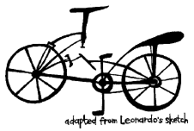 | The great artist, Leonardo Da Vinci, did this drawing of a bicycle about 500 years ago. However, it wasn’t until the the 19th century that people started to use the bicycle as a way of getting around.
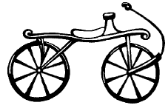 | At first, the bicycle was only a plank of wood joined to two wooden wheels. To move, you had to sit on the plank and push yourself along the ground with your feet. Therefore this machine was known as a Hobby-horse, and it wasn’t popular for long.
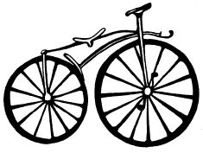 | By the mid 1860s, a Frenchman had the idea to add pedals to the front wheel of the bicycle. He called his invention a ‘velocipede’, meaning ‘fast foot’. Most people called it a bone shaker, because it was still all made of wood. Later, metal was used for the tyres.
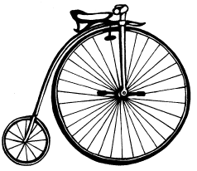 | In 1871, the first ‘Penny Farthing’ bicycle was seen. Its name comes from two English coins – a penny, which is large, and a farthing, which is small – like the wheels. The big wheel was needed for speed, as it meant you could travel further with one rotation of the pedals. The wheels were made of solid rubber and the frame was metal, so it was a bit more comfortable. This meant that more people used it and so it became known as the ‘Ordinary Cycle’.  However, because of the design of the dresses women wore at the end of the last century, cycling was mainly an activity for men.  It would cost an average of six months of a man's pay to buy a Penny Farthing. However, this bicycle gave people the freedom to travel using their own power. As a result, roads improved and road signs and laws for cyclists became necessary.
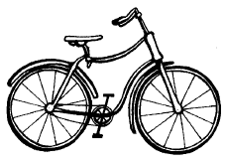 | In the late 1880s, major advances in bicycle design took place and the invention became far more practical. The new shape, known as the ‘diamond frame’, is still familiar in bicycles today. Also brakes and gears started to be used. In 1888, John Dunlop invented an air-filled, or pneumatic tyre to make his son’s tricycle more comfortable – a great leap that I think you will agree has been very useful!

