Road Safe

Years 4–6 Focus area 1
This section of the Road Safe programme contains one of the following focus areas for students at years 4–6 (ages 8–10):
- Passenger and pedestrian
- Safe cycling
- Cycling with confidence
- Preparing for future on-road cycling
Note: Research suggests that an effective programme should include learning experiences from each of the focus areas.

Focus area 1: Passenger and pedestrian

Contents
Focus area 1: Passenger and pedestrian 2
Focusing question 2
Explanation 2
Notes for the teacher 2
Curriculum links 3
Resources 3
Success criteria 3
Learning experience 1: Street smart 4
Learning intention 4
Activities 4
Optional learning experiences 4
Copysheet: Sample Route for Walking Practice – Urban 6
Copysheet: Sample Route for Walking Practice – Rural 7
Learning experience 2: Role models 8
Learning intentions 8
Activities 8
Optional learning experiences 9

Focus area 1: Passenger and pedestrian

Explanation
In this focus area the teacher can assess the road safety skills and knowledge of the students and can then revise and extend where necessary. The practical walking activity allows students to put this learning into practice. Students further solidify their knowledge by teaching simple safe pedestrian and passenger skills to younger children.

Notes for the teacher

Safe walking
When there is a footpath, students should always walk on the house/shop side of the footpath, well away from traffic. If they are with an adult, the adult should walk on the side closest to the road.
If there is no footpath, students should walk on the grass verge as far as possible from the road and facing the oncoming traffic. They should walk in single file, with the tallest person at the back so that everyone can see.

Crossing the road
Students should cross the road using kerb drill:
Stop one step away from the kerb, or edge of the road.
Look all ways that traffic might be approaching.
Listen for traffic.
When the road is clear, walk briskly across, looking each way for traffic.

Crossing the road between parked cars
Check that there are no drivers in the cars. If there is a driver in either car, choose a place to cross between the cars without drivers. Stand at the front of the car by the headlight nearest the road. Look and listen for traffic. When the road is clear, cross briskly, looking each way for traffic.

Using the pedestrian crossing
Students should use the pedestrian crossing if there is one available. The law says that if you are within 20 metres of a pedestrian crossing or traffic lights, you must use them.
Children sometimes believe that being on the pedestrian crossing is quite safe and that cars will automatically stop. They need to be reminded to use kerb drill in the usual way.

Safety as a passenger
Sit in the back seat of the car if possible. Always put on the safety belt in there is one. Sit quietly in the car or bus and don’t annoy the driver. On a bus, put any possessions safely under the seat or in the rack.

Practical walking
The school should complete a Risk Management Plan or RAMS (Risk Analysis and Management System) before taking students out into the roading environment.
Choose a convenient, safe route, preferably a circuit that will take about 15 minutes to walk. Ensure that all adult helpers are familiar with the correct procedures for walking and crossing the road.

Curriculum links
Key Competencies: Managing self (taking responsibility for keeping safe in a traffic environment); Relating to others (being aware of the rights and responsibilities of all traffic users)
Learning areas: Levels 3–4 Health and physical education: Strand A – Safety Management; Personal growth and development

Resources
Copysheet: Sample Route for Walking Practice – Urban
Copysheet: Sample Route for Walking Practice – Rural
New Zealand Transport Agency pamphlet: Making Safe Choices when Travelling to and from School by Bus (copies can be ordered using the order form on the NZTA website, www.nzta.govt.nz)
Students from a New Entrants class
Equipment to set up activities, such as chalk, chairs

Success criteria
At the end of this focus area students will be able to:
- explain correct procedures for walking safely on or near the road and crossing the road
- explain why they should model safe behaviour as passengers and pedestrians
- help younger children to become safe passenger and pedestrians.

Learning experience 1: Street smart

Learning intention
By the end of this learning experience students will be able to explain correct procedures for walking safely on or near the road and crossing the road.

Activities

1. Quiz
Do a quiz with the class. Divide the students into four groups:
- crossing the road
- walking on or near the road
- passenger safety
- traffic lights and pedestrian crossings.
Each group writes four questions about their topic. Each group in turn asks their questions of the other three groups, who discuss the question and then come up with their answer. The teacher checks the validity of the answers and corrects any misinformation. Each group gets a point for each correct answer.

2. Walk
Take students out for a practical walking activity, using a route similar to the ones outlined in Copysheets: Sample Routes for Walking Practice. Ask adult helpers to monitor the students’ safe walking skills so that any necessary revision of skills can take place at a later date.
After the walk, students work as a class or individually to complete a Plus: Minus: Improve chart like the one below.

Plus | Minus | Improve
Remembered to walk on house side of footpath.  Stopped one step back from kerb.  Waited until road was clear before crossing. | Forgot to look for traffic as we crossed.  Were pushing each other on the pedestrian crossing.  Nearly crossed in front of a car pulling out. | Will practise kerb drill again.  Revise crossing between parked cars.

Optional learning experiences
Divide students in to groups of four. Ask them to practise walking in single file around the classroom, with the tallest person at the back and shortest at the front. Remind them that this is a safe practice when walking on country roads with little space for pedestrians.
Each student keeps a log of their travel over the next four days. They should note where they went, how they got there, who they went with, and how long it took. Work with the class to graph the results and make some conclusions about their travel.
Students develop a Safe Walking Observation Sheet. They use this to monitor walking practices of people at different locations, such as outside the school, outside the supermarket, in the main street. They draw some conclusions about how safe people are when walking.
Each student prepares a Survey for Passengers and Pedestrians, which can be used to find out what people know about how to keep safe as a passenger and pedestrian. They trial this with a partner, refine the survey and then take it home for an adult to complete.

Copysheet: Sample Route for Walking Practice – Urban
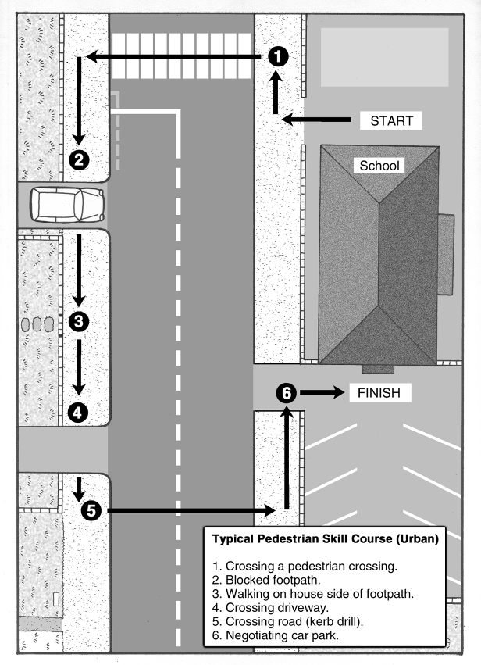

Copysheet: Sample Route for Walking Practice – Rural
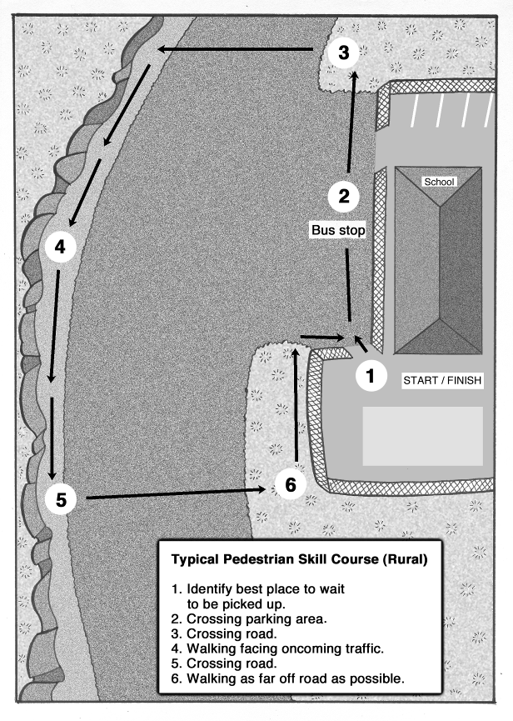

Learning experience 2: Role models

Learning intentions
By the end of this learning experience students will be able to:
- explain why they should model safe behaviour as passengers and pedestrians
- help younger children to become safe passenger and pedestrians.

Activities

1. Thinking about younger children
Ask: How are students in the New Entrants class different from you?
Use the Comma Thinking Rule to help students brainstorm the answers. Say “Comma” after each response and wait for the next answer, say “Comma” and keep repeating until you have at least ten0 responses.
Ask: How would these differences affect the safety of these students on or near the road?
Write the responses on the board. Possible responses could include that young children:
are far sighted, so might not see cars close by
have poor side vision.
have uncoordinated eyes
are closer to the ground, so it is difficult to see (or be seen) around parked cars
can’t judge distances and speed very well
can’t easily hear what direction traffic is coming from.
Ask: What does a role model do?
How could you be a role model for younger children?

2. Devising road safety activities for five-year-olds
Divide students into small groups. Each group must devise and set up activities to teach five-year-olds some of the skills listed below:
Do up their safety belt and sit quietly in a car.
Hold an older person’s hand when walking.
Walk on the house side of the footpath.
Use kerb drill to cross the road.
These activities should be done in the classroom or playground. For example, students could draw a road, kerb and footpath with chalk to practise kerb drill.

3. Self-evaluation
After the activity, use a human continuum to find out how well students think they did. One end of the line is “The little children learnt a lot” and the other end is “The little children didn’t learn very much”. Fold the line in half so that students are opposite a person from a different part of the line. They share their experiences with that person.


Optional learning experiences
Invite a parent or junior class teacher to talk to the class about the development level of young children.
Buddy each class member up with a five-year-old. They must teach their buddy some skills such as:
- tying their shoelaces
- catching a ball
- singing a song.
Working individually, in pairs or small groups, students can prepare one of the following items with a road safety theme to share with a junior class:
- big book
- play
- song
- puzzle or board game
- poster
- puppet show.

