Road Safe

Years 2–3 Focus area 4
This section of the Road Safe programme contains one of the following focus areas for students at years 2–3 (ages 6–7):
- Roads and traffic
- On the move
- By bus or by car
- Managing hazards
Note: Research suggests that an effective programme should include learning experiences from each of the focus areas.

Focus area 4: Managing hazards

Contents
Focus area 4: Managing hazards 3
Focusing question 3
Explanation 3
Notes for the teacher 3
Curriculum links 3
Resources 3
Success criteria 3
Learning experience 1: Traffic hazards 4
Learning intention 4
Competencies developed in this learning experience 4
Activities 4
Copysheet: Midnight Traffic 5
Copysheet: Traffic Hazards 6
Learning experience 2: What to do 7
Learning intention 7
Competencies developed in this learning experience 7
Activities 7
Copysheet: Managing Hazards 8
Learning experience 3: Helpers 9
Learning intention 9
Competencies developed in this learning experience 9
Activities 9
Learning experience 4: Safe places to play 10
Learning intentions 10
Competencies developed in this learning experience 10
Activities 10
Copysheet: Ball on the Road 12

Focus area 4: Managing hazards

Focusing question
What can I do manage traffic hazards?

Explanation
In this focus area students will learn to recognise potential hazards in the traffic environment and will make decisions about how to manage them. They consider who can help them in a traffic situation. They explore safe places to play.

Notes for the teacher
Before Learning experience 2, check out the route you are going to use for your hazard identification walk. Arrange for some obstacles, such as a car parked on the foot path, or a mower on the grass verge. Arrange for parent/caregiver helpers, and brief them thoroughly before the activity.

Curriculum links
Key Competencies: Managing self; Relating to others; Participating and contributing
Learning areas: Levels 1–2 Health and physical education: Strand A – Personal growth; Strand C – Relationships; Strand D – Community resources
Levels 1–2 English: Speaking, writing and presenting – Purposes and audiences, ideas; Listening, reading, and viewing – Purposes and audiences, ideas
Levels 1–2 Social Sciences: Roles and responsibilities

Resources
Copysheet: Midnight Traffic
Copysheet: Traffic Hazards (cut these up into sets)
Story: Monster on the Motorway by Anne McDonell in School Journal Part 1 Number 5 2003
Copysheet: Managing Hazards
Koosh ball
Copysheet: Ball on the Road (could be enlarged to A3 size)

Success criteria
At the end of this focus area students will be able to:
- identify traffic hazards
- use strategies to manage these
- identify people to ask for help
- know what to say to get the help they need.

Learning experience 1: Traffic hazards

Learning intention
By the end of this learning experience students will be able to identify traffic hazards.
Note: The driver is responsible for making sure that all children wear a safety belt. Children must be properly restrained in an approved child restraint until their 7th birthday.
Children should always sit in the back seat. This is especially important in cars with airbags as these can cause serious injuries to children.

Competencies developed in this learning experience
Road safety: identifying traffic hazards
Oral work – poetry
Writing onomatopoeic or acrostic poems
Working co-operatively

Activities

1. Midnight Traffic
Read the poem Midnight Traffic to the class from Copysheet: Midnight Traffic.
Ask: What is the danger talked about in the poem?
Why do cars sometimes squash possums?
What could possums do to keep safe?
Explain that cars that go too fast are only one sort of hazard for pedestrians.
Ask: What are some other hazards that pedestrians face?
List suggestions of other hazards on the board or a chart and talk about each.

2. Traffic hazards
Divide students into small groups. Give each group a set of cards made from Copysheet: Traffic Hazards. Choose ones that are relevant for your area.
Ask each group to discuss the cards and to put them in order, according to which they think are the most hazardous. Each group can report back, giving reasons for their first and last rankings, or groups can rotate around and see how other groups have ranked the hazards.
Alternatively, this activity could be done as a whole-class exercise.
For less able students, fewer of the hazard cards can be used. There are no right or wrong answers to this exercise. The important thing is that students discuss the hazards.
Read the story Monster on the Motorway from School Journal Part 1 Number 5, 2003 to the class. Ask students to identify the hazards that drivers in the story faced.

Copysheet: Midnight Traffic
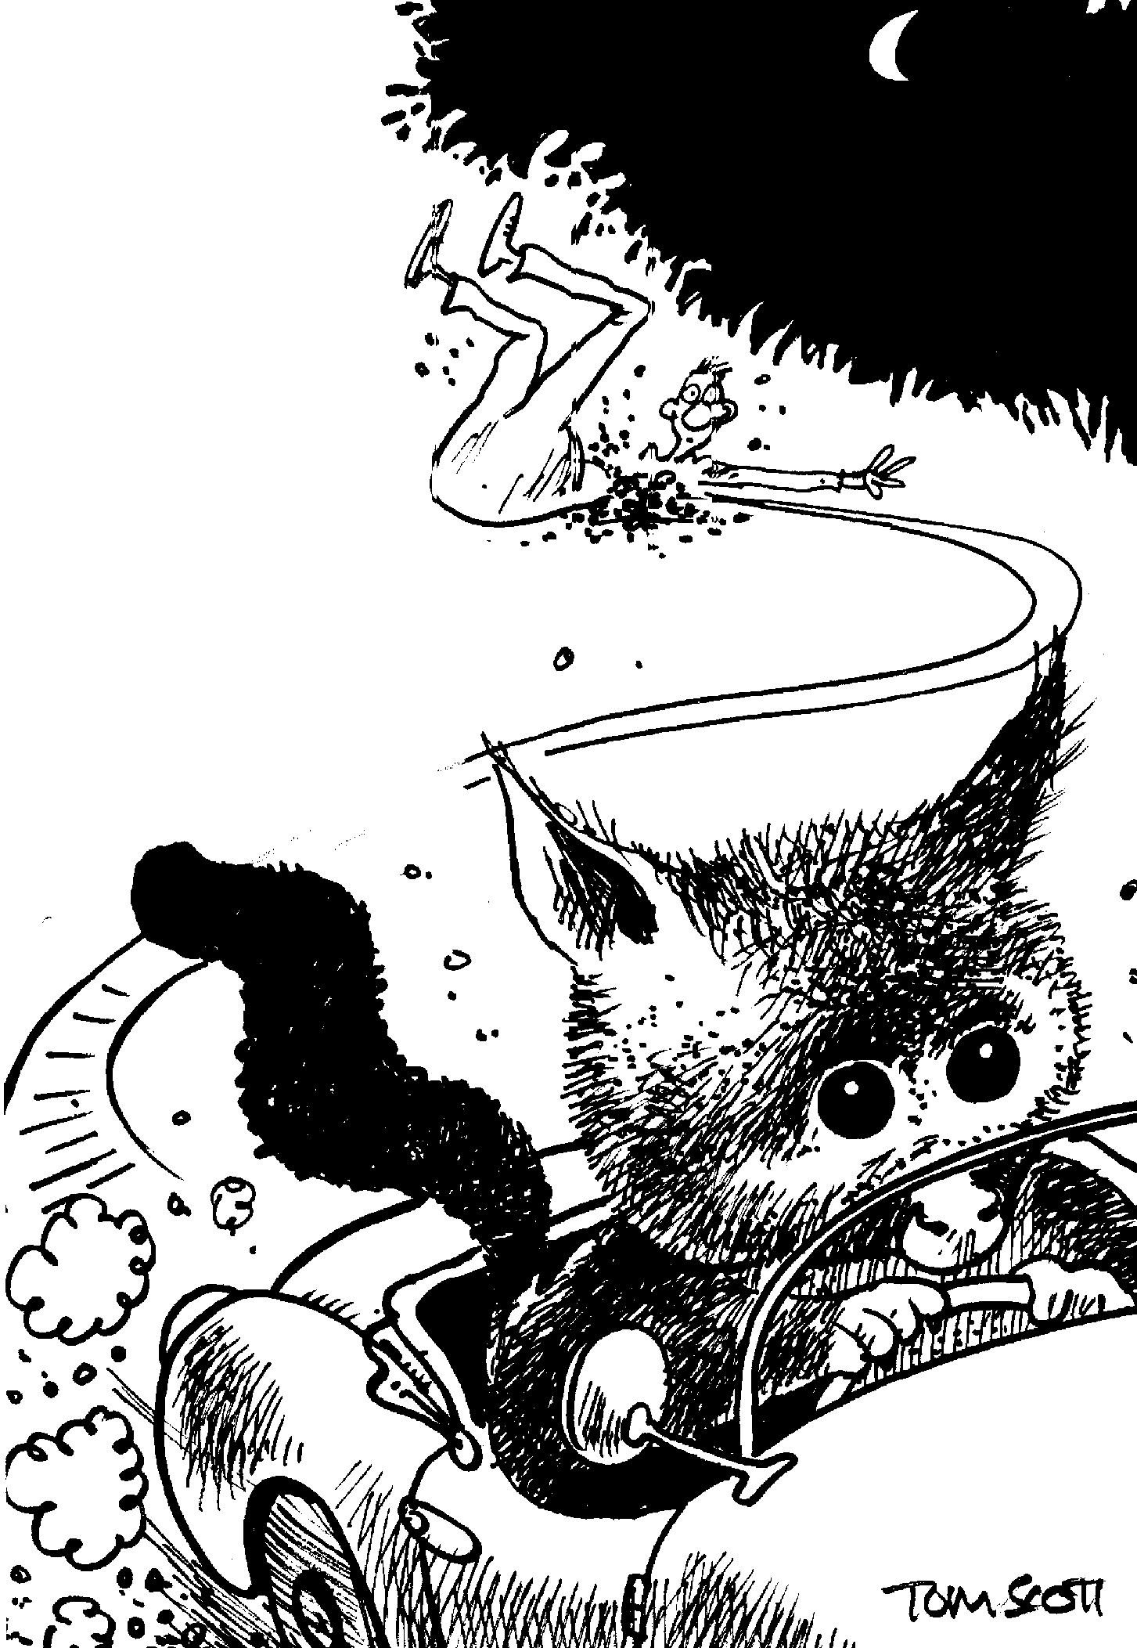
by Alan Bagnall,
School Journal Pt 1 Number 2 1992

Midnight traffic
Careering along
Beneath the stars
Just imagine
If possums drove cars
Would they follow
Our Codes?
Leaving squashed people
Along all the roads?

Copysheet: Traffic Hazards

Speeding car | Herd of cows on the road
Flooding on the road and footpath | Big truck with its load not tied properly
Tractor and mower cutting the grass beside the road | Milk tanker makes a lot of dust
Road works | Cyclist on the footpath
Footpath runs out | Big dog chases you
Rubbish truck coming down your street picking up rubbish | Lights out in the underground walkway
Car parked across the footpath | Parents parking on yellow lines outside the school
Traffic lights not working | Footpath dug up
Ice on the road

Learning experience 2: What to do

Learning intention
By the end of this learning experience students will be able to decide how to keep safe from traffic hazards.

Competencies developed in this learning experience
Road safety: managing hazards
Making decisions
Problem solving
Seeking help
Working co-operatively

Activities

1. Talking about hazards
Seat students in a circle. Give the first student the whole set of Managing Hazards cards from the copysheet, face down. Start playing music while the students pass the cards around the circle. When the music stops, the student holding the cards takes the top one, looks at the picture and reads out the caption (some students may need help with the reading) and says what they would do to manage this hazard.
Start the music again and repeat until all the cards have been used. Alternatively, the teacher could read out a card and the class could make suggestions. Choose cards that are relevant to the class.
Divide the students into small groups. Give them the following scenario:
You and a friend are walking to school. Just ahead you see a large dog standing on the footpath.
The group role-plays the situation to show what they would do (there will be roles for the two children and the dog, and possibly a helper). Ask some groups to show the class their role play. After each, ask:
Do you think they managed with this hazard well? Why, or why not?

2. Hazard walk
Take the class for a pre-planned walk outside the school. Before going out, revise safety practices. On the walk, encourage students to identify possible traffic hazards. As these are mentioned, ask the class to come up with ways of managing the hazard. Put these into practice. For example:
The class comes to a large area of road works that are blocking the footpath. They decide that the safest thing to do is to cross the road. They choose a safe place to cross and the whole class crosses in small groups, observing their kerb drill.

Copysheet: Managing Hazards
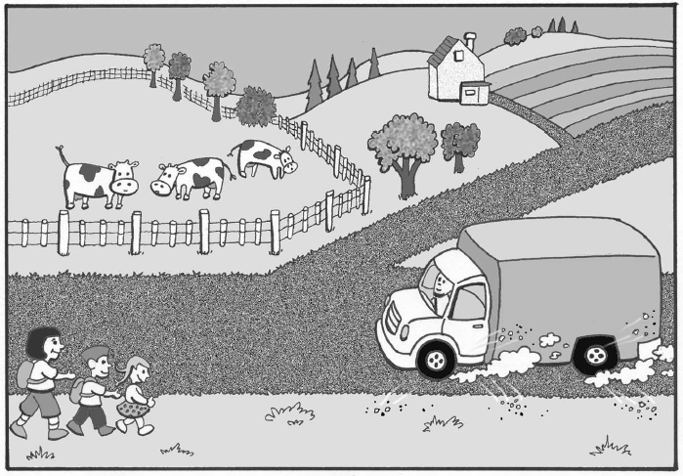
- You are walking along a gravel road with no footpath when a truck approaches going quite fast. What will you do to keep safe?
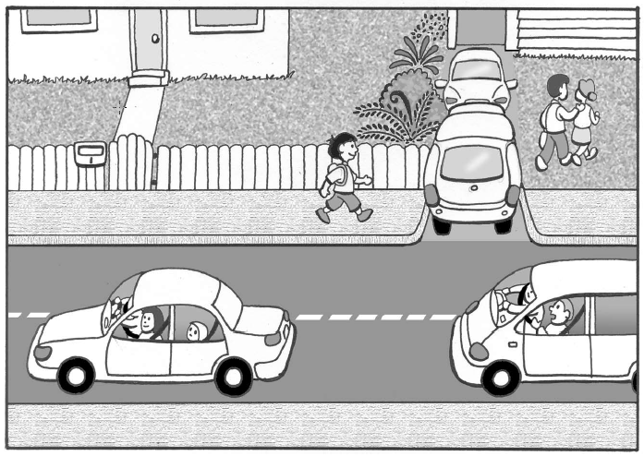
- You are walking on the footpath. There is a parked car on the footpath. What will you do to keep safe?
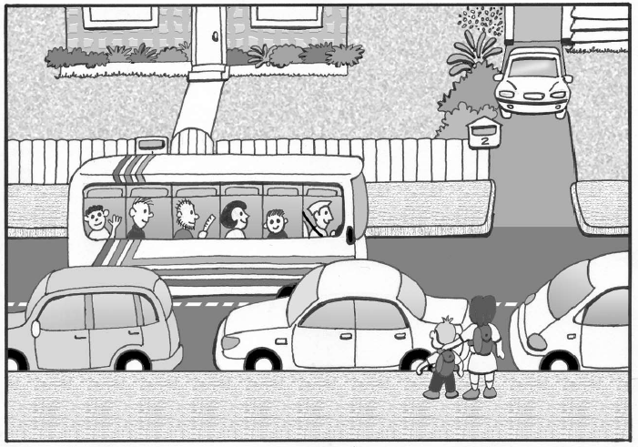
- You want to cross the road, but there are cars parked all along the kerb. There is no pedestrian crossing. What will you do to keep safe?
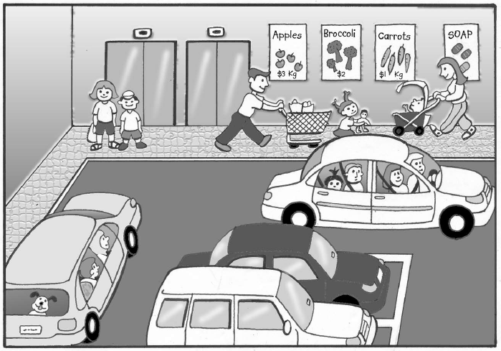
- You need to cross the supermarket car park, but there are a lot of cars moving about. What will you do to keep safe?
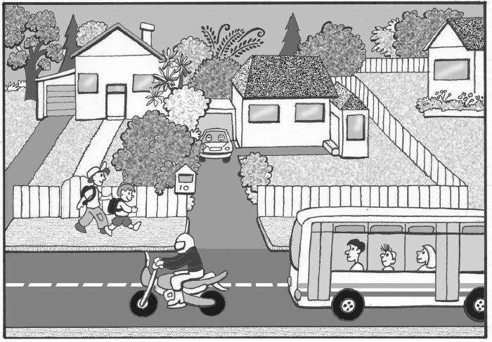
- You are walking on the footpath. You come to a driveway with lots of trees and bushes. It is hard to see if anything is coming. What will you do to keep safe?
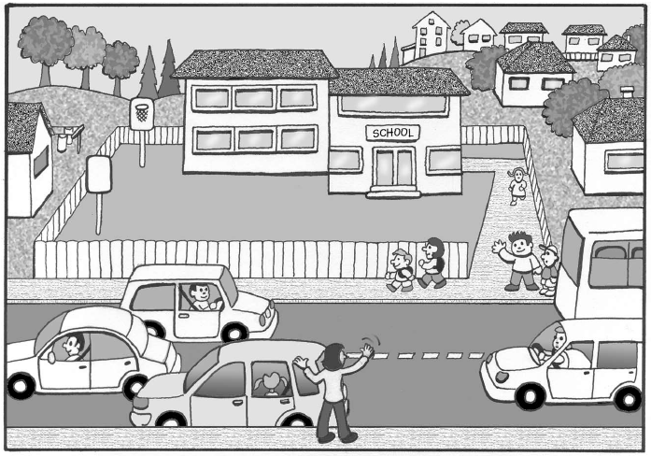
- You come out of school and see your parents’ car parked on the other side of the road. The road is very busy. What will you do to keep safe?
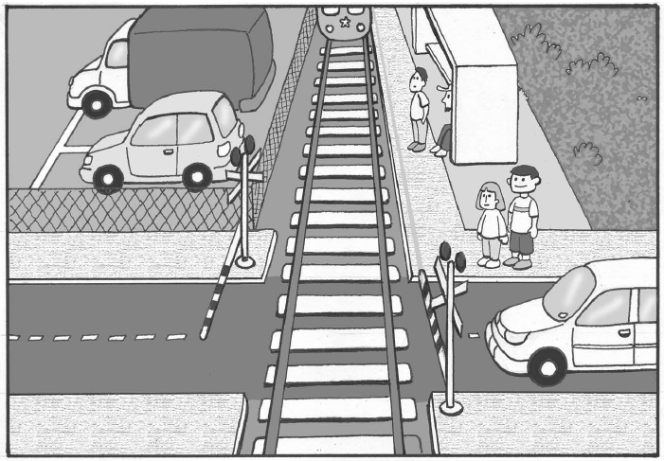
- You get to the railway line and the crossing lights are flashing. What will you do to keep safe?
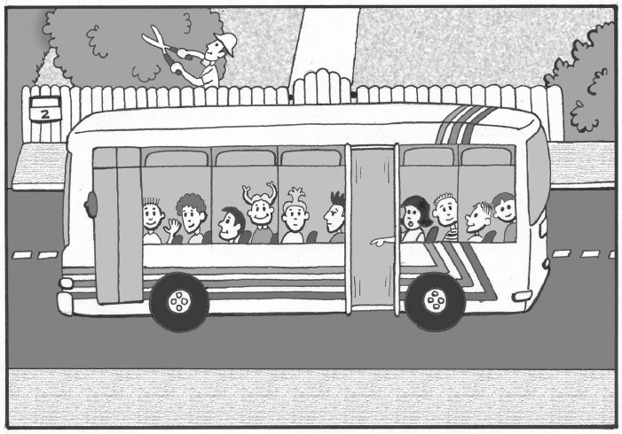
- You are on the school bus. You notice that the emergency door has come open. What will you do to keep safe?

Learning experience 3: Helpers

Learning intention
By the end of this learning experience students will be able to identify people in their community who can help them keep safe on the roads.

Competencies developed in this learning experience
Road safety:
- identifying helpers
- identifying when they might need help
- asking for help
Gathering information
Asking questions
Art work
Story writing

Activities

1. Who would I ask for help?
Seat students in a circle. Talk about how sometimes students need the help of other people to keep safe on or near the road, and to help them with hazards. Explain they are going to play the Who would I ask for help game.
Throw the Koosh ball to one student and give them a situation in which they might need to ask for help. The student says who they would ask for help and then throws the Koosh ball to another student. Give this student another situation, and so on. Keep the game going until all students have had a turn.
Possible situations could be:
You are at the school patrol and your shoelace has come undone.
You are on the bus and you can’t remember which stop is yours.
You get in the car, but you can’t get your safety belt done up.
Your father is watching you play ball when ball goes on the road.
You are in the car and you notice that the door is not shut properly.
2. Donut activity
Arrange students into two circles, an inner and outer one, facing each other (donut). Explain that for the first few rounds the person on the outside is the helper, and the person on the inside wants to ask for help. Get the circles to move round in opposite directions until you say “Stop”. Then give a situation in which the person on the inner circle asks the outside person for help. Use traffic-related situations. The circles then move on again, and you repeat the process. After about four stops, change the roles, so that the people on the outside ask for help.

Learning experience 4: Safe places to play

Learning intentions
By the end of this learning experience students will be able to:
- identify safe places to play
- know what to do if a ball or toy should go on the road.

Competencies developed in this learning experience
Road safety:
- drawing on own experiences
- identifying safe and unsafe places to play
Interpreting pictures
Making decisions

Activities

1. Who would I ask for help?
Ask the students what are their favourite things to play with outside. Record the answers in a chart like the one below. Go down the list and ask where they play these games, and record this information in the second column. Work with the students to decide if each of these places is a safe place to play or not. Put a ✓ beside safe places and an x beside unsafe places. In the last column, give the reason why the place is safe or unsafe.

Games/things we like to play with outside | Where we play this | Safe or unsafe? | Why this place is safe or unsafe
Throwing the ball | on the driveway | x | cars could come in or out  the ball could go on the road
Roller blades
Ask: Why is it never safe to play on or near the road?
Where are the safest places to play?

2. Ball on the road
Display Copysheet: Ball on the Road.
Ask: What is happening in this picture?
Can you see any hazards?
What do you think the child should do?
Why shouldn’t the child run straight after the ball?
Talk about safe things to do in this situation. These should cover:
Never chase after or try to stop the ball.
Wait and watch to see if the ball comes back to the gutter on your side of the road.
If there is an adult nearby, ask them to get the ball.
If the ball goes right over to the other side, use kerb drill before crossing to get it, walking straight across, looking each way for traffic.
Work with the class to complete the following statement. Place it on the wall, so that students can be reminded about it often.
Always play in a _ _ _ _ place, well away from _ _ _ _ _ _ _.. If the ball goes on the road, never
_ _ _ _ _ after it.

Copysheet: Ball on the Road
