Road Safe

Years 2–3 Focus area 3
This section of the Road Safe programme contains one of the following focus areas for students at years 2–3 (ages 6–7):
- Roads and traffic
- On the move
- By bus or by car
- Managing hazards
Note: Research suggests that an effective programme should include learning experiences from each of the focus areas.

Focus area 3: By bus or by car

Contents
Focus area 3: By bus or by car 2
Focusing question 2
Explanation 2
Notes for the teacher 2
Curriculum links 2
Resources 2
Success criteria 3
Learning experience 1: Car safety 4
Learning intention 4
Competencies developed in this learning experience 4
Activities 4
Learning intention 6
Competencies developed in this learning experience 6
Activities 6
Learning experience 3: Using the bus – practical 7
Learning intentions 7
Competencies developed in this learning experience 7
Activities 7

Focus area 3: By bus or by car

Focusing question
How can I cross the road safely?

Explanation
In this focus area students think about ways to keep safe when travelling in a car or a bus. They develop safety guidelines for these means of travel. In schools where there is a school bus, students meet the bus warden, and bus driver, and consider how they can help this person do his or her job.

Notes for the teacher
For more information on bus safety, see the page Safe Behaviour on Buses on the Ministry of Education’s website (www.minedu.govt.nz).
For Learning experience 3, if the school has a school bus, arrange for it to come a little earlier so that students can practise their safety skills while it is on the road. If the school does not have a regular school bus, you could make use of a bus that comes to the school to pick up students for a trip, or enlist the help of a bus company.

Curriculum links
Key Competencies: Managing self; Relating to others; Participating and contributing
Learning areas: Levels 1–2 Health and physical education: Strand A – Personal growth; Strand D – Community resources
Levels 1–2 English: Speaking, writing and presenting – Purposes and audiences, ideas; Listening, reading, and viewing – Purposes and audiences, ideas
Levels 1–2 Social Sciences: Roles and responsibilities

Resources
Large sheets of papers
Felt pens
Class chart: We keep safe in the car by ...
Car with a booster seat
Parent helpers
Wall chart showing a large outline of a bus
Chalks
Bus warden if appropriate
School bus or other bus
Bus driver if available

Success criteria
At the end of this focus area students will be able to:
- do up their safety belt or child restraint
- keep safe in and around car
- keep safe in and around a bus.

Learning experience 1: Car safety

Learning intention
By the end of this learning experience students will be able to list five rules for keeping safe when travelling in a car.
Note: The driver is responsible for making sure that all children wear a safety belt. Children must be properly restrained in an approved child restraint until their 7th birthday.
Children should always sit in the back seat. This is especially important in cars with airbags as these can cause serious injuries to children.

Competencies developed in this learning experience
Road safety:
- doing up a safety belt correctly
- behaving appropriately in a car
Working with others
Self-assessment
Design

Activities

1. Posters and class chart
Divide students into small groups. Give each group a large sheet of paper and felt pens.
Ask the group to work together to draw a car (it could be another passenger vehicle which has safety belts). In the car they put the driver and one student passenger. The student should be in the back seat. Remind them to draw in the safety belts. Put the posters up. Work with the students to complete the class chart We keep safe in and around the car by ...
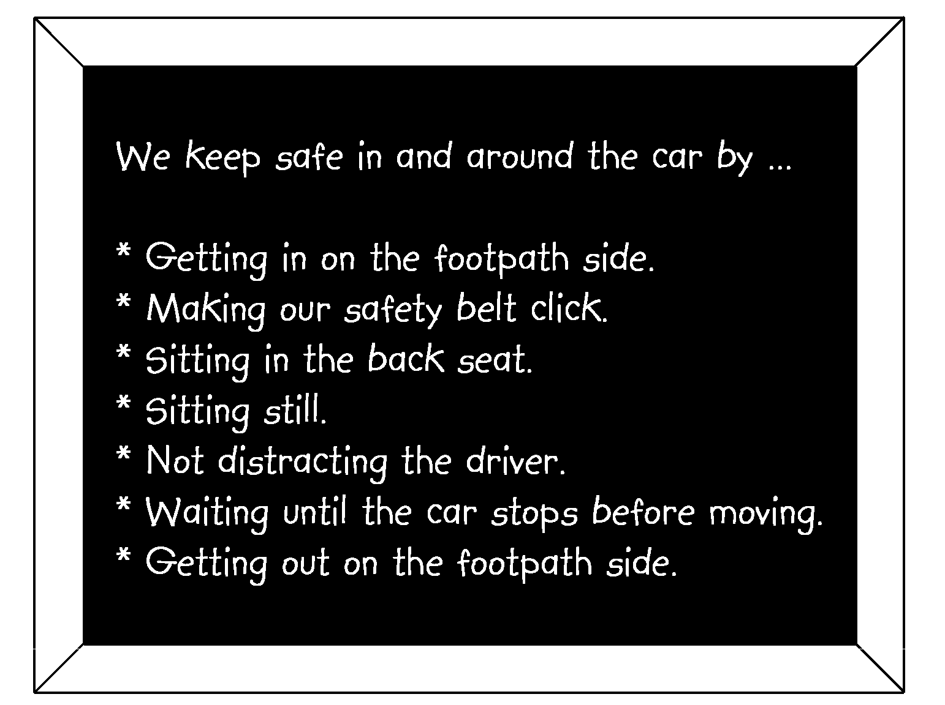
You may need to question students to get all the correct responses.
Ask: What could happen if we don’t wear our safety belt?
Why is it safer for a student to sit in the back seat?

2. Sitting in the car
Take students out to the car park, or bring the car close to the classroom if practical. If possible use adults as helpers. Give each student a turn at getting into the back seat of a car, sitting in the booster seat and doing up the safety belt. They should also practise sitting on the ordinary seat and doing up the safety belt.

Learning experience 2: Bus safety

Learning intention
By the end of this learning experience students will be able to list five rules for safety when travelling in a bus.

Competencies developed in this learning experience
Road safety: behaving appropriately in a bus
Simulation
Using imagination

Activities

1. Travelling by bus
Brainstorm with the class all the times when they might travel in a bus.
Record their answers in a poster of a bus as shown below.

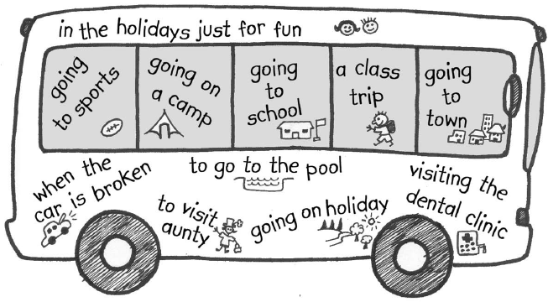
Ask: Why is it important to have rules for travelling in a bus?

2. Practice with pretend bus
Use the classroom furniture to make a ‘bus’. Mark the road and the footpath or grass verge with chalk. Revise the rules for safety in and around a bus with the class. These could be written as a class chart for revision. The rules should include:
- waiting for the bus well back from traffic
- waiting until the bus has stopped before approaching it
- getting on in an orderly way
- carrying your bag in front of you so it does not get caught in the door
- sitting properly
- not distracting the driver
- keeping noise down
- putting possessions out of other people’s way, on your lap or under the seat
- if you have to stand, putting your bag on the floor and hold on to a seat back or hand rail
- watching out for your stop
- waiting until the bus has stopped completely before getting out of your seat
- getting off in an orderly way
- waiting well back from the road until the bus has moved away and the road is clear in both directions before crossing using kerb drill.
Students take turns in small groups to demonstrate the rules in the pretend bus.

Learning experience 3: Using the bus – practical

Learning intentions
By the end of this learning experience students will be able to:
- demonstrate safe behaviour in and around a bus
- explain why it is important to follow the instructions of the bus warden and bus driver.

Competencies developed in this learning experience
Road safety:
- following safety instructions of the bus warden
- skills for being safe in and around the bus
Self-assessment
Drawing from own experience

Activities

1. When do we travel on the bus?
Invite the class to share experiences they have had of going on buses.
For some students this may be a daily occurrence, while for others it may occur only occasionally, or when they are away from home. Possible responses are:
Eli goes on the bus when he goes to stay with his Nana in Putaruru.
Siobhan comes to school on the bus every day.
Write students’ responses up on the board and revise safety skills in and around buses from the last session.

2. Practising getting on and off the bus
Take students out to the road side a short time before the bus is due to arrive, ensuring that they are waiting in a safe place. Once the bus comes, students can apply all the other skills as they get on and off the bus.
Ask: How well did we follow the rules?
What things should we work harder on next time?

3. Bus warden and bus driver
If the school has a bus warden, arrange for them to come to class to talk about their job. The bus driver could also be invited.
Ask: What can we do to help the bus warden and the driver?
Why is it important to follow the warden’s instructions?

