Road Safe

Years 2–3 Focus area 2
This section of the Road Safe programme contains one of the following focus areas for students at years 2–3 (ages 6–7):
- Roads and traffic
- On the move
- By bus or by car
- Managing hazards
Note: Research suggests that an effective programme should include learning experiences from each of the focus areas.

Focus area 2: On the move

Contents
Focus area 2: On the move 3
Focusing question 3
Explanation 3
Notes for the teacher 3
Curriculum links 4
Resources 4
Success criteria 4
Learning experience 1: Safe walking 6
Learning intentions 6
Competencies developed in this learning experience 6
Activities 6
Learning experience 2: Kerb drill 8
Learning intentions 8
Competencies developed in this learning experience 8
Activities 8
Copysheet: Stop, Look and Listen Song 11
Copysheet: Stop, Look and Listen 12
Information for the Teacher: Notes on Crossing Points 13
Pedestrian crossings 13
Crossing at intersections 13
Crossing at traffic lights 14
Crossing between parked cars 14
Key points 14
Learning experience 3: Going walking – practical 15
Learning intentions 15
Competencies developed in this learning experience 15
Activities 15
Copysheet: Sample Route for Going Walking – Urban 17
Copysheet: Sample Route for Going Walking – Rural 18
Learning experience 4: School patrols and traffic wardens 19
Learning intentions 19
Competencies developed in this learning experience 19
Activities 19

Focus area 2: On the move

Focusing question
How can I cross the road safely?

Explanation
In this focus area, students learn the skills to walk safely on or near the road and to cross the road correctly. They first learn these skills in the classroom and then practise them through a practical class excursion.

Notes for the teacher
Many children at this age are not ready to cross the road by themselves. Also, many parents insist that their young children cross the road only when holding an older person’s hand. The teacher and School Community Officer should therefore organise this activity in a way that recognises sound home rules. Some families, of course, don’t have clear road safety rules, and so it is especially important that parents are informed about what safety rules are being taught.
A Risk Management Plan should be completed before taking students out of the school grounds.
For Learning experience 2, use either the rural or urban version of the street plan (available from your School Community Officer), according to the school’s location. However, it is good experience for children to experience traffic environments other than their own. This could be a reason for working with both plans.
Parents/caregivers/helpers must be briefed before the activity so that they are very familiar with the correct procedures.
These skills should be practised at intervals during the year.
The Information for the Teacher contains notes on crossing at intersections, pedestrian crossings, at traffic lights and between parked cars.
For the walk in Learning experience 3, choose a convenient safe route, preferably a circuit that will take about 10 to 15 minutes to walk. Your School Community Officer will help you identify the most appropriate places to use. Check the sample route on the rural or urban Copysheet: Sample Course, whichever is appropriate.
The route should include as many as possible of the following:
- footpath
- driveways
- road with no footpath
- pedestrian crossing
- a car park (this could be at school )
- an area where students can’t see the road ahead when they are walking.
Make sure you walk the route beforehand. Complete a Risk Management Plan before you take students outside the school grounds. Find enough adult helpers to accompany the group. Brief them carefully about correct procedures.
The School Community Officer should be present for Learning experience 4.
School Traffic Safety Team (STST) is the collective term for school patrols, traffic wardens and bus wardens. This term is used in school and School Community Officer manuals. For students, however, it is best to use the individual names school patrol, traffic warden and bus warden. School patrols also operate at school crossing points (kea crossings), which are not pedestrian crossings and are a normal part of the road outside times when the school patrol is operating.
This activity need only be done if the school has a school patrol or traffic warden system, or if students use these teams from another school. Parents could be invited for this activity so that they know the correct operation of STSTs.

Curriculum links
Key Competencies: Managing self; Relating to others; Participating and contributing
Learning areas: Levels 1–2 Health and physical education: Strand C – Relationships; Strand D – Community resources
Levels 1–2 English: Speaking, writing and presenting – Purposes and audiences, ideas; Listening, reading, and viewing – Purposes and audiences, ideas
Levels 1–2 Social Sciences: Roles and responsibilities; Significant places

Resources
Photos 3, 4, 11, and 12 from the Stepping Out Photopack (available from your School Community Officer)
Class chart: Going Walking
Copysheet: Stop, Look and Listen Song (the song Stop, Look and Listen is on the CD available from your School Community Officer)
Street plan, rural and urban (available from your School Community Officer)
Information for the teacher: Notes on Crossing Points
Copysheet: Sample Course for Going Walking (Urban)
Copysheet: Sample Course for Going Walking (Rural)
Large plan of the route to be taken
Digital camera
School patrol or traffic wardens
School Traffic Safety Team equipment
STST Manual for teacher reference
Story: Cross Now! by Roly Hermans, School Journal Part 3 Number 2 2002. (This could be suitable for an advanced class)

Success criteria
At the end of this focus area students will be able to:
- use kerb drill
- walk on the house/shop side of the footpath
- use correct procedures for walking on country roads
- use correct procedures when unable to see the road ahead
- negotiate car parks safely.

Learning experience 1: Safe walking

Learning intentions
By the end of this learning experience students will be able to:
- explain where to walk on the footpath
- explain correct procedures for walking where there is no footpath
- indicate the best position to see the road ahead
- explain how to negotiate car parks.
Note: Children should always walk on the side of the footpath furthest from traffic. City children can be taught to walk on the house or shop side of the footpath. In a more rural setting, teach them to walk on the side away from the road.

Competencies developed in this learning experience
Road safety:
- walking on the house/shop side of the footpath
- walking on the grass verge well away from traffic when there is no footpath
- putting themselves in the best position when they can’t see the road ahead
- negotiating car parks safely
Interpreting photographs
Listening
Observation

Activities

1. Parts of the road in town
Work with Photo 3, Parts of the Road in Town.
Ask students to turn to the person next to them and talk about why the child is walking on the footpath and why they are walking there.
Work with students to complete the following sentence on the class chart:
When there is a footpath we should walk …
(The house/side of the footpath well away from traffic; on the side furthest from the road)

2. Parts of the road in the country
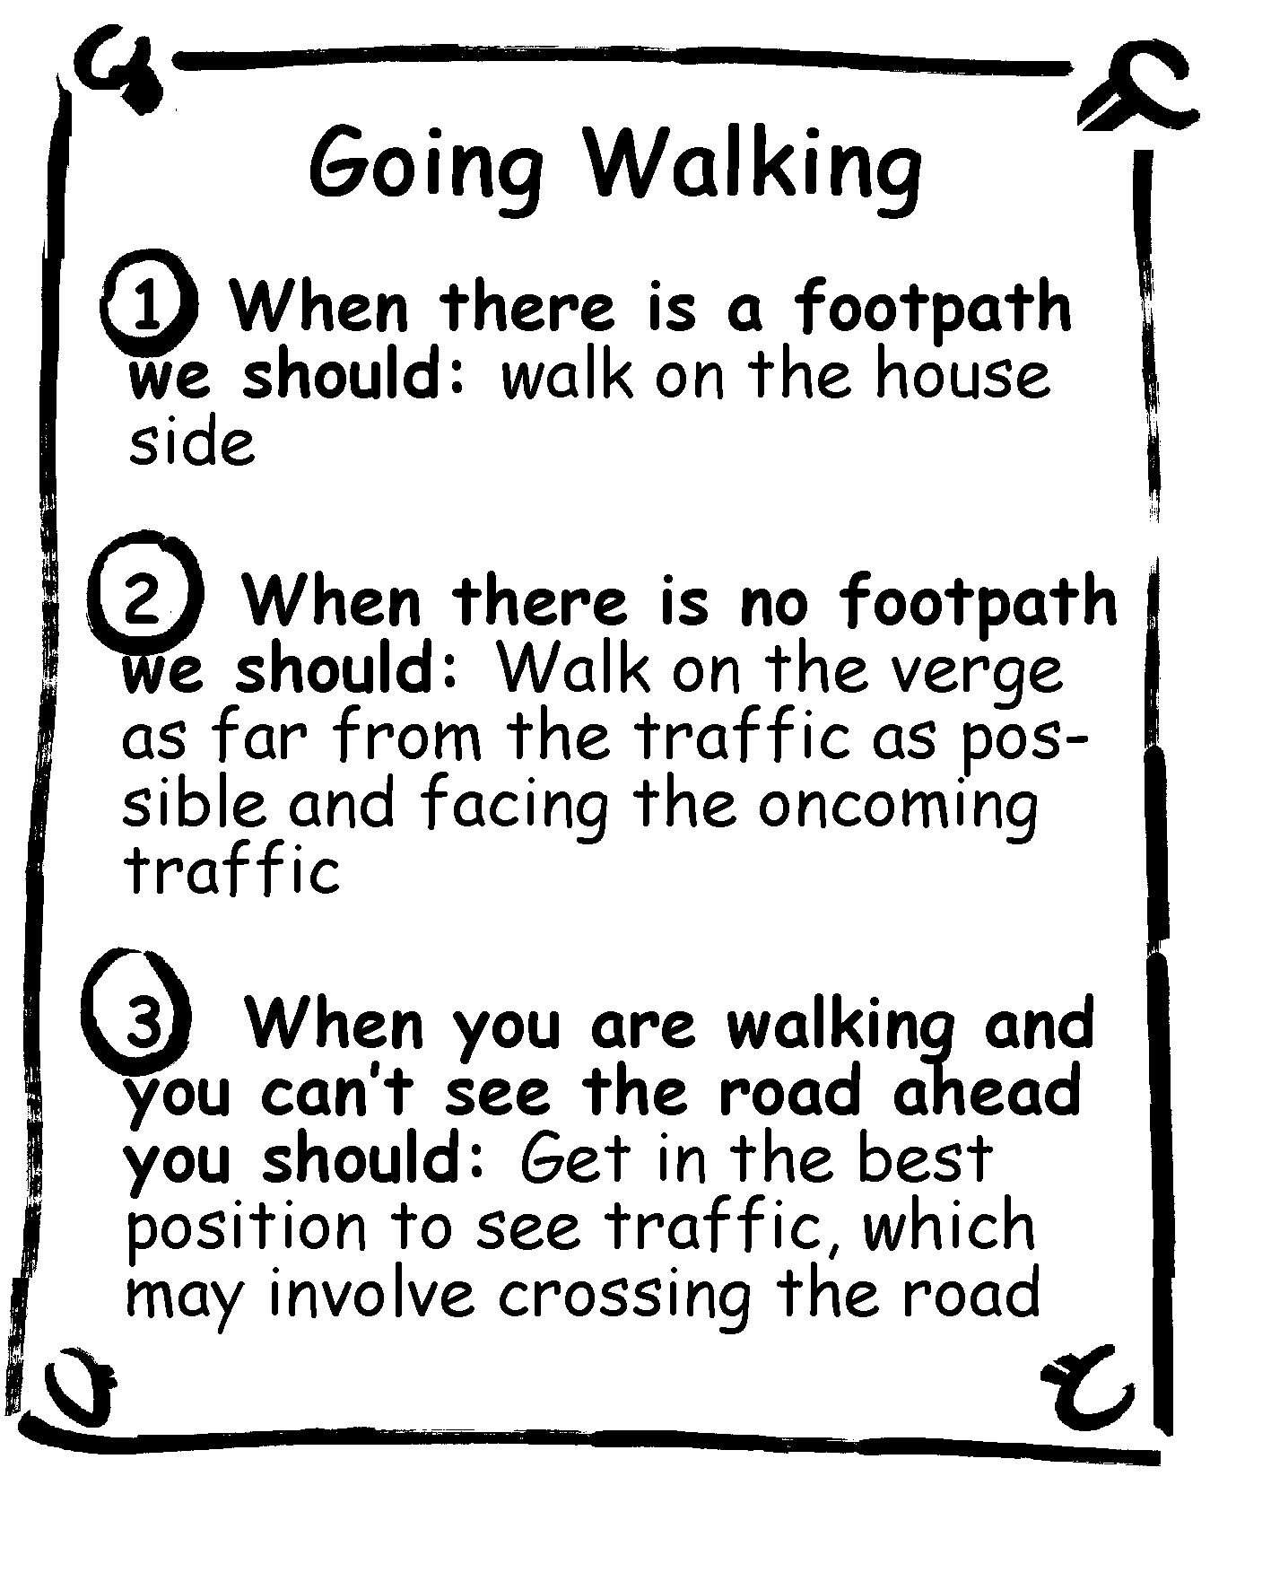
Work with Photo 4, Parts of the Road in the Country. Ask students to think of three questions they would like to ask the children to find out why they are walking where they are. Ask three students to take the role of children in the photo. The rest of the class asks them their questions.
Possible questions could include:
Where are you walking to?
Where have you come from?
Why are you walking in single file?
Why are you walking on the grass verge?
Why are you on that side of the road?
Work with the students to complete the second sentence on the chart:
When there is no footpath we should walk ...
(On the grass verge as far as possible away from the road; facing the oncoming traffic; in single file with the tallest at the back, so that everyone can see)
The completed chart would look like the one on the right.

3. Country walking
Work with Photo 11, Country Walking
Ask: Why are the children walking on this side of the road?
Are they walking in a safe place? Give a reason for your answer.
As they get closer to the bend, will they be able to see the road ahead? Why, or why not?
What do you think they should do about this? (Use kerb drill to cross to the other side of the road; cross back again once they are well round the corner)
Work with the class to complete the third sentence on the class chart:
When you are walking and you can’t see the road ahead, you should ...

4. Crossing the car park
Work with Photo 12, Crossing the Car Park.
Ask: Are car parks safe or unsafe place? Give a reason for your answer.
Where would be the safest place to walk in a car park? (On the footpath if there is one)
If there isn’t a footpath, what should you do?
What should you look for? (Drivers in vehicles; exhaust fumes; reversing lights; vehicles coming in to the car park; reversing vehicles)
What should you listen for? (Slamming doors; reversing beepers; cars starting up; cars driving)

Learning experience 2: Kerb drill

Learning intentions
By the end of this learning experience students will be able to:
- walk safely on the footpath, verge or road edge
- demonstrate safe procedures when crossing the road or driveway.

Competencies developed in this learning experience
Road safety:
- selecting crossing points
- stopping at a safe place
- looking all ways traffic might come from
- listening for traffic
- deciding when it is safe to cross
- walking quickly across the road, looking each way for traffic
Working with others
Interpreting plans

Activities

1. Stop, look and listen
Listen to the song Stop, Look and Listen.
Put up a stick figure on a chart. Question students to build up the Stop, Look and Listen rule. Explain that children have to use their head to make a decision about when it is safe to cross (see following diagram).
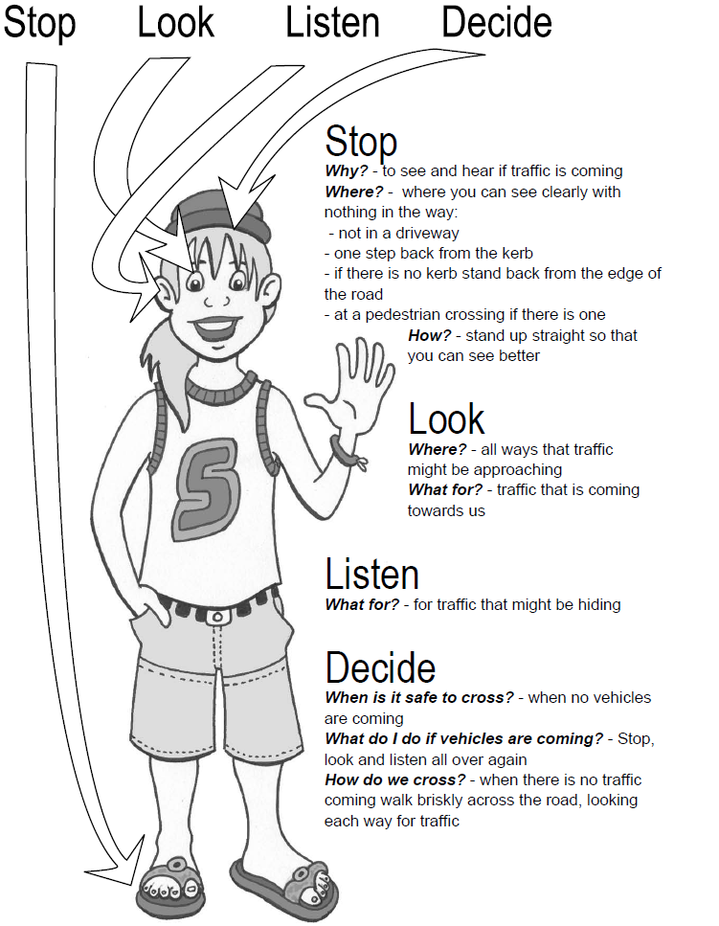

STOP
Why? To see and hear if traffic is coming.
Where? Where you can see clearly, with nothing in the way:
- not in a driveway
- one step back from the kerb
- if there is no kerb stand back from the edge of the road
- at a pedestrian crossing if there is one.
How? Stand up straight so that you can see better.

LOOK
Where? All ways that traffic might be approaching.
What for? Traffic that is coming towards us.

LISTEN
What for? For traffic that might be hiding.

DECIDE
When is it safe to cross? When no vehicles are coming.
What do I do if vehicles are coming? Stop, look and listen all over again.
How do we cross? When there is no traffic coming, walk briskly across the road, looking each way for traffic.
Give each student Copysheet: Stop, Look and Listen. You may like to enlarge this to A3. Ask them to answer the questions on it. The worksheet should be taken home and shared with an adult.
Ask: When do you use the Stop, Look and Listen kerb drill? (when crossing the road, at driveways or alleyways that cross the footpath ...)

2. Finding the best place to cross
Draw a line in chalk across the classroom floor or out in the playground, to represent a kerb. Give students the opportunity to practise the kerb drill before going out to the road later in the activity.
Gather students around the Street Plan. Alternatively this activity could be done in groups. Ask some general questions to help students start interpreting the plan. Examples might be:
What street is the school on?
What is the name of the biggest road?
Find two sets of traffic lights.
Students now practise deciding on the best place to cross various streets or roads on the plan, which are named by the teacher. An example might be:
You want to cross High Street to get to the dairy. Where is the best place to cross?
Choose a variety of different types of road with a variety of crossing places to give students a wide experience. These should include:
- Town: straight road, street with lots of driveways and trees, pedestrian crossing, full intersection, traffic lights, T intersection, school patrol, area where there are a lot of parked cars ...
- Rural: windy road with lots of bends, main street, the railway line ...
After each, ask:
Why is this a safe place to cross?
Talk about where to stand if you have to move between parked cars to see if the road is clear (stand at the rear of the car by its rear light; check first that there is not a driver in either car who might be going to drive away; check for backing lights).
Ask: Where are safe places to cross outside our school?
Why are they safe?

2. Practising kerb drill
Students must be given opportunities to practise their kerb drill and decision making about where to cross the road. To assist with this they should be divided into small groups, each with an adult. Talk about safe practices before going out of the classroom.
Each group should practise skills that are relevant in the immediate area around the school. One or two groups at a time could leave the school grounds under the supervision of the School Community Officer and adult helpers, while the rest of the class can do other activities within the classroom.
Skills to practise are:
- kerb drill
- crossing a straight road
- crossing at full and T intersections, and pedestrian crossing
- negotiating where to stand if there are parked cars
- using traffic lights.

Copysheet: Stop, Look and Listen Song

Stop, Look and Listen before you cross the street
Use your eyes and use your ears before you use your feet

Stop, Look and Listen before you cross the street
Use your eyes and use your ears before you use your feet

I’m not in a driveway
I’m not on a road
I’ll stand back one step
Just like I was told

Look all around –
Before I decide
I’ll check for traffic
So I won’t be surprised

Stop, Look and Listen before you cross the street
Use your eyes and use your ears before you use your feet

Make sure that it’s safe
Before I cross the road
Use the best skills I’ve got
To decide when to go!

Stand tall and straight
No time to dream
Walk safely and smartly
So I can be seen.

Stop, Look and Listen before you cross the street
Use your eyes and use your ears before you use your feet (x2)

Copysheet: Stop, Look and Listen
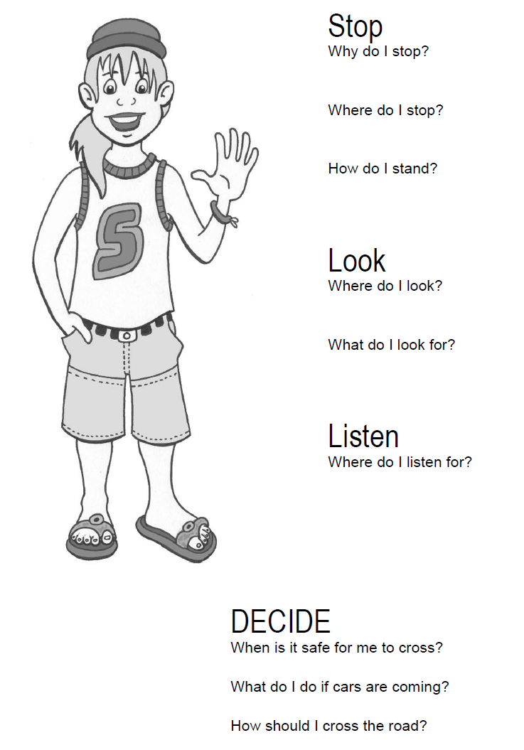

Information for the Teacher: Notes on Crossing Points
Adapted from Safe Walking

Pedestrian crossings
Contrary to popular belief, pedestrian crossings are not always safe places to cross the road. Potential dangers exist here that do not occur elsewhere. Traffic will not always stop, will not always remain stopped long enough for children of this age to make a decision, and may overtake vehicles already stopped, especially where there are multiple lanes.

Key points
- Stop one step back from kerb.
- Search for traffic.
Look in both directions wherever traffic is coming from, listening at the same time. Make sure that both ways are safe, even if traffic in one direction stops.
- Walk straight across.
Walk briskly across, keeping to the crossing.
- Check for traffic while crossing.
Especially around the side of any vehicle that has stopped for you, in case of overtaking vehicles.

Crossing at intersections
Children have difficulty in making decisions when the intersecting roads have different traffic volumes and the road being crossed is the quieter of the two – for example, should the child wait until both roads are clear, or can they cross the quieter road while watching for turning traffic? Students may need to learn the various signs that indicate traffic is about to turn, such as slowing, moving to centre, indicating.

Key points
- Select a crossing point.
Always choose the point with the best possible visibility for all traffic, especially from behind.
- Stop one step back from kerb, to prevent loss of balance.
- Search for traffic.
Look in all directions, including from behind, listening at the same time.
- Walk briskly straight across, taking the shortest route.
- Check for traffic while crossing.
Keep your head up, take a good look in all directions and be aware of traffic from behind.
Listening is also important here because of traffic approaching from behind.

Crossing at traffic lights
Traffic lights are safer places to cross, but care still needs to be taken.

Key points
- Select a crossing point.
If there are traffic lights nearby, use them, even if it means walking a little further.
- Stop by the traffic light crossing buttons.
Keep well back from traffic.
- Cross with the lights.
If Green Man/Walk/buzzer is operating, cross at once.
If Red Man/Don’t Walk sign is operating, press the traffic light crossing button and wait for the Green Man/Walk/buzzer sign.
- Search for traffic.
Look in all directions for traffic.
- Walk briskly straight across.
If the Red Man/Don’t Walk sign starts to flash as you are crossing, continue across.

Crossing between parked cars
This is a complex skill because of the large number of steps a child must remember. Crossing between parked cars should not be encouraged unless there is no other option.

Key points
- Select a crossing point.
When there is no safer option, select a gap between two vehicles in which there are no drivers. Choose smaller vehicles to cross between so that the child can see and be seen more easily. Make sure that:
- the space is too small for another car to enter
- the child is not standing in a driveway.
- Walk to the outside corner of vehicle and stop.
Stop at a point where they can see and be seen, in line with the outside edge of the parked cars.
- Search for traffic.
Look in all directions and listen.
- Walk briskly straight across, taking the shortest route.
- Check for traffic while crossing.
Keep your head up, take a good look in all directions and be aware of traffic from behind.

Learning experience 3: Going walking – practical

Learning intentions
By the end of this learning experience students will be able to demonstrate:
- walking on the house/shop side of the footpath
- using correct procedures for walking where there is no footpath
- choosing the best position to see the road ahead
- negotiating car-parks safely.

Competencies developed in this learning experience
Road safety:
- using kerb drill
- using pedestrian crossings
- walking on the house/shop side of the footpath, furthest from the road.
- walking on the grass verge well away from traffic when there is no footpath
- putting selves in the best position when they can’t see the road ahead
- negotiating car-parks safely
Listening
Observation
Taking photographs

Activities

1. Preparation
Explain to students that they are going out walking. Show them the route for the walk and go over it carefully. Refer them back to the class chart Going Walking that they prepared in Learning experience 2. Refresh their memories about other road safety skills they will be using.
Arrange to have a digital camera to take photos during the walk.

2. After the walk
Ask: Did you enjoy the walk? Why, or why not?
Did you feel safe on the walk? Why, or why not?
Did you use all your road safety skills?
The class could do some of the following:
- write a story about their outing
- draw a picture about the outing to be made into a frieze
- make a shared book
- draw a map to show where they have been and the things they have seen.
Make a display of digital photos taken during the walk, and use this as revision at a later stage.

Copysheet: Sample Route for Going Walking – Urban
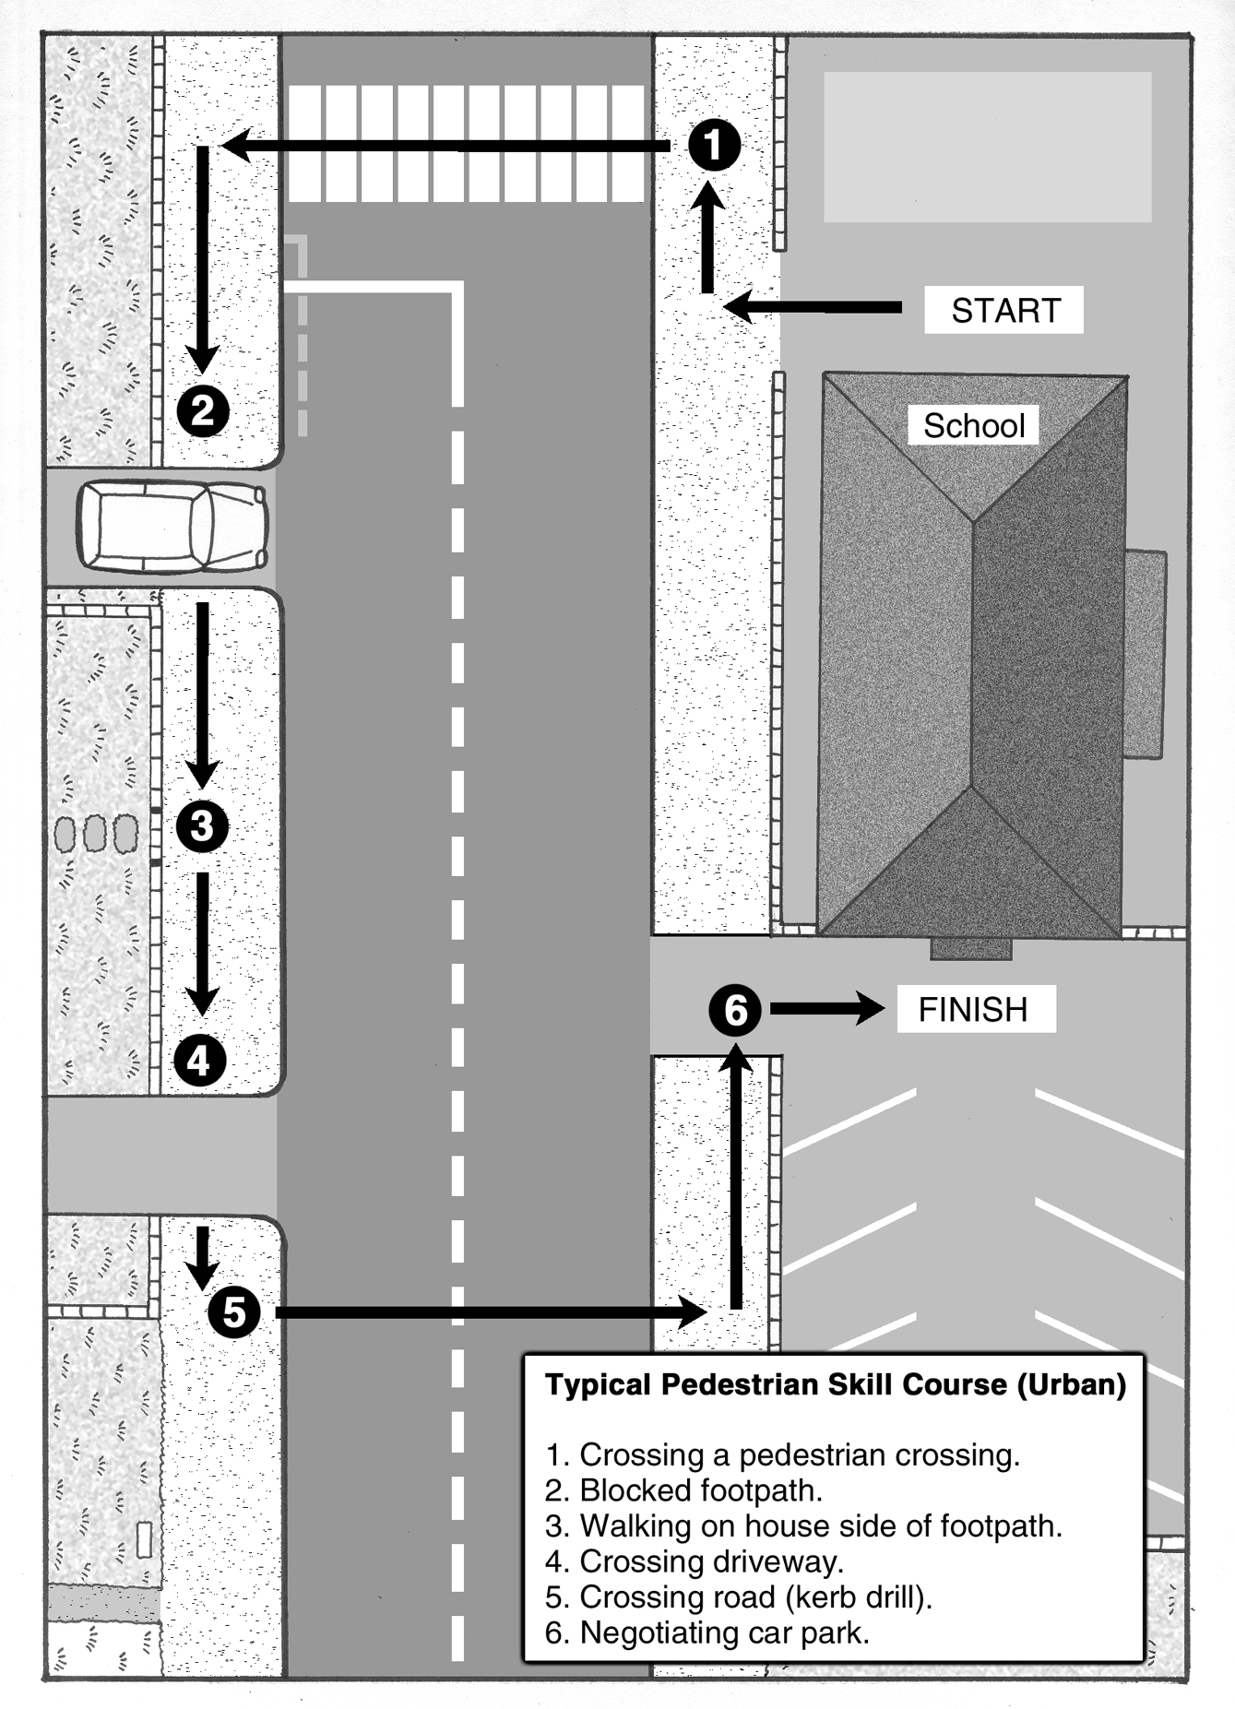

Copysheet: Sample Route for Going Walking – Rural
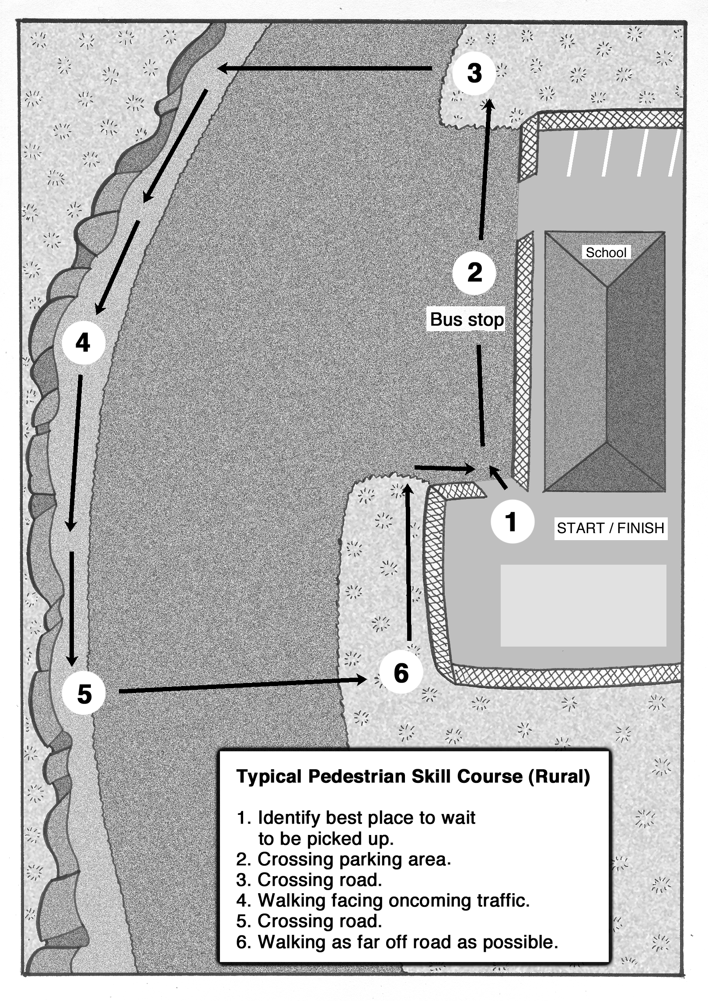

Learning experience 4: School patrols and traffic wardens

Learning intentions
By the end of this learning experience students will be able to:
- explain the importance of the school patrols and traffic wardens and why they should follow their instructions
- use correct procedures when using a school patrol or traffic warden crossing.

Competencies developed in this learning experience
Road safety
- crossing with the school patrol
- crossing with the traffic warden
Working with others
Design work
Interpreting stories

Activities

1. Class talk
Invite members of the school patrol or traffic wardens to class. They explain their role and bring the equipment they use to class.
Ask: How can we help the school patrols?
How can we help the traffic wardens?
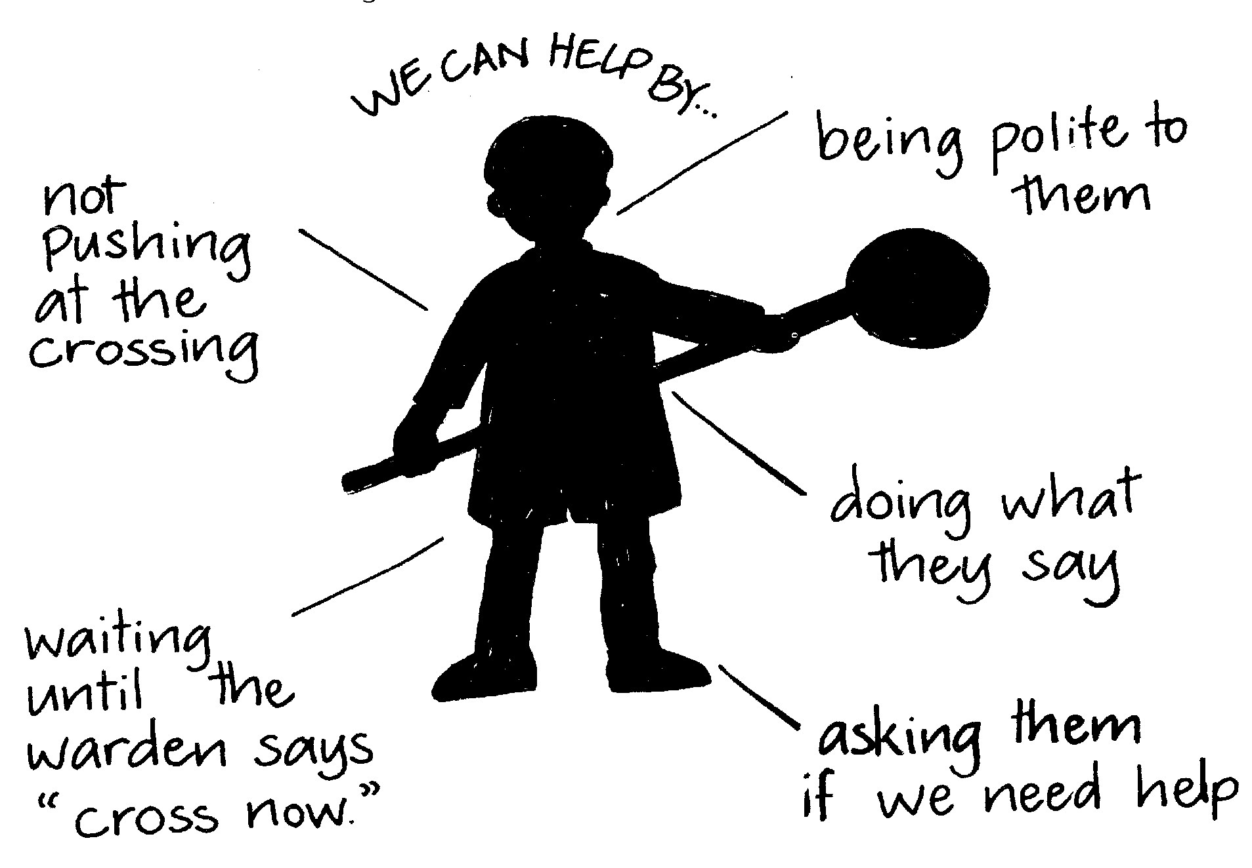
Build class ideas into a diagram like the one below.

2. Crossing with school patrol or traffic wardens
Do one or both of the following that are appropriate for the class.

School Patrol
In the classroom, go over the correct procedure for crossing at a school patrol. Take students out and in small groups have them cross with the patrol.

Traffic wardens
In the classroom, go over the correct procedure for crossing with the traffic wardens. Take students out and in small groups have them cross with the traffic wardens.
Each student makes themselves a certificate or a badge like the one below, to show that they work well with the school patrol or traffic wardens.
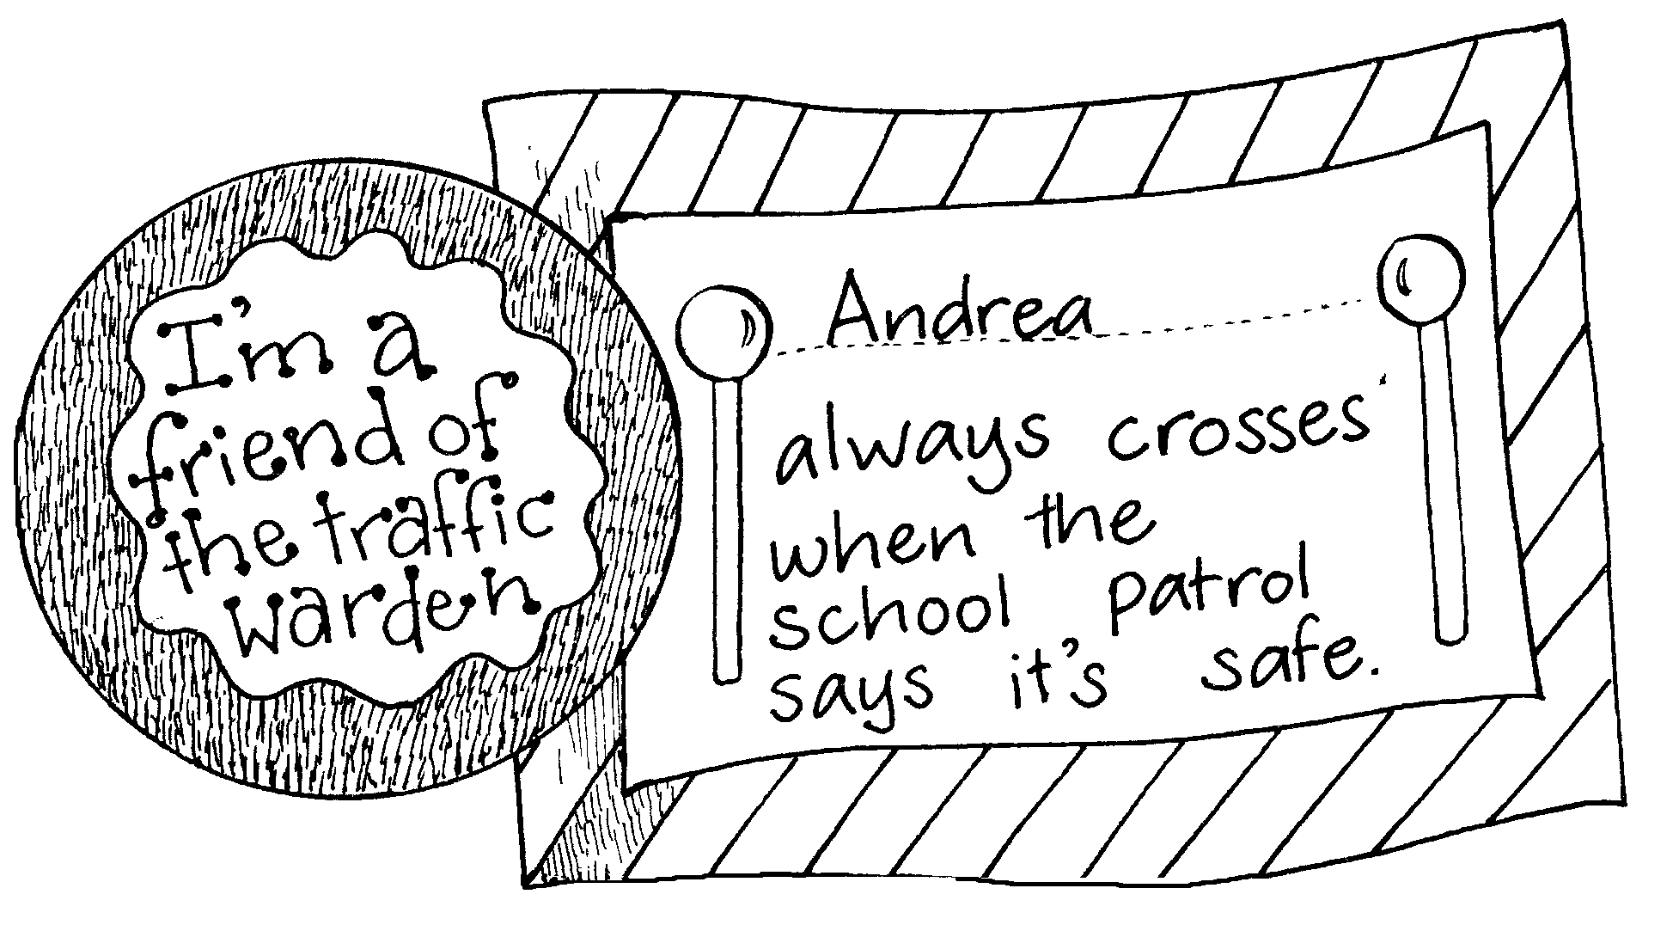

3. Story
The story Cross Now! from School Journal Part 3 Number 2 2002 could be read to more advanced classes.

