Road Safe

Years 2–3 Focus area 1
This section of the Road Safe programme contains one of the following focus areas for students at years 2–3 (ages 6–7):
- Roads and traffic
- On the move
- By bus or by car
- Managing hazards
Note: Research suggests that an effective programme should include learning experiences from each of the focus areas.

Focus area 1: Roads and traffic

Contents
Focus area 1: Roads and traffic 3
Focusing question 3
Explanation 3
Notes for the teacher 3
Curriculum links 3
Resources 3
Success criteria 4
Learning experience 1: Starter 5
Learning intentions 5
Competencies developed in this learning experience 5
Activities 5
Copysheet: Letter home 7
Learning experience 2: What is traffic? 8
Learning intentions 8
Competencies developed in this learning experience 8
Activities 8
Copysheet: Traffic 10
Learning experience 3: On and around the road 11
Learning intentions 11
Competencies developed in this learning experience 11
Activities 11
Copysheet: Road Signs 14
Copysheet: Road Signs –Answers 15
Copysheet: Roads and Traffic near Home 16

Focus area 1: Roads and traffic

Focusing question
What safety rules do we need to develop to keep safe on or near the road?

Explanation
In this focus area, the class is surveyed to find out how they come to school. They consider why it is important to develop safety rules to keep safe on the way to and from school. They think about different ways of getting to school and the benefits of these. They find out about different types of traffic and the appropriate place for each on the road. They learn to identify parts of the road and where they are safest. They identify road signs and markings. Students focus first on roads around their school and then on roads around their home.
Note: Police believe that children younger than 10 years of age should not be riding cycles unaccompanied on the road. The school should make a policy to endorse this. This would mean that the school makes it quite clear to parents that students under 10 do not bring cycles to school. The school may need to work with parents to find acceptable alternative ways of getting to school for these students. This is why cycling has not been dealt with in this programme.

Notes for the teacher
For Learning experience 3 a road mural should be made on a large chart. It could show an actual road around the school, or use a made-up road like the one shown in the learning experience. The mural will be used a number of times during the programme as students add information to it and so should be quite sturdy.

Curriculum links
Key Competencies: Managing self; Relating to others; Participating and contributing
Learning areas: Levels 1–2 Health and physical education: Strand A – Personal growth; Strand C – Relationships; Strand D – Community resources; Rights, responsibilities and laws
Levels 1–2 English: Speaking, writing and presenting – Purposes and audiences, ideas; Listening, reading, and viewing – Purposes and audiences, ideas
Levels 1–2 Social Sciences: Significant places
Levels 1–2 The Arts: Visual arts – Practical knowledge

Resources
Copysheet: Letter Home
Story: Don’t Miss the Bus! School Journal Pt 1 No. 1 2006
Helping Hands: A Guide for Parents and Caregivers (available from School Community Officer)
Copysheet: Traffic
Templates: Types of Traffic (available from School Community Officer)
Art materials
Magazines
Police car parked in the school car park
Large road mural
Copysheet: Signs
Copysheet: Signs – Answers
Copysheet: Roads and Traffic Near Home
Photos 3, 4 and 5 from the Stepping Out Photopack (available from School Community Officer)
Art materials
Digital camera

Success criteria
At the end of this focus area students will be able to:
- name and identify different types of traffic
- identify different parts of the road
- recognise road signs and markings.

Learning experience 1: Starter

Learning intentions
By the end of this learning experience students will be able to explain:
- why it is important to keep safe on or near the road
- that walking can be a good option
- why they are doing this road safety programme.

Competencies developed in this learning experience
Road safety: identifying means of transport
Surveying
Graphing

Activities

1. Survey
Survey students to find out how they get to school. Answers could include walking, on the school bus, by public transport, train, boat, horse, car … The students, or teacher, could graph the results.
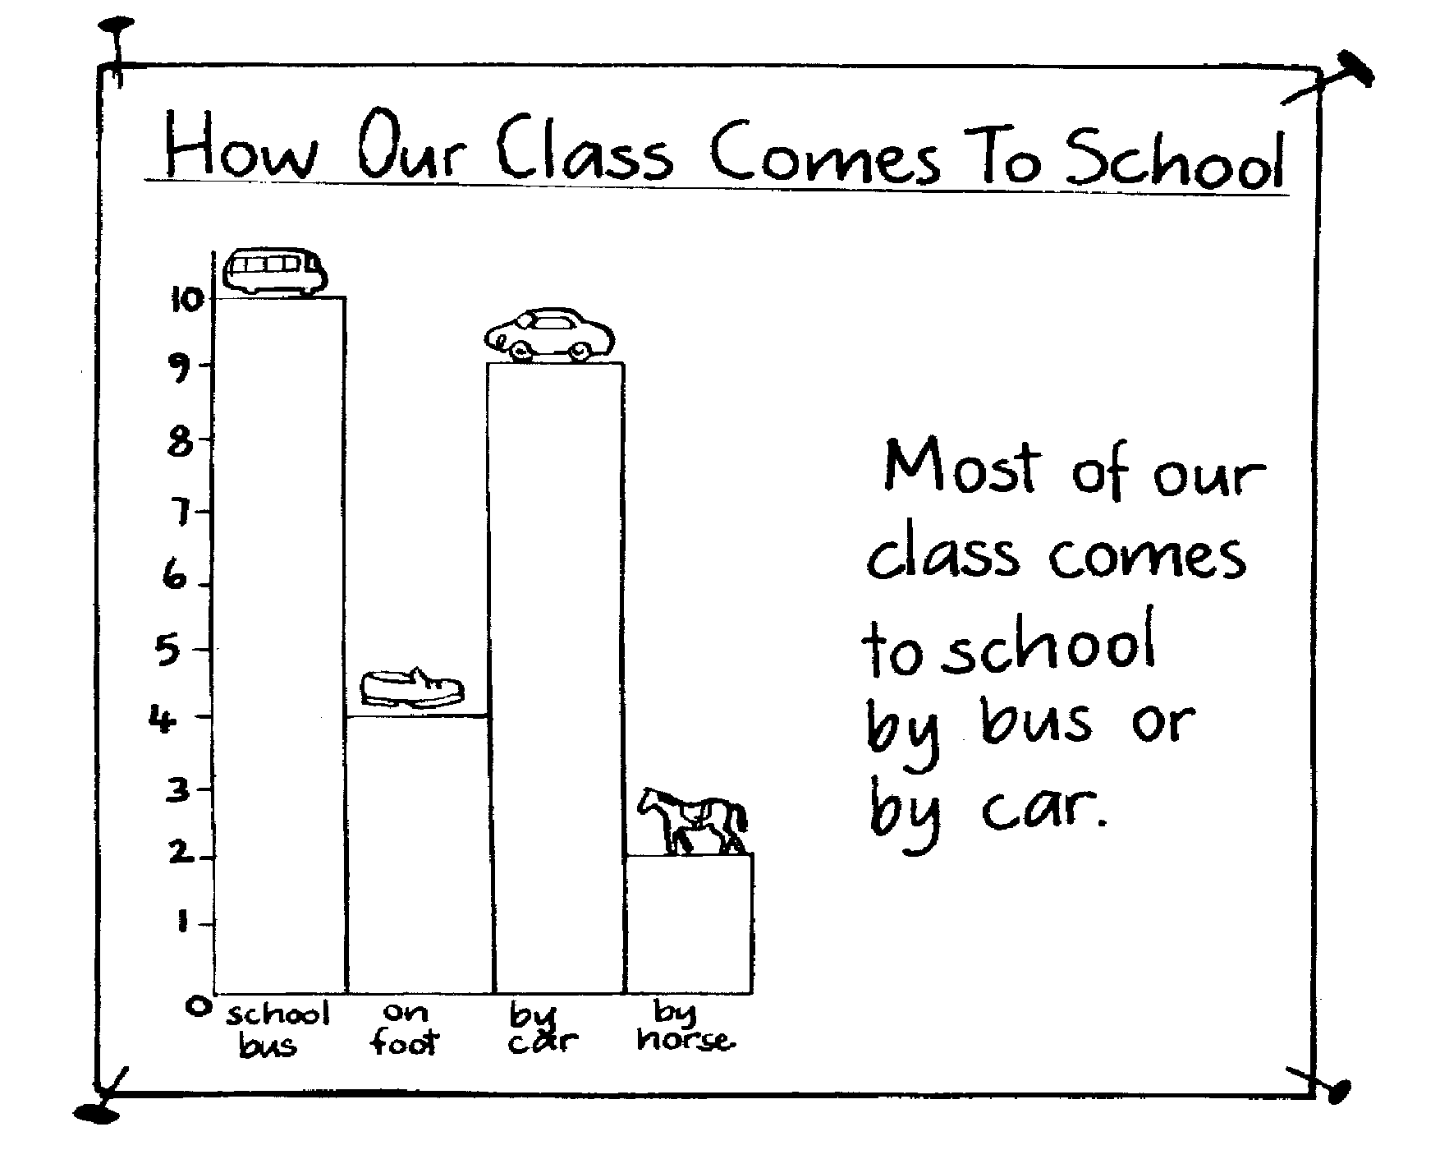
Make a summary statement. Examples might be:
Most students in our class come to school on the school bus.
Some of the students in our class walk to school.
Not many students come by horse.

2. Walking to school
Read the story Don’t Miss the Bus!
Ask: Do you think it would be fun to come to school by a walking school bus?
Does our school have a walking school bus?
What might be some of the good things about walking to school?
Record students’ answers on a sheet of paper to place on the wall for revision. Possible answers could include:
We get fit when we walk.
We like walking with our friends.
It is a good way to get exercise.
You can look at things along the way.
You breathe in fresh air.
Fewer cars on the road.
It saves money and petrol.
It helps keep the air cleaner.

3. Learning to keep safe on the road
Talk about how they need to learn to keep safe when they are coming to school and at any other time when they are on or near the road. Explain that over the next few weeks they will be doing the road safety programme. Remind them that they may have done road safety last year and that they will be looking again at things they learnt then. Now that they are older they will be learning new things as well.
Give each student a letter to take home to an adult at home. See Copysheet: Letter Home. Alternatively, students could address the letter to their parents and go as a class to post these. This would reinforce learning done in road safety in previous years.

Copysheet: Letter home

Dear Parent or Caregiver
Your child will be doing a road safety programme at school over the next few weeks. It will teach your child to behave in a safe way as a pedestrian and a passenger.
During the programme it would be helpful if you could talk to your child about what he or she is learning. Research shows that children learn best about road safety when they are taken out for practical activities with a responsible adult. Please take every opportunity to take your child out and ask them about road safety practices.
There will also be some activities for you to help with at home.
Adults are important role models for children. It is especially important that you always model safe pedestrian and passenger behaviour yourself. This includes things like putting on your safety belt, using kerb drill to cross the road and walking when possible for health and for the environment. Your child can explain what kerb drill is.
We are holding a meeting for parents/caregivers so that you can find out more about the programme.

Date:

Time:

Venue:

Please contact the school if you would like any more information.

Thank you for your help.

(Classroom teacher) (School Community Officer)

Learning experience 2: What is traffic?

Learning intentions
By the end of this learning experience students will be able to:
- name and identify at least five types of traffic
- identify a police car and other specialist vehicles.

Competencies developed in this learning experience
Road safety: identifying types of traffic
Art work
Comprehension
Grouping into Venn diagrams

Activities

1. What is traffic?
Read the poem Traffic from the copysheet to the class and show them the picture. Talk about any new words students may not know, such as pedal, vehicles, accelerator, pedestrian. Read the poem again. Invite students to do actions (pedalling, walking) or make appropriate noises (car horns, bicycle bells, footsteps).
Ask: What is traffic?
List students’ ideas on a chart. Make sure different types of vehicles are listed (bus, motor bike, truck, housebus, van) as well as pedestrians.
Talk about how different types of vehicles have different functions.
Take the class out to the school carpark, to look at the police car. Help students to identify all the things that tell us it is a police car.
Ask: What other specialist vehicles can you recognise? (Fire engine, ambulance, tow truck ...)

2. Types of traffic
Do one or more of the following, according to the ability of the class.
(a)
Students cut pictures of different types of vehicle from magazines. These could be made into a poster entitled Traffic is ... Each traffic type should be labelled. Alternatively, students can sort the different types of traffic into a Venn diagram, grouping them according to such things as number of wheels, use, or place on the road in which they would go.
(b)
Students can use the templates of different types of traffic available from the School Community Officer. These could be enlarged and pasted onto card and made into a mobile or poster. Each traffic type should be labelled.
(c)
Students do a traffic count outside the school. This could be done at different times during the day, such as before school, lunchtime, and for a set time during the afternoon. Students could graph the Information and draw conclusions about:
- the numbers of different types of vehicle that pass the school
- traffic patterns at different times of the day.

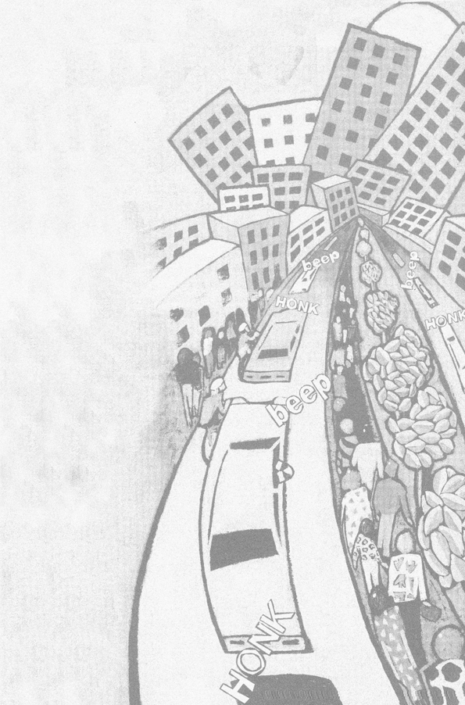
Copysheet: Traffic
by Bev Kemp

Pedal up

pedal down

wheels go round

bicycles

cycling

into town

Accelerator

up and down

wheels go round

vehicles

driving

into town

Walking up

walking down

walking around

pedestrians

going

into town.

Learning experience 3: On and around the road

Learning intentions
By the end of this learning experience students will be able to:
- name and identify the major parts of the road
- match the type of traffic with the parts of the road on which it goes
- recognise traffic signs and markings relevant to them and explain why they are used.

Competencies developed in this learning experience
Road safety:
- identifying parts of the road
- identifying parts of the road on which they are safest
- identifying road signs and markings
Picture interpretation
Art work

Activities

1. Parts of the road
Brainstorm with the class the parts of the road. Write these on the board or a chart and discuss each. (This is revision from work done in Years 0–1.) Ensure that these features below are covered:
footpath, gutter road lanes street
driveway car park centre line kerb grass verge
intersection pedestrian crossing house side of the footpath
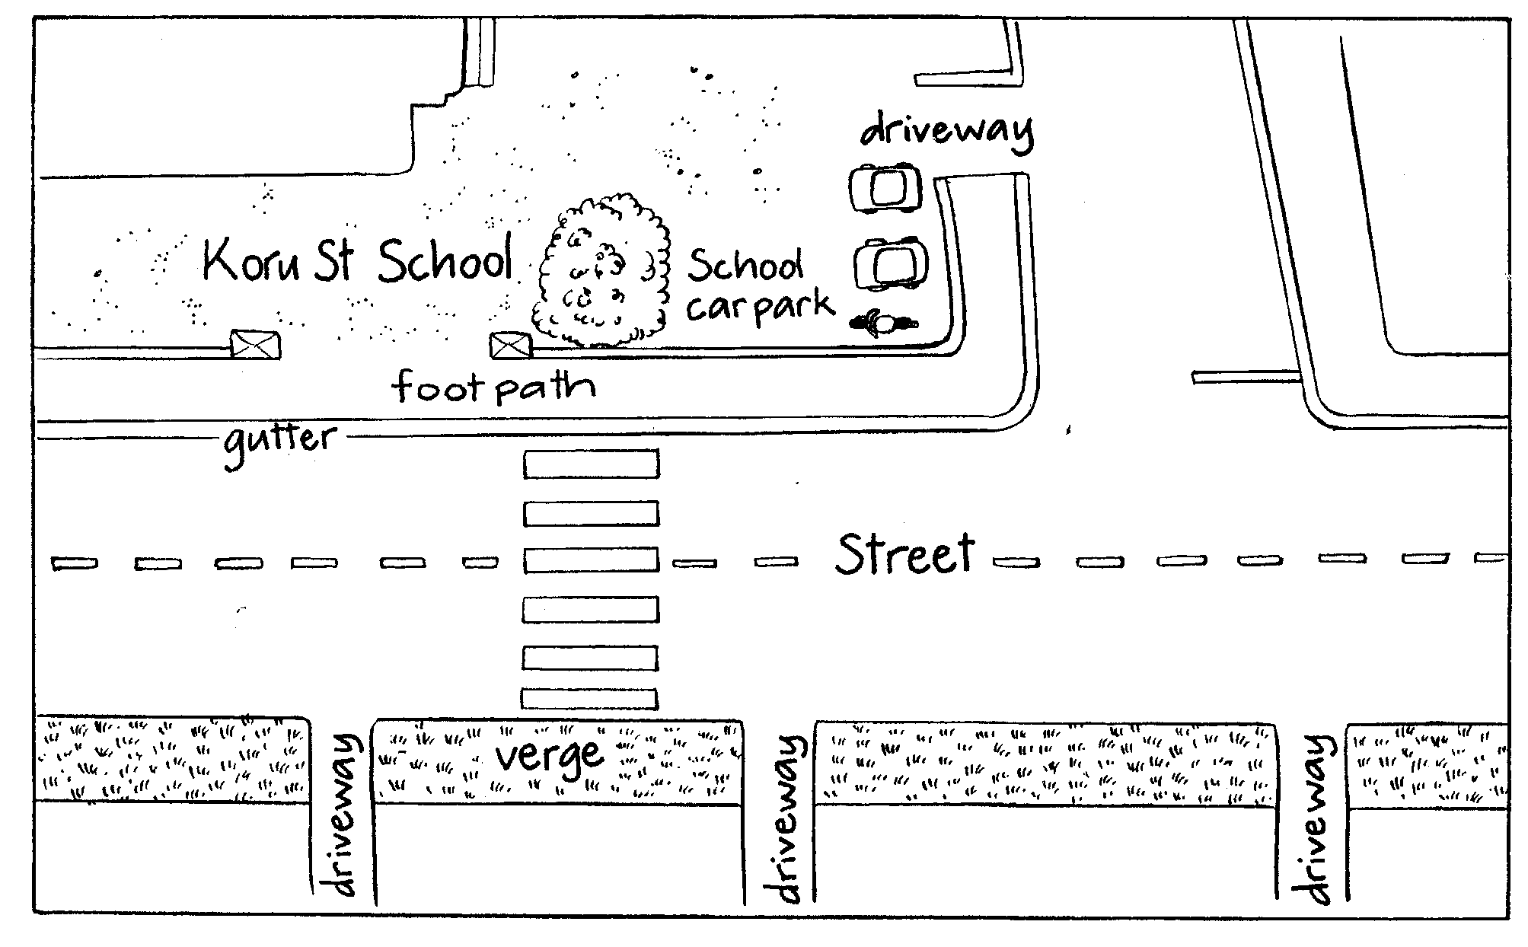
Ask: Where do you walk on the footpath? (On the house/shop side, or the side furthest from the road)
Where do you walk if there is no footpath? (On the grass verge well away from traffic and facing the oncoming traffic)
Gather students around the road mural that has been made. Ask students to identify the different parts of the road and label these by either writing on the mural or attaching pre-made signs.
Ask: Why is it important that we know the different parts of the road?

2. About road signs
Ask the class what signs are and why we have them. Talk about any signs in the classroom and school environment. Explain that there are special signs on the road, too. Some of these are written signs and some are markings on the road. Show them Photo 5 Road Signs from the Photopack. Ask students to identify both traffic and non-traffic signs.
Ask: What other road signs do you know?
Record these on the board.
Hand out Copysheet: Signs. Ask students to colour the signs in as given in the copysheet and explain that this is the colour that these signs always have. Explain that red signs must be obeyed; yellow signs warn us of a hazard; and blue signs give us information.
Ask students, individually or in pairs, to decide what each sign means. Go over the correct names, using Copysheet: Signs – Answers.

3. Looking for road signs
Explain that the class is going outside to look at the parts of the road and the road signs and markings. Review safe practices when near roads, including walking across the school car park, walking on the footpath side of the road, and kerb drill. During the walk, students identify and draw, or photograph, road signs they see. These should be displayed on the return to class.
Ask: Which signs and markings are especially for pedestrians?

4. Road mural
Gather students around the road mural. If road signs are shown on the mural, students can name them. If no signs are shown, students can decide where they should go and add them.
Either students use the templates of traffic and paste them on to the mural, in the appropriate places (pedestrians on footpaths, cars on road and so on), or they draw traffic on to the mural, in appropriate places.
Display the road mural in a prominent place in the classroom or school, where parents and caregivers can see it.
Ask: What does dangerous mean?
What are some things that can be dangerous?
Why can traffic sometimes be dangerous?
Why must we take special care near traffic?
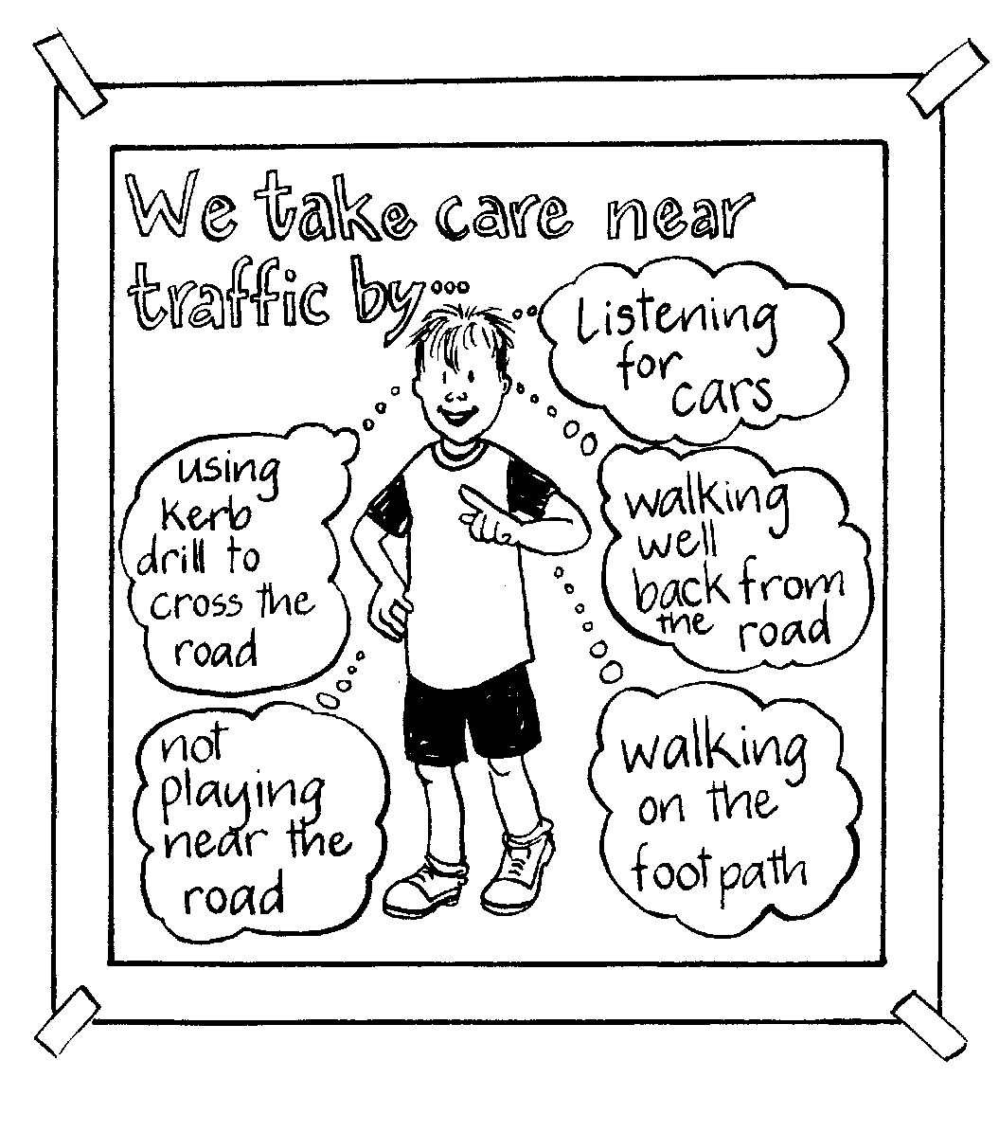
Brainstorm with students ways they can take care near traffic. Record these on a wall chart like the example given here.
Give students Copysheet: Roads and Traffic near Home to take home and complete with an adult.

Copysheet: Road Signs
- These signs are permanent warning signs to warn traffic about hazards that are always there. They are always yellow and black. Look for these signs when you are near the road.
- Colour them in yellow.
- Underneath each one write what you think it means.

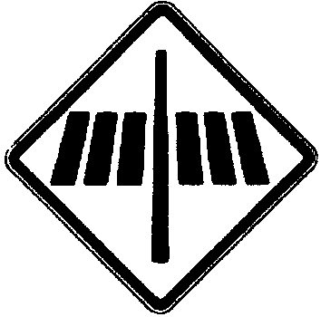 | 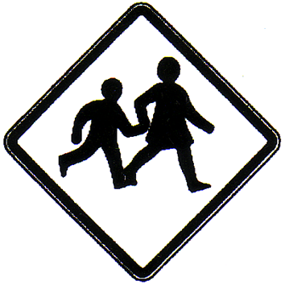 | 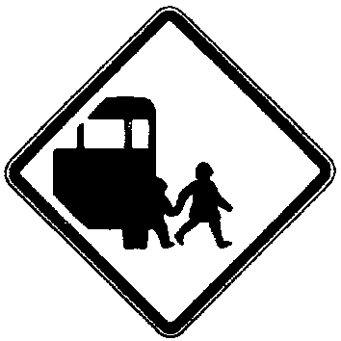 | 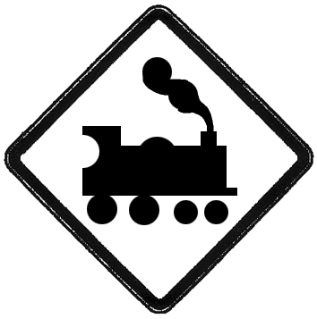

- These are temporary warning signs to warn traffic about temporary hazards. They are always orange and black. Look for these signs when you are near the road.
- Colour them in orange.
- Underneath each one write what you think it means.

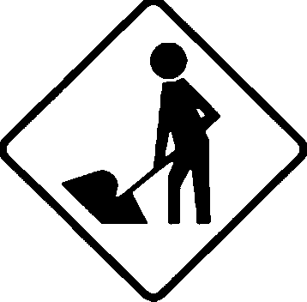 | 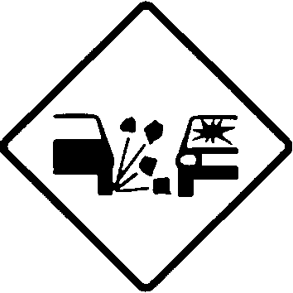 | 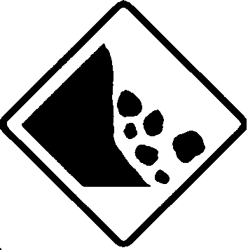 | 

- These regulatory road signs tell traffic what they can or cannot do. We must obey them. They are either red and white signs or blue and white signs. Look for these signs when you are near the road.
- Colour the two signs on the left in red and white, colour the two signs on the right blue and white.
- Underneath each one write what you think it means.

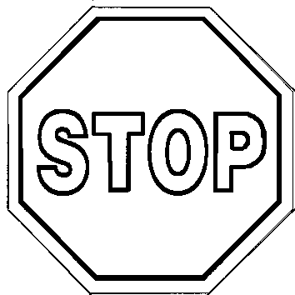 |  |  | 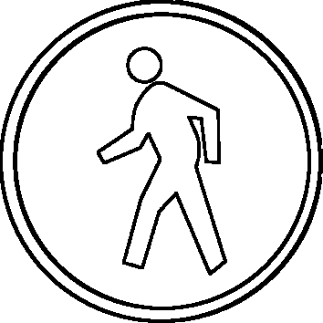

Copysheet: Road Signs –Answers

Pedestrian crossing Students School bus Train

Road works Gravel Slips Mower

Stop Give way Keep left Pedestrian

Copysheet: Roads and Traffic near Home

Parents, please help your child with the following activities.
The results will be displayed at school.

- Circle the words in the chart below that describe the road or street you live on.

Place | town | country | city | other
Type of road | main road | side road | cul-de-sac | crescent | no exit | other
Footpath | wide | thin | concrete | gravel | no footpath | other
Surface of road | gravel | sealed | other

- Write some other words to describe your road (quiet, busy ...)

- Tick in the box any of the following things that are near your home.

- bus stop  - one way signs  - traffic lights  - railway crossing | - school patrol  - pedestrian crossing  - yellow lines  - stop or give way sign

- Draw a sign in the space below that is near your street or road.

- Write down, or draw, five types of traffic that goes past your house.
Do this on the back of this page.

