Road Safe

Years 0–1 Focus area 4
This section of the Road Safe programme contains one of the following focus areas for students at years 0–1 (ages 4–5):
- Roads and traffic
- On the move
- By bus or by car
- Managing hazards
Note: Research suggests that an effective programme should include learning experiences from each of the focus areas.

Focus area 4: Managing hazards

Contents
Focus area 4: Managing hazards 3
Focusing question 3
Explanation 3
Notes for the teacher 3
Curriculum links 3
Resources 3
Success criteria 4
Learning experience 1: Hazard 5
Learning intentions 5
Competencies developed in this learning experience 5
Activities 5
Learning experience 2: Watch out for hazards 7
Learning intention 7
Competencies developed in this learning experience 7
Activities 7
Learning experience 3: Helpers 8
Learning intentions 8
Competencies developed in this learning experience 8
Activities 8
Learning experience 4: Safe play 10
Learning intention 10
Competencies developed in this learning experience 10
Activities 10
Copysheet: Safe Places to Play 12

Focus area 4: Managing hazards

Focusing question
What can I do when I see a hazard on or near the road?

Explanation
In this focus area, students learn to identify hazards, or potential hazards, on or near the road. They decide what they could do to handle these hazards. They identify people who could help, and practise asking for help. They explore safe places to play.

Notes for the teacher
A Risk Management Plan should be completed before taking students out of the school grounds.
Plan the walk in Learning experience 2 carefully, so that it does include some hazards. It may be necessary to enlist some support from local residents. Try and include some or all of the following, according to your local area: a car parked over the footpath; road works; a big puddle on the footpath; a driveway; a big, noisy farm vehicle.
If the class has done the Keeping Ourselves Safe programme they will have covered asking for help. If this is the case, a brief revision will be all that will be needed for Learning experience 3.

Curriculum links
Key Competencies: Managing self; Relating to others; Participating and contributing
Learning areas: Level 1 Health and physical education: Strand A – Safety management; Strand C – Relationships; Strand D – Rights, responsibilities and laws
Level 1 English: Speaking, writing and presenting – Purposes and audiences, ideas; Listening, reading, and viewing – ideas
Level 1 Social Sciences: Roles and responsibilities
Level 1 The Arts: Drama – Communicating and interpreting

Resources
Photos 2, 3, 4, 7, 8, 9 and 12 from Stepping Out Photopack (available from School Community Officer)
Koosh ball or bean bag
Digital camera
Parent helpers
Art materials
Photo 10 from the Stepping Out Photopack (available from School Community Officer)
Plain paper cups (or similar objects such as a table tennis ball, ice block stick, piece of cardboard tube, paper plate with an ice block stick at the bottom) that can be made into a person – one for each student
Story: Just to Be Safe (School Journal Pt 1 No. 4 2001)
Copysheet: Safe Places to Play
Balls

Success criteria
At the end of this focus area students will be able to:
- identify hazards on or near the road
- use safe strategies to manage hazards
- ask for help if they need to
- choose safe places to play.

Learning experience 1: Hazard

Learning intentions
By the end of this learning experience students will be able to:
- explain what a hazard means
- suggest ways to overcome hazards.

Competencies developed in this learning experience
Road safety:
- recognising times when they need to be careful
- recognising potential traffic hazards
- practising road safety skills learnt so far
Comprehension
Catching a soft object
Picture interpretation

Activities

1. Identifying hazards
Write the word Hazard on the board in big letters. Ask students what they think it means. Explain that it is the chance that something harmful might happen. Talk about how, when we are out walking, there could be hazards, and we need to be very careful so we don’t get hurt.
Use some or all of the suggested photos. For each:
Ask: Can you see a hazard?
What could the people do to keep safe?

Photo | Hazard; how to keep safe
2 | Vehicles reversing and not seeing children; stay well clear of the vehicle
3 | Cars could come out of the driveway; use kerb drill before crossing
4 | Car is coming and it might make stones fly up; stay as far away from the road as possible
7 | Can’t see the road because the bus is in the way; wait until the bus has moved away and the road is clear; use kerb drill to cross
8 | Road works have blocked the footpath; follow the new path set out
9 | Tractor is blocking the grass verge; use kerb drill to cross to the other side
12 | Vehicles moving in and out of the car park: vehicles reversing; look and listen carefully

2. What would you do to keep safe?
Seat the students in a circle. Explain that they are going to play the What Would You Do To Keep Safe game. Throw the bean bag to a student and ask a question similar to the ones given below. Repeat the process with another student and so on until they have all had a turn. The same questions can be repeated with different students.
Possible questions
There is a big truck on the footpath. What will you do?
A big truck is making dust. It is getting in your eyes. What will you do?
Cars keep coming when you want to cross the road. What will you do?
You are walking on the footpath, when it stops. What will you do?
A big tractor is mowing the grass on your side of the road. What will you do?

Learning experience 2: Watch out for hazards

Learning intention
By the end of this learning experience students will be able to identify hazards and decide what to do about them.

Competencies developed in this learning experience
Road safety: deciding how to deal with traffic hazards
Art work
Listening
Thinking critically
Making decisions

Activities

1. Walk
Tell the students that they are going to go for a walk outside the school.
Remind them about where to walk, to watch out for driveways and use kerb drill if they need to cross the road, and to watch out for traffic when crossing the school car park. This will help to keep them safe from hazards.
Ask: Why do we have to be extra careful on or near the road?
Why can roads and traffic be hazardous?
During the walk, ask students to identify hazards and decide what to do about them.
Ask: Why should we be careful here?
What can we do to make sure we are safe?
Take photos of students safely negotiating hazards.

2. Art activity
Each student draws a picture showing themselves keeping safe when they meet a traffic hazard. Underneath they finish the sentence that the teacher has started:
I can keep safe by …

Learning experience 3: Helpers

Learning intentions
By the end of this learning experience students will be able to:
- identify people in their community who can help them keep safe on the roads
- ask for help.

Competencies developed in this learning experience
Road safety:
- identifying helpers
- identifying when they might need help
- asking for help
Picture interpretation
Art work

Activities

1. Asking for help
Seat students in a sharing circle on the floor. Explain that sometimes when they are out walking they might need to ask other people for help.
Ask: When might we need to ask for help?
List students’ responses on the board.
Examples might be:
If we have to cross a very busy road by ourselves
To tell us which bus stop to get off at
If we meet a traffic hazard
If there was a crash
If I fell over
If I got lost
Show students Photo 10 from the Stepping Out Photopack.
Ask: What has happened?
Why does the boy need help?
Who has come to help him?
What do you think will happen next?
Put up a large picture of a Helpmobile, like the one shown on the next page. Inside it write: Big people from another school.
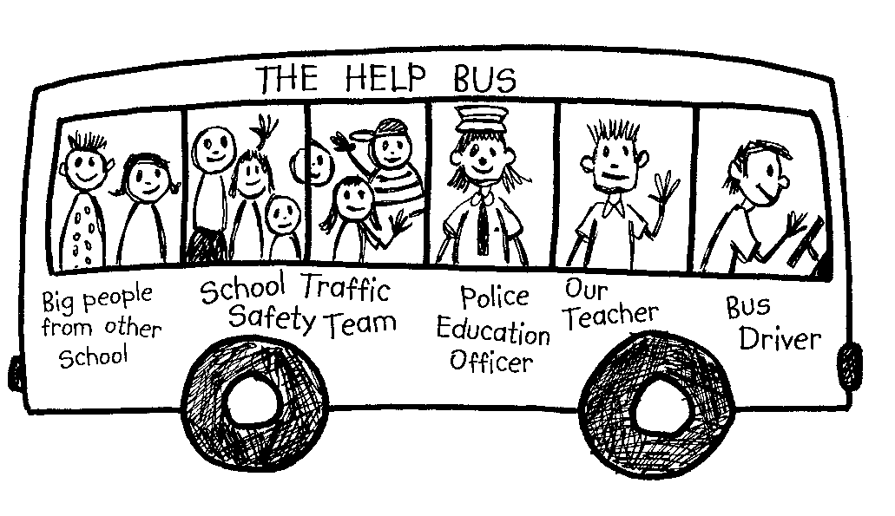
Brainstorm with students other people that can help. Add any new helpers to the Helpmobile.
Make sure that such people as the following are covered:
- parents
- other adults
- older children
- a police officer
- people working on the road
- people in shops
- a teacher
- a bus driver
- the school patrol.
Ask: Are there any other helpers we should add?

2. Art activity, role-play
Give each student a paper cup. Invite them to stick on or draw on their cup a face, hair and clothes. They can give their ‘person’ a name.
The teacher, and School Community Officer if present, should also make a ‘person’. The teacher models how the ‘person’ asks for help to cross the road.
Each student now uses their ‘person’ to ask for help crossing the road. Ask some students to demonstrate to the class. This could be repeated with other situations such as the following examples:
You forgot to get off the bus at your stop.
You are lost.
You can’t reach the button on the traffic lights.
Give each student a sticker or stamp and praise them for the way they asked for help.

Learning experience 4: Safe play

Learning intention
By the end of this learning experience students will be able to choose safe places to play.

Competencies developed in this learning experience
Road safety: identifying safe places to play
Listening
Interpreting stories

Activities

1. Safe and unsafe places to play
Read students the story Just to Be Safe.
Ask: Where did the children decide to swim?
Why was it safe there?
Why didn’t Kate go on the flying fox?
What play equipment did she play on instead?
Do you think grandma helped to keep Kate safe?
Write the words Safe Play on the board in big letters. Explain that it is very important that children always play in safe places.
Ask: Is the road a safe place to play? Why not?
Is the footpath a safe place to play? Why not?
Is the driveway a safe place to play? Why not?
Record the students’ answers in a chart like the one below.
Unsafe places to play | Why this is an unsafe place
Driveway | Vehicles could come in or out  Ball might go on the road
Footpath
Road
Car park

2. Safe and unsafe places to play in the neighbourhood
Divide students in to small groups. Give each group Copysheet: Safe Places to Play. They use a red cross to show places that would be unsafe to play. They use a green tick to show places that are safe to play. Talk to each group and ask them how they made their decision.

3. Practising safe play
Take students out into the school grounds. Choose an area near a driveway, having ensured that no vehicles will pass. Tell students that they are to pretend the driveway is a road. Give students balls to play with on the grassed area adjacent to the road. The first time a ball goes on the ‘road’, stop the students and sit them down.
Ask: What should we do if our ball goes on the road? (We stop and don’t run to follow it; we ask an adult to get it for us; it is better to lose the ball than to get run over)
Is this a safe place where we are playing? (No, it is too close to the road)
With the students’ help, find a safe place to play ball in the school grounds and let the students finish their game.

Copysheet: Safe Places to Play
