Road Safe

Years 0–1 Focus area 3
This section of the Road Safe programme contains one of the following focus areas for students at years 0–1 (ages 5-6):
- Roads and traffic
- On the move
- By bus or by car
- Managing hazards
Note: Research suggests that an effective programme should include learning experiences from each of the focus areas.

Focus area 3: By bus or by car

Contents
Focus area 3: By bus or by car 2
Focusing question 2
Explanation 2
Notes for the teacher 2
Curriculum links 2
Resources 2
Success criteria 3
Learning experience 1: By car 4
Learning intention 4
Competencies developed in this learning experience 4
Activities 4
Learning experience 2: Safety belts 6
Learning intentions 6
Competencies developed in this learning experience 6
Activities 6
Copysheet: Police Car 7
Learning experience 3: By bus 8
Learning intentions 8
Competencies developed in this learning experience 8
Activities 8
Copysheet: The Wheels on the Bus 10

Focus area 3: By bus or by car

Focusing question
How can I keep safe in the car?

Explanation
In this focus area students think about ways to stay safe when travelling in a car or a bus. They practise putting on their safety belts and can explain why they must always wear them. If there is a school bus, students meet the bus warden and consider ways that they can help this person do their job.

Notes for the teacher
Be aware of the rules for child restraints in cars:
The driver is responsible for making sure all children wear a safety belt.
Children must be properly restrained in an approved child restraint until their 7th birthday.
Children should always sit in the back seat. This is especially important in cars with airbags, as these can cause serious injuries to children.
For more information on bus safety, see Safe Behaviour on Buses (on the New Zealand Education page of the Ministry of Education’s website (www.minedu.govt.nz).

Curriculum links
Key Competencies: Managing self; Relating to others; Participating and contributing
Learning areas: Level 1 Health and physical education: Strand A – Safety management; Strand C – Relationships; Strand D – Community resources
Level 1 English: Speaking, writing and presenting – Purposes and audiences, ideas; Listening, reading, and viewing – ideas
Level 1 The Arts: Drama – Communicating and interpreting

Resources
Large soft toy
Copysheet: Police Car
School Community Officer with the police car parked in the grounds. The car should be equipped with child restraints (booster seat or child safety harness). Alternatively, use a suitable staff car that has a child restraint.
Copysheet: The Wheels on the Bus
Photo 7 from Stepping Out Photopack (available from your School Community officer)
Bus warden and school bus if appropriate

Success criteria
At the end of this focus area students will be able to:
- wait for the bus in a safe place
- get on the bus without pushing
- sit quietly on the bus with bags well out of the way
- wait until the bus has stopped before getting out of the seat
- get off the bus in an orderly way
- wait until the bus has moved off and the road is clear before moving away
- use kerb drill to cross the road
- be safe in and around vehicles
- do up their safety belt when one is available.

Learning experience 1: By car

Learning intention
By the end of this learning experience students will be able to describe and demonstrate ways to keep safe in and around vehicles:

Competencies developed in this learning experience
Road safety: following safety practices in a car
Comprehension
Singing
Reading
Listening

Activities
Ask: What things can we do to keep safe when we get in the car? (Get in from the footpath side; wait until the car has stopped; sit in the back seat)
What things can we do to keep safe when the car is moving? (Sit still; don’t distract the driver; keep the safety belt on all the time)
What things can we do to keep safe when getting out of the car? (Wait until the car has stopped; get out on the footpath side)
Record the key points in a chart like the one below.
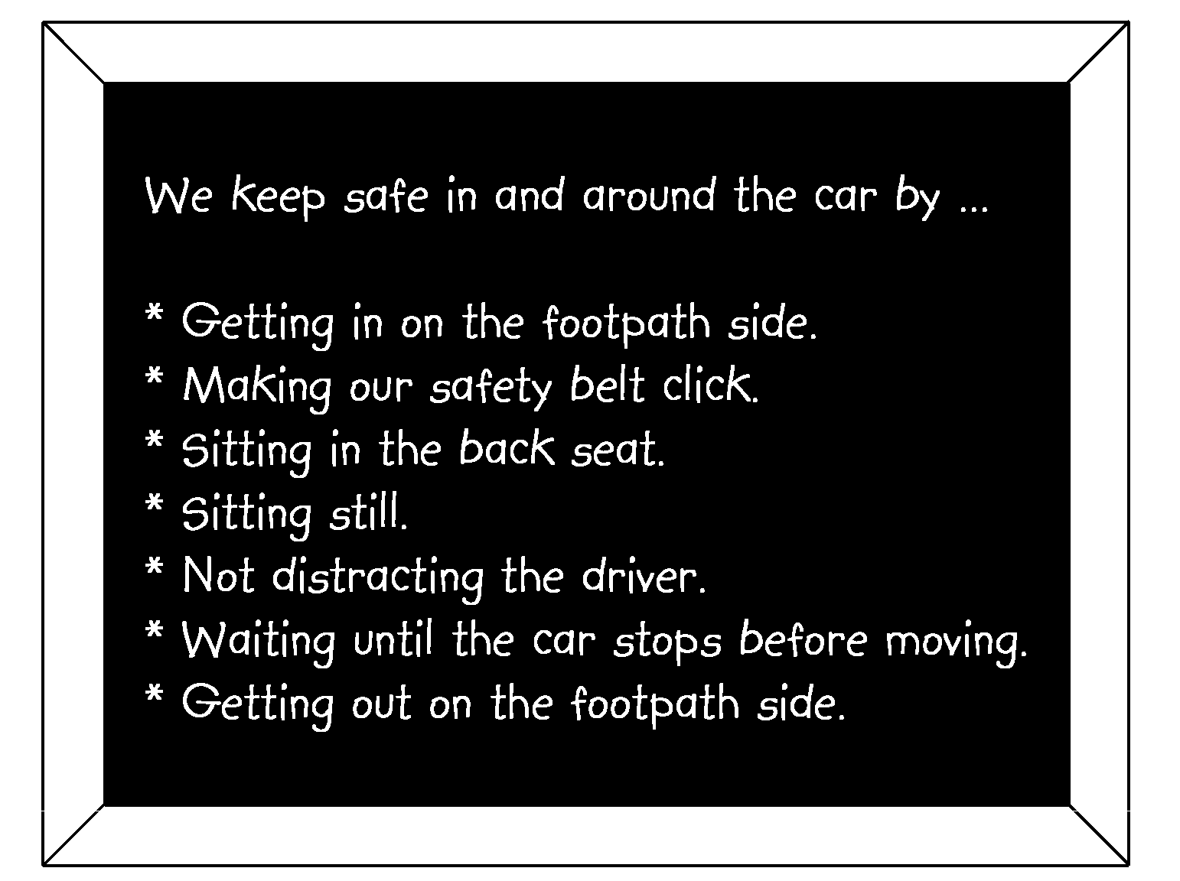

Use the classroom furniture to set up several passenger vehicles, such as a car, truck, van and bus. Mark the edge of the footpath and the road.
Students practise waiting for the vehicle to stop, getting in, sitting quietly and getting out. Praise each student as they do these things safely.
Each student draws a picture of themselves being safe in or around the car.
Display these on the board. Work with the student to write a message underneath – for example:
I keep safe by sitting nice and still.
I keep safe by getting in and out of the car on the footpath side.
I keep safe by not making loud noises and not distracting the driver.
I keep safe by keeping my safety belt on all the time.
I keep safe by sitting in my booster seat with my child restraint done up.

Learning experience 2: Safety belts

Learning intentions
By the end of this learning experience students will be able to:
- make their safety belt ‘click’
- identify a police car.

Competencies developed in this learning experience
Road safety:
- doing up a safety belt correctly
- identifying a police car
- identifying lights and signals on a car
Identifying colours
Colouring
Picture interpretation

Activities
Explain that the class is going out to the police car in the car park, to practise ‘making it click’. Remind them about what they have learnt about crossing a car park and the need to walk in a quiet and orderly way.
Ask: How can you tell that this is a police car?
Talk about the distinctive things about a police car, such as lights, words and markings.
Show and talk about the various parts of the car. Demonstrate the reversing lights and indicators.
Ask: Why is it important for pedestrians to watch for these lights?
Introduce students to the large soft toy that is belted up in the child restraint in the back seat.
Ask: Why is the toy wearing a safety belt?
Why should everyone in a car wear a safety belt?
How can you make sure your safety belt is done up properly?
Students could take turns at doing up the soft toy’s safety belt, making sure it ‘clicks’. Alternatively, students can take turns getting into the child restraint in the police car, to practise doing up their safely belt. An adult should observe each student to ensure that the safety belt is done up correctly.
Give each student Copysheet: Police Car. They can colour the picture in.

Copysheet: Police Car
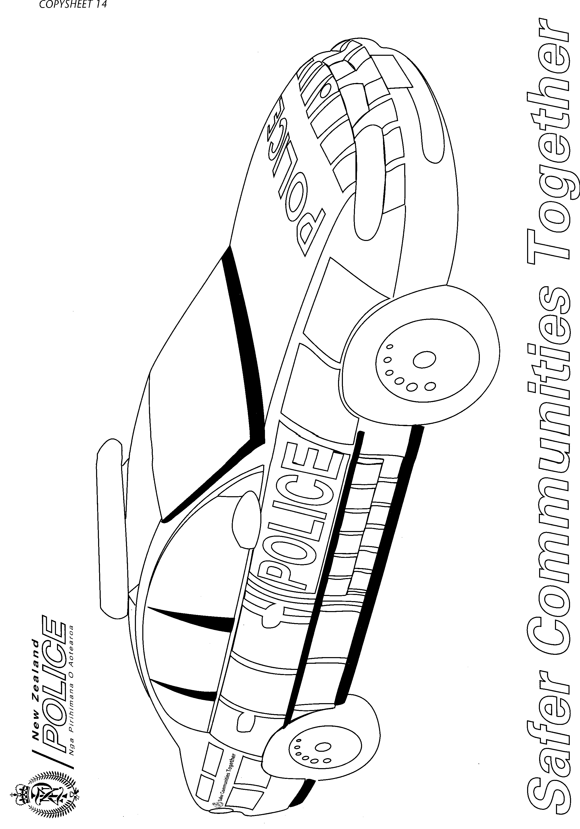

Learning experience 3: By bus

Learning intentions
By the end of this learning experience students will:
- be able to describe how to behave safely when in and around a bus
- know who the bus warden is and can explain what that person does.

Competencies developed in this learning experience
Road safety: behaving safely in a bus
Comprehension
Listening

Activities

1. Rules for bus safety
Students sing The Wheels on the Bus (see copysheet) with appropriate actions.
Ask: What does the song tell us that we should do when we are on the bus? (Take your seats; sit right down; tuck your bags away; be nice and quiet)
Show students Photo 6, Children Crossing the Road in the Country. Ask the questions on the back of the photo.
If students are using buses in the town or city, remind them that the same rules apply –wait well back off the road until the bus has stopped before getting on; get on the bus in an orderly way without pushing; if you have to stand, hold on to something; let the driver know where you want to get off; when you get off the bus, before crossing the road wait until the bus has moved off and you can see clearly that no other traffic is coming; always use kerb drill to cross the road.
Make a chart called Ways to Keep Safe in and around a Bus. Record all the safety points that have been discussed. This can be used at intervals for revision.

2. School bus warden
If the school has a school bus, and uses a bus warden, arrange for the bus warden to come to class, to talk about their job.
Ask: How can you help the bus warden?
Why is it important to follow the bus warden’s instructions?
Who else on a bus can help keep you safe?
How can you keep yourself safe on the bus?
If possible, arrange for the school bus to come a little early so that the class, and the bus warden if there is, one can practise waiting for the bus, getting on the bus, sitting quietly and getting off the bus. Maybe they can have a short ride on the bus.
Alternatively, if a bus is coming to school to take some students on a trip, it may be possible for your class to practise safety on and around the bus.
Ask: How well did we follow the rules?
How did the bus warden help us?
What things should we work harder on next time?

Copysheet: The Wheels on the Bus

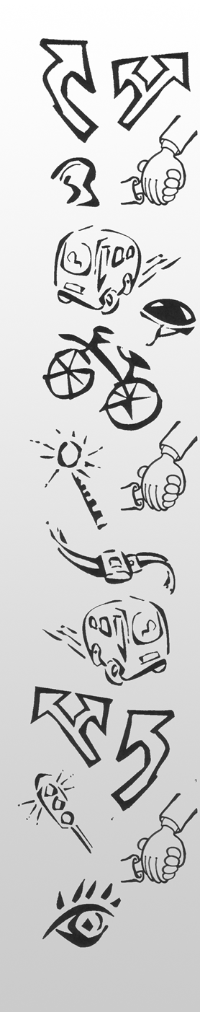
The wheels on the bus go round and round,
Round and round,
Round and round.
The wheels on the bus go round and round
Every day.

The children wait well back from the road,
Back from the road,
Back from the road.
The children wait well back from the road
Every day.

The driver on the bus says, 'Take your seats,
'Take your seats,
'Take your seats.'
The driver on the bus says, 'Take your seats,'
Every day.

The children on the bus, they sit right down,
Sit right down,
Sit right down.
The children on the bus, they sit right down
Every day.

The people on the bus tuck their bags away,
Bags away,
Bags away.
The people on the bus tuck their bags away
Every day.

Everyone on the bus is nice and quiet,
Nice and quiet,
Nice and quiet.
Everyone on the bus is nice and quiet
Every day.

The children wait ‘til the bus has gone,
Bus has gone,
Bus has gone.
The children wait ‘til the bus has gone
Every day.

