Road Safe

Years 0–1 Focus area 2
This section of the Road Safe programme contains one of the following focus areas for students at years 0–1 (ages 5-6):
- Roads and traffic
- On the move
- By bus or by car
- Managing hazards
Note: Research suggests that an effective programme should include learning experiences from each of the focus areas.

Focus area 2: On the move

Contents
Focus area 2: On the move 3
Focusing question 3
Explanation 3
Notes for the teacher 3
Curriculum links 3
Resources 4
Success criteria 4
Learning experience 1: Kerb drill 5
Learning intentions 5
Competencies developed in this learning experience 5
Activities 5
Copysheet: Stop, Look and Listen 8
Stop, look and listen 8
Before you cross the street. 8
Use your eyes, use your ears 8
Before you use your feet. 8
Copysheet: Stop, Look and Listen Songsheet 9
Learning experience 2: Walking safely 10
Learning intentions 10
Competencies developed in this learning experience 10
Activities 10
Copysheet: Sneaky Driveways 12
Learning experience 3: Taking a walk – practical 13
Learning intentions 13
Competencies developed in this learning experience 13
Activities 13
Learning experience 4: School patrols and traffic wardens 14
Learning intentions 14
Competencies developed in this learning experience 14
Activities 14
Copysheet: Listen to the School Patrol 15

Focus area 2: On the move

Focusing question
How can I cross the road safely?

Explanation
In this focus area students learn the skills to walk safely on or near the road and to cross the road correctly. They learn these skills initially in the classroom and practise them through a practical class excursion.

Notes for the teacher
At this age children are not ready to cross the road by themselves. Also, many parents insist that their young children cross the road only when holding an older person’s hand. The teacher and School Community Officer should therefore exercise caution in this section, so as not to put students at risk or to go against home rules.
Complete a Risk Management Plan before taking students out of the school grounds.
For Learning experience 3, plan a route close to the school that includes a pedestrian crossing, several driveways and, if possible, both a footpath and a road with no footpath. This will vary according to your local area. Enlist the help of the School Community Officer and some parent helpers. Ensure the helpers understand using kerb drill at driveways and pedestrian crossings, and where to walk on footpaths and where to walk when there are no footpaths.
The School Community Officer should be present for Learning experience 4.
School Traffic Safety Team is the collective term for school patrols, traffic wardens and bus wardens. This term is used in school and School Community Officer manuals. For students, however, it is best to use the individual names – school patrol, traffic warden and bus warden.
Learning experience 4 need only be done if the school has a school patrol, kea crossing or traffic warden system, or if students use these teams from another school. Parents could be invited for this activity so that they know the correct operation of STSTs.

Curriculum links
Key Competencies: Managing self; Relating to others; Participating and contributing
Learning areas: Level 1 Health and physical education: Strand A –Personal growth; Strand B – Movement skills; Strand D – Community resources
Level 1 English: Speaking, writing and presenting – Purposes and audiences, ideas; Listening, reading, and viewing – ideas
Level 1 Social Sciences: Roles and responsibilities
Level 1 The Arts: Drama – Communicating and interpreting

Resources
Copysheet: Stop, Look and Listen
Copysheet: Stop, Look and Listen Songsheet
Photos 6 and 7 from the Stepping Out Photopack (available from your School Community Officer)
Parents as buddies (they should be well briefed about road crossing procedures first)
Scissors and paste
Two large toy vehicles
Photos 3, 4 and 6 from the Stepping Out Photopack (available from your School Community Officer)
Chalk
Classroom furniture
Copysheet: Sneaky Driveways
Digital camera
School patrol or traffic wardens
School Traffic Safety Team equipment
STST Manual for teacher reference (one of these has been sent to each school operating a school patrol)
Copysheet: Listen to the School Patrol

Success criteria
At the end of this focus area students will be able to:
- remember to walk on the house side of the footpath
- remember to walk as far away from traffic as possible when there is no footpath
- remember to walk facing traffic on a country road
- use kerb drill to cross driveways
- use kerb drill to cross pedestrian crossings
- use correct procedures when crossing at the school patrol
- remember to choose a place to cross where they can see the road clearly both ways.

Learning experience 1: Kerb drill

Learning intentions
By the end of this learning experience students will be able to:
- use the ‘stop, look and listen’ kerb drill
- cross the road safely with an older person
- cross a driveway safely.

Competencies developed in this learning experience
Road safety:
- identifying where to cross the road
- using kerb drill
Oral work –poetry
Picture interpretation
Listening

Activities

1. Stop, look and listen
Teach younger students the rhyme on Copysheet: Stop, Look and Listen:
Stop, look and listen,
Before you cross the street.
Use your eyes, use your ears,
Before you use your feet.
Work with the students to develop appropriate actions.

2. When there are cars
Show students Photo 6 from the Stepping Out Photopack. Explain that the photo shows a town area where there are lots of cars. Talk about where the students have stopped to wait to cross (one step back from the kerb, where they can see clearly with nothing in the way), where they can look (all ways that traffic might come) and what they might be hearing (traffic coming).
If possible, they should choose an area to cross where there are no parked cars. Remind students who travel by bus that when they get off the bus they should wait on the same side of the road until they are picked up by their parent or caregiver.
Ask: When will it be safe for the people in the photograph to cross?
Show Photo 7 from the Stepping Out Photopack. Explain that the photo shows a country area where there is not so much traffic, and where often there are no footpaths. In this case, students should walk facing the oncoming traffic and as far off the road as possible. Talk about where the students have to stop to cross the road (on the grass verge or just off the road where they can see clearly with nothing in the way); where they should look (all ways that traffic might come from); and what they might be hearing (vehicles coming that they cannot see).
Students draw a picture of themselves from the waist down and colour it in. In a speech bubble they finish the sentence “Before I cross the road I must ...”. The pictures can be displayed on the wall.
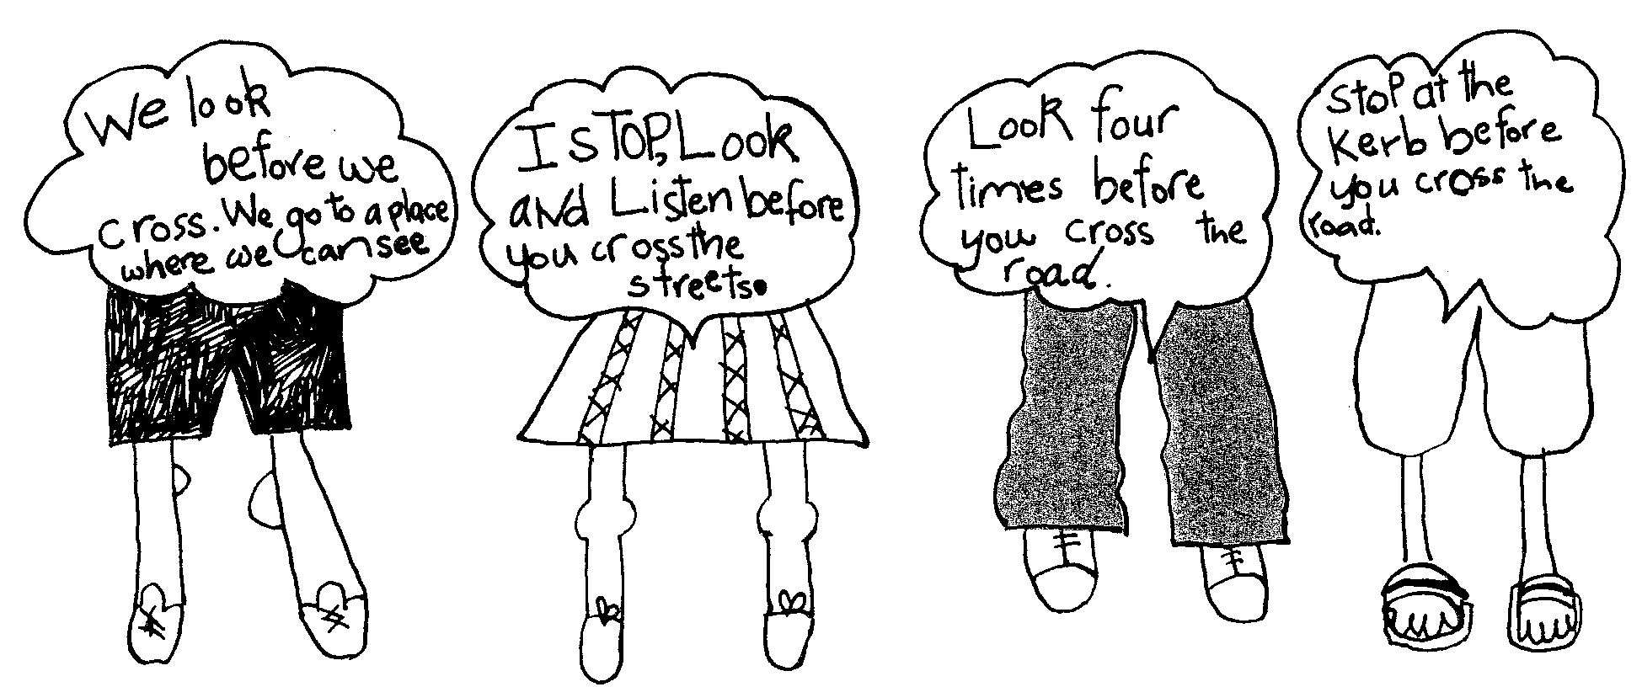

Ask: When you have done your kerb drill, how should you cross the road? (Walk briskly straight across, looking each way as you cross)

3. Practising in the classroom
Ask some students, one at a time, to demonstrate walking briskly from one side of the classroom to the other, while looking for traffic. Draw an imaginary road and footpath on the classroom floor or in the playground. In small groups, or individually, students practise their ‘stop; look and listen’ kerb drill.
Have a person stationed on either side of where the students are going to cross. When the person holds up a toy vehicle, it is not safe to cross. When the person isn’t holding any toy vehicle, students can cross the ‘road’ briskly, continuing to look each way for traffic. They must also pretend to listen for traffic. This exercise should be repeated until all class members are thoroughly familiar with it.
Ask: Why must we always remember our kerb drill?
Why might we sometimes forget? (If we are in a hurry, if our ball goes on the road, if mum or dad park on the other side ...)
What might happen if we forget?
Why do we walk briskly across?
Why do we keep looking for traffic as we cross?
What would we do if a car was coming?

4. Practising on the road
Arrange to take students out in small groups to practise kerb drill and crossing the road on a quiet stretch of road. The teacher or School Community Officer should accompany each group. Arrange for a parent to be a buddy to each student and hold their hand as they cross. Help students to find a sensible place to cross where they can see the road clearly both ways.
Young children often find it difficult to keep looking for traffic as they walk across the road. They may need to practise this several times on different occasions.
If desired, arrange to take photos of each group crossing. These should be displayed on the wall with an appropriate caption, as shown below. They can be used to point out any good, or not so good, practices.
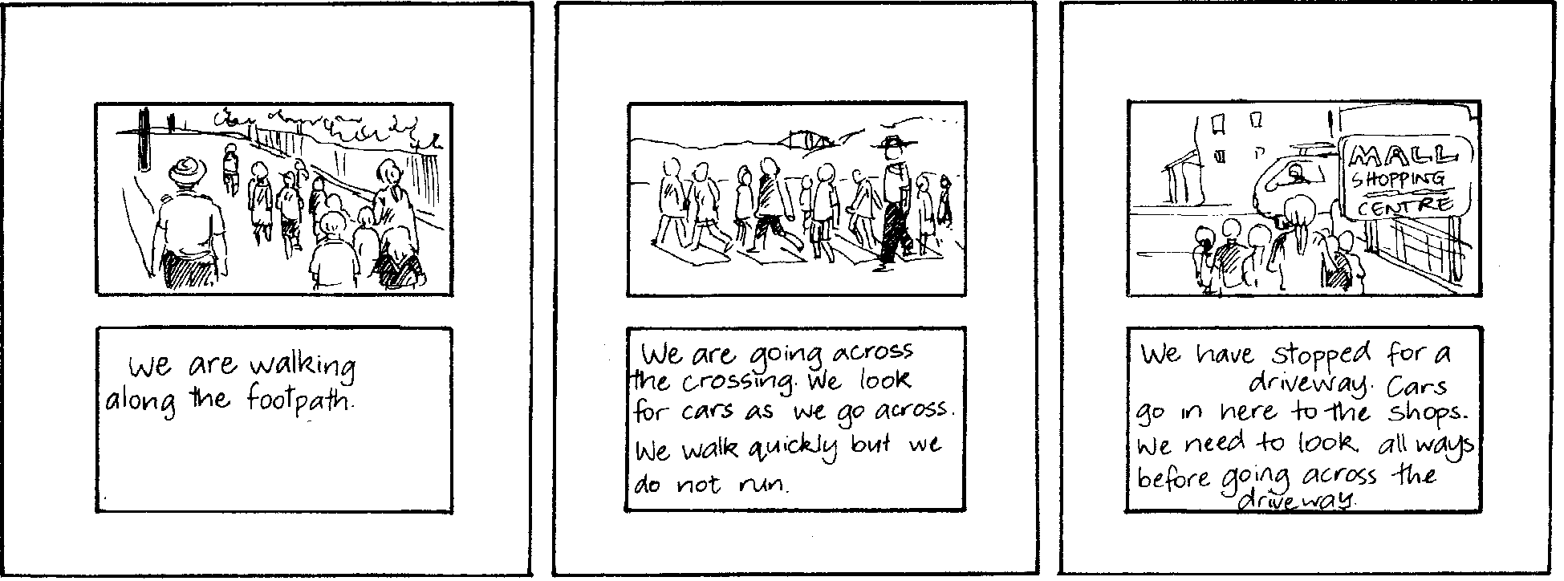

Copysheet: Stop, Look and Listen

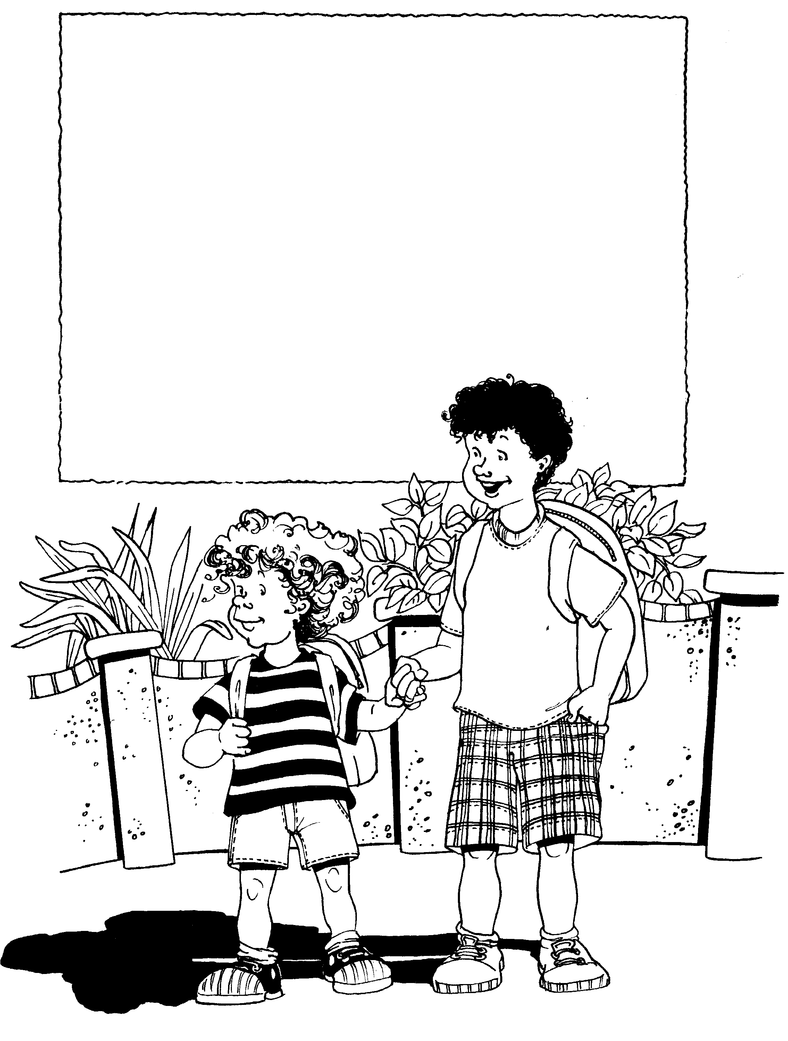

Stop, look and listen

Before you cross the street.

Use your eyes, use your ears

Before you use your feet.

Copysheet: Stop, Look and Listen songsheet
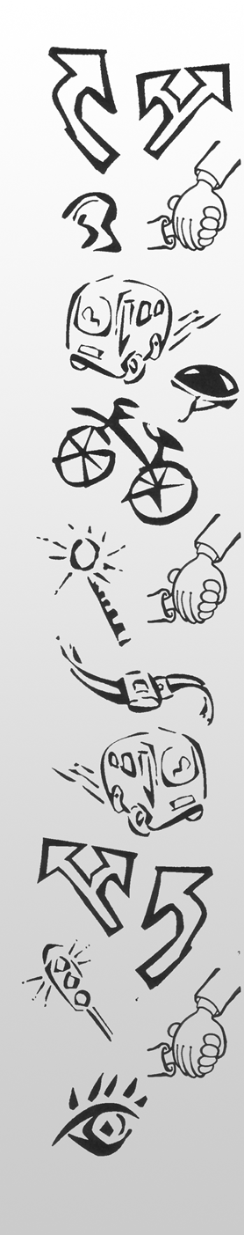

Stop, Look and Listen before you cross the street.
Use your eyes and use your ears before you use your feet.

Stop, Look and Listen before you cross the street.
Use your eyes and use your ears before you use your feet.

I’m not in a driveway.
I’m not on a road.
I’ll stand back one step
Just like I was told.

Look all around –
Before I decide.
I’ll check for traffic,
So I won’t be surprised.

Stop, Look and Listen before you cross the street.
Use your eyes and use your ears before you use your feet.

Make sure that it’s safe
Before I cross the road.
Use the best skills I’ve got
To decide when to go!

Stand tall and straight,
No time to dream.
Walk safely and smartly
So I can be seen.

Learning experience 2: Walking safely

Learning intentions
By the end of this learning experience students can explain:
- why they should walk on the house side of the footpath
- why they use kerb drill to cross a driveway
- why they should walk well off the road, if there is no footpath
- how to use a pedestrian crossing safely.

Competencies developed in this learning experience
Road safety:
- walking safely on the footpath
- walking safely where there is no footpath
- crossing correctly at a pedestrian crossing
Listening
Picture interpretation

Activities

1. Footpaths and driveways
Show the class Photo 3 from the Stepping Out Photopack.
Ask: Where is the footpath?
Where are the houses?
Where are the people walking? (On the house side of the footpath)
Why do you think they are walking there? (They are well away from the traffic)
Why is the child closest to the house/shops?
Where should the adult walk? (Closest to the traffic)
Read out the poem from Copysheet: Sneaky Driveways.
Ask: Why are driveways called sneaky?
Why do we have to take special care when we get to a sneaky driveway?
Why should we use kerb drill before we cross a sneaky driveway?
Why should you make eye contact with the driver before starting to cross?
Set up a footpath in the class. Use desks as houses/shops, a clear space for the footpath, a chalk line for the edge of the footpath. Be sure to include a driveway. One of the cars the students have made in Focus area 1 could be placed on the road. Check that students can identify the parts of the road.
Each student in turn walks along the house side of the footpath, using kerb drill when they get to a driveway. Praise each one.

2. Country road
Show the class Photo 4.
Ask: Why do you think there isn’t a footpath here?
Where are the children walking? (On the grass verge, as far off the road as possible)
Do you think this is a safe place to walk? Why?
Why is the tallest child at the back? (So they can all see the road clearly)
Set up a country road in the playground. Use a strip of lawn as the grass verge. Show the students where the ‘road’ is. Place one of the vehicles the students have made on the road. Check that students can identify the different parts of the road.
Invite students in groups of three to walk alongside the road, as far from the edge of the road as they can. Check that they are walking with the shortest person in the front and the tallest in the back. Praise each group.

3. Parts of the road
Show the class Photo 6. Ask students to identify the different parts of the road.
Ask: Why do we have pedestrian crossings?
How do we recognise a pedestrian crossing?
Why should we still be very careful at a pedestrian crossing?
Why should we use kerb drill to cross at the crossing?
Why should we make eye contact with the driver?

Copysheet: Sneaky Driveways
Sneaky Driveway, you won’t sneak up on me.
You’re a sneaky peeky driveway, but I can see.
You might be hiding, but I see you peeking out from that tree.
Sneaky peeky driveway, don’t sneak up ... on me!

No surprises on the road for me.
Don’t know what might be coming, what I can’t see.
A car (!), a truck (!), a bike (!), a duck (!) you never know what there might be.
Use my eyes, so no surprises can sneak up ... on me!

So don’t be silly, and always take good care.
Be safe, be smart, be seen, use your ears and your eyes,
So when you’re looking and you’re listening you won’t be surprised.
No sneaky-peeky driveway hiding anywhere.
Be safe, be smart, be seen … and always be aware!

Walking safely, going down the street,
Looking out for anything that I might meet.
Standing tall, and taking care.
Be safe, be smart, be seen … and always be aware!

So don’t be silly, and always take good care.
Be safe, be smart, be seen, use your ears and your eyes,
So when you’re looking and you’re listening you won’t be surprised.
No sneaky-peeky driveway hiding anywhere.
Be safe, be smart, be seen … and always be aware!

Learning experience 3: Taking a walk – practical

Learning intentions
By the end of the learning experience students will be able to demonstrate:
- walking on the house side of the footpath
- using kerb drill to cross a driveway
- walking on the grass verge well away from the road when there is no footpath
- crossing the pedestrian crossing using kerb drill.

Competencies developed in this learning experience
Road safety:
- walking on the house side of the footpath
- walking well away from traffic when there is no footpath
- use kerb drill to cross the pedestrian crossing

Activities
Explain to the class that they are going out walking to practise their walking skills. Remind them about taking care in the school car park and what to do when they come to a driveway.
Ask: Where do we walk on the footpath?
Where do we walk if there isn’t footpath?
What is a pedestrian crossing used for?
How do we cross at the crossing?
Why should we make eye contact with a driver?
Explain to students that if a car approaches and stops at the pedestrian crossing, they should make eye contact with the driver, then cross, while at the same time watching for traffic from the other direction.
Divide the students into pairs. Ask them to hold hands. Put the pairs of students into groups, each group with an adult leading them. Position an adult at the beginning and end of the line. Set off for your walk. Take photos of the students walking in the correct place, using kerb drill at sneaky driveways and the pedestrian crossing.
On your return, display the photos under headings ‘Walking on the footpath’, ‘Walking where there is no footpath’, ‘Crossing driveways’, and ‘Using the pedestrian crossing’. Invite individual students to view the photos and tell a story about what is happening in them.

Learning experience 4: School patrols and traffic wardens

Learning intentions
By the end of this learning experience students will be able to:
- explain why there are school patrols and traffic wardens
- use correct procedures when using a crossing where there is a school patrol or traffic warden.

Competencies developed in this learning experience
Road safety:
- crossing with the school patrol
- crossing with the traffic warden

Activities

1. School patrols and traffic wardens
Invite members of the school patrol or traffic wardens to class. They explain their role and bring the equipment they use to class.
Ask: How can we help the school patrols?
How can we help the traffic wardens?
Read out the poem on Copysheet: Listen to the School Patrol.

2. Revise procedures
Do one or all of the following that are appropriate for the class.

School patrol
In the classroom, revise the correct procedures for crossing at a school patrol. Take students out and in small groups have them cross with the patrol. This could be done in the half hour before the school patrol normally starts operation in the afternoon.

Traffic wardens
Revise correct procedures for crossing with the traffic wardens. Take students out and in small groups have them cross with the traffic wardens.

Copysheet: Listen to the School Patrol
Listen to the school patrol (listen to the school patrol).
Wait till they say I can go (wait till they say I can go).
Check both ways before I cross
The pedestrian crossing (the safest place to cross!)

Ready? (ready?)
Signs out! (signs out!)
Check? (check?)
Clear! (clear!)
Cross now!

Listen to the school patrol (listen to the school patrol).
Wait till they say I can go (wait till they say I can go).
Check both ways before I cross (check both ways before I cross)
The pedestrian crossing (the safest place to cross!)

'Cross now' the school patrollers call ('cross now' the school patrollers call).
It’s safe to cross for one and all (it’s safe to cross for one and all).
Signs go out, the traffic stops (signs go out, the traffic stops).
The pedestrian crossing (the safest place to cross).

Ready? (ready?)
Signs out! (signs out!)
Check? (check?)
Clear! (clear!)
Cross now!

