Road Safe

Years 0–1 Focus area 1
This section of the Road Safe programme contains one of the following focus areas for students at years 0–1 (ages 5-6):
- Roads and traffic
- On the move
- By bus or by car
- Managing hazards
Note: Research suggests that an effective programme should include learning experiences from each of the focus areas.

Focus area 1: Roads and traffic

Contents
Focus area 1: Roads and traffic 3
Focusing question 3
Explanation 3
Notes for the teacher 3
Curriculum links 3
Resources 3
Success criteria 4
Learning experience 1: Starter 5
Learning intention 5
Competencies developed in this learning experience 5
Activities 5
Copysheet: Safe Way Home 7
Learning experience 2: What is traffic? 8
Learning intention 8
Competencies developed in this learning experience 8
Activities 8
Copysheet: The Most 10
Copysheet: Traffic for Matching 11
Copysheet: Cars, Cars Everywhere 12
Learning experience 3: On and around the road 13
Learning intentions 13
Competencies developed in this learning experience 13
Activities 13
Learning experience 4: Observation walk – practical 15
Learning intention 15
Competencies developed in this learning experience 15
Activities 15
Copysheet: My Observation Walk 17
Copysheet: Traffic for Pictogram 18
Copysheet: Roads and Traffic near Home 19

Focus area 1: Roads and traffic

Focusing question
What do I need to know to keep safe on or near the road?

Explanation
In this focus area students talk about how they come to school. They find out about different types of traffic and the appropriate place for each on the road. They learn to identify the different parts of the road and the safest place for students to be. They identify simple signs and markings. They begin the process of developing safe practices when on or near the road.

Notes for the teacher
Ensure that students can give their name, address, telephone number, and rapid number if appropriate. This will be helpful when they are talking about getting from home to school safely. There is a privacy issue if personal address details are displayed in classrooms.
Students should be able to recognise the following signs and markings: pedestrian crossings, bus stop, stop signs, give way signs, traffic lights, school patrol signs (if appropriate).
The road tiles will be most effective if fastened with Bu-tak to a carpeted area. They could be made available for students to play with at lunchtimes, to reinforce learning.

Curriculum links
Key Competencies: Managing self; Relating to others; Participating and contributing
Learning areas: Level 1 Health and physical education: Strand C – Relationships; Strand D –Community resources
Level 1 English: Speaking, writing and presenting – Purposes and audiences, ideas; Listening, reading, and viewing – ideas
Level 1 Social Sciences: Significant places
Level 1 The Arts: Visual arts – Communicating and interpreting

Resources
Art materials, scissors
Copysheet: Safe Way Home
Helping Hands: A Guide for Parents and Caregivers (available from your School Community Officer)
Copysheet: The Most (poem)
Photos 1 and 2 from the Stepping Out Photopack (available from your School Community Officer)
Copysheet: Traffic for Matching
Copysheet: Cars, Cars Everywhere (poem)
Large cartons or paper bags
Photos 3, 4 and 5 from the Stepping Out Photopack (available from your School Community Officer)
Road tiles (available from your School Community Officer)
Toy vehicles, signs and people
Copysheet: My Observation Walk
Copysheet: Traffic for Pictogram
Copysheet: Roads and Traffic near Home
Digital camera

Success criteria
At the end of this focus area students will be able to:
- name and identify different types of traffic
- name and identify the different parts of the road
- identify and name traffic signs and markings close to the school.

Learning experience 1: Starter

Learning intention
By the end of this learning experience students will be able to describe how they come to school.

Competencies developed in this learning experience
Art work
Interpreting bar graphs

Activities

1. Introduction
Write Road Safety on the board in big letters. Tell the class that over the next few weeks they will be doing a road safety programme and that this will teach them how to keep safer on or near the roads. Explain that the School Community Officer will be coming to take part in some lessons, especially on days when they go out on to the road to practise new skills.

2. How we come to school
The teacher, and School Community Officer if present, tell the class how they come to school and why they come that way. Examples might be:
I walk to school if it is fine, because I like to get some fresh air and I live quite near the school. If it is raining, I catch the bus.
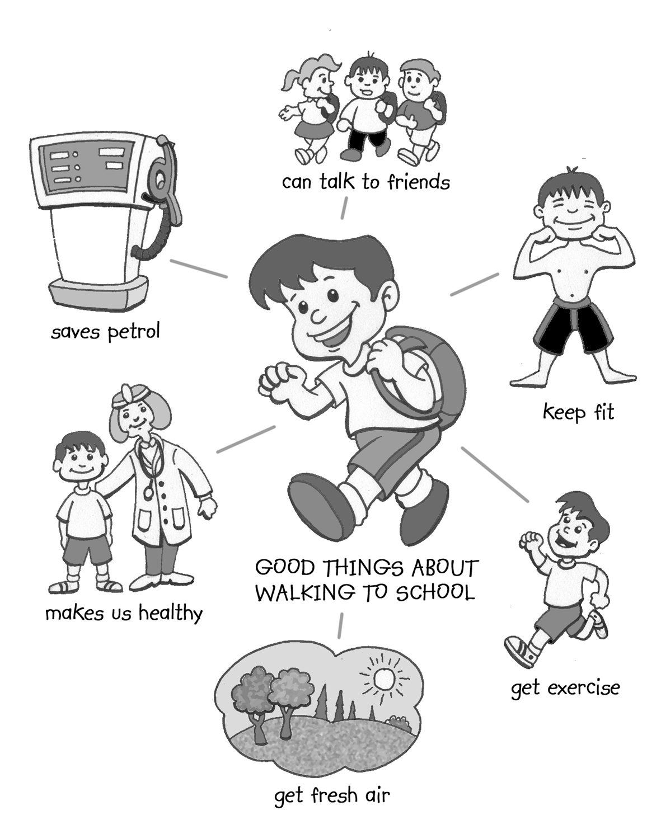
I come to school in the police car because I have to visit lots of schools and I need to be able to get to them all quickly.
Invite students to tell the class how they come to school. Ask some follow-up questions, such as:
- Do you always come to school this way?
- Who do you walk to school with?
- Who drives you to school in the car?
- What is it like coming to school on the bus?
Talk about how, if you usually come in the car, it is a good idea to walk to school at least once a week if it is not too far.
Ask: Why is it good for us to walk sometimes?
Record students’ answers in a star diagram like the one on the right.

Read the poem Walking to School (School Journal Pt2 No2, 1989).
Each student draws a picture of themselves coming to school in their usual way.
Arrange these in a graph like the one below.
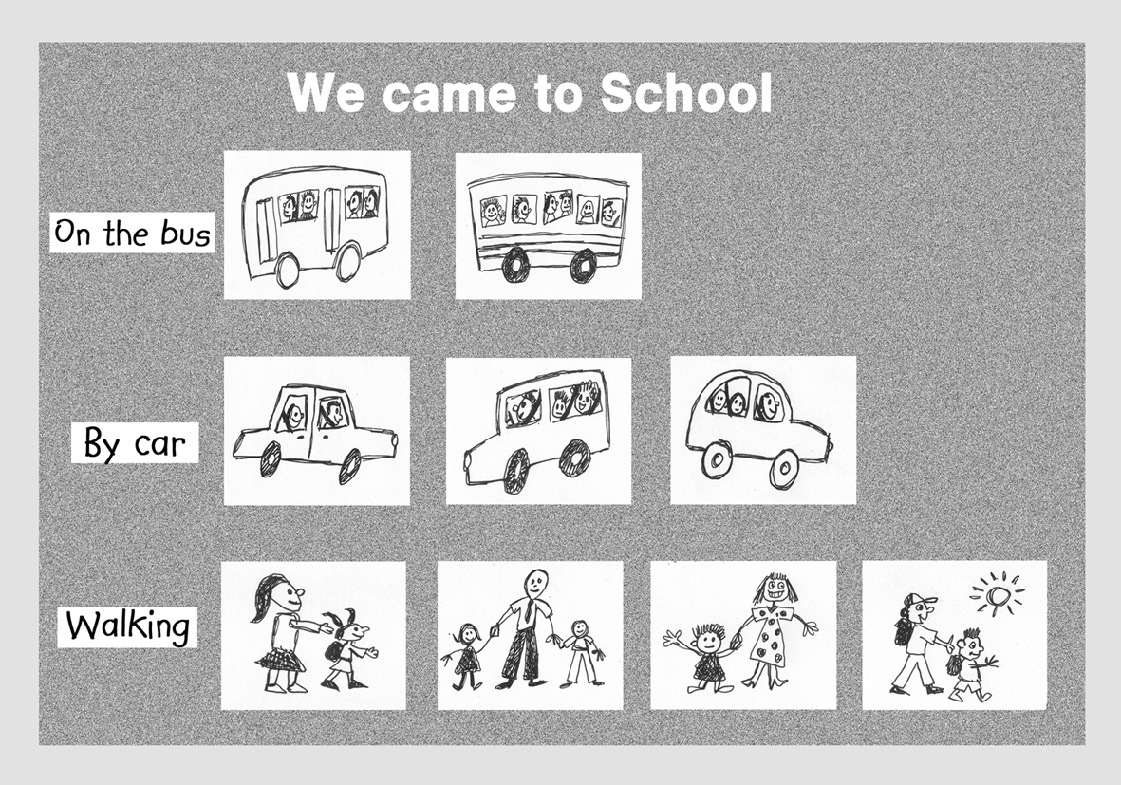
Talk about how it is very important, whichever way you come to school, to know how to keep safe on or near the road. Give some examples of how you keep safe on the way to school. Possible examples include:
I always put on my safety belt.
I use kerb drill when I cross the road.
I stand well back while I wait for the bus to arrive.
Give each student Copysheet: Safe Way Home to take home to their parents or caregivers. You may like to offer an incentive to get them all back. If parents have not attended the parents’ meeting, a copy of Helping Hands should also be sent home.

Copysheet: Safe Way Home

Dear Parent or Caregiver
Your child will be doing a road safety programme over the next few weeks. It will teach your child to behave in a safe way as a pedestrian and passenger. During the programme there will be some activities that you can help your child with. The first of these is set out below.
Please give your child the opportunity to show you what he or she has learnt.
Research shows that children learn about road safety best when they are taken out to do practical training with a responsible adult. Please take your child out whenever you can, and ask them about safe behaviour on or near the road.
Please remember to model safe pedestrian and passenger behaviour yourself. This includes things like always putting your safety belt on, making sure to ‘stop, look and listen’ before you cross the road, walking sometimes instead of taking the car, and parking the car and going to meet your child if you pick them up after school.

Please return this letter to school by .....................................

Thank you for your help.

......................................... .........................................................................................
(Classroom Teacher) (School Community Officer)

Tick the boxes to show which you have completed.
If your child walks to school
- We have walked the safe route to and from school together.
- During our walk we decided on safe places to cross the road.
- My child showed me the ‘Stop, Look and Listen’ kerb drill before we crossed the road.
- We walked safely along the footpath.
- Where there was not a footpath we walked as far off the road as possible.
If your child comes to school by car
- My child did his/her safety belt up correctly.
- My child sat quietly in the car.
- My child explained why it is safest to get out of the car on the footpath side.
- We talked about safe places to park at school.
- My child waited for me to get out of the car and meet them at school.
If your child comes to school on the bus
- We went together to the bus stop.
- My child showed me a safe place to wait while waiting for the bus.
- We talked about getting on and off the bus safely.
- We talked about being safe on the bus.
- We talked about waiting until the bus had moved away before starting walking.
If your child comes to school some other way
- Write what you and your child did to make sure they will be safe getting to and from school. Do this on the back of this page.

Learning experience 2: What is traffic?

Learning intention
By the end of this learning experience students will be able to name some basic types of traffic.

Competencies developed in this learning experience
Recognising types of traffic Co-operation
Design and art work Oral reading – poetry
Picture interpretation Matching
Colouring Counting
Grouping Design

Activities

1. Types of traffic
Read the poem The Most to the class.
Ask: What sorts of truck can you see in the picture?
What other sorts of truck are there?
Explain that trucks are one type of traffic. Traffic means all the things that travel on the road and the footpath. Ask the students to name other things that travel on the road or footpath – for example, cars, buses, horses, people and motorbikes.
Show the class Photo 1 from the photopack. Explain that this photo is in the city.
Ask: What sorts of traffic can you see?
List these on the board in a diagram like the one below.
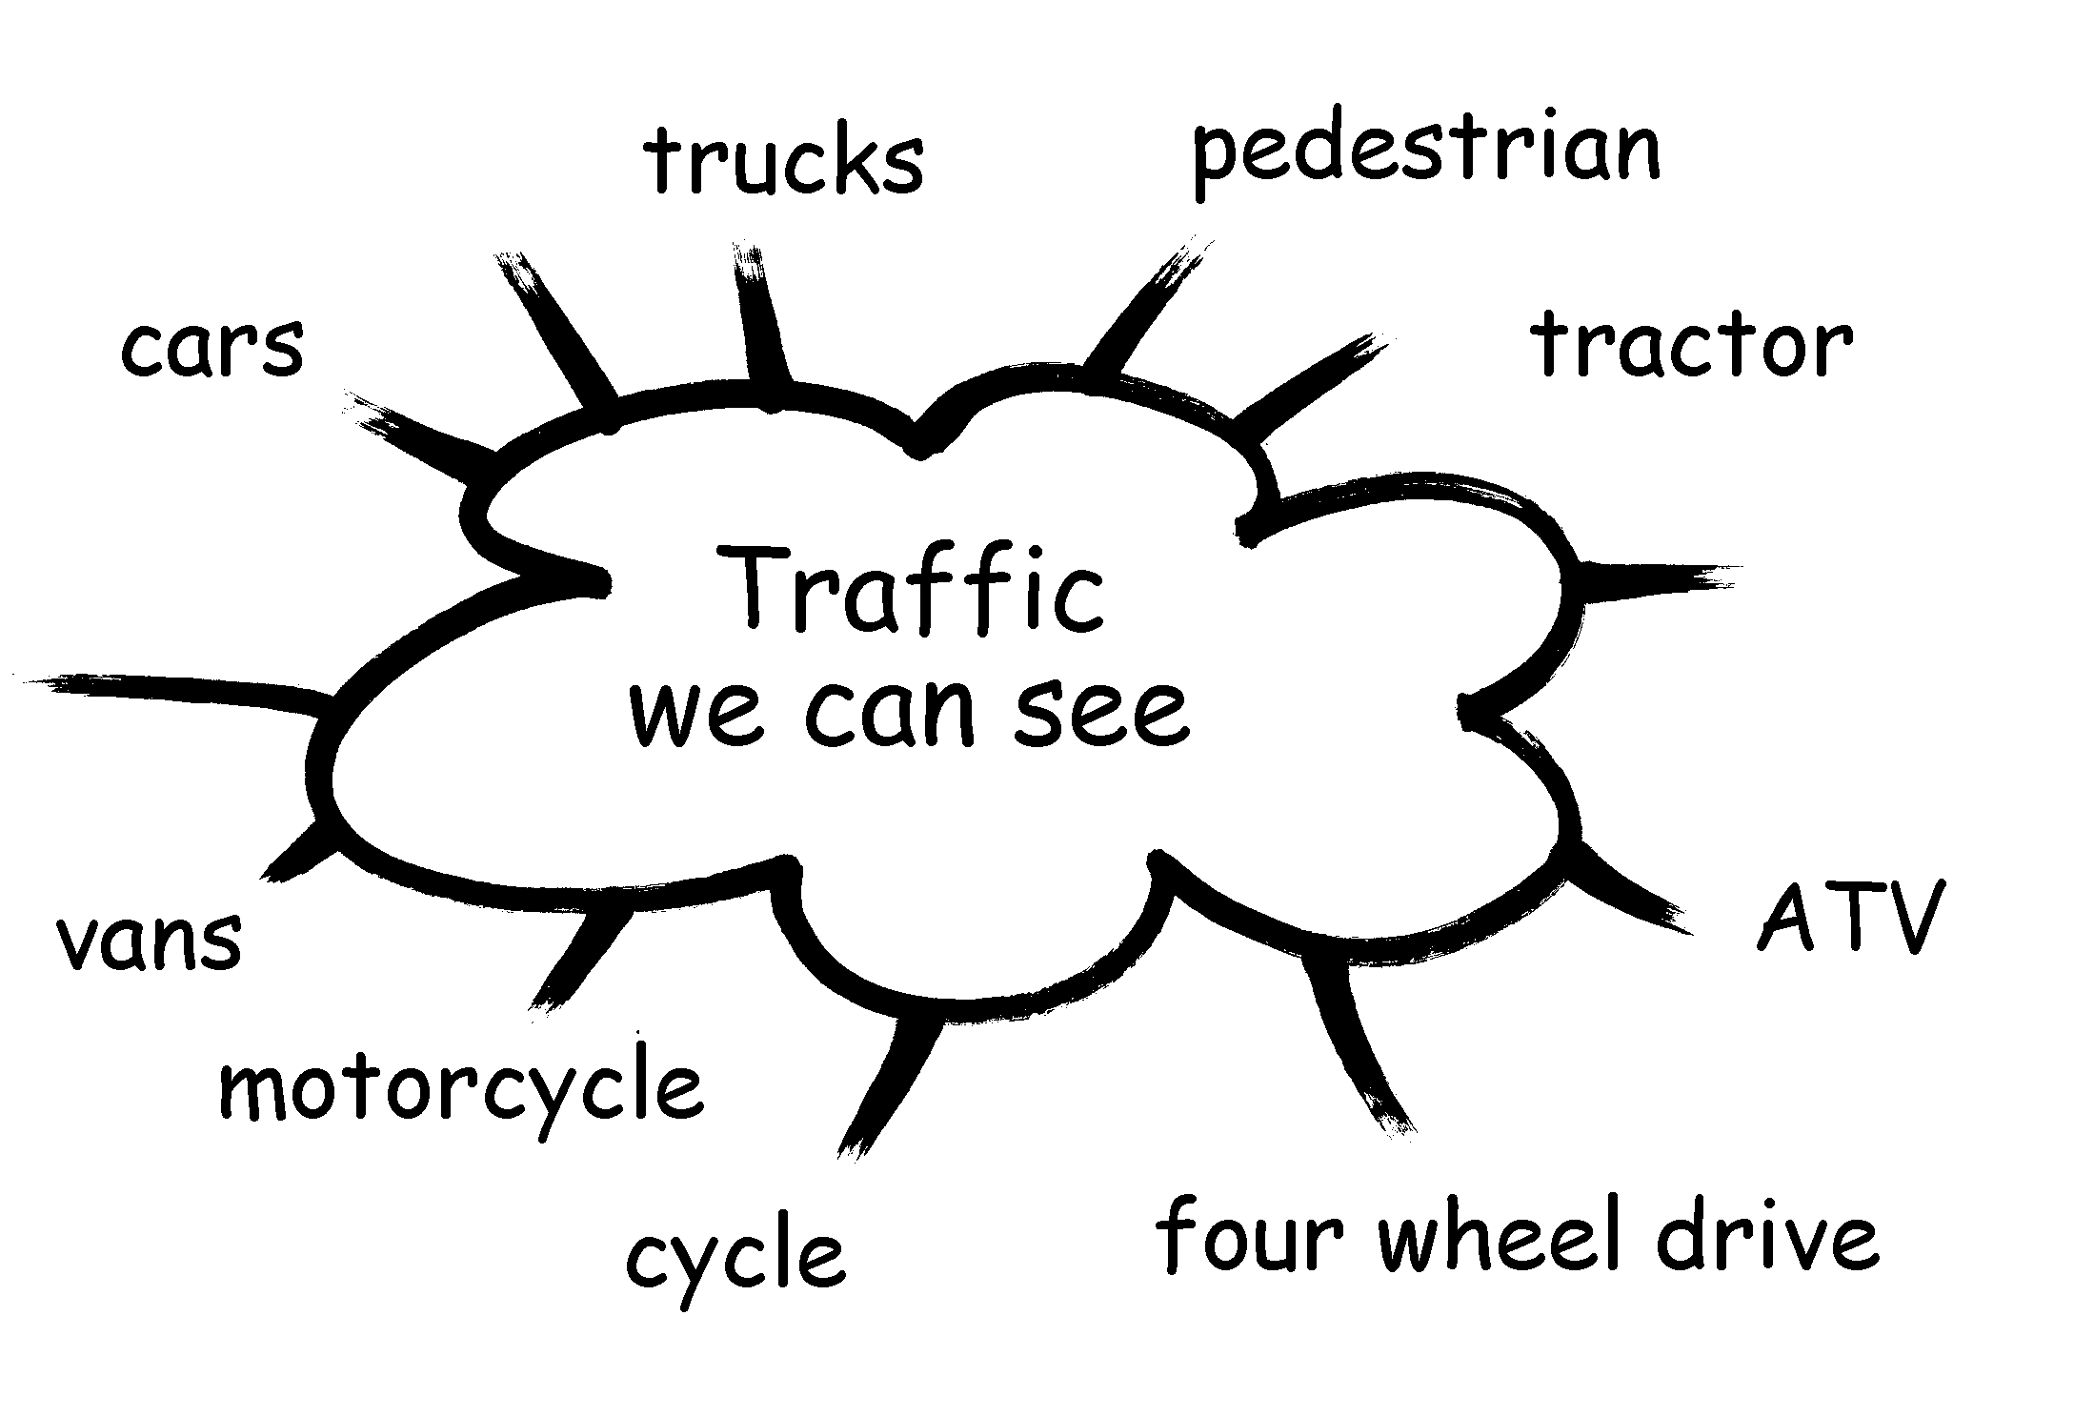

Show the class Photo 3. Explain that this is in the country.
Ask: What sorts of traffic can you see?
Add these to the diagram as well.
Ask: What sorts of traffic do we see in (name of local area)?

2. Matching activity
Hand out Copysheet: Traffic for Matching. Students can do some or all of the following:
- colour each type of traffic in one colour
- count the different types of traffic (cars, buses, pedestrians)
- count the number of each type of traffic (how many buses, cars ...)
- cut out the squares and group the different types of traffic together
- group traffic in different ways (all the traffic with wheels, all the traffic that goes on the road ...).

3. Art activity
Students could do one or both of the following:
- cut types of traffic from magazines and glue on to a collage
- make vehicles by either painting cartons that can be pushed around the floor or ‘driven’, or by painting large paper rubbish bags that can be worn. Roads can be drawn with chalk on the floor or playground, or marked on the sand area, so that students can use their vehicles.
Finish the session by reading the poem on Copysheet: Cars, Cars Everywhere or the poem Motorway Madness from Junior Journal 2002.

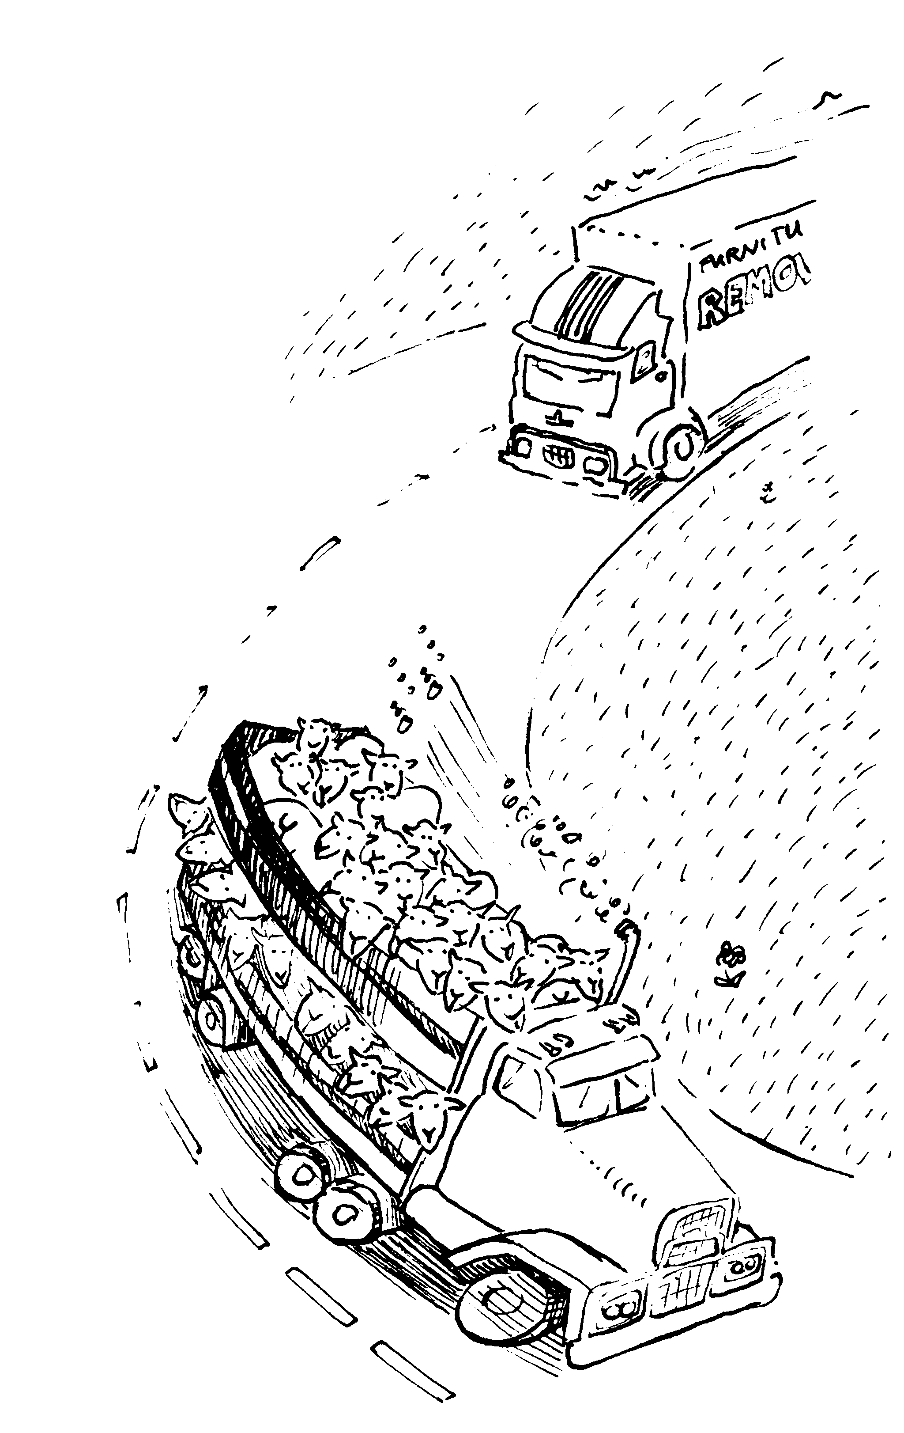
Copysheet: The Most
by Alan Bagnall

‘I’m carrying
The most!’
Each truck roars
As it races
Down the road.
‘I’m carrying
The most!
The most
Important load!’

Copysheet: Traffic for Matching
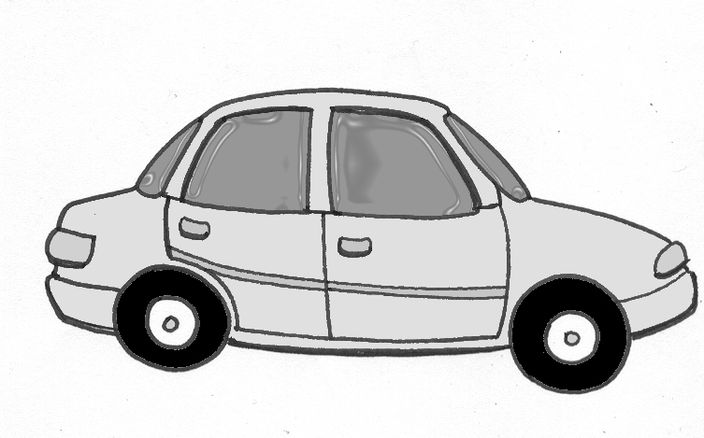 | 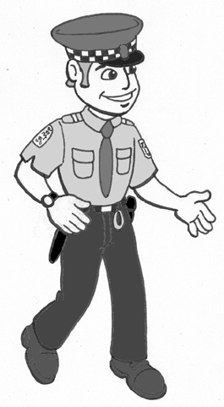 | 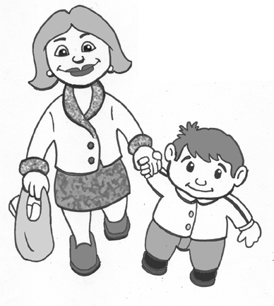
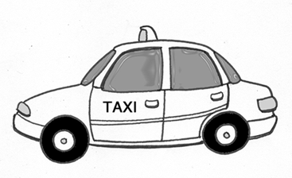 | 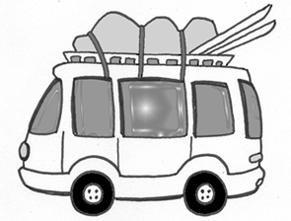 | 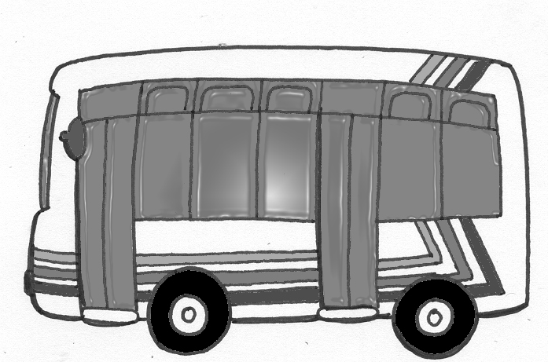
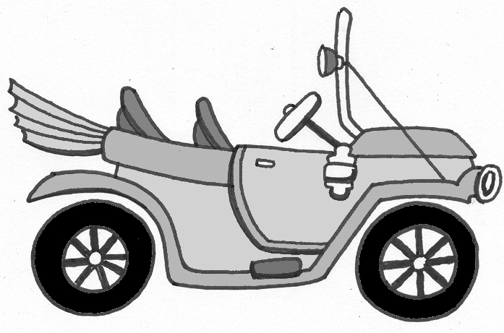 | 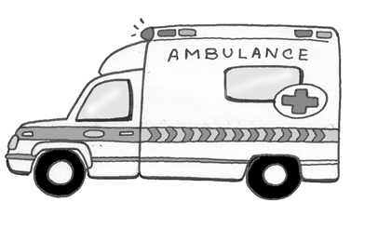 | 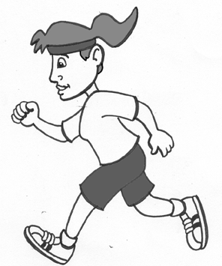
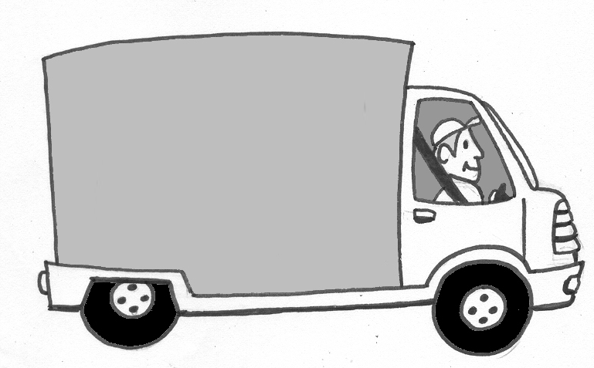 | 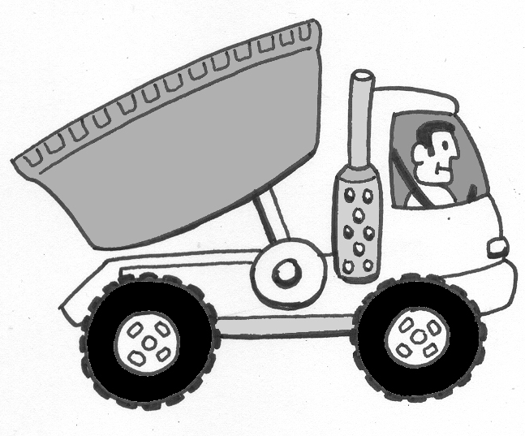 | 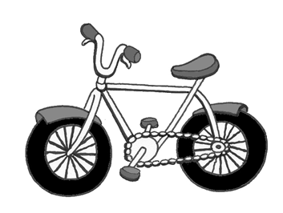
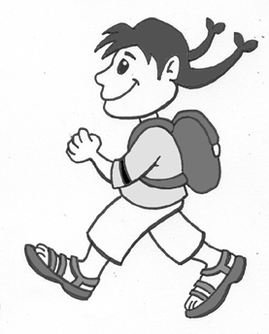 | 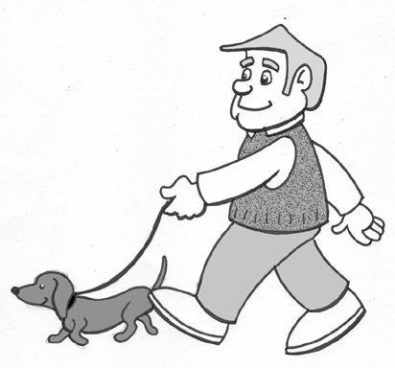 | 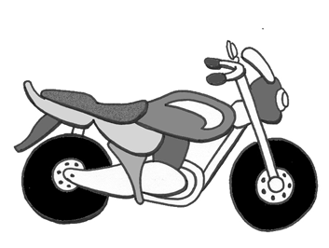

Copysheet: Cars, Cars Everywhere
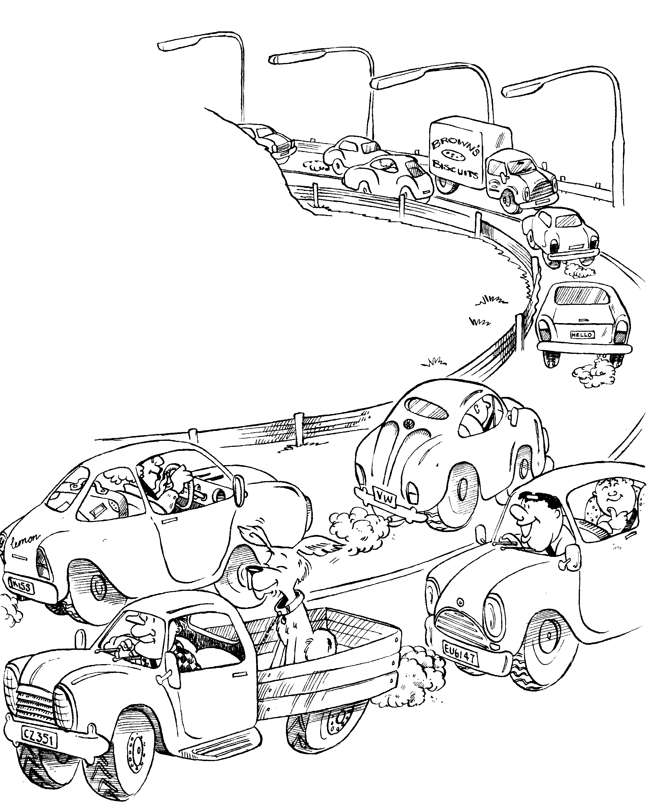
by Alan Bagnall

Up and down

The motorway

To and fro

They drive all day.

Cars, cars

Everywhere,

All intent

On getting there.

Learning experience 3: On and around the road

Learning intentions
By the end of this learning experience students will be able to:
- name and identify the major parts of the road
- explain which parts of the road are safest for them
- recognise some simple road signs and markings.

Competencies developed in this learning experience
Road safety:
- identifying parts of the road
- identifying parts of the road on which they are safest
- identifying simple road signs and markings
Listening and comprehension
Picture interpretation/inference

Activities

1. Identifying parts of the road
Write the following words on the board:
footpath gutter road
driveway grass verge kerb
house side of the footpath pedestrian crossing
Show in turn Photo 3 (city or town), and Photo 4 (country) from the Stepping Out Photopack. Referring to each word written on the board in turn, invite students to come up and identify these on the picture. Over the next few days, repeat this exercise so that all students can identify the parts of the road.

2. Road signs and symbols
Talk about how we use signs and symbols to give messages. Look at some of these in the class or school environment. Explain that traffic needs signs and symbols too, so that it knows what it must do and where it can go. People need signs to tell them when to cross the road and where to cross the road, and cars and trucks need to know when to stop and how fast to drive.
Brainstorm with students any road signs and road markings they know. Write these on the board or a chart and talk about each one.
Show Photo 5 from the Stepping Out Photopack. Have students identify road signs and symbols they recognise. Talk about ones that are new to them.

3. Road parts and markings
Lay out the road tiles, using either the urban or rural side, as appropriate.
Work with students to identify road parts and markings. Play the Where would ... game. For example, take a toy person and ask:
Where would it be safest for this person to walk?
Where it be safest for this person to cross the road?
Take a vehicle and ask:
Where should the car drive?
Where would it have to stop if people were crossing the road?
Give students time to play on the road tiles with toy vehicles and people.

Learning experience 4: Observation walk – practical

Learning intention
By the end of this learning experience students will be able to identify traffic, parts of the road, and road signs and markings near their school and home.

Competencies developed in this learning experience
Road safety:
- identifying traffic
- identifying road signs and markings
- identifying parts of the road
Art work
Working with others
Listening and respond to texts and relate them to personal experience

Activities

1. Looking and listening
Seat students in a circle on the floor. Blindfold one student and have them sit in the middle of the circle, or ask the student to cover their eyes. The other students, in turn, make a sound such as a whistle or hooter. The blindfolded student must point to the direction from which they think the sound is coming. Other students take turns.
Ask: How easy was it to tell where the sound was coming from?
When you hear a car or truck noise, is it hard to tell where the sound is coming from?
Talk about how, when you are on or near the road, it is very important to look as well as listen for traffic, to make sure which direction it is coming from.

2. Observation walk
Explain that the class is going out on an observation walk to look at parts of the road, road signs and markings, and to look and listen for traffic. Review safe practices when near roads, including walking across the school car park, if applicable. Remind students that they must walk in pairs on the house side of the footpath, well away from other traffic, and to stop, look and listen when they come to driveways.
Have students work in pairs. Give each pair Copysheet: My Observation Walk. Make four planned stops on the walk:
Stop 1 – work with students to identify the different parts of the roadway.
Stop 2 – work with students to identify traffic signs and markings.
Stop 3 – ask students listen to traffic sounds. They can try and identify traffic coming that they can’t see yet.
Stop 4 - stop in a safe place for about 5 minutes. In pairs, students complete the traffic observation exercise. They put a tick in the appropriate box each time they see a truck, car, cycle or motorbike.
Use the camera to take appropriate photos of the local area.

3. After the walk
Ask: Do you think the roads around our school are busy? Why, or why not?
Do you think the roads around our school are quiet or noisy? Why, or why not?
Do you think the traffic around our school goes fast or slow?
Put two pairs together as a group. They use the information from Copysheet: My Observation Walk and the vehicles from Copysheet: Traffic for Pictogram to create a pictogram like the one below. Display each group’s work.
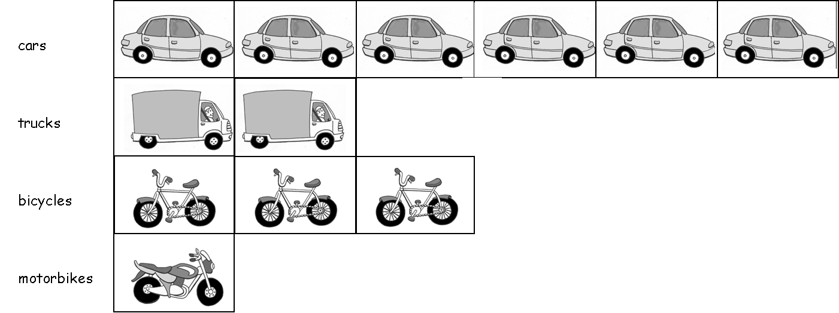

From Copysheet: Roads and Traffic near Home give each student the slip for Week 1 to take home. You may like to make a post box for students to ‘post’ the slips as they are returned.

Copysheet: My Observation Walk
Put a tick in the box if you see one of these things.

Type of traffic | Put a √ here

truck

car

motor bike

bicycle

Copysheet: Traffic for Pictogram

Copysheet: Roads and Traffic near Home

Week 1
Name of student:
As you know, your child is doing a road safety programme at school. To help reinforce the messages in the programme, please go for a walk with your child and count the number of driveways that you pass. Remember to stop, look and listen before you cross a driveway. Return this slip by the end of the week.
Number of driveways passed:

Week 2
Name of student:
As you know your child is doing a road safety programme at school. To help reinforce messages could you please go for a walk with your child and count the number of trucks that you see. Remember that your child should walk on the house side of the footpath or, if there is no footpath, as far from the traffic as possible. Return this slip by the end of the week.
Number of trucks seen:

Week 3
Name of student:
As you know, your child is doing a road safety programme at school. To help reinforce the messages in the programme, please go for a walk with your child and draw two traffic signs that you see, such as a Stop sign and Give Way. Remember that if you cross the road you should stop, look and listen for traffic. Return the slip by the end of the week.
Put the drawings on a separate page and attach it to this slip.

Week 4
Name of student:
As you know, your child is doing a road safety programme at school. To help reinforce the messages in the programme, please go for a walk and tick all the parts of the road that you see. Remember to hold your child’s hand to keep them safe. Return the slip at the end of the week.

- Footpath
- Road
- Gutter
- Grass verge
- Pedestrian crossing

