Doing the Right Thing

Focus area 5 Years 4-6
This section contains one of the following Focus areas from Doing the Right Thing for students at years 4–6 (ages 8–10):
- Respect
- Right and wrong
- Rules, laws, and consequences
- Honesty
- Role models

Focus area 5: Role models

Contents
Focus area 5: Role models 2
Notes for the teacher 2
Definitions 2
Key messages 2
Values 2
Curriculum links 2
Resources 2
Success criteria 3
Learning experience: Hero or role model? 4
Learning intention 4
Activities 4
Copysheet: Job Description 6

Focus area 5: Role models

Notes for the teacher
Make sure students do not confuse a role model with a hero, such as a sports person or a rock star. We tend to admire these people because of their physical qualities or prowess, not necessarily because of the positive values they have or because they behave in a pro-social way.

Definitions
Role model: Someone others look to as an example to imitate; someone who, because of their values and behaviour, is an example of how others should live their lives.

Key messages
I feel good when I do the right thing.
I will lead by example.

Values
The focus area will clarify students’ understanding of the values:
- honesty
- truthfulness
- kindness
- consideration and concern for others
- compassion
- responsibility
- respect.

Curriculum links
Key competencies: Managing self; Participating and contributing; Relating to others.
Learning areas:
Level 2 and level 3 Health and Physical Education – Strand A: Personal identity; Strand C: Identity, sensitivity, and respect; Strand D: Rights, responsibilities, and laws; Societal attitudes and values
Level 2 and level 3 Social Sciences – Roles and responsibilities in groups.

Resources
Copysheet: Job Description

Success criteria
Students will:
- write a job description for a role model that shows that they understand the qualities and behaviours that make a good role model.

Learning experience: Hero or role model?

Learning intention
Students will be able to explain what a role model is.

Activities

1. What makes a hero?
Ask the class to think of someone famous who they think of as a hero. Put the heading Hero on one side of the board.
Ask: What is it about this person that makes you admire them?
Put suggestions under the heading on the board. Suggestions might be: “She’s really pretty”, “His music is great”, “I love her books”, “He’s got lots of money”.

2. People we know
Divide students into groups of three. Ask the members of each group to think of someone closer to home who sets a good example of how to behave. They make a group list of why they have chosen this person – in other words, what qualities they have and how they behave (for example, kind, patient, good teacher).
Ask each group to join with another group. They share their lists and make one common list. Take reports from each group and write the qualities and behaviours they give on the board under a heading Role Model, putting a tick beside any that have already been given.
Ask students to discuss in pairs if they would rather be a hero or a role model. Hear some views.
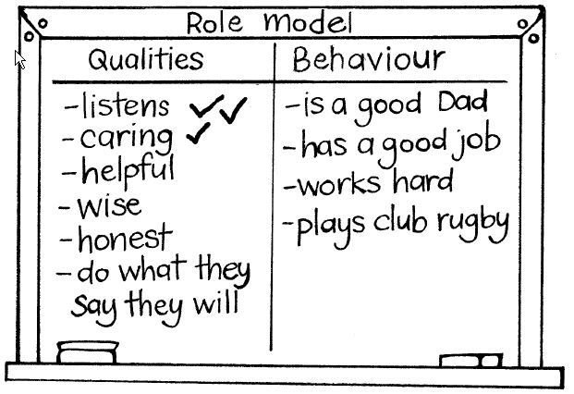

3. Job description for a role model
Working individually or in pairs, students write a job description for a role model for young people, using the format on Copysheet: Job Description. Go over the form carefully with the class, discussing the meaning of such terms as attitude, environment and qualities. Some of these could be shared with parents and caregivers at a parent/caregiver meeting or in the school newsletter.

Copysheet: Job Description

Position: Role model for children and young people
This is a particularly important job, which requires a special person who has positive values and behaves in a way that helps others and makes New Zealand a better place to live. The chosen applicant should show the following qualities:

Attitude to work/job:
Attitude to other people:
Behaviour towards other people:
Attitude towards the environment:
Things done to protect the environment:
Qualities as a member of a team:
Attitude to rules and laws:
Behaviour on the roads:
How they feel about themself:

