Doing the Right Thing

Focus area 4 Years 4-6
This section contains one of the following Focus areas from Doing the Right Thing for students at years 4–6 (ages 8–10):
- Respect
- Right and wrong
- Rules, laws, and consequences
- Honesty
- Role models

Focus area 4: Honesty

Contents
Focus area 4: Honesty 3
Definitions 3
Key messages 3
Values 3
Curriculum links 3
Resources 3
Success criteria 4
Learning experience 1: Say no to lying 5
Learning intentions 5
Activities 5
Copysheet: Masks 7
Learning experience 2: Does an honest person cheat? 8
Learning intention 8
Activities 8
Copysheet: Janet and Henare 10
The Boy Who Cried Wolf 11

Focus area 4: Honesty

Definitions
Honesty: The quality of being truthful, trustworthy and law-abiding.
Cheating: To trick someone in order to get something; to try to do well in a test or game by breaking the rules.
Lying: Saying something that you know isn’t true.
Stealing: Taking something that you know doesn’t belong to you.
Consequences: Something that happens because of something we have said or done. Consequences can be positive or negative.

Key messages
I will remember to think before I speak or act.
Honesty is the best way.
If I break the rules, I pay the price.
I can decide what is right and wrong.

Values
The focus area will clarify students’ understanding of the values:
- honesty
- truthfulness
- responsibility
- consideration and concern for others
- self-respect
- respect.

Curriculum links
Key competencies: Managing self; Participating and contributing; Relating to others.
Learning areas:
Level 2 and level 3 Health and Physical Education – Strand A: Personal identity; Strand C: Identity, sensitivity, and respect; Strand D: Rights, responsibilities, and laws; Societal attitudes and values
Level 2 and level 3 Social Sciences – Roles and responsibilities in groups.

Resources
Copysheet: Masks
Story: Pinocchio by C Collodi (there are a number of simple versions available)
Option – any other fairy tale, well known fable or Māori or Pacific Island legend that the students know well. The Boy Who Cried Wolf is given here.
Copysheet: Janet and Henare

Success criteria
Students will:
- use masks to indicate they can distinguish lies from the truth
- write slogans that show that cheating has negative consequences.

Learning experience 1: Say no to lying

Learning intentions
Students will:
- distinguish lies from truth
- explain that lying is wrong.

Activities

1. Pinocchio
Read or tell the story of Pinocchio to the class, or give them the synopsis:
Pinocchio tells the tale of a poor carpenter, Geppetto, who has no wife and no child. He dreams of having a son of his own. He carves himself a puppet boy out of wood and calls him Pinocchio. When the puppet comes to life, Geppetto’s dream has come true.
Except … Pinocchio turns out to be not such a nice boy after all. Pinocchio enjoys nothing better than creating mischief and playing mean tricks. As he discovers, being bad is much more fun than being good. Pinocchio, like other children, has a lot of lessons to learn in life. When he disobeys his father and runs away, he has a series of adventures that teach him these lessons. One of the lessons he learns is not to lie. When Pinocchio tells a lie, his nose grows longer. Pinocchio doesn’t like it when this happens.
Eventually, Geppetto and Pinocchio are reunited inside a large fish that has swallowed them up. Once home, Pinocchio promises to be good, and he turns into a real boy and a real son.
Ask: Why do you think Pinocchio told lies?
What happened when he told lies?
What can our bodies do when we tell lies? (Blush, look down, look guilty, not look the other person in the eye)
How do you feel when someone lies to you?
The School Community Officer or teacher can tell about a time someone lied to them and how it made them feel.

2. Masks
Give each student Copysheet: Masks. Invite them to cut out and colour their own facemasks – one with a short nose and one with a long nose.
Either
Explain that you are going to retell the story of Pinocchio. Some things you say will be lies and some will be the truth. When students think they have been told a lie, they put the mask with the long nose up to their face. When they think it is the truth, they put the mask with the short nose up to their face. Remind them to make up their own minds.
Example: Once upon a time a carpenter called Moses made a puppet called Pinocchio …
Or
Read or tell another well known fairy tale or fable to the class. Some things you say will be lies and some will be the truth.
Example: Little Red Riding Hood usually wore a blue cape with no hood.
When the children think they have been told a lie, they put the mask with the long nose up to their face. When they think it is the truth, they put the mask with the short nose up to their face. Remind them to make up their own minds.
Ask: What do people think of us when they know we are telling lies?
Why is telling lies wrong?

3. Visitor talk
Arrange a class visit from the principal to talk about how telling lies is not acceptable behaviour in the school. Alternatively, this could be done in assembly.

Copysheet: Masks
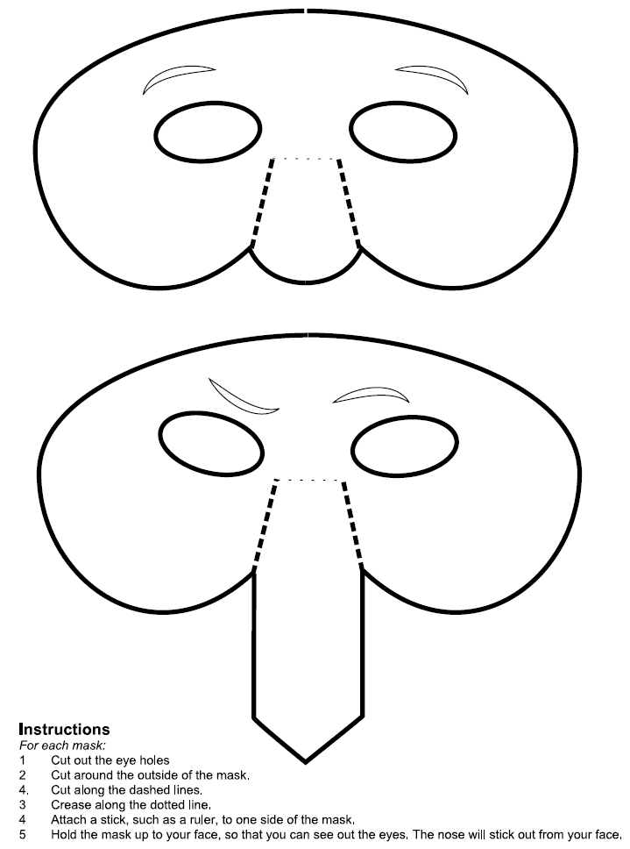

Learning experience 2: Does an honest person cheat?

Learning intention
Students will be able to explain that cheating has negative consequences.

Activities

1. Scenario: Janet and Henare
Present the scenario on Copysheet: Janet and Henare to students, either by reading or as a slide or chart.
Discuss the meaning of consequences.
Divide students into groups and allocate each group one of the following questions to answer:
What might the consequences be for Henare?
What might the consequences be for Janet?
What might the consequences be for the rest of the class?
What might the consequences be for the teacher?
What might the consequences be for the school?
What might the consequences be for Henare’s whānau?
What might the consequences for Janet’s family?
For a less able class, the questions could be rephrased – for example, “What might happen to Henare?” The last two questions could be left out.

2. Consequences
Put two headings on the board – Positive Consequences and Negative Consequences. As each group reports back, record the consequences they give under the appropriate heading, as shown in the diagram.
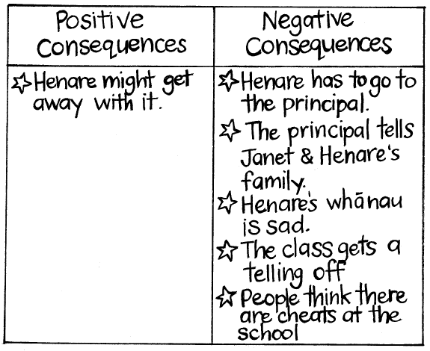
Invite the class to look at the completed chart, which should have far more negative than positive consequences. In pairs, students come up with a slogan to show what they have learnt. Some of their ideas could be recorded on a chart.
Examples might be:
Cheating doesn’t pay.
Honesty is the best policy.
Everyone gets hurt when someone cheats.

Taking action options
Either
Each student brings an old T-shirt. They choose one of the slogans and write it on their T-shirt, using fabric paints or crayons.
Or
Each student can make poster or bumper sticker displaying one of the slogans.
T-shirts, posters and/or bumper stickers could be displayed in a public place around the school and students invited to vote on the T-shirt that they think:
- has the best message
- has the best design.

Copysheet: Janet and Henare
Janet and Henare are sitting a test at school in the afternoon.

They meet at lunchtime and decide to copy one another’s answers during the test.

After the test, the teacher asks Henare if he and Janet have been cheating.

Henare claims that Janet copied off his answers, but he didn’t cheat.

The Boy Who Cried Wolf
Traditional tale
There once was a shepherd boy who was bored as he sat on the hillside watching the village sheep. To amuse himself he took a great breath and sang out, “Wolf! Wolf! The wolf is chasing the sheep!”
The villagers came running up the hill to help the boy drive the wolf away. But when they arrived at the top of the hill, they found no wolf. The boy laughed at the sight of their angry faces.
“Don’t cry ‘wolf’ when there’s no wolf, shepherd boy!” said the villagers. They went grumbling back down the hill.
Later, the boy sang out again, “Wolf! Wolf! The wolf is chasing the sheep!” To his naughty delight, he watched the villagers run up the hill to help him drive the wolf away.
When the villagers saw no wolf, they sternly said, “Save your frightened song for when there is really something wrong! Don’t cry ‘wolf’ when there is no wolf!”
But the boy just grinned and watched them go grumbling down the hill once more.
Later, he saw a real wolf prowling about his flock. Alarmed, he leapt to his feet and sang out as loudly as he could, “Wolf! Wolf!”
But the villagers thought he was trying to fool them again, and so they didn’t come.
At sunset, everyone wondered why the shepherd boy hadn’t returned to the village with their sheep. They went up the hill to find the boy. They found him weeping.
“There really was a wolf here! The flock has scattered! I cried out, ‘Wolf!’ Why didn’t you come?”
An old man tried to comfort the boy as they walked back to the village.
“We’ll help you look for the lost sheep in the morning,” he said, putting his arm around the youth. “Nobody believes a liar ... even when he is telling the truth!”

