Doing the Right Thing

Focus area 3 Years 4-6
This section contains one of the following Focus areas from Doing the Right Thing for students at years 4–6 (ages 8–10):
- Respect
- Right and wrong
- Rules, laws, and consequences
- Honesty
- Role models

Focus area 3: Rules, laws, and consequences

Contents
Focus area 3: Rules, laws, and consequences 2
Definitions 2
Key messages 2
Values 2
Curriculum links 2
Resources 3
Success criteria 3
Learning experience 1: Play by the rules 4
Learning intentions 4
Activities 4
Learning experience 2: Pros and cons 5
Learning intentions 5
Activities 5

Focus area 3: Rules, laws, and consequences

Definitions
Rules: A regulation or guideline designed to make people behave in a desired way for the good of all. An example of a school rule is that no student can leave the school grounds during the day without a note.
Laws: A set of rules accepted by a country to ensure that its members behave in a desired way for the good of all. Laws are enforced by penalties. Anyone who breaks the law commits an offence. An example of a New Zealand law is that no-one is allowed to steal.
Customs: Something that is usually done. An example is to have a Christmas tree at Christmas time.
Consequences: Things that happen because of what you have done. An example would be that if you break the driving speed limit you will be fined.
Pros: The advantages of or argument for something.
Cons: The disadvantages of or argument against something.

Key messages
It is wise to obey the rules and laws.
If I break the rules, I will pay the price.
I know that my actions have consequences.
I will remember to think before I speak or act.
Will my actions harm others or myself?

Values
This focus area will help clarify students’ understanding of the values of:
- respect
- honesty
- responsibility
- fairness
- consideration and concern for others.

Curriculum links
Key competencies: Managing self; Participating and contributing; Relating to others.
Learning areas:
Level 2 and level 3 Health and Physical Education – Strand A: Personal identity; Strand C: Identity, sensitivity, and respect; Strand D: Rights, responsibilities, and laws; Societal attitudes and values
Level 2 and level 3 Social Sciences – Roles and responsibilities in groups.

Resources
Set of resources for groups to construct a game (for example, dice, paper, pens, ruler, game board)
School Community Officer or another police officer

Success criteria
Students will:
- come up with a list of positive rules for a chosen group
- disagree with the statement: Spraying the wall was just a bit of fun
- agree with the statement: We should respect other people's property.

Learning experience 1: Play by the rules

Learning intentions
At the end of this learning experience students will be able to:
- explain why rules are needed
- draft some positive group rules.

Note for the teacher
Task 2 may be enhanced with the following photos from the obsolete Police Big Picture Pack, if it is still available from your School Community Officer:
- Young Offender
- Home Visit
- Alternative Action.

Activities

1. A game with rules
Divide students into groups of about five. Give each group a set of equipment. Ask them to invent a game and write clear and concise game rules.
Each group then passes their equipment and game rules on to another group, who will play the game.
At the conclusion, ask:
Did everybody’s game work? Why, or why not?
Did anyone have rules that didn’t work, or didn’t make sense? Explain.
What would have happened if we hadn’t had the rules?

2. We all need rules
Talk about how, whenever people live, work or play together, they need rules to make sure that they behave appropriately. This helps to keep people safe and cared for.
Ask: What are some groups you belong to that have rules?
What are some examples of these rules?
Put students back into their work groups. Ask students to decide on a group of people they want to belong to. These could be fictional or real – for example, a sports group, passengers on a boat, a group of people stranded on a desert island, or first settlers to New Zealand. They might like to give their group of people a name.
The students must come up with a list of rules to ensure that everyone in their group of people is kept safe and is respected and cared for. Explain that they should write the rules in positive language – for example, “Always lock the door when you leave” instead of “Never go out without locking the door”.
Students present their rules as a written chart.
Display all the sets of rules on the wall. Look for, and comment on, similarities and differences. Look at some of the charts in turn and ask the following question:
What could happen if rules are broken in our group of people?

Learning experience 2: Pros and cons

Learning intentions
As a result of this learning experience students will be able to:
- explain that actions have consequences
- make a responsible decision about respecting other people’s property.

Activities

1. Scenario
Tell the following story to the class.
One day Kelly was walking home from school with Scott and Sela. When they got to a high white wall, Kelly got a can of spray paint from her bag and suggested that they all write something on the wall. It would be fun. Sela wasn’t keen and started to move away. Scott thought it was quite funny and was keen to have a go. They didn’t know who lived in the house.
Put the headings Pros and Cons on the board. Check students’ understanding of these words. Brainstorm with the class the pros and cons of spraying the wall. Record these under the appropriate heading, as shown in the diagram below.
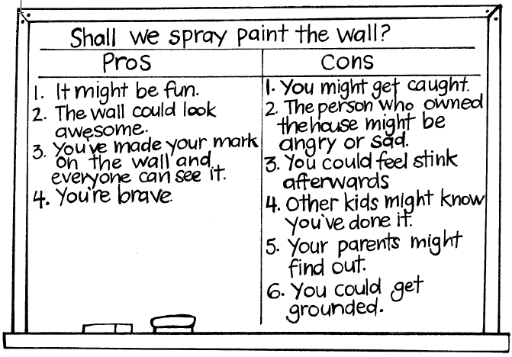
Ask: Is it worth the risk? Why, or why not?

2. What happens next?
The police officer explains to the class that spray painting a wall is an offence against the Summary Offences Act 1981. This law says that it is an offence to damage or deface any building, structure, road, tree, property, or other thing by writing, drawing, painting, spraying, or etching on it, or otherwise marking it without lawful authority and without the consent of the owner or occupier or other person in control of the building, structure etc. This law has been made to help protect people’s property.
Because Kelly is over 10 years of age she is criminally responsible for her actions and will have to face the consequences. She has been diverted from the formal court system and is being dealt with by a Home Visit. This can also be called alternative action.
Ask: Who are the people who would be involved in a home visit?
What do you think will happen at the home visit?
How do you think each of the people is feeling?
What do you think might happen next?
The Youth Aid Officer discusses the situation with Kelly’s parents and together they, and Kelly, decide what should be the consequences for Kelly.
Check if the class wants to add anything to the Pros and Cons Chart.
Tell the class that at the Home Visit it was decided that Kelly should apologise to the homeowner and paint the wall.
Ask: Who are the people who would be involved in the apology?
What do you think will happen when Kelly apologises?
How do you think each of the people is feeling?
What do you think might happen next?

Check if the class wants to add anything to the Pros and Cons Chart.

5. Continuum
Explain that you are going to give the class some statements, one at a time. After each they will be asked to position themselves on a continuum line, one end of which is agree and the other disagree. You will ask people from different points of the line the reason for their position.
Statements
Spraying the wall was just a bit of fun.
The alternative action was a fair consequence.
Sela should have stopped Kelly from using the spray paint.
We should respect other people’s property.

Taking action options
Students could:
- write a letter from Kelly to the lady who owned the fence, apologising and saying how she felt about the whole episode
- write or role-play a conversation between Kelly, Scott, and Sela before the spray painting started, to show how they could have dealt with this in a positive manner
- draw a cartoon or picture to show how Kelly might now deal differently with a similar situation – for example being, asked to keep watch while a friend steals from the dairy.

