Doing the Right Thing

Focus area 1 Years 4-6
This section contains one of the following Focus areas from Doing the Right Thing for students at years 4–6 (ages 8–10):
- Respect
- Right and wrong
- Rules, laws, and consequences
- Honesty
- Role models

Focus area 1: Respect

Contents
Focus area 1: Respect 2
Notes for the teacher 2
Definitions 2
Key messages 2
Values 2
Curriculum links 2
Resources 2
Success criteria 3
Learning experience 1: Respect in the community 4
Learning intentions 4
Activities 4
Learning experience 2: Respectfully me 5
Learning intention 5
Activities 5
Copysheet: Respectfully Me 6

Focus area 1: Respect

Notes for the teacher
The resource person needs to be briefed carefully before the activity. Explain that the class is working on the value of respect. The visitor is being brought to class as a person who commands respect in the community, because of their good works, qualities, achievements, and so on. Ask them if they would talk to the class about their job and the things they have done, and if they could include in some way the two key messages for the focus area.

Definitions
Respect: To think highly of someone because of their qualities or achievements and to treat this person with courtesy.

Key messages
I treat people with respect.
When I give respect, I earn respect.
I can change my behaviour.

Values
This focus area will help clarify students’ understanding of the values of:
- honesty
- respect
- responsibility
- care and consideration.

Curriculum links
Key competencies: Managing self; Participating and contributing; Relating to others.
Learning areas:
Level 2 and level 3 Health and Physical Education – Strand A: Personal identity; Strand C: Identity, sensitivity, and respect; Strand D: Rights, responsibilities, and laws; Societal attitudes and values
Level 2 and level 3 Social Sciences – Roles and responsibilities in groups.

Resources
A resource person from the community, who deserves respect (examples could include the School Community Officer, the principal, kaumatua, the mayor)
Drawing materials
Glue
Copysheet: Respectfully Me
A photo or drawing of each child. Give students prior notice to bring a photo of themselves if they can.

Success criteria
Students will be able to:
- name some people in the community they respect
- explain how people earn their respect
- describe one way they can show respect
- identify qualities about themselves that make people respect them
- identify some things they want to change about their behaviour to make them more worthy of respect.

Learning experience 1: Respect in the community

Learning intentions
Students will be able to:
- name people in the community whom they respect
- explain how they show these people respect.

Activities
Before the visitor enters the classroom, explain to the class that you have invited a visitor to talk to them, someone that you respect. You may need to define respect for the class.
Ask: How should we treat/show respect to this person?
Answers might include: Invite them politely into the room, show them to a comfortable chair, listen carefully to what they say, be quiet when the person is talking, ask sensible questions.
Arrange for one person to escort the visitor into the room, one person to thank them, and one person to escort them from the room.
The visitor is brought into the classroom, takes a seat and talks to the children. Allow some time for questions. The visitor is thanked and is escorted from the room.
Ask: Do you think this person is someone we can respect? Why, or why not?
Do you think we were respectful to our visitor? Explain your choice of answer.
What could we do to show this person that we really appreciated them coming to class?
Ask students what other people in the community they respect. A list of these could be written on the board. They could be generic people, such as the fire fighter, or a named person, such as Constable Maxwell.
Each student chooses one person they respect in the community, draws a picture of that person and around the drawing writes reasons why they respect them. The class drawings could be made into a frieze.
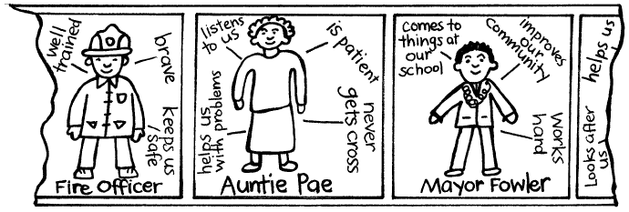

Learning experience 2: Respectfully me

Learning intention
Students will be able to:
- consider things about themselves that make them worthy of respect
- identify things they want to change about their behaviour.

Activities

1. What is respect?
Remind the class about the definition of respect. Go round the room and ask each student to give an example of behaviour that makes us respect people. Give some examples first, such as being polite, always on time, honest. Allow students to pass if they can’t think of anything.

2. Being worthy of respect
Give each student Copysheet: Respectfully Me. Show them your own completed version. In the frame they either draw a picture of themselves, or glue in a photo. Around the top they write things about themselves that would make other people respect them. Around the bottom, they write things they want to work on to make them even more worthy of respect. Some students may need help to identify these qualities and behaviours.
Invite some students to share their work with the class. Students could either take their work home to share with family members, or it could be displayed on the wall.

Copysheet: Respectfully Me
Draw a picture of yourself, or paste a photo in the picture frame below. Around the top, write things about you that make people respect you – for example, you are always a good friend. Around the bottom, write things that you want to work on so that people will respect you even more – for example, I won’t take other people’s things without asking.

Things people respect about me:
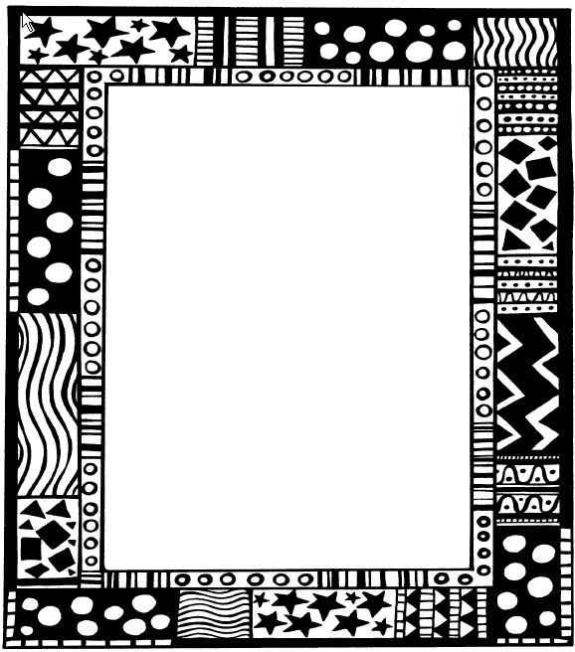

Things I want to change so that people will respect me more:

