Doing the Right Thing

Focus area 5 Years 0-3
This section contains one of the following Focus areas from Doing the Right Thing for students at years 0-3 (ages 5–7):
- Respect
- Right and wrong
- Rules, laws, and consequences
- Honesty
- Role models

Focus area 5: Role models

Contents
Focus area 5: Role models 2
Notes for the teacher 2
Definitions 2
Key messages 2
Values 2
Resources 2
Curriculum links 2
Success criteria 3
Learning experience: Who I want to be like 4
Learning intention 4
Activities 4

Focus area 5: Role models

Notes for the teacher
Make sure students do not confuse a role model with a hero, such as a sports person or a rock star. We tend to admire these people because of their physical qualities or prowess, not necessarily because of the positive values they have or because they behave in a pro-social way.

Definitions
Role model: Someone you like and admire, whom you want to copy.

Key messages
I treat people with courtesy.
When I respect others, I earn respect.

Values
The focus area will clarify students’ understanding of the values:
- honesty
- truthfulness
- responsibility
- compassion
- consideration and concern for others
- kindness
- respect.

Resources
Copysheet: People I Look Up To (cut up into words or phrases)
Drawing materials and glue

Curriculum links
Key competencies: Managing self; Participating and contributing; Relating to others.
Learning areas:
Level 1 and level 2 Health and Physical Education – Strand A: Personal identity; Strand C: Identity, sensitivity, and respect; Strand D: Rights, responsibilities, and laws
Level 1 and level 2 Social Sciences – Roles and responsibilities in groups.

Success criteria
Students can:
- name and draw a person who they want to be like.

Learning experience: Who I want to be like

Learning intention
Students will be able to identify someone in their life who is an example to them.

Activities

1. Real-life role model
Invite the School Community Officer to tell students a true story (or the teacher tells their own story) about how someone has been a great role model for them. It should be someone who is close to them (see the note about heroes.) As the story is told, the teacher writes up each quality or type of behaviour that is mentioned. The story might sound a bit like this:
Someone I have always admired and respected all my life is my brother. He is older than me and has always made sure that he looked after me – if I fell over, he would help me up, if I couldn’t do my homework he would help. (Teacher writes on the board kind, looks after me, helps with homework). I can remember once when I was sick, my brother stayed home on Saturday to keep me company, even though he really wanted to go to the rugby. (Teacher writes up cares about me, isn’t selfish)
When the police officer has finished the story, the teacher draws students’ attention to the words on the board and goes over them, explaining any new words.
The teacher asks the police officer:
What did you learn from your brother?
Do you still try to behave like him?

2. Our own role models
Talk about how we all have people whom we can look up to like that. They might not be someone in our family. It could be someone at school, or at church, or a friend’s parent. The teacher can give their own example.
Work with the class to help each student identify someone they look up to. Each student does a drawing of this person and completes the sentence:
I look up to …
Help each student to choose from words cut out from Copysheet: People I Look Up To that they think describe their person and to paste them around their drawing. They may add other words that they would like to include. Place all the drawings on the wall. Every day, choose one drawing to talk about with the class.
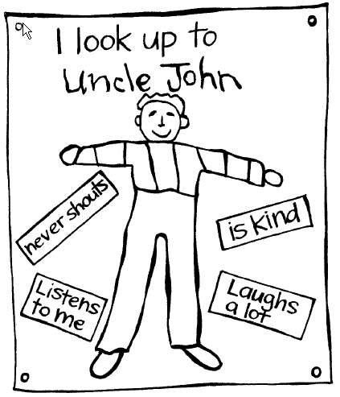
Copysheet: People I Look Up To

Thinks about others
Is kind
Always tells the truth
Listens to me
Helps me when I have a problem
Has good table manners
Cares about the pets
Puts their rubbish in the bin
Doesn’t take other people’s things
Laughs a lot
Looks after other people
Is gentle
Never shouts

