Doing the Right Thing

Focus area 4 Years 0-3
This section contains one of the following Focus areas from Doing the Right Thing for students at years 0-3 (ages 5–7):
- Respect
- Right and wrong
- Rules, laws, and consequences
- Honesty
- Role models

Focus area 4: Honesty

Contents
Focus area 4: Honesty 3
Notes for the teacher 3
Definitions 3
Key messages 3
Values 3
Curriculum links 4
Resources 4
Success criteria 4
Learning experience 1: Telling the truth 5
Learning intentions 5
Activities 5
Copysheet: Painting – Frame 1 7
Copysheet: Painting – Frame 2 8
Learning experience 2: Cheating 9
Learning intentions 9
Activities 9

Focus area 4: Honesty

Notes for the teacher
Constantly reinforce the message about not telling lies. Praise students who tell the truth. If you find that someone has told a lie, talk about why they did that and what they should have said.

Definitions
Honesty: Not stealing, cheating or telling lies.
Cheating: To trick someone in order to get something; to try to do well in a test or game by breaking the rules. To act dishonestly or unfairly in order to gain an advantage.
Lying: Saying something that you know isn’t true.
Stealing: Taking something that you know doesn’t belong to you.
Consequences: Something that happens because of something we have said or done. Consequences can be positive or negative.

Key messages
I will remember to think before I speak or act.
Honesty is the best way.
How would I feel if that were me?
Will my actions help others or myself?
I feel good when I do the right thing.

Values
The focus area will clarify students’ understanding of the values:
- honesty
- truthfulness
- responsibility
- consideration and concern for others
- kindness
- respect.

Curriculum links
Key competencies: Managing self; Participating and contributing; Relating to others.
Learning areas:
Level 1 and level 2 Health and Physical Education – Strand A: Personal identity; Strand C: Identity, sensitivity, and respect; Strand D: Rights, responsibilities, and laws
Level 1 and level 2 Social Sciences – Roles and responsibilities in groups.

Resources
Copysheet: Painting – Frame 1
Copysheet: Painting – Frame 2
Art materials
Another adult to take part in the role play with the teacher
Two small tables and chairs for the role play
Paper and pens

Success criteria
Students will be able to:
- explain that lying is wrong and has consequences
- explain that cheating is wrong and has consequences.

Learning experience 1: Telling the truth

Learning intentions
Students will be able to:
- distinguish lies from truth
- explain that lying is wrong.

Activities

1. Painting frames
Show students Copysheet: Painting – Frame 1. Read them the following story:
Pieri and Susi are in the paint corner. Pieri likes painting. He has started a lovely picture of a boat bouncing on the sea. Susi likes painting too. She and Pieri often paint together. Susi is making a picture of her family. She is using really bright colours.
Pieri is concentrating very hard. He turns round to get another brush and knocks the jar of paints on to the floor. He didn’t mean to do it. He feels a bit frightened, because the paints have made a big mess. Susi stops painting and looks at the mess too.
Show them Copysheet: Painting – Frame 2. Read them the continuation of the story:
Mr Scott, the teacher, hears the crash when the paints land on the floor and he comes over. He looks a bit cross.
“Did you do that?” he asks Pieri.
“No,” says Pieri, shaking his head. ”She did it.” He points to Susi.
Ask: Did Pieri mean to knock the paints on the floor? Why, or why not?
How did he feel when it happened?
How did the teacher feel when he saw the paints on the floor?
What did he think had happened?
Why do you think that Pieri said he didn’t do it?
What do you think he should have said?
Explain to the class that when you say something that isn’t true, it is called a lie. You are not being honest. Pieri told the teacher a lie because he didn’t want to get into trouble. When we tell a lie we might blush, look down, or not look directly at the person we are talking to. This can tell the person that we are lying.
Talk about how it is always important to tell the truth. Other people respect you if you tell the truth. Explain that the principal and teachers at this school are proud of people who tell the truth.

2. Art activity
The students can paint a picture to show what might happen next. This could be Pieri and the teacher cleaning up the paint together, or Pieri painting a picture.

Success criteria
Students can complete the sentence:
Lying is …

Copysheet: Painting – Frame 1

Frame 1
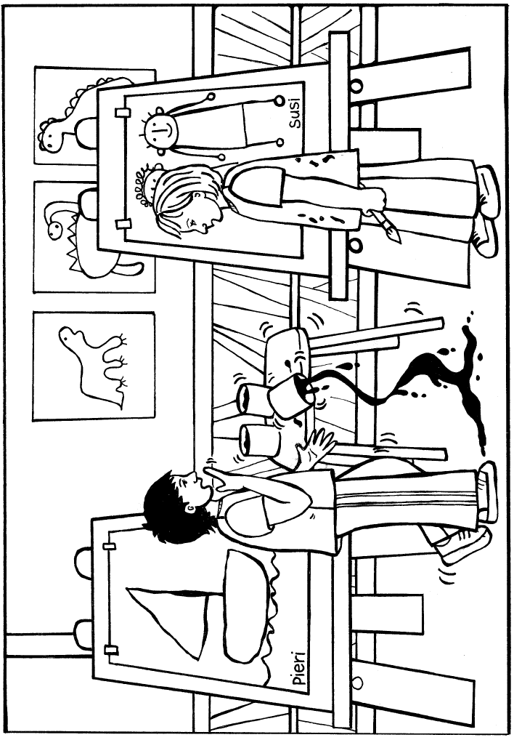

Copysheet: Painting – Frame 2

Frame 2
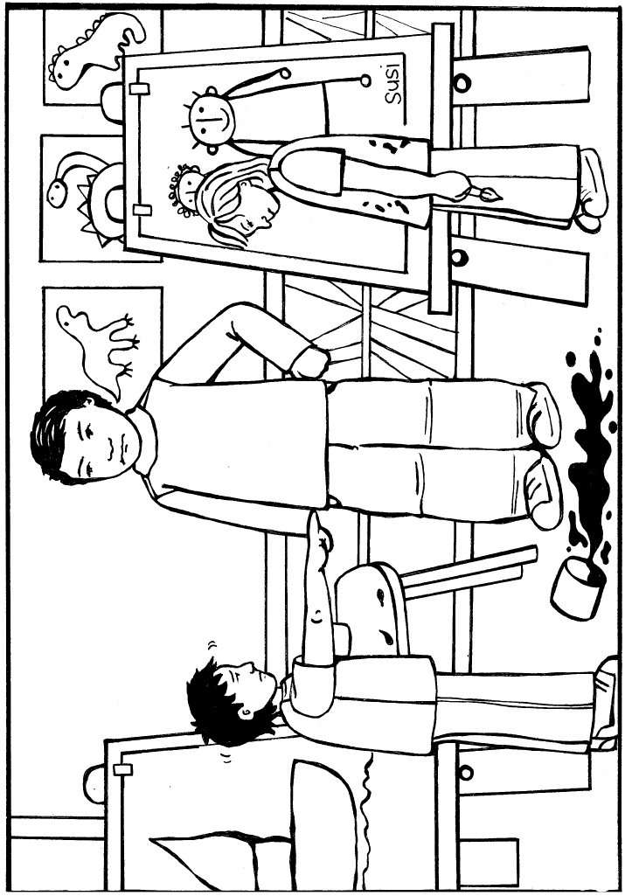

Learning experience 2: Cheating

Learning intentions
Students will be able to:
- explain that cheating is wrong
- explain that cheating has consequences.

Activities
The teacher and another adult role-play the following scene. They are both sitting at school desks. Set the scene by saying something like this: “___________ and ___________ (give suitable Christian names) are doing a test in class.”

Role-play 1
Student A is working very hard on the test. Student B is obviously finding it a bit harder – gazing around, chewing on the pencil. Student B then starts trying to look at Student A’s answers. Student A tries to cover up their work. Student B tries even harder – seems to find an answer and writes it down, then starts trying to look at Student A’s answers again.
Once the role-play is complete, ask:
What do you think is happening?
What do we call it when someone tries to copy someone else’s work? (Introduce the word cheating)
Is it a good thing to do? Why, or why not?
Why do you think people cheat?
Talk to the class about how cheating is wrong. When we cheat, it’s not fair on the person we cheat from. Also, it’s not fair on other people in the class. It often makes us feel guilty, because we know that it is wrong.
Continue the role-play. Set the scene by saying something like: “The teacher has seen _____ cheating and has called him/her up to his/her desk.”
Student B is now standing in front of the teacher, head down, test paper in hand. The teacher is saying that cheating is wrong and that they are very disappointed that Student B has been cheating. The teacher says that they won’t accept Student B’s test and Student B will have to sit the test again, after school.
Ask: How is the teacher feeling?
How do you think Student B is feeling?
Do you think that it is fair for Student B to do the test again? Why, or why not?

Success criteria
Students can complete the sentence:
Cheating is …

