Doing the Right Thing

Focus area 3 Years 0-3
This section contains one of the following Focus areas from Doing the Right Thing for students at years 0-3 (ages 5–7):
- Respect
- Right and wrong
- Rules, laws, and consequences
- Honesty
- Role models

Focus area 3: Rules, laws, and consequences

Contents
Focus area 3: Rules, laws, and consequences 2
Notes for the teacher 2
Definitions 2
Key messages 2
Values 2
Curriculum links 3
Resources 3
Success criteria 3
Learning experience 1: Rules in our class 4
Learning intentions 4
Activities 4
Nature Rules 5
Learning experience 2: Who gets hurt? 8
Learning intentions 8
Activities 8
Copysheet: Picture Series 10
Copysheet: Finger Puppets 11

Focus area 3: Rules, laws, and consequences

Notes for the teacher
Ensure that you take opportunities to praise students who follow the rules, and to remind students of the rules when they forget them.
When someone hurts someone in the class, or takes their property, bring this to the attention of the class. Ask them to consider how the person who has been hurt feels. If appropriate, ask the class for suggestions as to what the consequences should be.

Definitions
Rules: Something that everyone ought to obey.
Laws: A set of rules accepted by a country to ensure that its members behave in a desired way for the good of all. These rules are enforced by penalties. Anyone who breaks the law commits an offence. An example of a New Zealand law is that no-one is allowed to steal.
Laws: A rule or set of rules that everyone in a country must keep.
Customs: Something that is usually done. An example is to have a Christmas tree at Christmas time.
Consequences: Things that happen because of what you have done. An example would be that if you break the driving speed limit, you will be fined.

Key messages
It is wise to obey the rules and laws.
If I break the rules I will pay the price.
I know that my actions have consequences.
How would I feel if this was me?
Will my actions harm others or myself?

Values
This learning experience will help clarify students’ understanding of the values of:
- respect
- honesty
- responsibility
- fairness
- consideration and concern for others.

Curriculum links
Key competencies: Managing self; Participating and contributing; Relating to others.
Learning areas:
Level 1 and level 2 Health and Physical Education – Strand A: Personal identity; Strand C: Identity, sensitivity, and respect; Strand D: Rights, responsibilities, and laws
Level 1 and level 2 Social Sciences – Roles and responsibilities in groups.

Resources
Story: Nature Rules by Diana Noonan
Class rules, written on a chart
Drawing materials
Copysheet: Picture Series (perhaps blown up to A3 and coloured)
Puppets made from Copysheet: Finger Puppets – older students could cut out and colour their own puppets
Parent helpers for the puppet activity

Success criteria
Students will be able to:
- explain why we need rules in the classroom
- say one thing that might happen if a class rule is broken
- explain how we feel when we, or our property, get hurt.

Learning experience 1: Rules in our class

Learning intentions
Students will be able to:
- explain why we need rules in the classroom
- explain what might happen if they break the rules.

Activities

1. Rules
Read the story Nature Rules to the class.
Ask: How did the class feel when they saw the monarch caterpillars?
What rules did they make to keep the caterpillars safe?
What rules got broken?
What might have happened because some children forgot the rules?
Why did they let the butterfly fly away?

2. Why do we need rules?
If you have a class animal, such as a goldfish or guinea pig, review the rules that you have to keep them safe.
Put up a list of the classroom rules or guidelines on a chart. Go over them with the class.
Ask: Why do we need rules in our class?
Answers might include “To help us keep safe”, “So we can hear the teacher”, “So we can do our work”, and “So we are happy together”.
Choose one of the class rules – for example, always walk when you are holding scissors. Talk about what might happen if someone did run with the scissors.
Discuss with the students how, when people live, work or play together, they need rules so that they know how to behave. This helps to keep people safe and to make sure they respect and care for each other. Families have rules, Scouts and Brownies have rules, and schools have rules.

3. Art activity
Each student can choose one of the class rules, or a rule they have in their family, and draw or paint a picture to illustrate it.

Nature Rules
by Diana Noonan
It was Monday morning and Siale couldn’t wait to get to school. On Friday, Mrs Arnett had said that she was bringing a very special surprise to school for the class. She was collecting it at the weekend.
“Has she brought it?” Siale called out to his friend Chandrabati when he reached the playground.
“There’s a really big box on her desk!” Chandra called back.
The bell rang and everyone went into class. It was hard to sing morning waiata when the box was there at the front of the room, but Siale tried his hardest. Then, when they were finished, Mrs Arnett asked all the children to sit on the mat. She said that she had something to show them. Siale squeezed Chandra’s arm. He had a funny, excited feeling in his stomach.
“I know that we always ask someone from the class to help open a surprise,” said Mrs Arnett, “but this surprise contains living things, so I’m going to open it myself. Then we’re going to make some rules so that everyone can enjoy what’s inside without harming any of the creatures.”
Living things! Creatures! Siale’s heart did a flip. What was in the box?
“Can everyone see?” asked Mrs Arnett as she cut down each side of the box.
The children stretched their necks as Mrs Arnett carefully lifted a bright green bush from the box.
“This is a swan plant,” she said, “and on it are monarch caterpillars.”
“Co-oo!’ squealed Chandra. “They turn into these awesome big orange butterflies.”
“They will if we look after them and treat them with respect,” smiled Mrs Arnett. “Can anyone think of some rules that will help us to look after the caterpillars and the plant?”
“You can’t run fast around the plant or you might bump the caterpillars off,” said Siale.
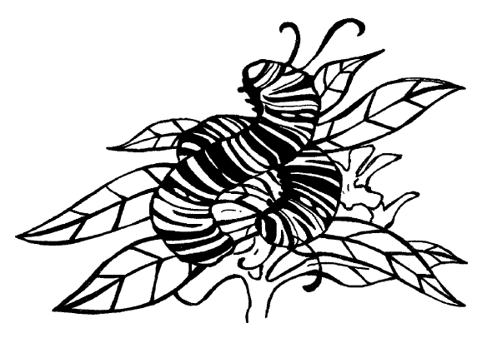
“Good point!” said Mrs Arnett. She wrote it on the whiteboard.
“The swan plant has to get watered every day,” said Maui, “or it’ll die and the caterpillars won’t have any food.”
“My Mum says you’re not supposed to touch caterpillars,” said Mei Mei. “It makes their skin all oily and it’s bad for them.”
“Excellent rules,” said Mrs Arnett. “They’ll help keep the plant growing and the caterpillars safe.”
She wrote up all the rules. Then she made a list of plant waterers, and set the swan plant on top of the science table.
In the first week, the caterpillars grew fatter and fatter. Some made shiny green and gold cocoons that hung from the swan plant’s leaves. The plant grew, too. Everyone was very careful to follow the rules.
But on the next Monday morning, something scary happened. Josh and Mei Mei came running into class, playing tag. Mei Mei fell against the science table and the swan plant went crashing over.
“Oh, no!” said Chandra. “Are the caterpillars okay?” She touched each one as she counted them. Then she remembered the no-touching rule. She hoped she hadn’t hurt them.
“We’re going to have to be much more careful,” said Mrs Arnett, “if we want to see the caterpillars turn into butterflies.”
Wednesday was a real sun-hat day. Even with all the windows open, the classroom was boiling hot. Suddenly, Siale looked over at the swan plant. It was drooping so much that the caterpillars in their cocoons were almost touching the desk.
“Someone forgot to water the swan plant!” he said.
He quickly found a jar and tipped water into the soil.
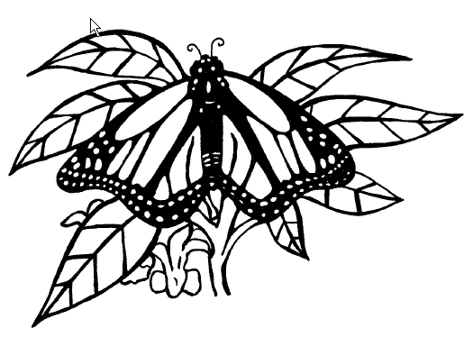
“I think the plant will recover,” said Mrs Arnett, “but we mustn’t forget our watering job when it’s our turn. If the plant dies, the caterpillars will have nothing to eat and then they’ll die, too.”
It seemed to take forever for the caterpillars to hatch out of their cocoons. Siale checked them every day. Then, one day when he hadn’t been watching, he walked past and saw a bright orange butterfly with folded wings sitting on the swan plant. He wanted to shout out to the whole class about what he’d seen but, instead, he walked quietly past the plant to Mrs Arnett’s desk and whispered to her what had happened.
“Good on you for keeping calm,” said Mrs Arnett. “We don’t want to disturb the butterfly.”
Mrs Arnett called the class onto the mat and, very quietly, told them the good news. Then everyone was allowed to stand up and move very, very carefully past the plant to see the butterfly.
“It’s so-oo beautiful,” said Chandra, when it opened its wings. “It looks like pretty dress material.”
“I wish I could be a butterfly,” said Josh. “They look so cool.”
For the rest of the day, the children watched the butterfly. It flew onto the curtains and onto the School Journal shelves. Once it flew back to the swan plant. Then all it seemed to want to do was to fly from window to window.
At the end of the day, Mrs Arnett said that she had something important to say. The children packed up their desks and listened.
“We’ve all enjoyed watching the butterfly today, and there will be more hatching very soon. Your rules have helped to keep the plant and the caterpillars and the cocoons safe. Ka pai! Well done, all of you! Rules are so important. Now there’s another rule that we have to think about. It’s the most important rule of all – the rule of nature.”
“What’s the rule of nature?” asked Mei Mei.
“The rule of nature,” explained Mrs Arnett, “says that all wild creatures must be free. Our beautiful monarch butterfly isn’t a pet, like a dog or a cat or a guinea pig. It belongs outside in the wild where it can find a mate and lay more eggs on another swan plant.”
Does that mean we have to let it go?” asked Siale. He didn’t want to do that – not just yet.
“It does,” said Mrs Arnett. “We’ve enjoyed watching it all day, and we’ll have more butterflies to watch very soon. But now we have to set our monarch free.”
The children watched as Mrs Arnett opened the top window where the butterfly was sitting. It must have smelled the fresh air because it opened and closed it wings and then, very gracefully, it flew outside and over the bushes in the school garden.
Siale felt sad, but he knew that Mrs Arnett was right. Rules were important and the rule of nature was the most important rule of all. He looked back at the swan plant. Perhaps, tomorrow, another cocoon would hatch – and he’d be the first to spot it!

Learning experience 2: Who gets hurt?

Learning intentions
Students will be able to:
- say how people feel when someone hurts them or their property
- suggest some consequences when we hurt others or their property.

Activities

1. Picture series
Show the class Copysheet: Picture Series. The first frame shows a boy, Matt, taking someone’s lunch when no one is looking. The second frame shows a girl, Kiri, looking in her lunch box and finding that her lunch has gone. Ask the following questions for each frame:
What do you think the boy is doing?
How do you think he is feeling?
Why might he be feeling like this?
How do you think Kiri feels when she opens her lunch box?
Why does she feel like this?
Talk about how Matt broke the rules and took something that didn’t belong to him. Talk about how when someone takes something of ours we feel upset and sad. When we take something that does not belong to us, we might feel bad.
Put the Kiri puppet on one finger and the Matt puppet on the other. Model a conversation between your puppets in which Kiri tells Matt how she is feeling and he responds.

2. Puppet activity (years 2–3)
Parent helpers would be useful for this activity.
Provide each child with a Kiri and Matt puppet, or provide them with the template and let them make their own.
Either
Have each child make their own dialogue between their puppets – that is, Kiri telling Matt how she feels, and Matt responding.
Or
Put children in pairs, one with the Kiri puppet and the other with Matt. They carry out the same dialogue as above.
Ask: What do you think should happen to Matt? (He should say he is sorry, the teacher should tell him off, he should give the lunch back ...)
Go over each suggestion with the children to help them decide what would be the best thing for Matt to do. Children draw a picture to show what they think should happen. Display finished drawings on the wall.

Copysheet: Picture Series

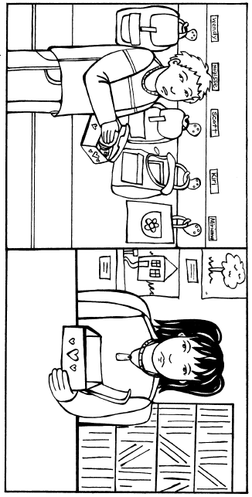

Copysheet: Finger Puppets
