Doing the Right Thing

Focus area 1 Years 0-3
This section contains one of the following Focus areas from Doing the Right Thing for students at years 0-3 (ages 5–7):
- Respect
- Right and wrong
- Rules, laws, and consequences
- Honesty
- Role models

Focus area 1: Respect

Contents
Focus area 1: Respect 2
Definitions 2
Key messages 2
Curriculum links 2
Resources 2
Success criteria 2
Learning experience: Understanding respect 3
Learning intentions 3
Activities 3
Winner for a Week 5

Focus area 1: Respect

Definitions
Respect: To think highly of someone because of their qualities or achievements and to treat this person with courtesy.
Respect (Junior): The feeling you have for someone you like and admire.

Key messages
I treat people with respect.
When I give respect, I earn respect.

Curriculum links
Key competencies: Managing self; Participating and contributing; Relating to others.
Learning areas:
Level 1 and level 2 Health and Physical Education – Strand A: Personal identity; Strand C: Identity, sensitivity, and respect; Strand D: Rights, responsibilities, and laws
Level 1 and level 2 Social Sciences – Roles and responsibilities in groups.

Resources
Story: Winner for a Week
A resource person from the community who deserves respect (examples could include the School Community Officer, the principal, kamatua, the mayor).
Paper, crayons, and pencils

Success criteria
Students can:
- help make a class definition of 'respect'
- name at least one person they respect
- give at least one reason why they respect them.

Learning experience: Understanding respect

Learning intentions
Students will be able to:
- explain the concept of respect in their own words
- name one person they respect
- say why they respect that person.

Activities

1. Defining respect
Read the story Winner for a Week to the class.
Ask: Why did Damien win the Principal’s Award?
How did he show that he respected Mr Rennie?
Why do you think he respected Mr Rennie?
What did Crusoe do that showed that she didn’t respect Damien’s things?
Do you think that Damien respected his Grandad?
Why do you think he respected him?
Write the word Respect on the board. Now that students have been introduced to the idea of respect in the story, help them to decide on a definition in their own words. Display the definition on the wall.
Each student could draw a picture of one part of the story Winner for a Week. The drawings could be made into a big book, which could be read to students at intervals to reinforce the value of respect.

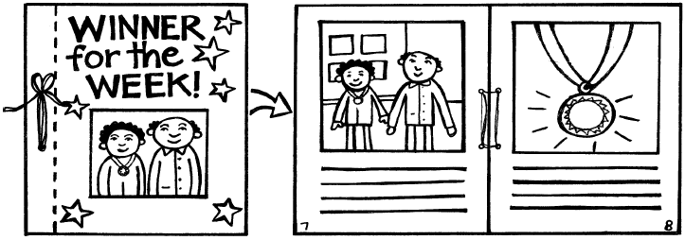

2. Who we respect, and why we respect them
Share with the class people that you respect, why you respect them and how you show that respect. For example: I really respect our principal, Mrs Jones. She is very helpful and always listens when I have a problem. I am always polite to her and do everything she asks.
Discuss with the class the meaning of respect and the qualities that earn respect in a person.
Ask students who they respect. Write each name on the board. For each name:
Ask: Why do you respect this person? Write students’ responses beside the name.
How do you show respect to this person? (Be polite, be helpful, do things for them, listen to them, show them you care...)
Help each student to choose one person they respect. They draw a picture of this person and around it they write ways in which they show respect.
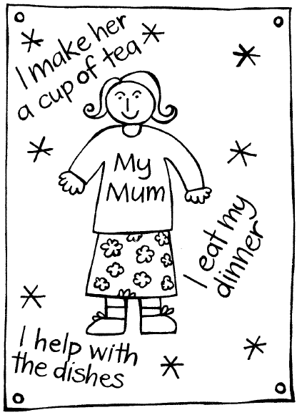
Talk to the class about how, even though some people earn our respect more than others, we should always treat all people with respect. If we do this, they are more likely to treat us with respect.

Winner for a Week
It was Friday afternoon assembly, just before home time. Damien sat on the mat with his arms folded and his tummy full of butterflies. He couldn’t wait to get home to play with Crusoe. Her family had just moved in next door and this afternoon Mum was babysitting her.
“Now,” said the principal, Mrs Whatuira, after she had given out certificates for the fun run, “it’s time for the Principal’s Award.” She patted the purple velvet cushion on the table beside her. On top of it was a silver medal on a chain. “As you all know, the Principal’s Award this week is for someone who has been noticed showing respect. We show respect for people or things by caring about them. This week we had some very special visitors at our school: parents, grandparents, kaumatua, and ex-teachers. They came to help us open our new library.”
Damien smiled. The library opening had been fun. Everyone had been given a balloon and a bookmark to take home.
“Some children showed respect for our visitors by holding doors open for them. Kapai!” said Mrs Whatuira. “Others showed respect by passing the afternoon tea to the visitors before helping themselves. Very good.”
The children whispered excitedly. Everyone wanted to know who would win the medal.
“But there was one person who showed respect in an extra-special way,” said Mrs Whatuira. “This person gave up their whole lunch time to talk to our oldest visitor, Mr Rennie.
Mr Rennie was a teacher at this school many years ago.”
Damien held his breath – was Mrs Whatuira talking about him? “While the grown-ups were in the staffroom and the children were playing outside, Damien Cooper showed Mr Rennie all his school books and then took him around the school buildings. Congratulations, Damien.”
Everyone clapped as Damien went up the front. Mrs Whatuira shook his hand and put the medal around his neck. “Well done!” she said. “This medal is yours to wear for the whole week.”
When Damien got home, he couldn’t wait to show Mum the medal. But first, he stopped at the back door and took off his shoes. “Fantastic!” smiled Mum, when she saw the medal. “You’re the best! Wait ‘till Grandad hears about this. He’s coming round for tea tonight.”
There was a knock at the door. It was Crusoe, and she was really excited. “I’m playing at your house today,” she squealed.
“You are!” said Mum. “Let’s take your shoes off and then you can come inside.”
“I want them on!” said Crusoe. “I have them on in my house.”
Mum smiled. “I know,“ she said. “But it’s different rules for different houses. And in our house, we have to respect the rule that say ‘shoes off inside’.”
Damien took Crusoe into his room. “We can play with my special dinosaur collection,” he said.
But Crusoe wasn’t listening. When Damien reached up for the box of dinosaurs, he heard a splash.
“Crusoe!” he shouted. She was dropping his toy cars into the goldfish tank. “Don’t! You’ll frighten Fin and Rosie! And you’ll ruin the cars.”
But Crusoe just giggled. She dropped in another one.
“Mum!” called Damien. Mum came straight away. “This is Damien’s room,” she told Crusoe, when she saw the cars in the goldfish tank. “We have to care for his things or he won’t want us in here.” She took Fin and Rosie into the kitchen. “I’ll dry the cars on the heater,” she told Damien.
Crusoe wasn’t so silly after that but she wasn’t much fun to play with, either. Damien had to watch her all the time. And after she’d gone home, he found that she’d left the tops off his best felt pens and broken the ear on his rabbit money-box.
That night, when Grandad came round for tea, Damien showed him the medal. Grandad was so proud. Then Damien told him what Crusoe had done.
“Hmm,” said Grandad. “It sounds as though she doesn’t respect your things. You, know,” he said, “I can’t lend my garden tools to some people for the same reason. They just don’t respect them.”
“You’re tools are sharp and shiny,” said Damien. “They smell nice and oily.”
“That’s because I look after them,” said Grandad. “I respect them.”
After tea, Grandad helped Damien put the tops back on his pens. Then he glued the ear back on the rabbit money-box.
“Would you like me to read you a book?” asked Grandad when he’d finished.
“Yes, please!” said Damien, “but first I’ve got something for you.” Damien took the medal from around his neck and put it over Grandad’s head.
“This is for you – because you respect my things, and you care about Mum and me,” he said. “You can wear it until you go home.”
Grandad liked the medal very much. He even polished it on his jersey.
Then he picked up the book. “Respect,” he said. “You know, Damien, it’s a funny old word – but I like it.”

