Rail Safe

Years 7–8 Focus area 2
This section of the Rail Safe programme contains one of the following focus areas for students at years 7–8 (ages 11–13):
- About trains
- About tracks
- About us
An effective programme should include learning experiences from each of the focus areas.

Focus area 2: About tracks

Contents
Focus area 2: About tracks 2
Focus question 2
Explanation 2
Notes for the teacher 2
Curriculum links 2
Resources 2
Success criteria 2
Learning experience 1: Out of bounds 4
Learning intentions 4
Activities 4
Copysheet: The Rail Corridor, Single and Double Tracks 6
Learning experience 2: Crossing legally and safely 7
Learning intention 7
Explanation 7
Activities 8

Focus area 2: About tracks

Focus question
How can you take care around the rail corridor?

Explanation
The following key messages will become part of students’ thinking as a result of this lesson.
- The rail corridor is out of bounds.
- You’re only allowed to cross the railway tracks at a legal crossing.
- Stop, Look and Listen.

Notes for the teacher
Rail Corridor - Train tracks are about one metre wide. The area of land five metres on either side from the middle of the track is called the rail corridor. Tracks and the rail corridor are for trains only. The Railways Act 2005, which came into effect on 20 July 2005, has been set up to protect people from the dangers associated with railways. The Act makes it illegal to be on the rail corridor, except at designated crossing places and at stations. It is a criminal offence to cross or walk along the rail corridor. It is also an offence to interfere with railway tracks, trains signals and such. The penalty for doing this is a fine of up to $10,000. Railway workers are the only people permitted to be on the tracks and they must follow strict safety rules. This also applies to railway yards, where there is an additional danger of trains shunting back and forth.

Curriculum links
Key Competencies: Thinking (thinking about actions when near trains and tracks); Managing self (taking responsibility for keeping safe when near trains and tracks)
Learning areas: Levels 3 Health and physical education: Strand A – Safety management; Strand C – Interpersonal skills
Level 3 Social Sciences: how groups make and implement rules and laws

Resources
NZTA Tracks are for Trains SlideShare.
Copysheet: The Rail Corridor, Single and Double Tracks
Internet access to the Railways Act 2005
School’s EOTC Guidelines

Success criteria
At the end of this focus area students will be able to:
- explain why it is illegal to be in the rail corridor and the consequences of this
- identify legal crossing places
- explain why they should use Stop, Look and Listen before they cross the tracks
- cross the tracks using Stop, Look and Listen.

Learning experience 1: Out of bounds

Learning intentions
By the end of this learning experience students will be able to explain why it is illegal to be in the rail corridor and the consequences of this.

Activities

1. The law about the rail corridor
Check students’ knowledge of ‘out of bounds’.
Check students’ understanding of ‘rail corridor’ (see Teachers’ Notes). Use slide 12 of the NZTA Tracks are for Trains SlideShare and Copysheet: The Rail Corridor, Single and Double Tracks to clarify understanding.
Put students into small groups. Ensure that there are some sound readers in each group. Get each group to access the Railways Act 2005 on the internet. Ask each group to:
- Read Section 73 Part 3 and Section 92 Subpart 4 of the Act.
- Give examples of when people would have ‘lawful authority’ to be in the rail corridor.
- Write an explanation of that section in their own words, beginning “You are breaking the law if you….”.
- List examples of offences against this Act that they have seen being committed in the local area.
Take feedback from some groups.
Ask: What is the penalty for committing these offences? Do you think these are fair? Why or Why not?
What other consequences might there be?

2. What do you think?
Explain to students that you are going to give them some statements and ask them to place themselves along a continuum line, according to their opinion. One end of the line is strongly agree and the other is strongly disagree. When students have positioned themselves on the line after each statement, ask some students to explain their position.
Statements
- People who try to interfere with trains, tracks or signals are just having a bit of fun.
- Sometimes it is okay for people to be on the rail corridor.
- The penalties for committing these offences are too harsh.
Note: Make sure that after statement 2 it is made quite clear that the only place a person can enter a rail corridor is at a legal crossing point or on a platform.
Ask: Why do you think this law has been made?
Did you know about it before?
Will it change your behaviour in any way? Explain.
Copysheet: The Rail Corridor, Single and Double Tracks

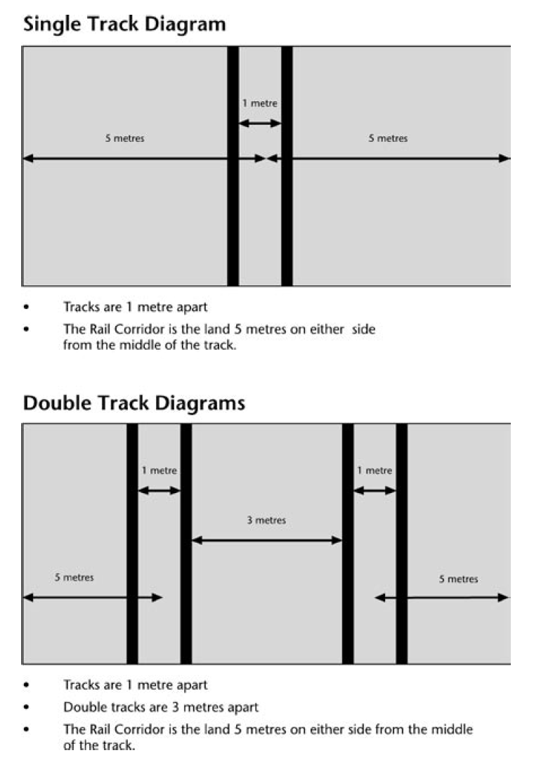
Learning experience 2: Crossing legally and safely

Learning intention
At the end of this lesson students will be able to:
- identify legal crossing places
- explain why they should use Stop, Look and Listen before they cross the tracks
- cross the tracks using Stop, Look and Listen.

Explanation
Pedestrian rail crossings have been built to allow people to safely cross the railway tracks.
Pedestrian crossing
Pedestrian crossings are protected by warning signs before and at the crossing. They can have bells, automatic alarms, barrier arms, and/or signs advising people to look for trains. Some pedestrian crossings have mazes. A maze is a zigzag path before and after the railway tracks. It means that a person has to zigzag through barriers before reaching the railway tracks. This slows people down and makes sure that they turn to look in both directions to see if a train is coming. The zigzags also give people time to hear an approaching train. There are signs advising people to look for trains before they cross.
Pedestrian underpass
A pedestrian underpass goes underneath the railway tracks. It can be from a car park to the railway platform or from one side of the rail tracks to the other. It means that people can walk safely underneath the railway tracks, even when a train is on the tracks.

Level crossings
A level crossing is where a road crosses the railway tracks. There are public and private level crossings.

Public crossings
All crossings on public roads have warning signs and most have markings on the road. These crossings may also have alarm bells, flashing lights and barrier arms. Like a road crossing, a level crossing has rules to help those using the rail and road to stay safe. Trains have the right of way at all times.
Private crossings
Most private crossings are on driveways or access roads to a single property such as a farm. Private crossings are required to have appropriate signage, but some private crossings may not have them. If they have little traffic the signage will be at the lower end of the scale (St Andrew’s Cross, Give Way Sign). If there is a high traffic volume there will be a higher level of protection.

Activities

1. Types of crossings
Brainstorm with the class all the types of rail pedestrian and level crossings that they know of. Mark any that are in the local area.
Check that the following are all covered:
Pedestrian bridge
Pedestrian underpass
Pedestrian crossing (which could have bells, automatic alarms, warning signs, barrier arms, maze)
Level crossing with lights, bells and barrier arms
Level crossing with warning signs
Private level crossing

2. Plus, minus or interesting
Show the class slides 5-11 of the NZTA Tracks are for Trains SlideShare, so that they can identify the characteristics of each crossing type.
Keep the pictures displayed.
Divide the class into groups and allocate each group one of the crossing types. Ask them to complete a PMI diagram for their crossing type, like the one below, from the point of view of a pedestrian wishing to cross the tracks.
PMI Chart for a Pedestrian Crossing with a Maze
Plus | Minus | Interesting
- Gives you time to look both ways | - Takes a longer time to get to the crossing point | - Have never seen one of these

3. Stop, Look and Listen
Remind students about Stop, Look and Listen. This is how they have been taught to cross the road. Explain that they should use Stop, Look and Listen to cross the railway tracks too.
Ask: Where would you stop? (Look at each slide and decide on a safe place in each situation). Remind students that the train is much wider than the tracks.
What will you look for and where will you look? (Reinforce for students that they need to look both ways as trains can come from either direction. Also review double tracks. Pedestrians will also have to look out for cars on a level crossing.)
What will you listen for? (Remind students to listen for trains and also for warning bells. Reinforce that fact that some trains are quiet.)

4. Practice
Work with students to mark out a rail corridor on the tennis court or playing field. Show clearly the railway tracks, and the rail corridor. Mark on a pedestrian crossing. (see Copysheet: The Rail Corridor, Single and Double Tracks). Put students into small groups and have each group in turn practise Stop, Look and Listen. They cross the tracks briskly, giving two good looks to check if trains are coming.
This activity may be repeated at a real level crossing if there is one close to the school. Review the school’s EOTC Guidelines before this activity.

