Rail Safe

Years 4–6 Focus area 2
This section of the Rail Safe programme contains one of the following focus areas for students at years 4–6 (ages 8–10):
- About trains
- About tracks
- About us
An effective programme should include learning experiences from each of the focus areas.

Focus area 2: About tracks

Contents
Focus area 2: About tracks 2
Focus question 2
Explanation 2
Notes for the teacher 2
Curriculum links 2
Resources 2
Success criteria 3
Learning experience 1: Tracks and the rail corridor 4
Learning intentions 4
Activities 4
Learning experience 2: Where and how shall I cross 5
Learning intentions 5
Explanation 5
Activities 6
Learning experience 3: Stations and platforms 8
Learning intentions 8
Explanation 8
Activities 8
Copysheet: Labels for rail corridor 10
Copysheet: The rail corridor - single and double track diagrams 11

Focus area 2: About tracks

Focus question
What is the rail corridor and why is it out of bounds?

Explanation
The following key messages will become part of students’ thinking as a result of this lesson.
- The rail corridor is out of bounds.
- You’re only allowed to cross railway tracks at a legal crossing.
- Stop, Look and Listen.
- Keep at least 1.5 metres back from the edge of the platform.

Notes for the teacher
Rail tracks are about one metre wide. The area of land five metres on either side from the middle of the track is called the rail corridor. Tracks and the rail corridor are private land and for trains only.
The Railways Act 2005, which came into effect on 20 July 2005, has been set up to protect people from the dangers associated with railways. The Act makes it illegal to be on the rail corridor, unless they have “lawful authority to do so”, such as at designated crossing places or at the station. It is a criminal offence to walk along the rail corridor or to cross it apart from at a legal crossing. The penalty for doing this is a fine of up to $10,000. Railway workers are the only people permitted to be on the tracks and they must follow strict safety rules. This also applies to railway yards, where there is an additional danger of trains being shunted back and forth.

Curriculum links
Key Competencies: Thinking (thinking about actions when near trains and tracks); Managing self (taking responsibility for keeping safe when near trains and tracks)
Learning areas: Levels 2–3 Health and physical education: Strand A – Safety management; Strand C – Interpersonal skills;
Level 3 Social Studies: How people make and implement rules and laws
Level 2 Mathematics and statistics: Measurement

Resources
NZTA Tracks are for Trains SlideShare.
Copysheet: Labels for Rail Corridor – cut up into separate labels
Copysheet: The Rail Corridor - Single and Double Track Diagrams
School’s EOTC Guidelines
Tape measure and chalk

Success criteria
At the end of this focus area students will be able to:
- identify features that make up the rail corridor
- explain why the rail corridor is out of bounds
- identify legal crossing places
- explain why they should use Stop, Look and Listen before they cross the tracks
- cross the rail tracks using Stop, Look and Listen
- explain why a person should stand at least 1.5 metres back from the edge of the platform
- demonstrate safe behaviour on or near a platform.

Learning experience 1: Tracks and the rail corridor

Learning intentions
By the end of this learning experience students will be able to:
- identify features that make up the rail corridor
- explain why the rail corridor is out of bounds.

Activities

1. Features of the rail corridor
Print out the NZTA Tracks are for Trains SlideShare and place the pictures around the classroom. These show different views of the rail corridor. Divide the class into small groups and give each group one of the labels made from Copysheet: Labels for Rail Corridor. Invite each group to place their label on a picture in the place where they think it best fits, using blu-tak. When all groups have finished, talk about each of the features of the rail corridor. Explain that everything they see in both photographs is the rail corridor. Correct the positions of any labels that are in the wrong place.
Ask: Where should cars cross the tracks?
What signs are there to tell drivers that this is a rail crossing and they must look out for trains?
How would the driver know if a train was coming?
Where should people cross the tracks?
Why has this special place been provided for people to cross?
Which of the features on the poster have we got in our local rail corridor?

2. Stay off the rail corridor
Explain that the whole area shown in slide 12 is called the rail corridor. That is the area of land five metres on either side from the middle of the track.
Ask students to draw a diagram of the rail corridor with one track, clearly marking the width of the track (one metre) and the width of the rail corridor (5 metres on either side from the middle of the track).
Ask: Why do you think the rail corridor is so wide?
Why do you think it is illegal for people to be on the rail corridor apart from at approved places such as legal crossing places and stations?
What do you think might happen to people who are caught on the rail corridor? (See Teachers’ Notes above)

Learning experience 2: Where and how shall I cross

Learning intentions
By the end of this learning experience students will be able to:
- identify legal crossing places
- explain why they should use Stop, Look and Listen before they cross the tracks
- cross the rail tracks using Stop, Look and Listen

Explanation
Pedestrian rail crossings have been built to allow people to safely cross the railway line.
- Pedestrian crossing
Pedestrian crossings are protected by warning signs before and at the crossing. They can have bells, automatic alarms, barrier arms, and/or signs advising people to look for trains before they cross. Some pedestrian crossings have mazes. A maze is a zigzag path before and after the railway tracks. It means that a person has to zigzag through barriers before reaching the railway tracks. This slows people down and makes sure that they turn to look in both directions to see if a train is coming. The zigzags also give people time to hear an approaching train.
- Pedestrian bridges
A pedestrian bridge can link a car park to the railway platform or go from one side of the rail corridor to the other. It allows a person to walk above the railway tracks even when a train is on the tracks.
- Pedestrian underpass
A pedestrian underpass goes underneath the railway track. It can be from a car park to the railway platform or from one side of the rail crossing to the other. It means that people can walk safely underneath the railway tracks, even when a train is on the tracks.

Level Crossings are where a road crosses the railway tracks. There are public and private level crossings.
- Public crossings
All crossings on public roads have warning signs and most have markings on the road. These crossings may also have alarm bells, flashing lights and barrier arms. Like a road crossing, a level crossing has rules to help those using the rail and road to stay safe. Trains have the right of way at all times. Remember to obey the warning signs.
- Private crossings
Most private rail crossings are on driveways or access roads to a single property such as a farm. Private rail crossings are required to have appropriate signage. If they have little traffic the signage will be at the lower end of the scale (St Andrew’s Cross, Give Way Sign). If there is a high traffic volume there will be a higher level of protection.

Activities

1. Rail pedestrian crossings
Display slides 5-11 on the board or wall. Work with students to identify and name the different types of pedestrian crossings shown.
Complete a similarities and differences chart for the types, like the one below.
Ask: Which of these crossings do you think would be safest? Why?
Which of these crossings do we have in our local area?
Why do you think some people choose not to use the bridge (or an underpass)?
What would you say to these people?

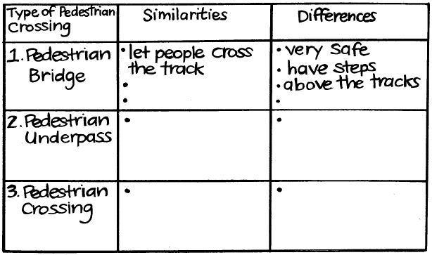

2. Rail level crossings
Display slide 7 on the wall or board.
Ask: What is the purpose of a level crossing?
What things are used to warn drivers that they will be crossing railway tracks?
How will the driver tell if a train is coming?
What does a pedestrian have to do at a level crossing?

3. Stop, look and listen
Have students write a list of the three rail pedestrian crossings and types of level crossing, like the one below. Alternatively write the list on the board.
Pedestrian bridge
Pedestrian underpass
Pedestrian crossing
Level crossing with lights and bells
Level crossing with Stop sign
Level crossing with a Give Way sign
Private level crossing

Invite students to grade each crossing type from 1-5 (1 = safest for pedestrians; 5 = least safe for pedestrians). Discuss their views.
Ask: What advice would you give to any pedestrian who has to cross the railway tracks?

Remind students about Stop, Look and Listen. This is how they have been taught to cross the road. Explain that they should use Stop, Look and Listen to cross the railway tracks too.
Ask: Where would you stop? (Look at each photo on Poster 4 and 5 and decide on a safe place in each situation. Remind students that the train is much wider than the tracks)
What will you look for and where will you look? (Reinforce for students that they need to look both ways as trains can go in either direction. Also review double tracks. Pedestrians will also have to look out for cars on a level crossing)
What will you listen for? (Remind students to listen for trains and also for warning bells. Reinforce that fact that some trains, particularly electric commuter trains in Auckland andWellington, are quiet.)

4. Practice
Mark out the rail corridor on the tennis court or playing field. Show clearly the railway tracks, and the width of the rail corridor. Mark on a pedestrian crossing. (see Copysheet: The Rail Corridor, Single and Double Tracks).
Take small groups of students out to this rail corridor to practise Stop, Look and Listen. They then cross the tracks briskly, giving two good looks to check if trains are coming.
This activity may be repeated at a real level crossing if there is one close to the school. Review the school’s EOTC Guidelines before this activity.

Learning experience 3: Stations and platforms

Learning intentions
At the end of this lesson students will be able to:
- explain why a person should stand at least 1.5 metres back from the edge of the platform
- demonstrate safe behaviour on or near a platform.

Explanation
- Before carrying out the following activity, please contact the rail safety charitable trust TrackSAFE NZ (04 498 2010) who will put you in touch with the right organisation so you can check that it is suitable for the class to visit the station. Some stations are owned by KiwiRail, but in the major cities the stations are owned and operated by local government organisations. You will need to ensure that KiwiRail (the locomotive drivers and Train Control) know about your visit to the station. KiwiRail will be able to confirm the times that trains pass through the station.
- Some platforms have a safety line which indicates the distance commuters should stand back from the platform edge in the interests of safety. This line is either a painted yellow line or a yellow tactile strip. Commuters should stand well behind the line until the train has come to a stop. If the platform does not have a marked line, commuters should stand at least 1.5 metres back from the platform edge.
- Back Draft- If a train is driving right through a station it may well be going quite fast. As it passes it creates a suction of wind, called a back draft. If people are standing too close to the edge of the platform they could be blown over or even sucked under the train.

Activities

1. Platforms
Display slides 15-17 on the wall or board. Work with the class to prepare a checklist of safety guidelines for platform users. It should include such things as the following:
- Stand at least one and a half metres back from the edge of the platform.
- If there is a safety line, stand well behind it.
- Always walk on the platform; no roller blading, biking, skate boarding or running.
- Keep play equipment, such as balls, safely in your bag.
- Wait until the train has stopped and the doors are open before moving close to the train.
Decide on a reason for each guideline.
Ask: Why is it important that you always follow these guidelines?
What effect might your behaviour have on younger children?
What could you do to protect little brothers or sisters, or other young children, when they are on the platform with you?

2. Practice
Arrange to take the class to the local station. Review the school’s EOTC Guidelines beforehand.
On arrival, point out the safety line to students. If there is no safety line on the platform, (check this out before you go) use the chalk to make a safety line 1.5 metres back from the edge of the platform. Make sure all students stand well back behind the safety line.
Ask: Why do you think these safety lines are marked on platforms?
What would you do if you went on a platform where a safety line wasn’t marked?
At the time the train is due to arrive ask students to be silent so that they can hear it approaching. Ask them to put up their hands as soon as they hear the train.
Ask: Was the train easy to hear as it approached?
Did you feel the back draft?
How safe did you feel behind the safety line?

Copysheet: Labels for rail corridor

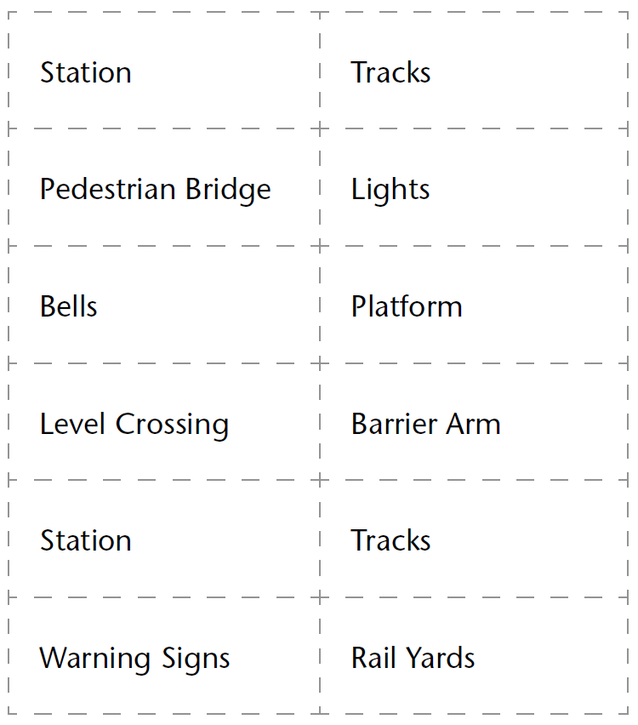

Copysheet: The rail corridor - single and double track diagrams
