Rail Safe

Years 4–6 Focus area 1
This section of the Rail Safe programme contains one of the following focus areas for students at years 4–6 (ages 8–10):
- About trains
- About tracks
- About us
An effective programme should include learning experiences from each of the focus areas.

Focus area 1: About trains

Contents
Focus area 1: About trains 2
Focus question 2
Explanation 2
Notes for the teacher 2
Curriculum links 3
Resources 3
Success criteria 3
Learning experience 1: What are trains like? 4
Learning intentions 4
Activities 4
Copysheet 1A: Parts of trains – Freight 6
Copysheet 1B: Parts of trains – Commuter 8
Learning intention 10
Activities 10
Copysheet 2: Hazards 12

Focus area 1: About trains

Focus question
What are trains like?

Explanation
The following key messages will become part of students’ thinking as a result of this lesson.
- Trains are heavy and can’t swerve or stop quickly.
- You can’t always hear a train coming.
- Always take care around trains and tracks.

Notes for the teacher
Different Types of Trains
Trains provide transport for people and freight across New Zealand. They operate on rail networks and use a locomotive to pull along carriages or freight wagons.
- Long Distance Passenger Trains
These run between cities and towns stopping at stations to pick up people along the way. A passenger train has a locomotive, a number of passenger carriages and a luggage van.
- Commuter Trains
Commuter trains operate in both Auckland and Wellington metropolitan areas and take people from the suburbs to the city and home again. Most commuter trains are electric multiple unit sets of up to eight carriages which can be driven from either end, so they don’t need to be turned around. These trains are powered by electricity from overhead electric wires. All other commuter trains are pulled by locomotives.
- Freight Trains
A freight train is used to move containers and other freight from one destination to another. A freight train is led by one or more locomotives and can have up to 60 wagons following behind.

Length of Trains
A train can be up to a kilometre in length, which is equal to the length of 10 rugby fields.

Weight of Trains
An average train weighs 1,500 tonnes, which is equal to 1,000 cars. A locomotive engine without wagons or carriages weighs 100 tonnes.

Curriculum links
Key Competencies: Thinking (thinking about actions when near trains and tracks); Managing self (taking responsibility for keeping safe when near trains and tracks)
Learning areas: Levels 2–3 Health and physical education: Strand A – Safety management; Strand C – Interpersonal skills; Strand D – Rights, responsibilities and laws

Resources
Video: Tracks are for Trains (accessible from your School Community Officer)
Slideshare: Tracks are for Trains http://www.slideshare.net/nztaeducation/tracks-are-for-trains-2014
Copysheet 1A: Parts of Trains – Freight
Copysheet 1B: Parts of Trains – Commuter
Copysheet 1C: Parts of Trains – Freight – Answers
Copysheet 1D: Parts of Trains – Commuter – Answers
Copysheet 2: Hazards

Success criteria
At the end of this focus area students will be able to:
- identify characteristics of trains
- explain why people have to take care near trains.

Learning experience 1: What are trains like?

Learning intentions
By the end of this learning experience students will be able to identify characteristics of trains.

Activities

1. What trains are like
Brainstorm with the class the question
What are trains like? Put children’s suggestions on the board, in a chart like the one below.
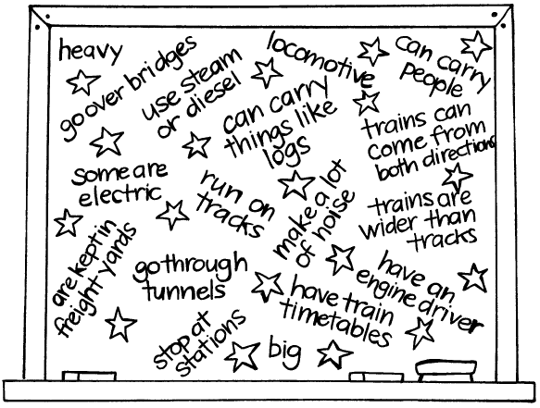
Explain that they are going to watch some videos about trains. Ask them to look out for other things about trains to add to the chart. Show children the video or slideshare Tracks are for Trains, or other videos such as https://www.youtube.com/watch?v=W3fiCS2zTFc (freight trains and how they operate) or https://www.youtube.com/watch?v=CORPm2QFdQ4 (long-distance passenger trains) .
Ask: Is all the information we wrote up about trains true? (For example, if children have said trains are noisy this should be corrected to show that not all trains are noisy and that sometimes you can’t hear a train coming.)
What new information about trains should we add to our chart?
Once new information has been added, ask children to read all the things they have come up with about trains.

2. Parts of trains
Give each student Copysheet 1A: Parts of Trains - Freight and Copysheet 1B: Parts of Trains -Commuter. Ask them to choose words from the list at the bottom of each page to fill in each blank label. Suggest they use pencil. Students could work in pairs or small groups.
When students have finished, give them the correct labels by showing Copysheet 1C and Copysheet 1D.
Go over any new vocabulary and start a class vocabulary list from the glossary.

3. Assessment activity
Ask students to draw:
either: a freight train showing the locomotive, tracks, load, fuel tank, wagons and bogies.
or: a commuter train at the station showing tracks, platform, commuters, passenger carriages, and overhead wires.
Under their drawing they complete the following sentence.
Trains take a ----------- time to stop because they are -------------.
Trains have to stay on the -------------.
You may not --------- a train coming because sometimes they are very quiet.
Trains travel much -------- than they look.

Copysheet 1A: Parts of trains – Freight
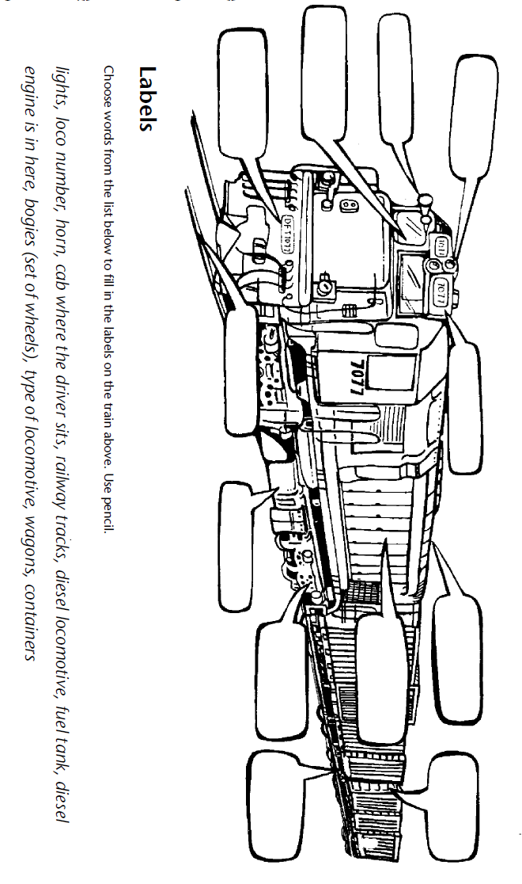

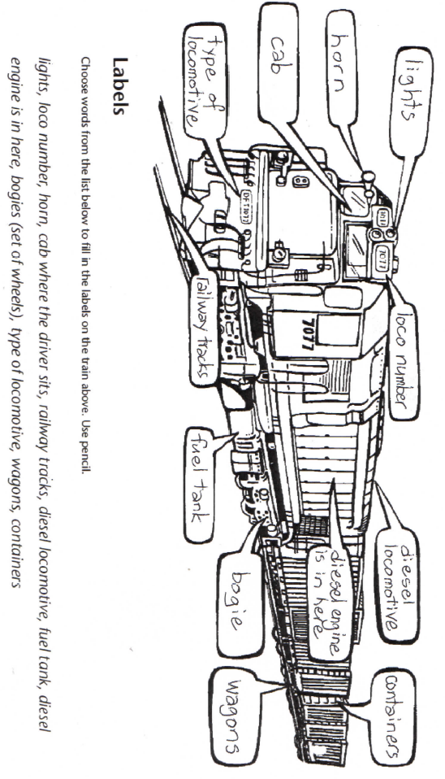

Copysheet 1B: Parts of trains – Commuter
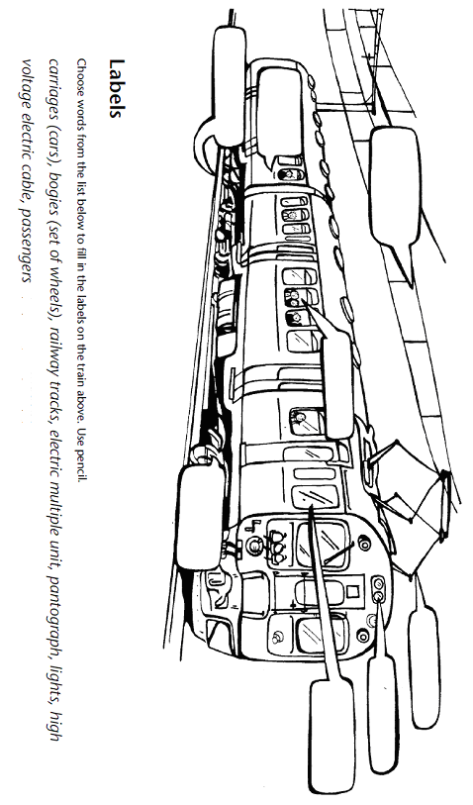

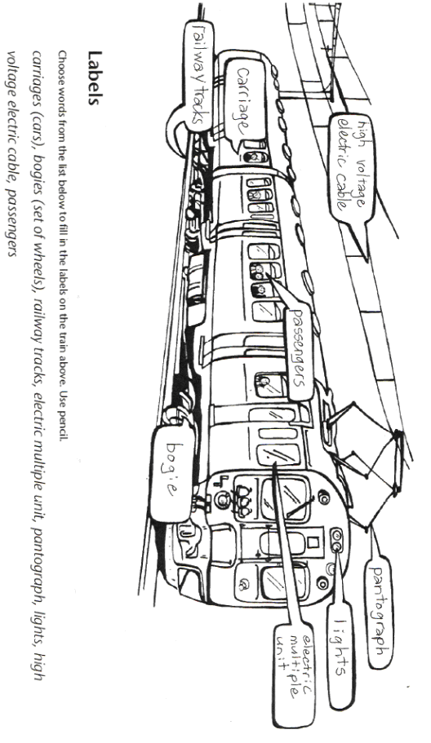
Learning experience 2: Take care around trains

Learning intention
At the end of this lesson students will be able to explain why people have to take care near trains.

Activities

1. Why we need to take care around trains
Invite children to review the drawings of trains that they did in the last lesson.
Ask: Why do you think we need to take great care around trains?

Answers could include:
Because we might not hear them coming.
They are very heavy and would cause a lot of harm if they hit them.
They would take a long time to stop.
They have to stay on the tracks and couldn’t swerve to miss a car or person.

2. Hazards
Give each student Copysheet 2: Hazards. Ask them to look at each picture and decide what the hazard is. They then share their thoughts with a partner and write answers to the two questions underneath each picture. The questions are:
What is the hazard?
What might happen?
Bring the class back together and ask the pairs to share their answers. Ensure that students have correctly identified the hazard and provide any additional information from the answers (below) that students need. Work with the class to identify a safety message that relates to each hazard. For example a safety message for Picture 1 could be “Always stand at least 1.5 metres back from the edge of the platform to avoid the back draft.”
Picture 1: Back draft
If a train is driving right through a station it will be going quite fast. As it passes it creates a suction of wind, called a back draft. If people are standing too close to the edge of the platform they could be blown over or even sucked under the train. People should stand at least 1.5 metres back from the edge of the platform.
Picture 2: Trains can’t stop quickly
A child might think that if a train is in the distance there is plenty of time for them to cross the tracks safely. However, trains go fast (often faster than they appear) and because they are heavy they wouldn’t be able to stop in time if there was a person on the line.
Picture 3: Double tracks
Two railway tracks running side by side are called double tracks. There is usually a space of three metres between double tracks. Trains could come from either direction at the same time. Children may not realise this. If one train has passed they may think it is safe to cross and be hit by a second train. They need to wait until they can see that each track is clear in both directions.
Picture 4: A train is wider than the tracks
Train tracks are about one metre wide. A train can be 2.5 – 2.8 metres wide (this includes the width of wagons and containers). A child may not realise this and stand too close to the tracks while waiting to cross. The area of land on either side from the middle of the track is called the rail corridor. Tracks and the rail corridor are for trains only.
Picture 5: Tunnels
A tunnel is 3 metres wide. A train is 2.5 – 2.8 metres wide. So when a train travels through a tunnel there is very little space between the train and the wall of the tunnel. A person may think that if they were in a rail tunnel they could outrun the train, but this is impossible. The average speed of a moving train is around 80k/hr. As you can never be sure when a train is coming, a person should never go into a rail tunnel.
Picture 6: Rail bridges
Train bridges are only 2.1 metres wide, while a train is 2.5 - 2.8 metres wide. This means that the train will overhang the sides of the bridge. So, there is no place for people to go if a train comes, except off the side of the bridge. As you can never be sure when a train is coming, a person should never go on a rail bridge.

3. Getting the message across
Talk to the class about how, at their age, they can be responsible about taking care around trains now that they know the hazards. Younger children may need more help. Explain that they are going to take these safety messages to younger students in the school. Put the class into groups. Allocate each group one of the six hazards. The group must decide how they will get that message across. They might:
- make a poster
- prepare a role play
- write a poem or rap
- prepare a visual display
- write a presentation
- make a YouTube video (but not near tracks or trains)
- other.
Arrange for the groups to deliver their messages to junior classes.

Copysheet 2: Hazards
