Rail Safe

Years 0–3 Focus area
This focus area of the Rail Safe programme contains learning experiences for students at years 0–3 (ages 5–7).

Focus area: Taking care around tracks and trains

Contents
Focus area: Taking care around tracks and trains 2
Focus question 2
Explanation 2
Curriculum links 2
Resources 2
Success criteria 2
Learning experience 1: What are trains like? 3
Learning intentions 3
Activities 3
Learning experience 2: Safe at the railway station 4
Learning intentions 4
Activities 4

Focus area: Taking care around tracks and trains

Focus question
What are trains like?
How do you keep safe on a station platform?
What do you already know about trains and train stations?
How can the students teach each other?

Explanation
The following key messages will become part of students’ thinking as a result of this lesson.
- Trains are really big.
- Trains go fast.
- Stay away from trains and tracks.
- Stay behind the safety line.

Curriculum links
Key Competencies: Thinking (thinking about actions when near trains and tracks); Managing self (taking responsibility for keeping safe when near trains and tracks)
Learning areas: Level 1 Health and physical education: Strand A – Safety management

Resources
NZTA Tracks are for Trains SlideShare.
Poster 1B: Matu goes to the station (accessible from your School Community Officer)

Success criteria
At the end of this focus area students will be able to:
- explain that trains are big and go fast
- give 2 reasons why they should stay away from trains and the rail corridor
- explain what a safety line on a platform is
- describe how to behave when waiting at a railway station.

Learning experience 1: What are trains like?

Learning intentions
By the end of this learning experience students will be able to:
- explain that trains are big and go fast
- give 2 reasons why they should stay away from trains and the rail corridor.

Activities

1. Experiences of tracks and trains
Gather information about the number of children who have had some experiences of tracks and trains. Get them to put up their hands in response to the following questions. After each, ask some children to share their experiences.
Ask: Who has been on a train?
Who has been to a railway station?
Who has to cross rail tracks on the way home?

2. Features of tracks and trains
Show children slides 15 and 17 of the NZTA Tracks are for Trains SlideShare.
Ask: Who is in the picture?
What are they doing?
Why do you think they are doing this?
What can you tell me about the train?

Point out some of the rail corridor features such as tracks, locomotive, carriages, signs.
Ask: Why do we have to stay well away from trains and tracks?

Each child draws a picture of a train. Older children can complete the sentence: We have to stay well away from tracks and trains because………
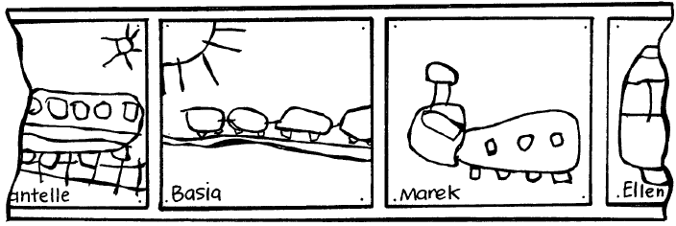\

Learning experience 2: Safety at the railway station

Learning intentions
By the end of this learning experience students will be able to:
- explain what a safety line on a platform is;
- describe how to behave when waiting at a railway station.

Activities

1. Matu's story
Display Poster 1B where all the children can see it. Read the class the following story.
Matu was very excited. Mum was coming home on the train from Ohakune, where she had been staying with Auntie Bessie. The train got in not long after Matu finished Playcentre. Dad picked him up and down they went to the station. They were a bit early. Dad took Matu’s hand and they walked on to the platform at the railway station. There were some other people there already. Dad held Matu’s hand. He showed Matu a line on the platform and said that was a safety line and that they had to stand well behind it that so they were safe when the train came. Dad also said that you should always stand still on the platform, not run about or play games with a ball. That would be an unsafe thing to do.
Just then they heard the train coming. It made a very big noise and Matu held Dad’s hand tightly. Then he saw Mum waving through the train window. She was wearing a bright blue dress and she was smiling. Although Matu wanted to run towards the train he knew that wasn’t a good thing to do. Instead he waved back at Mum.
Then the train finally stopped and the doors opened. After a little while Mum came out of the doors and stepped onto the platform. Then Dad and Matu went to meet her. First she gave Matu a big hug. Then she gave Dad a big hug. They were all smiling. Dad went down to the luggage van to get Mum’s suitcase. They walked together, all holding hands, back to the car.
Matu looked back at the station and saw the train moving off again, slowly at first and then it got faster and faster until it disappeared out of sight.
Ask: How was Matu feeling when he and Dad went to the station? Why did he feel like this?
Why was there a line on the platform?
What did Matu and Dad do to make sure they were safe when the train came?
Do you think Mum was pleased to be home? How do you know?
Ask children to look at the poster. Ask children in turn to come up and point to the following things:
Matu
Matu’s Dad
The safety line
The edge of the platform
The station buildings
The tracks
The train
Invite children to draw a picture of one part of the story. Display these on the wall in sequence.

2. Evaluation
From time to time refer children back to the picture story that they have made on the classroom wall.
Ask them all the things they need to do to keep safe near tracks and trains.

