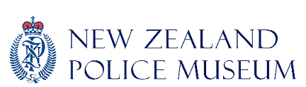
NZPM booking form
ADMIN USE. PEM reference number:

School
Coordinating Teacher
Postal Address
Phone
Email

Education Programme
□ People who help us | Early childhood
□ Introductory Tour | Y1+ □ Identikit | Y1-3
□ Fascinating Fingerprints | Y1+ □ Intro to Forensics | Y6+
□ Detective Activities | Y1-9 □ Careers | Y8-13
□ 20th Century events | Y11-13 □ Self guided (no charge)

Class name
Class teacher
Contact number
Date of visit
Time of visit
Age/ Yr level
Student no.
Accompanying
adults
(ratio 1:8 primary, 1:15 secondary)

Group Information
To ensure we can provide you with the best possible experience we need some information about your group. Please take a few minutes to answer these questions.
Special Needs. Are there any special physical, medical or behavioural needs we should be aware of?

Group Background. Please advise us of any recent trauma issues so we can adjust our tour content, eg: recent suicide, death, accident, assault or arrest experience.

Visit Objectives. What is the main objective of your visit?

Further Information
Programmes cost $3 per student, adults free of charge. Payment preferred on day. Cash, eftpos, cheque. Invoices can be arranged.
Thank you, we look forward to seeing you soon.

