Workshop resources

2021



# Contents

### For facilitators

Consent scenarios 3

Facilitator feedback form 2021 9

**For ākonga**

Consent and the law 11

Power and control wheel 13

Cycle of abuse 14

Equality wheel 15

Examples of how to step in 16

Who can help 17

Be an agent of change! 18

Student feedback form 2021 20

This document is available on the NZ Police website, in the School Portal, Successful relationships section:

<https://www.police.govt.nz/advice-services/personal-community-safety/school-portal/resources/successful-relationships/loves-me>

# 

# Consent scenarios

## Scenario 1

A is at a party. It’s been an awesome night with good mates and he has had a bit to drink, but all of a sudden he feels sick. “I think I’m gonna puke,” he mumbles, and stumbles off. B follows him to make sure he’s ok, and once he’s done takes him upstairs to a bedroom and leaves him to rest.

He dozes, things spinning a bit, and after a while sees B entering the room. They’re pretty friendly at school and he’s glad someone is there because he sure doesn’t feel good. B sits on the bed. “You ok?” he asks.

“I feel sick, I need some water.” A mumbles.

“Alrighty, back in a sec, mate,” B says.

A is sipping the water as B flops down beside him. A feels a hand on his thigh. B turns to face A, getting closer as he does. “How’s that water going down?” A doesn’t answer. He feels odd, his eyes heavy.

All of a sudden B is on top of him. “It’s ok, I won’t hurt you,” he whispers. A tries to push him off but can’t get his arms to move properly. His head is spinning with the exertion and he passes out. When he wakes he is alone and he feels discomfort in his anus.

## Scenario 2

D’s mate was bragging. “I get heaps of nudes. Haven’t you even got one from J yet?”

“Oh yeah, is that right?” D said, “What’s your secret then?”

“I don’t take no for an answer.” D raised his eyebrows. This wasn’t the first time he’d heard this.

“Just ask her. Play the nice card. If you have to, send one of you first.” Sometimes D felt he was the only one not getting nudes, and he was starting to feel like a bit of a loser in front of his mates.

“Sweet. I’ll give it a go, eh.” He typed ‘Hey, I can’t see you tonight, but how about a nude instead? ;)’

A reply, ‘No!’

“Keep asking,” D’s mate said. “They never say yes at first.”

D typed ‘Aww, come on. Don’t be shy. Just for me. I won't show.’

‘Stop being a dick.’

‘You’re not boring are you?’

Minutes passed. Then a ping. D opened the message and smiled. “Wow! Bro, it works! Look!” His mates crowded round.

## Scenario 3

They’ve been together for a while, and are kissing at a party. He starts to take it further. She feels uncomfortable. “I don’t want to do that,” she says.

“Come on,” he says, “you promised, and I can’t keep waiting.”

“Not yet,” she says quietly.

He backs off, but the voices of his mates keep running in his head. They’d been giving him heaps all week for not having done it with her yet. “Gotta be tonight!” they’d teased him on their way to the party.

“Come on, we talked about this before. You said you were ready.” She looks at him and shakes her head.

He gets annoyed. “There is no point in us staying together if it is going to be like this.” She starts to cry quietly.

He says, “Look, what’s the problem? Just go with it. You love me, don’t you?” and starts to put his hand up her top. She freezes and lies completely still. He has sexual intercourse with her.

## Scenario 4

They are hanging out together for the night, lying together on the bed kissing – her parents have gone out to dinner and won’t be home until late.

“Are you sure?” he asks.

They are both 16, and have been together for some months, consenting to intimate cuddling and kissing. They have not had sexual intercourse but have talked about it and when they might be ready.

A nod, “I’ll tell you if I want to stop.’”

“OK, I will, too.”

They decide to keep going and end up having sexual intercourse. They talk afterwards about it and how they are feeling.

## Scenario 5

Practice had finished, and B was walking towards the door. Coach called out, “B, can you hang about for a few minutes? I’d like to ask you a question.”

Staying had become a regular thing, and while at first it was all good fun and Coach had been really helpful, this time B paused. Last time it felt weird. There had been questions about some personal issues B had been dealing with, and some strange intimations about being there to help.

Nevertheless, B walked back towards the court, trying to smile in an attempt to make this time more like the good ones. Coach reached out a hand.

I really want to get out of here, B thought, but said nothing.

Coach moved close and grabbed B by the waist. “I remember you saying last time we talked that you just needed to be with someone who understood you. That can be me. I can help you.”

Silence. Coach pulled B closer, tighter.

Nothing happened for what felt like ages, but then B felt Coach’s hand slipping under their clothes. And then a kiss. B flinched. Coach paused, and said, “You know, you have so much potential, but you’ve got to be willing to be helped. I don’t know what I can do for you if you don’t meet me halfway.”

B felt sick, but then … It kinda was true – every dream required a sacrifice. But not this type of sacrifice. “No, I don’t want your help,” B whispered, wrenching free and running for the door.

## Scenario 6

D has been going out with her boyfriend for eight months and they’ve been having consensual oral sex on a regular basis.

This night, she wasn't really feeling up to having oral sex, but he’d been insistent so she went along with it. But, then she started to feel sick and told him she wanted to stop.

“You already said yes. You can't just say no now,” he said.

“I don’t want to tonight,” she said, but he pulled her back roughly. “It won’t be long,” he said, holding her down. It hurt, and she felt scared, so she stopped fighting and kept going until he'd finished.

Afterwards he swore at her. “What do you think you were doing? You can't just change your mind! What did you think I was going to do, just stop halfway through? You're so stupid. Don't you ever do that again or I’ll tell your mates how useless you are!”

# Facilitator feedback form 2021

|  |  |  |  |
| --- | --- | --- | --- |
|  | **Yes** | **No** | **Partly** |
| 1. Do you think your facilitation team established a safe environment for young people to share their views? |  |  |  |
| 1. Did your students contribute thoughtfully in Loves-Me-Not? |  |  |  |
| 1. Did you feel adequately prepared to facilitate  Loves-Me-Not? |  |  |  |
| 1. Were your resources appropriate, well prepared and organised? |  |  |  |
| 1. Did you feel the Loves-Me-Not topics were relevant to the lives of young people in New Zealand? |  |  |  |
| 1. Did you feel you were adequately supported to take disclosures from students? |  |  |  |

1. If you answered “no” or “partly” to some of the above questions, please tell us what we could do to improve this next time:
2. What were the most effective aspects of the Loves-Me-Not workshop?
3. What should be changed to enable you to better deliver the workshop?

# 

# Consent and the law

## Consent to sexual activity

New Zealand law does not define consent, but it sets out things that are necessary for full, voluntary, free and informed consent to sexual activity.

It describes situations when consent to sexual activity is **not given**:

* A lack of protest or physical resistance does not mean consent has been given.
* If force is used, or there is the threat (implied or explicit) or fear of force being used, consent has not been given.
* If someone is asleep or unconscious, consent has not been given.
* If someone is so impaired by alcohol or drugs they cannot meaningfully give consent, consent has not been given.
* If someone is impaired physically, intellectually, or mentally, consent has not been given.
* If someone is mistaken about who the other person is, or is mistaken about the nature and quality of the sexual activity, consent has not been given.

It is illegal to have sex with a person under the age of 16 years, even if they consent.

(From the [Crimes Act 1961](https://www.legislation.govt.nz/act/public/2005/0041/latest/DLM346175.html) section 128A)

### Consent to sexual activity is …

*“A person consents to sexual activity if they do it actively, freely, voluntarily and consciously without being pressured into it.”* ([Police website](https://www.police.govt.nz/advice-services/sexual-assault-and-consent/understanding-sexual-assault-and-consent))

*“Consent means true consent freely given by a person who is in a position to make a rational decision.”*  ([Courts of NZ website](https://www.courtsofnz.govt.nz/for-lawyers/question-trails/sex-offences/sexual-violation-by-unlawful-sexual-connection-section-128-crimes-act-1961/))

*Consent is “a free agreement made together” and “an enthusiastic yes”.* ([Rape Prevention Education NZ website](https://rpe.co.nz/consent/)):

Rape Prevention Education also say:

* *“Consent is not a contract; people are free to change their minds at any time. It is an agreement made in the moment, and needs to happen every single time—even if two people have already had sex together before. A person should always feel like they are free to say “no”.”*
* What is an enthusiastic yes? It’s when *“people are genuinely eager to do the sexual activity that they are agreeing to.”*

### Legal consequences: No consent to sexual activity = Sexual assault

Sexual assault is a term used to describe a range of sex crimes committed against a person. It is any unwanted or forced sex act or behaviour that has happened without a person’s consent.

Sexual assault may include:

* Rape – sexual intercourse without consent
* Indecent assault – unwanted sexual touching
* Acts of indecency – exposure.

Sexual assault is applicable to any age, and can occur regardless of relationship status, for example, it can happen in a marriage.

The [Crimes Act 1961](https://www.legislation.govt.nz/act/public/1961/0043/latest/DLM329048.html) sets out penalties for conviction for sexual crimes. These include:

* A person convicted of sexual violation can be imprisoned for up to 20 years.
* If a person attempts sexual violation, or attempts to assault a person with the intent to sexually assault them, they can be imprisoned for up to 10 years.
* If someone engages in a sexual act with a person, and knows they have been induced to consent by threat, for example blackmail or physical violence, they can be imprisoned for up to 14 years
* If someone engages in an indecent act with a person, and knows they have been induced to consent by threat, they can be imprisoned for up to 5 years.

## Consent and the digital world

The law applies in the physical and digital world.

* You must have consent to record an image of a person who is partially clothed, naked, or engaged in an intimate sexual activity, in a private place. This could be an *“intimate visual recording”* as defined in section 216G of the Crimes Act 1961.
* You must have consent from that person about what happens to that recording, for example, whether you can share it and how, who you can show it to, when and how you must delete it.

[Section 22 of the Harmful Digital Communications Act 2015](https://www.legislation.govt.nz/act/public/2015/0063/latest/DLM5711856.html) makes it an offence to cause harm to someone by posting something online if:

* you intend to cause them harm by posting that information online
* it would cause harm to an ordinary reasonable person in their position.

An example of this offence might be revenge porn.

# 

# Power and control wheel

When one person in a relationship repeatedly scares, hurts or puts down the other person, it is abuse. The Power and control wheel lists examples of forms of abuse.

Remember, abuse is much more than slapping or grabbing someone.

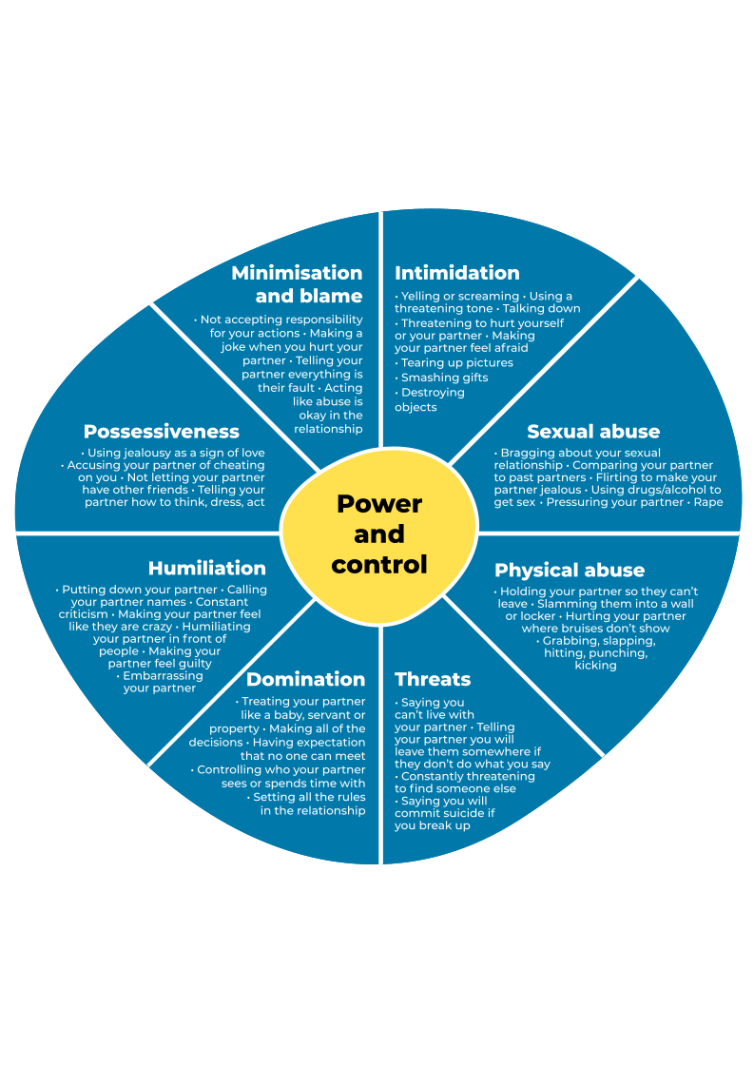

***“A relationship full of control is really out of control.”***

Reproduced with kind permission of the Domestic Abuse Intervention Project, Duluth, Minnesota as adapted by the Kansas Coalition Against Sexual and Domestic Violence.

# Cycle of abuse

In an unhealthy relationship, abusive behaviours tend to increase over time. In other words, relationships don't usually start bad, but some go bad.

Most abusive relationships follow a certain type of cycle. This cycle can help explain why some people stay in unhealthy and abusive relationships.

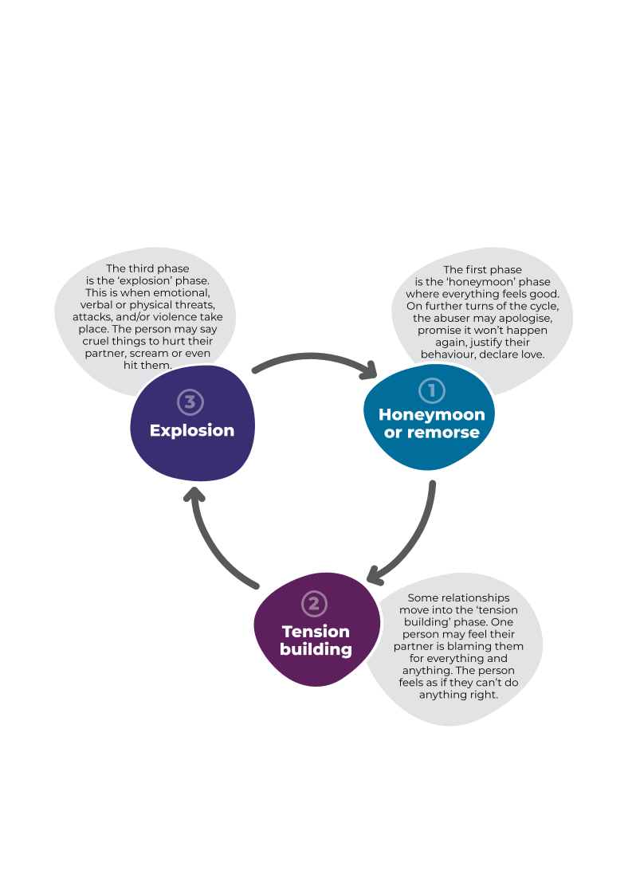  
This cycle can repeat many times. Each time the gaps between the phases may become smaller, and the tensions and explosions may become worse.

# Equality wheel

Equality is the defining characteristic of a healthy relationship. The spokes of the Equality wheel are ways that both partners can have a more equal relationship, even when dealing with the conflicts that can crop up in any relationship.

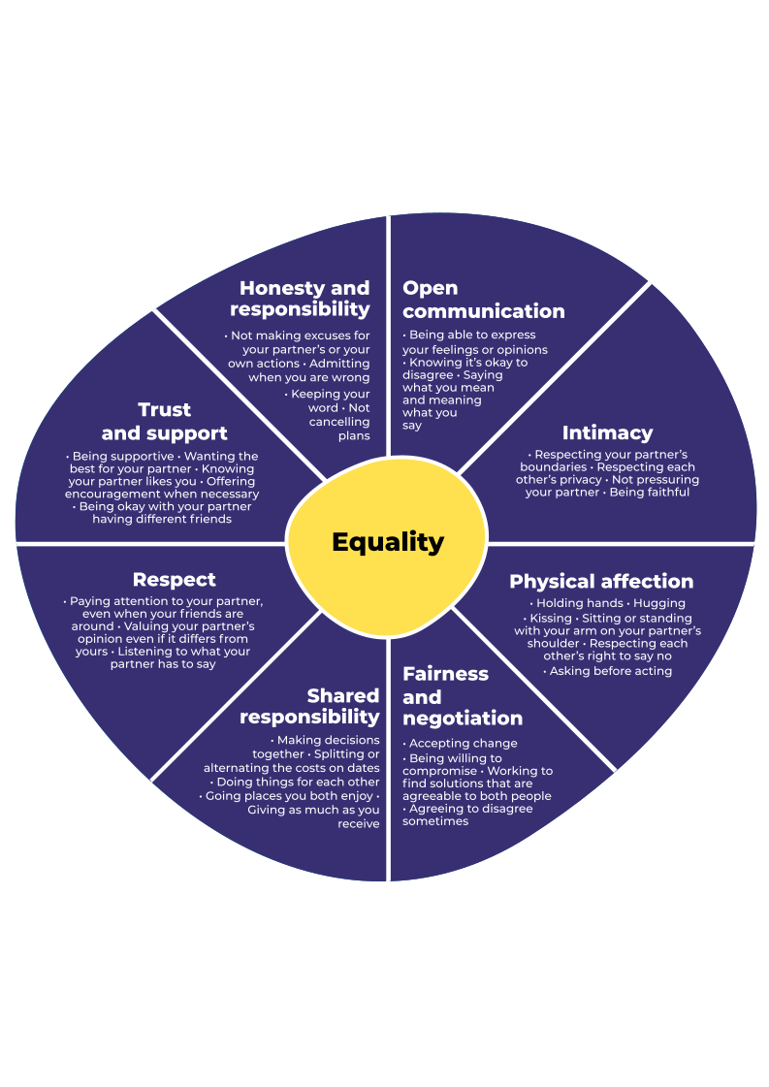

Source: Domestic Abuse Intervention Programs, Home of the Duluth Model, https://www.theduluthmodel.org/wheels/

# Examples of how to step in

When you step in, you move from being a passive bystander to an active one.

|  |  |
| --- | --- |
| **Direct actions** | **Indirect actions** |
| Create a distraction   * Make a joke * Change the topic * Start an activity for everyone to do * Share out food.   Talk to the person in trouble   * Who did they come with? * Do they want some other company?   Enlist the help of others   * Get someone to help you approach the person at risk * Find their friend to take them away from the situation * Tell someone with authority what’s happening, for example, a teacher, parent, security guard or bouncer.   Confront the situation   * Threaten to pull out your phone and record what’s happening * Call 111 * Call Crimestoppers * Call a helpline, for example, Youthline. | Create an awareness campaign  Confront derogatory comments and attitudes   * Tell them it’s not cool to talk about others in that way. * Remind them that actually doing what they are saying is illegal.   Fundraise to support organisations  Work to effect cultural change   * Can your school work to address the issue of consent and sexual violence? * Be conscious about how you speak and act towards others: respect * Volunteer with one of the agencies working in the sexual violence space. |

Want to know more? Check out these online sources:

* [respected.org.nz](https://respected.org.nz/)
* [rpe.co.nz/be-an-active-bystander](https://rpe.co.nz/be-an-active-bystander/)
* [justthefacts.co.nz/get-sti-help/worried-about-sexual-abuse-or-sex-assault](https://www.justthefacts.co.nz/get-sti-help/worried-about-sexual-abuse-or-sex-assault)
* [rainn.org/articles/steps-you-can-take-prevent-sexual-assault](https://www.rainn.org/articles/steps-you-can-take-prevent-sexual-assault)

# Who can help

When a friend's relationship is having problems that you are concerned about, there are organisations you can go to for help.

|  |  |  |
| --- | --- | --- |
| National organisations | | |
| Youthline  [youthline.co.nz](http://www.youthline.co.nz)  0800 376 633 | Free text 234 | Netsafe  [netsafe.org.nz](http://www.netsafe.org.nz)  0508 NETSAFE (638 723) | Police  [police.govt.nz](https://www.police.govt.nz/)  111 |
| LIFELINE 24/7  [lifeline.org.nz](https://www.lifeline.org.nz)  0800 543 354 | Free text 4357 | Alcohol drug helpline  [drughelp.org.nz](https://drughelp.org.nz)  0800 787 797 | Crimestoppers  [crimestoppers-nz.org](https://www.crimestoppers-nz.org/)  0800 555 111 |
| Mental Health Foundation  [mentalhealth.org.nz](https://mentalhealth.org.nz/getting-through-together)  0800 611 116 | Free text 1737 | Safe to Talk  [safetotalk.nz](http://www.safetotalk.nz)  0800 044 334 | Toah-Nest  [toah-nnest.org.nz](http://toah-nnest.org.nz/) |
| Victim Support  [victimsupport.org](http://www.victimsupport.org)  0800 VICTIM (842 846) | Women’s Refuge  [womensrefuge.org.nz](https://womensrefuge.org.nz/)  0800 REFUGE (733 843) | Rape Prevention Education  [rpe.co.nz](http://rpe.co.nz)  0800 88 33 00 |

|  |  |  |
| --- | --- | --- |
| Local organisations | | |
|  |  |  |

# 

# Be an agent of change!

The group members are:

|  |  |  |  |  |
| --- | --- | --- | --- | --- |
| Name |  |  |  |  |
| Expertise |  |  |  |  |
| Role |  |  |  |  |

The action I/we want to take seeks to effect change on the following level:

PERSONAL | INTERPERSONAL | COMMUNITY

The idea for action is:

Use the Action Competence Learning Process, or your school’s inquiry model, to help you 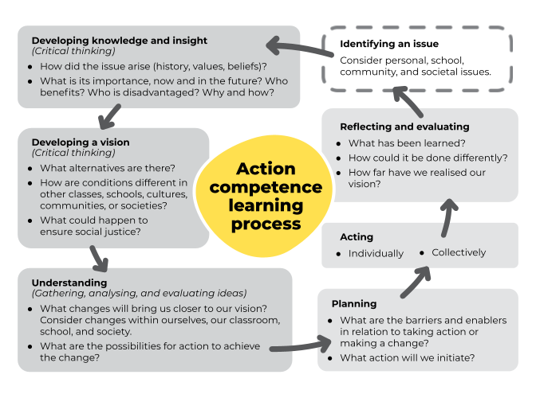design the action you wish to take.

# My/our planning

|  |  |
| --- | --- |
| The best stage of the inquiry process for me/us to start at is |  |
| The potential outcomes I/we are seeking are |  |
| For the inquiry to be successful, I/we need this knowledge |  |
| For the inquiry to be successful, I/we need these skills |  |
| For the inquiry to be successful, I/we need these relationships |  |
| To get to the next stage of my/our action, the next step is |  |
|  |  |

# Student feedback form 2021

1. **How safe was it for you to participate in the Loves-Me-Not workshop?**

Very safe 1 2 3 4 5 Not safe

1. **How relevant were the learning activities for you?**

Very relevant 1 2 3 4 5 Not relevant

1. **Would you be more likely now to act or speak up, if someone you knew was   
   in an unhealthy or abusive relationship?**

More likely 1 2 3 4 5 Less likely

1. **How well do you think you now know the early signs of abuse in a relationship?**

Very well 1 2 3 4 5 Not at all

1. **Having learnt about sexual consent, how well do you think you are now able to ensure the person you are with is saying "yes"?**

Very well 1 2 3 4 5 Not at all

1. **How much did today’s workshop help you to decide whether all your relationships are healthy or not?**

A lot 1 2 3 4 5 Not at all

1. **How well was the workshop facilitated/led?**

Very well 1 2 3 4 5 Not well

1. **What was the most important part of the workshop for you?**
2. **How could we improve the workshop next time?**

* Tick here if you want to talk to someone further about anything you’ve heard today, and provide a contact phone number and/or email address: