Focus areas

Introductory activities
0.1 | Introducing the workshop
0.2 | Ground rules

Focus area 1: Your future relationship
Students develop a trusted picture of a healthy relationship, and a sense of their personal journey towards it.
1.1 | A healthy relationship
1.2 | What makes a healthy relationship?
1.3 | What influences my thinking?

Focus area 2: Barriers to a healthy relationship
Students learn about negative behaviours that develop into increasingly one-sided power and control in a relationship, and positive behaviours that increase equality.
2.1 | Power and control
2.2 | Cycle of abuse
2.3 | Is that right?

Focus area 3: Consent – only ‘yes’ means ‘no’
Students learn what active sexual consent is, and what damage is caused by sexual assault. ……………………
3.1 | What is consent?
3.2 | Consent scenarios

Focus area 4: Stepping up
Students learn to appreciate their important role in helping their friends to be aware and safe in their relationships.
4.1  4.2 | Stepping in  Should I step in?
4.3 | Who can help?

Focus area 5: Lashing out
Students explore the reality of relationship violence in New Zealand, and how they can help themselves and others safely if a relationship becomes violent.
5.1 | Relationship violence in New Zealand
5.2 | Sophie’s story

Focus area 6: Be the change!
Students explore positive actions they can take right now with their schools and communities to promote healthy relationships, and sum up the workshop.
6.1 | Taking action
6.2 | Summing up

About this workshop

Place of this workshop
Research shows that a whole school approach is the most effective way of creating behaviour change (see pages 5-6 of the Implementation Guide). Therefore the Loves-Me-Not workshop is not a full programme in itself, but rather a teaching and learning workshop that can form part of a whole school approach to healthy relationships.

It can be included with other internal or externally provided secondary school programmes that look more in-depth at gender inequality, societal influences on gender, safe sex, respect etc. The workshop offers a focused opportunity for students to explore healthy and unhealthy relationships.

Planning and timetabling
The process of planning and preparing the workshop is covered in Steps Five and Six on pages 12-13 of the Loves-Me-Not Implementation Guide).

Plan which sessions your workshop will cover in each of the six Focus Areas. This will depend on factors such as existing learning from other programmes, the needs of the students, or the time available. The school may consider delivering some of the sessions separately from the workshop.

For ease in adapting this resource, each activity takes up a standard two pages. If you do change the order or remove some of the activities, you will also need to adjust the PowerPoint accordingly.

Student-led action
Student-led action to promote healthy relationships is a fundamental outcome of Loves-Me-Not. Therefore the school will need to provide opportunities for students to implement their action after the workshop.

To emphasis student-led action, schools may decide to deliver Activity 6.1 outside the workshop, for example by using the student inquiry learning process, such as the action competence learning model described on page 7 of the Implementation Guide.
Preparation
Clarify which facilitator will be responsible for:
- facilitating each activity
- recording (if required) during that activity
- keeping the activity to time.

Preview the PowerPoint slideshow and its links to the videos before the workshop. Please do not share these videos online. Ensure that:

- all the videos open correctly from Police’s closed YouTube channel (note that the video links in the PowerPoint only work from the Slideshow view).
- the projector’s aspect ratio is 4:3
- the Settings in YouTube are adjusted to highest HD (or Auto on slower school internet systems) for each video
- each video is enlarged to Fullscreen.

Introductory activities  Introducing the workshop |  | Focus area  0.1
Learning intention:  - Students will understand what Loves-Me-Not is, and why it applies to them. | Facilitator:  (ideally led by principal)  Duration:  Planned start time:  Planned end time:
TIP: If the workshop is being delivered to more than one class, you may consider running the activities on this page as a large group in the hall, before breaking up into separate classrooms.

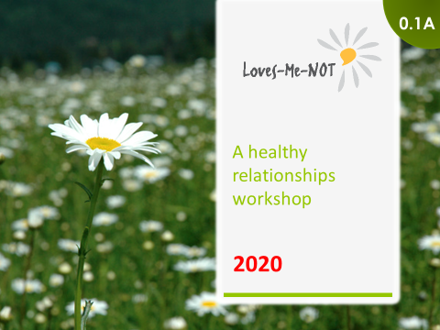 | Show slide ‘Loves-Me-Not – a workshop for healthy relationships’ (slide 0.1A).  Follow the school’s protocol/kaupapa – classes may start with karakia or morning prayer.

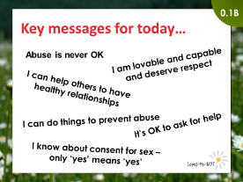 | Show slide ‘Key messages’ (slide 0.1B).  Say: These are the messages for you to take away from today’s workshop.

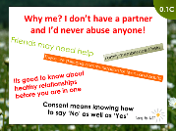 | Show slide ‘Why me?’ (slide 0.1C).  Say: If you don’t have a partner, or if you’d never abuse anyone, why do you think it’s still important to be here today? This slide shows some reasons, but can you think of any more?

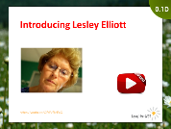 | Show slide ‘Introductions’ (slide 0.1D).  Say: Loves-Me-Not was originally the brainchild of a woman called Lesley Elliott. We will be meeting Lesley at various times during the day. Through her experience we will explore some of the challenges that young people have as they journey towards having great relationships, whether as just friends or something deeper.  Show the video of Lesley Elliott.

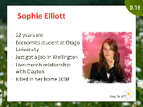 | Show slide ‘Sophie Elliott’ (slide 0.1E).  Say: This is Lesley’s daughter, Sophie Elliott – we’ll talk more about her story through the day.

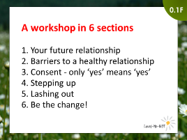 | Show slide ‘Today’s topics’ (slide 0.1F).  TIP: Adapt this slide beforehand if your workshop is organised differently.  Say: The workshop is divided into [six] sections.  Explain the organisation of the day:  - workshop timeframes  - break times  - the location of toilets  - where the time out/zone out room is (if pre-arranged)  - response in an emergency (e.g. evacuation procedure).  Say: We want to make an agreement with you because we have a lot to cover today.  In one workshop we can only explore so much. Some of the things we talk about you may want to explore more deeply than we have allocated time for.  We apologise in advance where we have to move on. But do let your teachers know if there is anything you would like to cover more deeply at a later date.

Introductory activities  Ground rules |  | Focus area  0.2
Learning intention:  - Students will agree on ground rules for the effective running of the workshop. | Facilitator:  (ideally led by teacher)  Duration:  Planned start time:  Planned end time:
Materials
- 1 blank sheet of A5 paper per student (for making nameplates)
- A1 flipchart or whiteboard for ground rules
- Box for anonymous questions and disclosures (if you plan to use a drop-box)

TIP: If you started the workshop as a large group in the hall, now is the time to break up into separate classes.

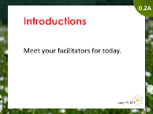 | Show slide ‘Introductions’ (slide 0.2A).  Invite each facilitator to introduce themselves (preferably with their pepeha or mihi) and to explain why they’ve each chosen to facilitate the Loves-Me-Not workshop.  Say: If you want to, you are all capable of having really great, happy relationships that contribute to your life and the life of your friends and partners.  Today we're going to talk about what that relationship could look like, and discuss some of the challenges and risks you and your friends or partners might have to deal with on your way to having really great, happy relationships.  Ask students to fold an A5 sheet in half, write their name on it, and place it on the desk in front of them, so that the facilitators can refer to them personally.  Get each student to introduce themselves saying:  - their name  - one thing in their life they are proud of.

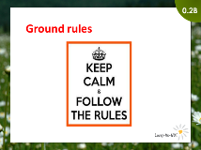 | Show slide ‘Ground rules’ (slide 0.2B).  Teacher leads the discussion on ground rules. If the school has specific values that define the desired behaviours (e.g. from PB4L), or standard ground rules for classes, then the teacher should use these as a start to develop agreed ground rules for the workshop.  Say: What we are discussing today is serious stuff, so we need some ground rules to make sure we all get the best out of the day.  Brainstorm and record the agreed ground rules. These could include:  - respect (e.g. listening to others, not interrupting, keeping comments positive)  - confidentiality (e.g. what we say in here stays in here, take self-care about how much you want to reveal, you are not expected to share personal information today)  - participation (e.g. engage in the day as much as possible)  - tolerance (e.g. respect the different opinions of others).

Say: During the day we will identify people and places you can go to get further help or to explore anything you want to cover in more detail.

Remind students what to do if they find the content particularly personal or upsetting (e.g. when and where the school counsellor and/or Police are available).

TIP: You may also wish to set up a drop-box for students to ask questions or disclose anonymously if they wish. This will need to be managed and checked regularly.

Your future relationship  A healthy relationship |  | Focus area  1.1
Learning intention:  - Students will identify the qualities of a healthy relationship | Facilitator:  Duration:  Planned start time:  Planned end time:
Materials:
- 1 sheet of A4 paper per person
- 1 large sheet of paper or a whiteboard, drawn up with a Y-chart

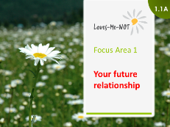 | Show slide ‘Focus area 1’ (slide 1.1A).  Say:  If you want to, everyone in this room is capable of having a really great, happy relationship that contributes to your life and contributes to the life of your partner.  Today we're going to talk about what that relationship could look like, and discuss some of the challenges and risks you and your friends might have to deal with on your way to having a really great, happy relationship.  Let's start with thinking about what a healthy relationship is like ...  First, please close your eyes. [pause]  Tune out from this room. [pause]  Imagine you are about 21 years old. It's a normal sort of day. You are sitting on a bench at the park near your work having lunch. The sun is shining. You have just got off your mobile phone, having rung your partner of several years to see how their day has been going, and to talk about your own day. It was a cheerful conversation, even though things hadn't gone that great at work that morning.  Keeping your eyes closed, please think about this relationship.  What does it looks like to be in the healthy relationship you imagined? [pause for at least 15 seconds]  What does it sound like? [pause for at least 15 seconds]  What does it feel like? [pause for at least 15 seconds]

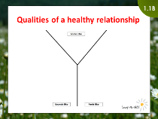 | Show slide ‘Qualities of a healthy relationship’ (slide 1.1B).  Give each student a piece of A4 paper.  Get each student to head their paper with the words ‘A healthy relationship’, and to draw a ‘Y-chart’ as shown on the slide.  A healthy relationship …  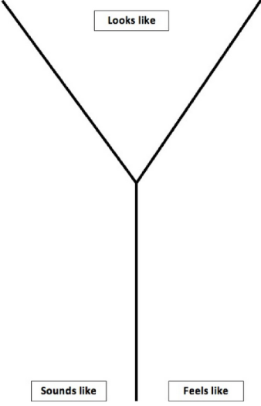  Ask students to each write words or statements on their own chart to answer the following three questions:  - What does it look like to be in the healthy relationship you imagined?  - What does it sound like?  - What does it feel like?  Say: Fold your paper up, and keep it somewhere safe, as we’ll look at it again at the end of the workshop.

Brainstorm the class’s combined ideas of the qualities that make a healthy relationship, and record them on a large Y-chart drawn on a large sheet of paper or the board.

Your future relationship  What makes a healthy relationship? |  | Focus area  1.2
Learning intention:  - Students will identify the features that make a healthy relationship. | Facilitator:  Duration:  Planned start time:  Planned end time:
Materials:
- Four headings printed out on A4 paper or written at the top of a large sheet of paper
- Several blank Post-It notes per student

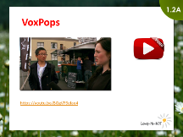 | Show slide: ‘VoxPops on what makes a healthy relationship’ (slide 1.2A).  Say: To help arrange our ideas, here's a video describing some of the qualities of a healthy relationship.  Show video.  Ask: Which of your suggested qualities from the Y-chart we did in Activity 1.1 were mentioned in this video?

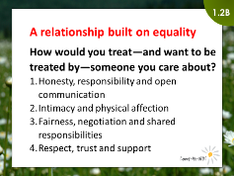 | Show slide: ‘A relationship built on equality’ (slide 1.2B).  Place these four headings on the floor:  - Honesty, responsibility and open communication  - Intimacy and physical affection  - Fairness, negotiation and shared responsibilities  - Respect, trust and support  Divide the class into small groups and give them a pile of Post-It notes. Ask them to come up with the top qualities of a healthy relationship built on trust, and then place their ideas under the appropriate heading. When completed, discuss and compare with the suggested qualities on the following page.  Say: Great, so now you have provided a picture of a healthy future relationship.

Qualities of what makes a healthy relationship
A healthy relationship is based on equality and respect. Think about how you treat—and want to be treated by—someone you care about.

Honesty, responsibility and open communication
Honesty and responsibility  - Not making excuses for your partner’s or your own actions  - Admitting when you are wrong  - Keeping your word  - Not cancelling plans | Open communication  - Being able to express your feelings or opinions  - Knowing it’s okay to disagree  - Saying what you mean and meaning what you say

Intimacy and physical affection
Intimacy  - Respecting your partner’s boundaries  - Respecting each other’s privacy  - Not pressuring your partner  - Being faithful | Physical affection  - Holding hands  - Hugging, kissing, sitting or standing with your arm on your partner’s shoulder  - Respecting each other’s right to say no  - Asking before acting

Fairness, negotiation and shared responsibilities
Fairness and negotiation  - Accepting change  - Being willing to compromise  - Working to find solutions that are agreeable to both people  - Agreeing to disagree sometimes | Shared responsibilities  - Making decisions together  - Splitting or alternating the costs for dates  - Doing things for each other  - Going places you both enjoy  - Giving as much as you receive

Respect, trust and support
Respect  - Paying attention to your partner–even when your friends are around  - Valuing your partner’s opinion even if it differs from yours  - Listening to what your partner has to say | Trust and support  - Being supportive  - Wanting the best for your partner  - Knowing your partner likes you  - Offering encouragement when necessary  - Being okay with your partner having different friends

Adapted from ‘Reaching and Teaching Teens to Stop Violence’, Nebraska Domestic Violence Sexual Assault Coalition, 1996.

Your future relationship  What influences my thinking? |  | Focus area  1.3
Learning intention:  - Students will explore influences that may encourage or discourage healthy relationships. | Facilitator:  (ideally led by teacher)  Duration:  Planned start time:  Planned end time:

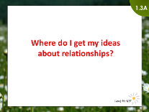 | Show slide ‘Where do I get my ideas about relationships?’ (slide 1.3A).  Brainstorm with the students where they get their ideas from about relationships. Answers might include parents, friends, church, blog sites, social media groups, porn sites, and entertainment media.

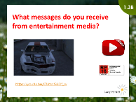 | Show slide ‘Entertainment media video’ (slide 1.3B).  Say: In this video we will look at a range of entertainment media. As you watch this, ask yourself:  - What does this clip say about relationships?  - What does this clip say about how men should behave in a relationship?  - What does this clip say about how women should behave in a relationship?  Show the video.  NOTE: This video contains violence and sexual material. It is rated RP16, which means that it is restricted to persons 16 and over, but because of its educational value and purpose, may be made available to persons under 16 anyone accompanied by a parent, teacher or other responsible adult.

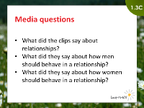 | Show slide ‘Media questions’ (slide 1.3C).  Discuss the video.  - What did the clips say about relationships?  - What did the clips say about how men should behave in a relationship?  - What did the clips say about how women should behave in a relationship?

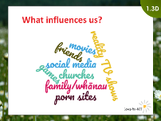 | Show slide ‘What influences us?’ (slide 1.3D).  Break the class into small groups or pairs.  Ask each group or pair to consider a different source of information about relationships, and how the messages from this source might influence their ideas about healthy relationships.  For example:  - the influence of movies  - the influence of reality TV shows  - the influence of games  - the influence of friends  - the influence of porn sites  - the influence of churches  - the influence of family/whānau  - the influence of social media.  Discuss whether these sources of behavioural expectations in relationships encourage or discourage healthy relationships.  Say: When you decide what you want in a healthy relationship, think critically about the messages you receive from different sources.

Time management of Focus area 1
Expected start time: _______________ Actual start time: ________________
Expected finish time: ______________ Actual finish time: _______________
Barriers to a healthy relationship  Power and control |  | Focus area  2.1
Learning intention:  - Students will identify negative behaviours that increase power and control in a relationship, and positive behaviours that increase equality. | Facilitator:  Duration:  Planned start time:  Planned end time:
Materials:
- Copysheet: Power and control wheel (one per student)
- Copysheet: Equality wheel (one per student)

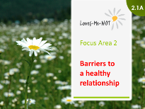 | Show slide ‘Barriers to a healthy relationship’ (slide 2.1A).  Say: While we think of ‘good’ relationships as being smooth and happy, in the real world even in the best relationships conflicts still happen that are hard to handle. They can range from merely frustrating to seriously relationship-threatening.

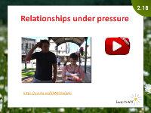 | Show slide ‘Relationships under pressure’ (slide 2.1B).  This video shows young people like yourselves in just a few years’ time, dealing with the type of conflicts that could possibly happen in any relationship.  Show the video.  Ask:  - Why are these conflicts?  - Who is to blame for them?  - How are both people feeling?  - What do they want to achieve now?

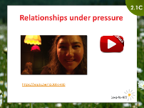 | Show slide ‘Relationships under pressure’ (slide 2.1C).  NOTE: This video contains some swearing, sexual references and violence.  Say: This video picks up from the last one to show what might happen next.  Show the video.  Ask:  - How did that feel?  - These bad responses were all different - but what did they have in common? [answer: power and control]
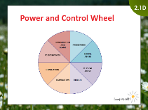 | Show slide ‘Power and Control Wheel’ (slide 2.1D).  Give students Copysheet: Power and Control Wheel.  Explain: Power and control sit at the centre of the wheel. The spokes are ways that one partner gains power and control over the other. They might use just one, or several of the spokes.  Ask: Which spokes of the Power and Control Wheel did the video show?  TIP: If time permits, show the video again so students can clearly identify where each of the qualities in the Power and Control Wheel is shown.

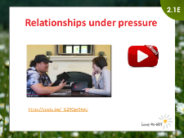 | Show slide ‘Relationships under pressure’ (Part 3) (slide 2.1E).  Ask:  - What would it take for the characters to go down a positive path instead?  - What would they have to do with their tough, difficult feelings?  Say: This video rewinds and shows another option of what might happen next.  Show the video.  Ask:  - How did that feel?  - What was different about the way the characters dealt with the conflicts?  - These responses were all different - but what did they have in common? [answer: equality]  - Does a good relationship mean sucking up bad feelings? Why / why not?  - What’s the difference between a fight and a hard conversation?

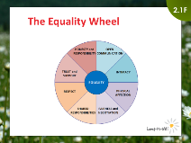 | Show slide ‘The Equality Wheel’ (slide 2.1F).  Give students Copysheet: Equality Wheel.  Explain: Equality, instead of power and control, sits at the centre of this wheel. The spokes are ways that both partners can have a more equal relationship, even when dealing with the conflicts that can crop up in any relationship.  Ask:  - Which spokes of the Equality Wheel did the video show?  - How do the spokes compare with those in the Power and Control Wheel?  - Did you notice that the Equality Wheel uses the same qualities that make a healthy relationship which we discussed in Activity 1.2?  TIP: If time permits, show the video again so students can clearly identify where each of the qualities in the Equality Wheel is shown.

Source: Domestic Abuse Intervention Programs, Home of the Duluth Model, https://www.theduluthmodel.org/wheels/
Barriers to a healthy relationship  Cycle of abuse |  | Focus area  2.2
Learning intention:  - Students will be able to recognise the cycle of abuse in unhealthy relationships. | Facilitator:  (ideally led by NGO)  Duration:  Start time:  End time:
Materials:
- Copysheet: Cycle of Abuse (one per student)
- [optional] Copysheet: Story – Jake and Maddie (one per student).

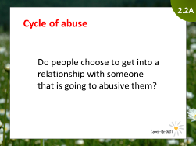 | Show slide ‘Cycle of abuse’ (slide 2.2A).  Ask: Do you think people choose to get into a relationship with someone that is going to be abusive to them?  [Answer: People don't usually choose to get into a relationship with someone who regularly displays abusive or unhealthy behaviour.]  Explain: In an unhealthy relationship, abusive behaviours tend to increase over time. In other words, relationships don't usually start bad, but some go bad. Most abusive relationships follow a certain type of cycle. This cycle can help explain why some people stay in unhealthy and abusive relationships.

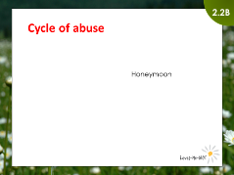 | Show slide ‘Cycle of Abuse - Honeymoon phase’ (slide 2.2B).  Say: The first phase of the cycle of abuse is the ‘honeymoon’ phase.  Ask:  - What does the ‘honeymoon’ phase sound/look/feel like?  [Answers could include: Both people are really excited about the relationship, and everything feels great.]  - Do healthy relationships also go through a honeymoon phase?  [Answer: Yes]

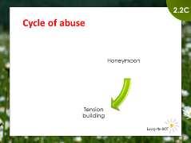 | Show slide ‘Cycle of Abuse - Tension building phase’ (slide 2.2C).  Say: After the honeymoon phase, some relationships move into a second phase, called the ‘tension building’ phase.  Ask:  - What does the ‘tension building’ phase sound/look/feel like?  [Answers could include: One person may feel as if their partner is blaming them for everything and anything. The person feels as if they can’t do anything right.]
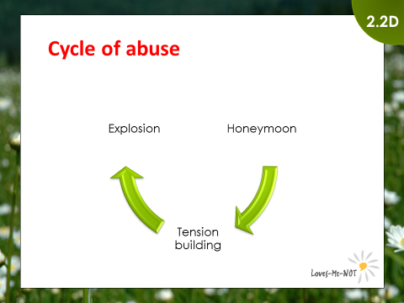 | Show slide ‘Cycle of Abuse - Explosion phase’ (slide 2.2D).  Say: The third phase is the ‘explosion’ phase.  Ask: What does the ‘explosion’ phase sound/look/feel like?  [Answers could include: This is when emotional, verbal or physical threats, attacks, and/or violence take place. The person may say cruel things to hurt their partner, scream or even hit.]

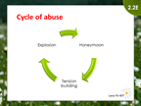 | Show slide ‘Cycle of Abuse’ (slide 2.2CE).  Ask: What usually happens after this phase that can make it hard for the other partner to recognise the unhealthy relationship or leave?  [Answers could include: The cycle circles back to the honeymoon (now remorse) phase, the abusive partner apologises, seeks forgiveness, and tries to make up.]  Say: This cycle can repeat many times. Each time the gaps between the phases may become smaller, and the tensions and explosions may become worse.  Most relationships don't start out as bad, but some go bad. Some key points to prevent relationships from going bad are to avoid:  - excusing your partner’s unhealthy or abusive behaviours  - thinking like you can change your partner’s unhealthy or abusive behaviour  - making excuses for any behaviours that you show that are unhealthy or abusive (own your behaviour and take responsibility for how you behave).  Give students Copysheet: Cycle of Abuse.

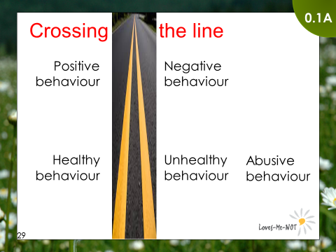 | Optional activity  Show slide ‘Crossing the line’ (slide 2.2F).  Say: What some people think is OK behaviour, others will think is not OK. I am going to read a story. As I read this story, your task is to identify when the behaviour is healthy or unhealthy, or even abusive. If the behaviour is:  - healthy – stay still and do nothing  - unhealthy – raise hand above your head  - abusive – hand raised with closed fist.  Read Copysheet: Story – Jake and Maddie. Whilst you read, get the students to indicate as described above.  Ask: Did the class identify different behaviours as healthy, unhealthy or abusive?  TIP: If the students all have access to devices, you could run this task using an app such as Kahoot! to anonymously display their decision points on a screen, rather than by raising their hands. Or this task could be done as a quiet reading exercise, where the students mark in pen where there is healthy, unhealthy and abusive behaviour, and then compare their results.
Barriers to a healthy relationship  Is that right? |  |  | Focus area  2.3
Learning intention:  Students will explore some common myths that may perpetuate power and control in relationships. |  | Facilitator:  Duration:  Planned start time:  Planned end time:
Materials:
- Copysheet: Agree/disagree continuum (made up as signs)
TIP: Instead of doing this as one complete session, you could do each continuum at a different point throughout the day.
TIP: More on how to run a continuum activity: Barometer: Taking a stand on controversial issues

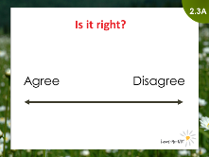 | Show slide ‘Is it right?’ (slide 2.3A).  Place the ‘Agree’ and ‘Disagree’ signs from Copysheet: Agree/disagree continuum at each side of the room.  Say: We are going to do an activity in which we look at opinions on healthy and unhealthy relationships. An opinion is held at one particular moment. It can change at any time based on new knowledge and experience.  Discuss guidelines in preparation for this activity, such as:  - one person speaks at a time  - you have the right to pass if you wish  - use ‘I’ statements when speaking - this shows that it is a personal opinion  - don’t question or comment on another person’s statement  - feel free to move along the continuum after hearing other people’s thoughts.
Read the following statements, one by one (do all five if time allows, or less if time is limited). Ask students to stand on a continuum for each statement, from ‘agree’ at one end to ‘disagree’ at the other end, with 'neutral' or 'don't know' in the middle. Invite them to share why they have chosen their places on the continuum.

Important: The facilitator should not express their own opinion. But sometimes you may need to prompt a point of view that hasn’t come up, e.g. “Have you considered…”, “Other people might think…”

- A person in an abusive relationship is stupid if they don't just leave.
- People who provoke their partner into anger deserve to be beaten.
- Violence in relationships is caused by drugs and/or alcohol.
- Females invite sexual assault by the way they dress and behave.
- My partner is only jealous because they love me.
After discussing each statement, share the following information. After hearing this information, let students change their places on the continuum if they wish.
- A person in an abusive relationship is stupid if they don't just leave.
There are many reasons people stay in abusive relationships. These include:
- fear that the violence will escalate
- financial dependence
- belief that they can fix the relationship
- concern for their children
- love for their partner – but they hope the violence will stop
- doubt of their own ability to be independent
- isolation
- not realising that they are in an abusive relationship
- religious or moral values.

An abusive friend or partner intentionally uses lots of different negative behaviours that we have already discussed to keep them under control. For example, threats of self-harm or suicide, possessiveness, or ongoing promises to change. These tactics can make it really hard to leave abusive relationships, without help.
- People who provoke their partner into anger deserve to be beaten.
Anger is a normal emotion, and everyone has feelings of anger. It's what you do to express that anger that can become the issue. There are many healthy ways of dealing with anger (e.g. walking, talking with a friend). Using an angry feeling to hurt another person, or as a power and control behaviour, is never OK.
- Violence in relationships is caused by drugs and/or alcohol.
Almost equal numbers of sober and drunken people are violent. Many drunken people do not abuse their friends or partners. Alcohol and other addictive substances are used as excuses, but they don’t cause violence. However, the severity of the assault may increase if the abusive person has used such substances.
- Females invite sexual assault by the way they dress and behave.
Females (like all people) may dress so as to attract someone for sex or to feel good about themselves. It does not mean they are asking to be assaulted. You don’t know whether they are looking for sex unless you ask them. If they do want to have sex they want to choose who with and when. The abuser is responsible for sexual assault, not the recipient.
- My partner is only jealous because they love me.
Being jealous of someone, and acting on that jealousy, is a form of control. Fighting over someone is about control. Remember, we don’t own anyone. Jealousy is not an indication of someone's love for another person.

Time management of Focus area 2
Expected start time: _______________ Actual start time: ________________
Expected finish time: ______________ Actual finish time: _______________
Consent – only “yes” means “yes”  What is consent? |  | Focus area  3.1
Learning intention:  - Students will define consent, recognise when they have consent, and identify the risks and consequences of non-consensual sex. | Facilitator:  (ideally led by Police or NGO)  Duration:  Planned start time:  Planned end time:

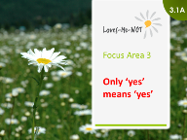 | Show slide ‘Focus area 3 – only “yes” means “yes”’ (slide 3.1A).  Say: In this focus area we will look at sex and consent.  Ask: What is sex?  Facilitate answers to expand views of sex from sexual intercourse to a broader range of activity e.g. cuddling, kissing, oral sex, anal sex.  Important: Avoid heteronormative phrases (i.e. that heterosexuality is the only normal and natural expression of sexuality) such as ‘normal’ sex when referring to penis and vagina sex.

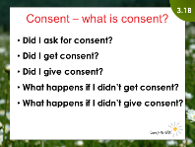 | Show slide ‘Consent – what is consent?’ (slide 3.1B).  Discuss what consent is.

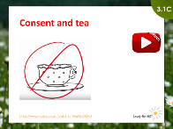 |  | NOTE: There are three options for how to cover this activity.  OPTION 1:  Show slide ‘Consent and tea‘ (slide 3.1C).  Say: Here’s a way of looking at consent.  Show external YouTube video Consent and Tea.  Ask:  - Obviously it is not acceptable to coerce someone into drinking a cup of tea, so why do some people think it is OK to push someone into having sex?  - Why are boundaries obvious and easy to respect when we are talking about tea, but it seems more complicated when we are talking about sex?  Say: We all know how to be respectful and listen. We just need to do this is our relationships. So think back to the media clips in Activity 1.3. We get many messages about sex – and not respecting boundaries is sometimes seen as OK.
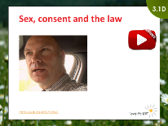 | OPTION 2:  Show slide ‘Sex, consent and the law’ (slide 3.1D).  Say: Consent is not just an attitude towards a sexual partner. It is part of the law about relationships. Let’s look at consent from a Police perspective.  Either …  show video.  or …  the police member of the facilitation team discusses consent and the law with the students, covering:  - legal definition of  - sex  - consent  - sexual assault and rape  - consequences for the offender  - impacts for victims:  - short term, e.g. loss of face, reputation  - long term, e.g. loss of trust and loss of self-belief leading to difficulty in sustaining long term relationships  - description of consent for online material, e.g. does agreeing to be videoed in sexual act for a boyfriend/girlfriend mean that they have consent to share it electronically?

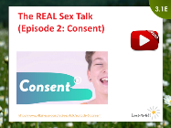 | OPTION 3:  Show slide ‘The REAL Sex Talk – Episode 2: Consent’ (slide 3.1E).  Say: 'Consent' is the buzzword of modern sex ed. But what does it mean? And how do you know when someone has given it? What if someone is drunk or high? Does not saying 'no' mean ‘yes’? (Spoiler: no!) This video from The REAL Sex Talk series takes a closer look at consent.  Show external video The REAL Sex Talk - Episode 2: Consent created by Villainesse.  Discuss what consent is.

Consent – only “yes” means “yes”  Consent scenarios |  | Focus area  3.2
Learning intention:  - Students will use scenarios to identify whether consent was given, and consequences for people either receiving or demonstrating abusive behaviour if consent wasn’t given. | Facilitator:  Duration:  Planned start time:  Planned end time:
Materials:
- Copysheet: Scenarios (divided into two scenarios for each small group)

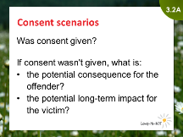 | Important: Be aware that this activity may strike home for some students if they have been in these sorts of situations before. Facilitators must be aware of how to deal with disclosures (as outlined on pages 25-26 of the Implementation Guide).  Show slide ‘Consent scenarios’ (slide 3.2A).  Break class into groups.  Give each group two (of the five) scenarios from Copysheet: Scenarios.  Get groups to discuss each scenario and decide if consent was given.  Facilitate a class discussion on the options and what they would do if they knew someone who had sex without consent.  Say: Remember we have support available in the school, and the main people you can approach are ...

Discuss the following questions:

- What do you think might be the long-term impact on a person who has been sexually violated (sex they did not consent to)?
- Imagine that you had non-consensual sex with someone. Would you be deeply concerned about the long-term impact of that non-consensual sex on that person? If not, why not?
- How might having non-consensual sex with someone affect a person’s future sexual decision-making and relationships?

Time management of Focus area 3
Expected start time: _______________ Actual start time: ________________
Expected finish time: ______________ Actual finish time: _______________
[page left blank on purpose]

Stepping up  Stepping in |  | Focus area  4.1
Learning intention:  - Students will describe the range of ways in which someone could step in. | Facilitator:  Duration:  Planned start time:  Planned end time:

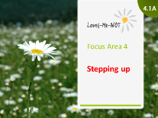 | Show slide ‘Stepping up’ (slide 4.1A).  Stepping in can be hard! It can mean different things. It might mean:  - personally stepping in – like ‘getting in your face’  - indirectly stepping in – like ‘distracting them’  - getting help if it isn't safe for you to step in.  Brainstorm the actions that people could take when they have concerns about the way their friend is treating someone else. Record responses on a whiteboard.  Examples of stepping-in actions might include:  - making a joke  - changing the topic  - making a distraction  - yelling at them to settle down  - punching the person who is being abusive  - pulling out your phone and saying that you will video the confrontation  - telling the school guidance counsellor about the behaviour you saw  - telling your most trusted teacher  - calling the police on 111  - ringing a helpline (e.g. Youthline) or an anonymous line (e.g. Crimestoppers).

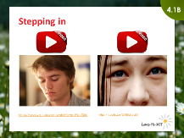 | Note: For this activity you will need to decide beforehand which video to show.  Show slide ‘Stepping in’ (slide 4.1B).  Say:  We will shortly watch a video about being a bystander. As you watch the video, take on the role of the bystanders and decide if and when you would intervene to keep both yourself and the target from being abused.  If you would do something, choose a visible sign (e.g. raise your hand, thumb up) when you would do something and you know what you would do at that time.  Show either or both of the videos, getting the students to use the signals discussed to indicate when they would step in:  - Observing street behaviour  - The bystander … the action movie  WARNING: These videos contain some swearing, sexual references and violence.  Ask several students who used the visible sign (e.g. thumb up) what they thought they would do.  Ask some of the students who did not use a visible sign why they wouldn't step in.  Answers might include:  - they may be afraid that they will become the next target of abuse  - they may not know how to stop the behaviour  - they may feel that they will make things worse for the person being abused  - they may think that ‘It is just another domestic, and none of my business’  - they may be afraid that they will be labelled as a ‘dobber’ or a ‘nark’  - they may think that the person being abused deserves it  - they may think that they are powerless to intervene.  Important: Be sensitive - some students may have experiences as to why they wouldn’t intervene.

Stepping up  Should I step in? |  | Focus area  4.2
Learning intention:  - Students will describe how to safely take action. | Facilitator:  (ideally led by teacher)  Duration:  Planned start time:  Planned end time:
Materials:
- 6 pieces of paper per group e.g. A4 cut into 6, or ‘Post-its’

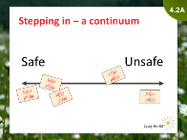 | Show slide ‘Stepping in – a continuum’ (slide 4.1A).  Either …  ask each student to select and write one of the stepping-in actions from Section 4.1 on a ‘post-it note’ and stick it on their forehead.  Get the students to whey walk around the room reading other people’s ideas, and arrange themselves on a whole class continuum from ‘safe’ to ‘unsafe’.  … or  ask small groups to select and write 4–6 stepping-in actions onto separate small pieces of paper.  Students arrange the stepping-in actions along their table or along the floor in a continuum, from ‘safe’ to ‘unsafe’ actions.

Get students to form into groups of four so they can create their own relationship scenarios. They take on roles: two students are the partners, one student is the bystander, and one student is the ‘good fairy’ (who figuratively sits on the shoulder of the bystander) giving advice to the bystander on what to do so that everyone is kept safe.
Debrief the role play with questions like.
- Did the bystander step in at the right time?
- Did their actions diffuse the situation?
- Were their actions safe or unsafe for them? For the person they were helping?
- What else could they have done?

TIP: This activity should only be run by the teacher or another facilitator who is skilled in using role-play as a teaching tool.

Say: To step in you usually have to:
- accept that someone’s behaviour may harm someone else
- accept that something has to happen or someone will be harmed (including emotional / psychological harm)
- be confident that your actions will prevent harm
- accept that you have the skill to step in safely.

Stepping in can be a hard and risky decision. But remember, stepping in need not necessarily need intervening personally, but rather getting help in some other way.
If we want to live in a safe community we all have to step in somehow and someway.
The police officer may finish by sharing strategies they use to diffuse family violence situations.

Stepping up  Who can help? |  | Focus area  4.3
Learning intention:  - Students will identify a range of helping agencies. | Facilitator:  (ideally led by Police or NGO)  Duration:  Planned start time:  Planned end time:
Materials:
- A1 flipchart – to be placed on the wall with the heading 'Who can help?’
- [Optional] Some facilitators (schools/NGO/Police) may have pre-prepared a handout for the students that lists local and national agencies that can help, and how to contact these agencies.

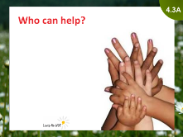 | Show slide ‘Who can help?’ (slide 4.3A).  Brainstorm the different people or agencies the students could go to for help when a friend’s relationship is having problems that they are concerned about.  Record the answers on an A1 flipchart.  Add any other appropriate agencies that the class did not identify themselves.  Describe [NGO and Police] what your organisations do to help people in abusive relationships who seek their help.  Describe [teacher] the procedure the school follows if a disclosure occurs at school.  Option: Give a handout showing local support agencies to students.

Time management of Focus area 4
Expected start time: _______________ Actual start time: ________________
Expected finish time: ______________ Actual finish time: _______________
[This page left blank on purpose]

Lashing out  Relationship violence in New Zealand |  | Focus area  5.1
Learning intention:  - Students will explore the level of relationship violence in New Zealand, and the impact of the level of violence. | Facilitator:  (ideally led by Police or NGO)  Duration:  Planned start time:  Planned end time:

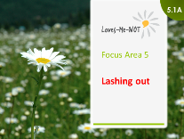 | Show slide ‘Lashing out’ (slide 5.1A).  Discuss with the class whether they think violence in relationships is a problem in New Zealand?

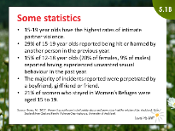 | Show slide ‘Statistics’ (slide 5.1B).  Ask students in their groups to discuss which statistics most surprised them and why.  Get one person from each group gives one statistic that surprised their group and explains why.

TIP: If you want more statistics, a good source is the New Zealand Family Violence Clearing House: https://nzfvc.org.nz/family-violence-statistics

[This page left blank on purpose]

Lashing out  Sophie’s story |  | Focus area  5.2
Learning intention:  Students will use this scenario to reinforce their understanding of:  - different unhealthy and abusive behaviours  - the escalation of unhealthy and abusive behaviours  - bystander responses  - the long-term effect on people in abusive relationships. | Facilitator:  Duration:  Planned start time:  Planned end time:
Materials:
- Copysheet: Sophie's bystanders (cut into one sign for each small group)

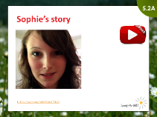 | Show slide ‘Sophie’s story’ (slide 5.2A).  Say: Sophie’s story shows an actual incident that ended in tragedy. As you watch this story, think about:  - her desire for a healthy relationship  - how power and control was gained and lost in their relationship  - the unhealthy behaviours in their relationship  - how the behaviours escalated.  While very few unhealthy relationships end in such tragedy, the warning signs shared in Sophie’s story are typical of many that Police and helping organisations hear about.  Sophie’s story may be upsetting. If you feel upset, please go to … [room set aside].  Show the video (note that this video is 21 minutes long).  Facilitate a discussion for students to express their immediate feelings about Sophie’s story. For example, some students could come up with a word or phrase that describes how they feel after watching the film.

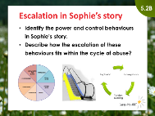 | Show slide ‘Escalation in Sophie’s story’ (slide 5.2B).  Say: We are going to use Sophie’s story to look again at what we have learnt today about relationships that go bad, including:  - recognising power and control  - identifying the escalation through the cycle of abuse  - understanding the challenging role of bystanders to step in.  Get small groups to identify power and control behaviours, and the role of the cycle of abuse in Sophie’s story.  Ask one member from each group (selected randomly e.g. the tallest, the oldest) to report back to the class.

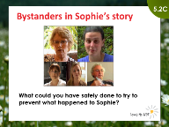 | Show slide ‘Bystanders in Sophie’s story’ (slide 5.2C).  Say: As with all relationship abuse, there are bystanders who could have or did try to intervene as the abuse escalated.  Give each group one of the bystanders in Sophie’s story (see Copysheet: Sophie’s bystanders).  Either …  get each group to discuss the following question:  - ‘If you were this person, what could you have safely done to prevent what happened to Sophie?’  One member from each group reports back to the class.  or …  assign a student to the role of the bystander, and place them in the ‘hot seat’ to be interviewed by other students pretending to be counsellors or police officers, with questions like:  - ‘Are there any clues that you saw in Sophie and Clayton’s relationship that could have predicted Clayton harming Sophie so violently?’  - ‘When you recognised that Sophie could have been harmed by Clayton, is there anything you wish you could have done differently to prevent Sophie being murdered?’

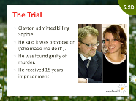 | Show slide ‘The trial’ (slide 5.2D).  Say: Just to round off Sophie’s story, this is what happened to Clayton.

Remind students about the ‘I want to help’ section of the It’s Not OK website, which provides information if they want to help a friend: http://www.areyouok.org.nz/i-want-to-help/

Time management of Focus area 5
Expected start time: _______________ Actual start time: ________________
Expected finish time: ______________ Actual finish time: _______________
Be the change!  Taking action |  |  | Focus area  6.1
Learning intention:  - Students will explore a range of actions they can take to keep themselves, their friends and family safe, and to influence their community to encourage healthy relationships. |  | Facilitator:  (ideally led by teacher)  Duration:  Planned start time:  Planned end time:
Materials:
- Copysheet: Be the change – planning template (one per small group)
TIP: This activity is extremely important, as it is designed to instigate genuine student-led action. Therefore, consider ways to enhance this session, for example by:
- running this session on a following day
- implementing it as a separate inquiry (see page 7 of Implementation Guide)
- providing student-only time to plan and implement their suggestions.

TIP: Funding is available from the Sophie Elliott Trust Fund for student projects that come out of this session. An application form can be downloaded from the Police School Portal.
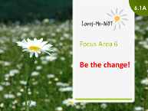 | Show slide ‘Be the change!’ (slide 6.1A).  Say: Today we’ve learned all about healthy relationshisp and what can erode them. But how can you turn this knowledge into action? In this focus area you’ll come up with ideas of what, as a result of doing Loves-Me-Not, you can do to promote healthy relationships in our community.

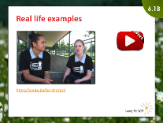 | Show slide ‘Real life examples’ (slide 6.1B).  Say: This video shows some real-life exaples of what students at two schools did to promote healthy realtionships after completing the Loves-Me-Not workshop.  Show the video.  Ask:  - What actions did these students take?  - Who were the audiences (both intended and unintended) for these actions?  - What were/could have been the results of these actions?

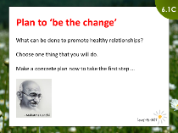 | Show slide ‘Plan to be the change’ (slide 6.1C).  Say: So what will you do to promote healthy relationships and reduce the negative statistics of relationship abuse in Aotearoa/New Zealand?  Brainstorm some practical things the students could do to reduce relationship abuse around them and across New Zealand, based on a student inquiry learning process (see Loves-Me-Not Implementation Guide page 7).  Examples of potential actions include (but are not restricted to):  - writing articles in the school or local newspaper  - organising a fundraiser for Women’s Refuge, Rape Crisis or the Sophie Elliott Foundation  - setting up and using a freeform writing board for thoughts and comments about abuse  - holding a competition for stories, posters, artwork and so on  - printing posters related to events that highlight abuse and putting them up in the community  - having a feature at lunchtime each day for a week, e.g. a drama or a relevant guest speaker  - creating a song and putting it onto YouTube, like Walk Away by Tina Cross  - running a Students Against Abuse stall at the school gala  - running an in-school campaign by senior students to help educate the younger students  - doing a chalk-drawing day at your school, with a healthy relationships theme  - promoting an ‘abuse-free week’ at school – teachers use abuse as theme for their lessons.

Give groups Copysheet: Be the Change - planning template for recording their planning.
Say: We would like each group to select something that you would like to do to encourage healthy relationships in our school and community.
You can start planning what you might like to do implement this idea. Think as creatively as you can. Our brainstorm might give you some ideas, or you might come up with something else that hasn’t been thought of.
We would like you to eventually put these ideas into action in real-life. However, it is unlikely that today you’ll be able to do much more than just your initial thinking about a plan.
Discuss how your school intends to provide opportunities for students to turn their ideas into real-life actions.
Explain that if there are costs involved in their actions, there is potential funding available from the Sophie Elliott Foundation Trust. An application form can be downloaded from the Police School Portal.

Be the change!  Summing up |  | Focus area  6.2
Learning intention: | Facilitator:  Duration:  Start time:  End time:
Materials:
- Copysheet: Student Process Evaluation (one per student)

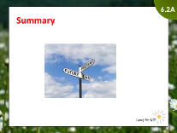 | Show slide ‘Summary’ (slide 6.2A).  Ask students to get out the Y-chart they filled in during Activity 1.1 ‘A healthy relationship’.  Ask: As a result of this workshop what would you add to your answer, or what would you change from your answers, to the question:  - What does it feel like/look like/sound like to be in a healthy relationship?

Sum up the workshop, thank the students, farewell them and offer a challenge before you close – for example:

- Thank you for being part of and contributing to this workshop today.
- Having a great relationship is a cool thing if it helps you to be happier and better than you can be on your own.
- Today we have considered the qualities that make up a healthy relationship and we recognise that you are all on a journey to getting there.
- On the way you may make some mistakes, but we can learn from those. It’s important that you all know your worth and believe you deserve to have a great life with healthy relationships.
- As a result of this workshop, we hope that you have [only include those of the following bullets that you have covered in the workshop]:
  - developed a trusted picture of a healthy relationship, and a sense of your personal journey towards it
  - learned about negative behaviours that develop into increasingly one-sided power and control in a unhealthy relationship, as well as equality makes for a healthy relationship
  - found out what active sexual consent is, what damage is caused by sexual assault
  - appreciated your important role in helping your friends to be aware and safe in their relationships
  - explored the reality of relationship violence in Aotearoa/New Zealand, and how you can help yourselves and others safely if a relationship becomes violent
  - become enthused about positive actions that you can take right now with your school and community to promote healthy relationships.
- Remember: Your power in an unhealthy relationship is that you don’t have to be in it.
- We wish you well as you seek to 'be the change' that the future needs so that all Aotearoa/New Zealand citizens can live in a safe and caring country.

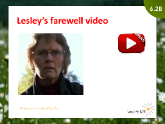 | Show slide ‘Lesley’s farewell video’ (slide 6.2B).  Show video.  Get students to complete Copysheet: Student Process Evaluation.  Inform students (if appropriate) that they will all get [or can request] a free copy of Lesley Elliott’s book Loves-Me-Not.

Follow the school’s protocol/kaupapa for closing. They may wish to finish with a karakia or poroporoaki.

Time management of Focus area 6
Expected start time: _______________ Actual start time: ________________
Expected finish time: ______________ Actual finish time: _______________

