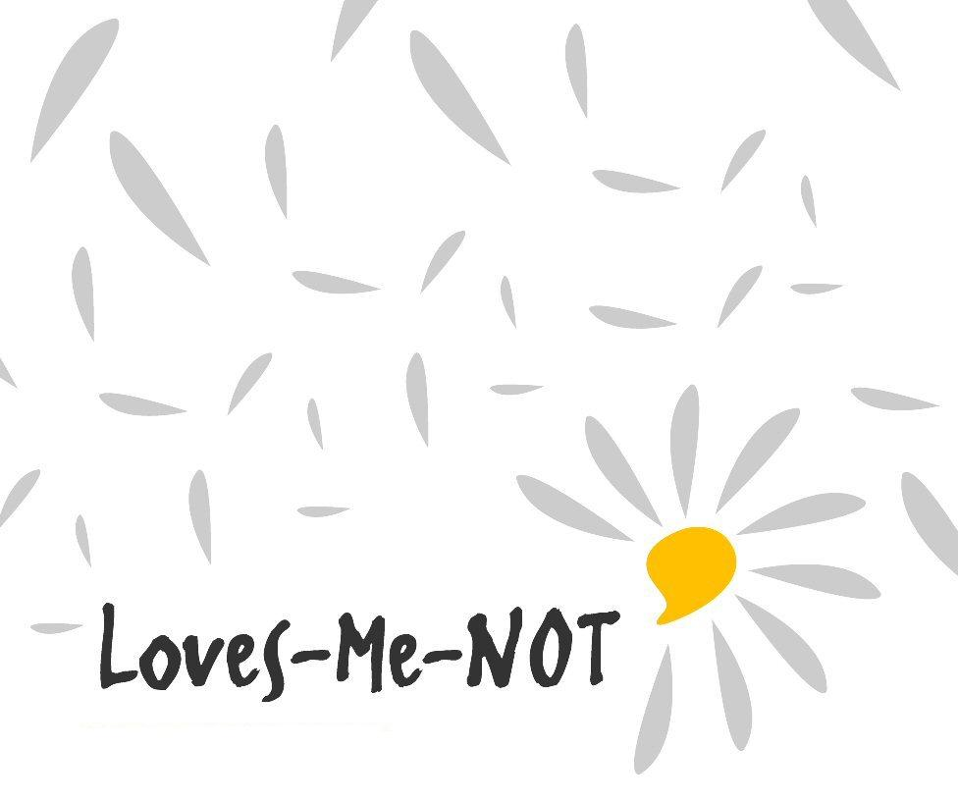

Student Workbook 2018
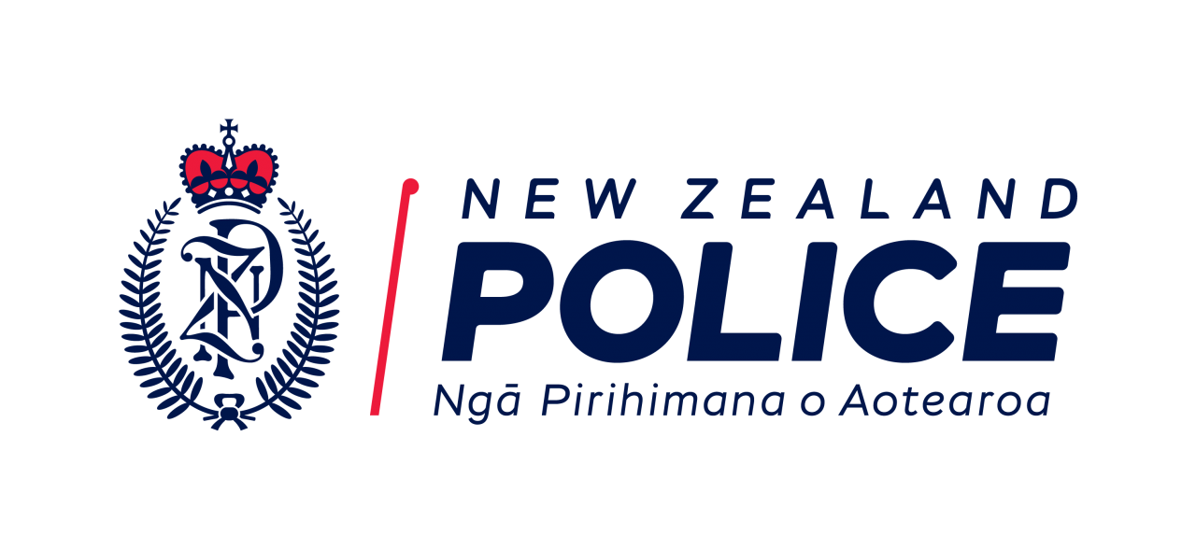
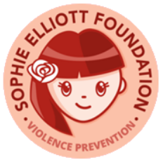

Loves-Me-Not student workbook 2018

Contents Page

Key messages from workshop . . . 3
1.3 A healthy relationship 4
1.4 Features of a healthy relationship 5
1.6 Personal Experience 9
2.1 Grouping behaviour 11
2.2 Is that right? 12
3.1 What is consent? 13
4.3 Stepping in 15
4.4 Who can help? 16
5.2 Sophie’s Story 17
6.1 Be the change! – Taking action 18
Agencies that help (adapt for your own community) 20

Key messages from workshop . . .

- Abuse is never ok.

- I can do things to prevent abuse.

- I can make things better for healthy relationships.

- I am lovable and capable and deserve respect.

- It’s ok to ask for help.

- I know about consent for sex – only ‘yes’ means ‘yes’.

1.3 A healthy relationship

1. What does it feel like to be in this healthy relationship?

2. What does your partner do that makes your life better?

1.4 Features of a healthy relationship

Qualities:

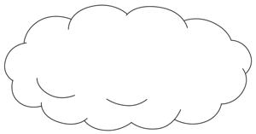

Respectful, kind
and uplifting

___________________________________________________
Eroded by:

1.4 Features of a healthy relationship

Qualities:

Fair and
Sharing

___________________________________________________
Eroded by:

1.4 Features of a healthy relationship

Qualities:

Safe and
secure

___________________________________________________
Eroded by:

1.4 Features of a healthy relationship

Qualities:

Accepting
and free

___________________________________________________
Eroded by:

1.6 Personal Experience
POSITIVE RELATIONSHIP QUIZ
THE PERSON I AM WITH . . . |  | YES |  | NO
 | Supports my choices |  | 0 |  | 1
 | Listens to my opinions |  | 0 |  | 1
 | Is positive and encourages me |  | 0 |  | 1
 | Accepts when I say I don’t want to have sex |  | 0 |  | 1
 | Accepts what I wear and how I look |  | 0 |  | 1
 | Is not liked by my friends and family |  | 1 |  | 0
 | Makes me feel like I can't do anything right |  | 1 |  | 0
 | Makes fun of me or calls me names |  | 1 |  | 0
 | Sulks or gets angry when he/she doesn’t get what they want |  | 1 |  | 0
 | Blames me for his/her problems |  | 1 |  | 0
 | Texts or calls me all the time to check up on me |  | 5 |  | 0
 | Makes it hard for me to see my friends and family and gets jealous when I do |  | 5 |  | 0
 | Pressures me to have sex or do things I don’t want to |  | 5 |  | 0
 | Threatens to hurt himself/herself, me or others |  | 5 |  | 0
 | Does things that scare me (breaking things, yelling, driving fast) |  | 5 |  | 0
 | TOTAL
SCORING
For questions 1-5 Score 1 point for every NO
For questions 6-10 Score 1 point for every YES
For questions 11-15 Score 5 points for every YES

SCORE : 0 POINTS
Your relationship seems to be healthy and respectful.

SCORE : 1-2 POINTS
There may be a few unhealthy aspects to your relationship. This can be a warning sign that it will become more abusive. It’s a good idea to address these early.

SCORE : 3-4 POINTS
There may be some warning signs that your relationship is abusive. It’s important to take warning signs seriously as abuse can get worse over time.

SCORE : 5 POINTS OR MORE
There are definitely warning signs in your relationship. Abuse and controlling behaviours can get worse over time and it’s sometimes hard to see how bad things have become.
POSITIVE RELATIONSHIP QUIZ
IN A RELATIONSHIP, I. . . |  | YES |  | NO
 | Support my partner’s decisions |  | 0 |  | 1
 | Get on OK with her/his friends and family |  | 0 |  | 1
 | Listen to her/his opinion |  | 0 |  | 1
 | Spend time by myself |  | 0 |  | 1
 | Trust my partner |  | 0 |  | 1
 | Criticise or make fun of her/him in front of others |  | 1 |  | 0
 | Get annoyed if I want sex but she/he doesn’t |  | 1 |  | 0
 | Get jealous when she/he talks to others |  | 1 |  | 0
 | Constantly worry she/he is cheating on me |  | 1 |  | 0
 | Text or call all the time to check up on them |  | 1 |  | 0
 | Follow or check up on them (read their texts or emails) |  | 5 |  | 0
 | Often get upset about what she/he does |  | 5 |  | 0
 | Expect her/him to tell me where they are all the time |  | 5 |  | 0
 | Think it’s OK to be rough sometimes |  | 5 |  | 0
 | Take out my frustration on her/him |  | 5 |  | 0
 | TOTAL

SCORING
For questions 1-5 Score 1 point for every NO
For questions 6-10 Score 1 point for every YES
For questions 11-15 Score 5 points for every YES

SCORE : 0 POINTS
Your relationship seems to be healthy and respectful.

SCORE : 1-2 POINTS
There may be a few unhealthy aspects to your relationship. This can be a warning sign that it will become more abusive. It’s a good idea to address these early.

SCORE : 3-4 POINTS
There may be some warning signs that your relationship is abusive. It’s important to take warning signs seriously as abuse can get worse over time.

SCORE : 5 POINTS OR MORE
There are definitely warning signs in your relationship. Abuse and controlling behaviours can get worse over time and it’s sometimes hard to see how bad things have become.

http://areyouok.org.nz/i-need-help/positive-relationship-quiz/

2.1 Grouping behaviour

Negative behaviours erode
healthy relationships.

What are types of abuse that can erode the qualities of a healthy relationship?

(Write your answers to the above question on pages 5-8 under ‘Eroded by’)

2.2 Is that right?

Why do you think some people
want to have power and control
over other people?

3.1 What is consent?

What is sex?

What is consent?

What are some long-term effects on a person abused by rape or sexual violation?

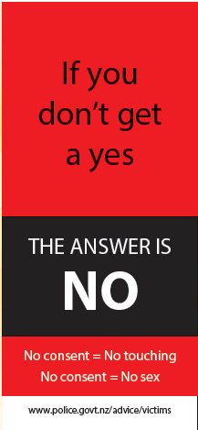
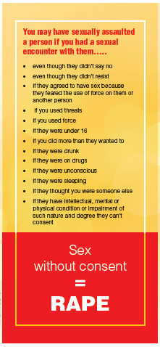

4.3 Stepping in

Why do you think some people don't step in?

What actions could you take when you have concerns about the way a friend is treating someone else?

4.4 Who can help?

Who are the different people
or agencies you can go to for
help when a friend's relationship
is having problems that you are
concerned about?

5.2 Sophie’s Story

6.1 Be the change! – Taking action

Practical actions to promote
healthy relationships in our
community

Planning to take action
In groups complete a planning template below.

Use this planning sheet once you have decided what action your group will take to make it safer to have healthy relationships, and to reduce the likelihood of relationship abuse.

The action our group is going to take is: __________________________________________________________

Members of our group are:
1. __________________________ 2. _____________________________ 3. _______________________
4._________ _________________ 5. _____________________________

To complete this task, there will be a number of sub-actions that you will need to take.

Before taking action |  |  | After taking action
What are the sub-actions to be completed? | When will this sub-action be completed? | Who is going to do this sub-action? | What happened when we did this sub-action? | How well did it go? | Who or what helped?

Agencies that help (adapt for your own community)
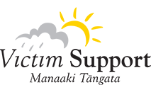 | 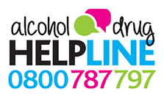
Get help  Call 0800 victim (0800 842 846) | Problems with alcohol and drugs  Call 0800 787 797
 | 
www.youthline.co.nz  Call 0800 376 633 | Free TXT us 234 | www.netsafe.org.nz  0508 NETSAFE (0508 638 723)
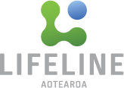 | 
Lifeline - 24/7  Call 0800 543 354 | Need to talk? Contact the lowdown team  FREE TXT 5626
 | 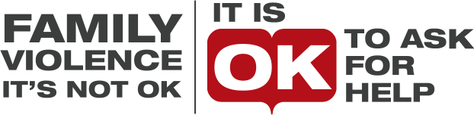
Report crimes anonymously  Call 0800 555 111 | Stopping Violence Services  Call 0800 478 778
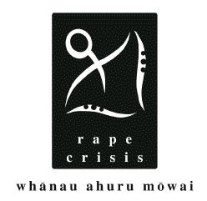 | 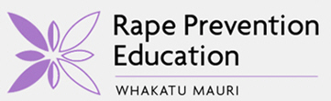
Rape Crisis www.rapecrisisnz.org.nz/  Call 0800 88 33 00 | Rape Prevention Education  http://rpe.co.nz
 | 