Loves-Me-Not workshop resources (2020)
Each class will need to have a whiteboard and/or flipcharts, and an audio-visual system (e.g. a laptop, a data projector, speakers)

Focus area | Resources required | Purpose
0.1 | Nil
0.2 | - 1 blank sheet of A5 paper for each student  - A1 flipchart or whiteboard  - Box for anonymous questions/disclosures (if this option is used) | For making nameplates  For ground rules  For questions/disclosures
1.1 | - A4 paper (one sheet per student)  - A3 large sheet paper or whiteboard, drawn up with ‘Y’ chart | For Healthy Relationships exercise  For group brainstorm
1.2 | - Four headings printed out on A4 paper or written at the top of a large sheet of paper  - Several Post-It notes per student | For collating and displaying relationship qualities  For identifying relationship qualities
1.3 | Nil
2.1 | - Copysheet: Power and control wheel (one per student)  - Copysheet: Equality Wheel (one per student) | For identifying negative behaviours  For identifying positive behaviours
2.2 | - Copysheet: Cycle of Abuse (one per student)  - [optional] Copysheet: Story – Jake and Maddie (one per student) | For explaining abuse cycle  For identifying decision points
2.3 | - Copysheet: Agree/Disagree continuum (made up as signs) | For class agree-disagree continuum
3.1 | Nil
3.2 | - Copysheet : Scenarios (divided into two scenarios per group) | For each group to consider scenarios
4.1 | Nil
4.2 | - Copysheet: Safe/Unsafe (made up as signs)  - 6 pieces of paper per group e.g. A4 cut into 6, or ‘Post-its’ | For class safe/unsafe sorting  For arranging responses
4.3 | - A1 flipchart –placed on the wall with heading 'Who can help?’  - [Optional] Some facilitators (schools/NGO/Police) may have pre-prepared a handout for the students that lists local and national agencies that can help, and how to contact these agencies. | For identifying helping agencies
5.1 | Nil
5.2 | - Copysheet: Sophie's bystanders (cut into one sign per group) | For identifying bystander actions
6.1 | - Copysheet: Be the change! - planning template (one per group) | To guide student action
6.2 | - Copysheet 6.2: Student process evaluation (one per student) | To do evaluations of the workshop
Copysheet: Power and Control Wheel Activity 2.1

- When one person in a relationship repeatedly scares, hurts or puts down the other person, it is abuse.
- The Power and Control Wheel lists examples of each form of abuse.
- Remember, abuse is much more than slapping or grabbing someone.

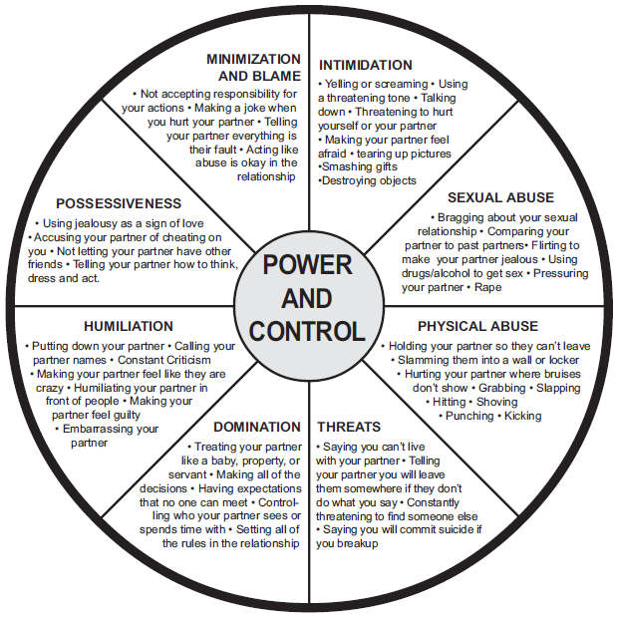

‘A relationship full of control is really out of control.’

Reproduced with kind permission of the
Domestic Abuse Intervention Project, Duluth, Minnesota
as adapted by the Kansas Coalition Against Sexual and Domestic Violence.
Copysheet: Equality Wheel Activity 2.1

Equality, instead of power and control, sits at the centre of this wheel.
The spokes are ways that both partners can have a more equal relationship,
even when dealing with the conflicts that can crop up in any relationship.

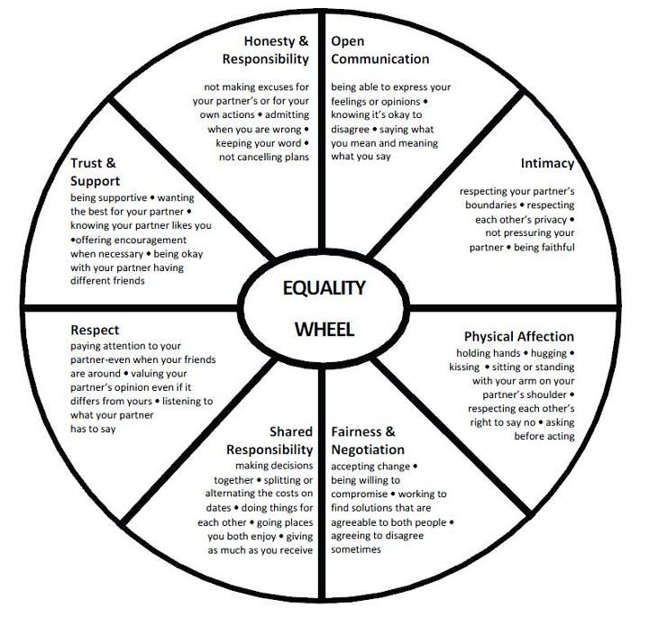

Source: Domestic Abuse Intervention Programs, Home of the Duluth Model, https://www.theduluthmodel.org/wheels/
Copysheet: Cycle of Abuse Activity 2.2

In an unhealthy relationship, abusive behaviours tend to increase over time.
In other words, relationships don't usually start bad, but some go bad.
Most abusive relationships follow a certain type of cycle.
This cycle can help explain why some people stay in
unhealthy and abusive relationships.

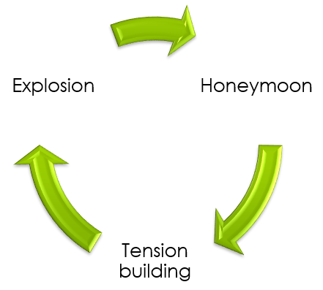

1. HONEYMOON or REMORSE
The first phase is the ‘honeymoon’ phase where everything feels good. On further turns of the cycle, the abuser may apologise, promise it won’t happen again, justify their behaviour, declare love.
3. EXPLOSION
The third phase is the ‘explosion’ phase. This is when emotional, verbal or physical threats, attacks, and/or violence take place. The person may say cruel things to hurt their partner, scream or even hit them.

2. TENSION-BUILDING
Some relationships move into ‘tension building’ phase. One person may feel as if their partner is blaming them for everything and anything. The person feels as if they can’t do anything right.

This cycle can repeat many times.
Each time the gaps between the phases may become smaller,
and the tensions and explosions may become worse.

Copysheet: Story - Jake and Maddie Activity 2.2 [optional]
Jake and Maddie have just left the party with Maddie’s friend Pippa. Jake puts his arm around Maddie and she nuzzles into his shoulder. They both walk a bit wobbly, drunk from alcohol, towards Jake's car.

Maddie says to Jake, ‘That was so much fun tonight. Your singing was great with that Karaoke.’

Jake replies, ‘Yeah! It was awesome! And you got everyone up and dancing.’

They separate and Maddie does a twirl with Pippa – and then nearly falls over. Jake laughs and gives Maddie a long hug.

When they eventually get to the car, Jake tries to hand Maddie the keys. She steps back, gently pushes his hand away and says, ‘Woah, I’m not driving! I am waaay too drunk to drive.’

Jake accidently drops the keys on the ground. He stares at her with his mouth open for long time.

Maddie starts to giggle to chill out the moment.

Jake’s face slowly screws up like he's smelling something awful.

Maddie stops laughing and takes a small step backwards from him to where Pippa is standing.

Maddie says quietly, ‘Man, why did you drink so much when you knew we brought your car?’

Jake steps towards her, puts his face close to hers and says, ‘Aw, come on! You know I always drink when we go out with my mates! Look, all the other girls are driving their boyfriends home. Don't you bloody care if I lose my licence?’

Maddie shoves him away from her. She shouts, ‘Look, I decided it was my turn to get drunk and have fun! Don’t be so bloody selfish!’

Jake leans in and screams in Maddie's face, ‘You dumb bitch!’

She shoves him away again, harder.

He shoves her back, harder still, and she crunches into the car, cries out in pain and falls down onto the road, sobbing.

He stands over her with clenched fists, breathing heavily, and puts the boot in …

Copysheet: Agree/disagree continuum Activity 2.3

Agree

CUT-------→
Disagree

Copysheet: Scenarios Activity 3.2

Scenario 1
Guy A is at a party and has had a bit to drink. He feels sick and tells a mate he needs to lie down. His mate takes him upstairs to a bedroom and leaves him to rest. As he is lying down he notices Guy B from school entering the room. They are pretty friendly at school and he is glad someone is there. Guy B asks him if he can lie down with him. Guy A mumbles, ‘I feel sick, I need some water.’ Guy B lies down and starts caressing him. Guy A doesn’t say anything and the next thing he knows Guy B is on top of him and saying, ‘It’s OK, I won’t hurt you.’ Guy A tries to push him off but can’t get his arms to move properly. ‘What are you doing?’ says Guy A as Guy B is taking his pants off. Guy A wants to call out to his mate, but is confused and his head is spinning. Guy A passes out and the next time he wakes Guy B is gone and he feels discomfort in his anus.

CUT----------→

Scenario 2

An 18-year-old girl is in a relationship with a nearly 15-year-old boy for 3 months. They have regularly made out and talked together about having sexual intercourse. He consented to it, saying that he was ready. His mother finds out that they have had sexual intercourse and is furious. She takes the matter to the Police to be investigated.

Scenario 3
A girl and guy who have been together for a while are kissing. He starts to take it further. She feels uncomfortable and says, ‘I don’t want to do that.’ He says, ‘Come on, you promised and I can’t keep waiting.’ She says quietly, ‘Not yet.’ He backs off for a while. After some time he says, ‘Come on, we talked about this before, you said you were ready.’ She looks at him and shakes her head. He says, ‘It will be OK, it’s nothing to worry about.’ She says nothing and looks away. He is getting more annoyed and says, ‘There is no point in us staying together if it is going to be like this.’ She starts to cry quietly. He says, ‘Look, what is the problem? Just go with it, you love me, don’t you?’ She freezes up and lies completely still. He has sexual intercourse with her and she continues to cry.

CUT----------→

Scenario 4
A girl and a guy have been together for some months and had been consenting to intimate cuddling and kissing. They have not had sexual intercourse but have talked about it and when they might be ready. They are both 16 and have never had sexual intercourse before. They are hanging out together at her house for the night. Her parents have gone out to dinner and won’t be home until late. They are lying together on her bed kissing. He says, ‘Are you sure?’ She nods and says, ‘I’ll tell you if I want to stop.’ He says, ‘OK, I will, too. I have a condom if we need it.’ They decide to keep going and end up having sexual intercourse. They talk afterwards about it and how they are feeling.
Scenario 5

A girl has been going out with her boyfriend for 8 months and they have been having oral sex on a regular basis. It has always been consensual, but the last time they were together she wasn't feeling up to having oral sex. After a bit of time she realised she didn't mind and she told her boyfriend it was OK. After a short time she started to feel sick and told him to stop. He refused and said, ‘You already said yes, you can't just say no now.’ She tried to stop it and kept saying, ‘No.’ He held her down and said it wouldn't be long, so she stopped fighting and he kept going until he'd finished. He then got up and swore at her, saying, ‘What do you think you are doing? You can't just change your mind. What did you think I was going to do, just stop halfway through? You're so stupid. Don't you ever do that again or I will tell your mates how useless you are.’

Copysheet: Safe/Unsafe Activity 4.2

Safe

CUT-------→
Unsafe

Copysheet: Sophie's bystanders Activity 5.2

One of Sophie's friends

CUT----------→

Sophie’s father

Sophie’s mother

CUT----------→
Sophie and Clayton’s workmate

Copysheet: Be the change! - planning template Activity 6.1

The action our group is going to take is __________________________________________________

Our group members are:
1. ________________________ 2. ________________________
3. ________________________ 4. ________________________ 5. _____________________

Our planning template

 | After taking action | Who or what helped?
 | After taking action | How well did it go?
 | After taking action | What did we complete of this sub-action?
 | Before taking action | Who is going to do this sub-action?
 | Before taking action | When will this sub-action be completed?
 | Before taking action | What are the sub-actions to be completed?
Copysheet: Student process evaluation 2020 Activity 6.2

1. How easy was it for you to participate in the Loves-Me-Not workshop?
Very easy 1 2 3 4 5 Very hard
2. How actively were you involved in the learning activities?
Very active 1 2 3 4 5 Not very active
3. Having participated in Loves-Me-Not, would you be more or less likely to act or speak up if someone you knew was in an unhealthy/abusive relationship?
Much more likely 1 2 3 4 5 Much less likely
4. How well do you now know the early signs of abuse in a relationship?
Very well 1 2 3 4 5 Not at all
5. Having learnt about sexual consent, how well are you now able to ensure the person you are with is saying "yes"?
Very well 1 2 3 4 5 Not at all
6. How useful was today's workshop to help you decide whether your relationships are healthy or unhealthy?
Very useful 1 2 3 4 5 Not at all
7. How well was the workshop facilitated/led?
Very well 1 2 3 4 5 Not very well
8. What was the best part of the workshop for you?

9. What was the least favourite part of the workshop for you?

- Tick here if you want to talk to someone further about anything you’ve heard today, and provide a contact phone number and/or email address:

