|  |  |
| --- | --- |
|  | |
| Implementation guide    2021 |  |
|  | |

# Contents

What’s in this guide 3

What is Loves-Me-Not? 3

A whole-school approach to healthy relationships 5

A student inquiry learning process 6

Implementation process – overview 7

Implementation process – things to consider 8

Workshop delivery roles 20

Useful resources 21

Appendix 1 – Loves-Me-Not in The New Zealand Curriculum 23

Appendix 2 – Loves-Me-Not and NZ qualifications 26

Appendix 3 – Logic model 31

Acknowledgements 32

This guide is available on the Police website, in the School Portal, Successful relationships section:

<https://www.police.govt.nz/advice-services/personal-community-safety/school-portal/resources/successful-relationships/loves-me>

# What’s in this guide

This guide provides a process for planning, preparing for, and delivering Loves-Me-Not in a school.

It is for primarily for:

* school leaders – to plan and implement Loves-Me-Not in a whole-school approach
* Police – to provide community support and leadership for Loves-Me-Not.

Community services supporting the workshop may find it useful to read and understand this guide in addition to using the Facilitators guide.

# What is Loves-Me-Not?

## Purpose

Loves-Me-Not is designed to be part of a school’s whole-school approach to promoting healthy relationships and preventing abusive behaviour in relationships.

* Relationship abuse is a pattern of abusive and coercive behaviours inflicted by a person who wants power and control over another person.
* Over time abuse in relationships tends to escalate and erode the victim's confidence to such a degree that getting help and getting out can be difficult and dangerous.
* Abuse in relationships and sexual assault occurs in all communities, regardless of their ethnic, socio-economic, geographic, or religious make-up.

## Structure

Loves-Me-Not supports student wellbeing. It is based on a student inquiry learning process where ākonga, students, take action – personal action, effective bystander action or community action – to prevent harm from relationship abuse.

Loves-Me-Not includes a one-day workshop for all year 12 and/or year 13 ākonga, in which ākonga discuss abusive behaviour in relationships. The workshop is delivered by facilitation teams to groups of 25 ākonga.

Workshop facilitation teams include school staff, Police staff, and NGO or community sector specialists, with at least one facilitator being male.

This composition is a fundamental principle of the Loves-Me-Not workshop. It brings a combination of approaches to the workshop:

* teachers maintain continuity and offer classroom expertise
* police provide real-life examples and explain about family and sexual violence as crime
* community sector representatives talk about their experience and the support available.

It is strongly recommended that the facilitation team represent the student demographics.

## Aims

Loves-Me-Not aims to:

* encourage and empower young people to absolutely reject abuse in relationships
* encourage young people to be safe and active bystanders who take action against unhealthy relationships
* encourage young people to take a stand against myths that perpetuate relationship violence
* help young people know who they can go to in their community to seek advice and support if they need it as victims or bystanders or perpetrators
* encourage young people to contribute to, or create, a wider community response to encourage others to accept only healthy relationships.

## Key messages

Having a great relationship is an awesome thing. Relationships are central to our wellbeing. But we all need to recognise and respond when things aren’t going right.

* Abuse is never OK in our school or among our ākonga.
* I can recognise signs of healthy and unhealthy relationships.
* As an active bystander I can take action when I recognise signs of an unhealthy relationship.
* Only "yes" means “yes” for consenting to sexual acts.
* It is not OK to ask for consent to sex or sexual acts when the other person is so impaired by alcohol or drugs they cannot meaningfully give consent.
* It's not OK to be abusive in a relationship.
* It's OK to ask for help.

## 

## Logic model

See Appendix 3 for the logic model that informs the design of Loves-Me-Not.

# A whole-school approach to healthy relationships

The learning activities in Loves-Me-Not should operate within a whole-school approach. A whole-school approach begins with the school culture and leadership, and is underpinned by the school’s agreed attitudes and values.

Schools could use the model described in the guidelines Relationships and Sexuality Education: Years 9-13 (Ministry of Education, 2021) to design their whole-school approach.

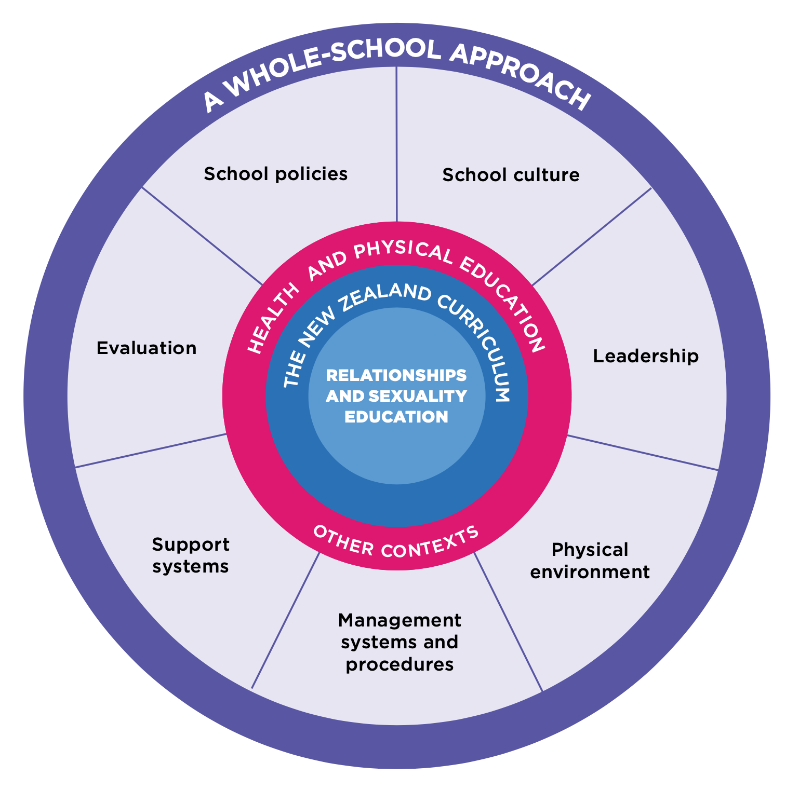

For further information on this whole-school approach model, see:

[Relationships and Sexuality Education; years 9-13](https://health.tki.org.nz/Teaching-in-Heath-and-Physical-Education-HPE/Policy-Guidelines/Relationships-and-Sexuality-Education), pages 18-27.

# A student inquiry learning process

Loves-Me-Not can provide an opportunity for ākonga to take action.

School’s can use their own inquiry process or the [action competence learning process](https://health.tki.org.nz/Key-collections/Curriculum-in-action/Making-Meaning/Teaching-and-learning-approaches/Action-competence-learning-process) shown in the diagram below.

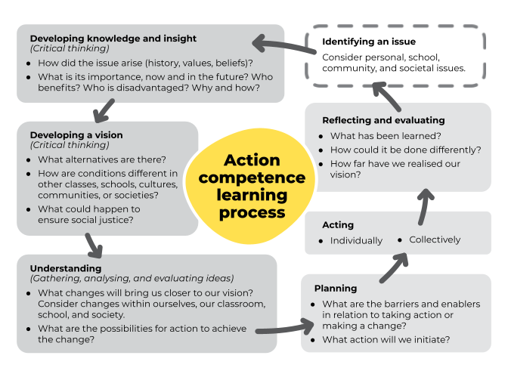(health.tki.org.nz, based on Tasker, G., ed. (2000). Social and Ethical Issues in Sexuality Education: A Resource for Health Education Teachers of Year 12 and 13 Students. Christchurch: Christchurch College of Education.)

# 

# Implementation process – overview

There are twelve steps for implementing a whole-school approach for Loves-Me-Not. This is an overview of the process. Things to consider at each step follow in the next section of this guide.

|  |  |  |  |  |
| --- | --- | --- | --- | --- |
|  | Step | Involves | Timeframe | Our dates |
| 1 | **Initial contact** – Agree to partner; appoint coordinators | School leaders  Police coordinator | > 4 months before workshop |  |
| 2 | Registering – Agree dates and register | School coordinator  Police coordinator | > 4 months before workshop |  |
| 3 | Auditing – Review the school environment | School coordinator, staff and ākonga | > 4 months before workshop |  |
| 4 | Planning – Plan whole-school activities | School coordinator, staff and ākonga | > 3 months before workshop |  |
| 5 | Logistics – Organise the practicalities | School coordinator  Police coordinator | > 2 months before workshop |  |
| 6 | Preparing the workshop – Adapt content and prepare workshop materials | School coordinator, staff and ākonga | > 1 month before workshop |  |
| 7 | Communicating – Inform staff, ākonga and whānau | School coordinator | 1 month before a workshop |  |

|  |  |  |  |  |
| --- | --- | --- | --- | --- |
| 8 | Training – Prepare all facilitators | School coordinator  Police coordinator  All facilitators | 2-4 weeks before a workshop |  |
| 9 | Workshops – Deliver to year 12/13 students | School coordinator  Police coordinator  All facilitators  All ākonga |  |  |
| 10 | Reviewing – Analyse workshop feedback | School coordinator  Police coordinator | <1 week after workshop |  |
| 11 | Taking action – Strengthen impact | School coordinator, staff and ākonga | <1 month after workshop |  |
| 12 | Evaluating impact – Complete survey | School coordinator  Selected staff and ākonga | 3-4 months after workshop |  |

# 

# Implementation process – things to consider

## Step one – Initial contact

The principal or a senior leader meets with the police coordinator to discuss the programme.

The school and the police coordinator might also:

* share information on the views and experiences of the school and wider community. The school can share data from, for example, its latest whānau consultation on health education, and school wellbeing surveys
* discuss what community sector organisations they could approach as a possible partner(s) for Loves-Me-Not in the school.

If the school wishes to proceed with Loves-Me-Not, appoint a school coordinator and inform the Board of Trustees (BOT). The school coordinator could be the HOD Health, guidance counselor, a deputy or assistant principal, or a dean.

## Step two – Registering

In preparation for meeting with the police coordinator, the school coordinator downloads and reads the following documents from the Police website [Loves-Me-Not](http://www.police.govt.nz/advice/personal-and-community-advice/school-portal/resources/successful-relationships/loves-me-not) page:

* Loves-Me-Not registration form
* Loves-Me-Not implementation guide
* Loves-Me-Not facilitator guide
* Loves-Me-Not FAQ.

The police and school coordinators meet to begin the planning process and set dates for the facilitator training and the workshops.

Facilitator training is vital. Discuss the time needed for the session and how to make this available for all facilitators.

The workshop could be delivered on one day or over a number of days with teacher follow up after each session. Discuss the pros and cons of different options, and agree on the approach.

After the meeting the school coordinator completes the registration form and sends it to [schools@police.govt.nz](mailto:schools@police.govt.nz)

## 

## Step three – Auditing

The school coordinator organises a review of the school environment and the school’s current approaches to relationships education.

Consider organising a team of staff and ākonga to assist with this step and the following steps of the implementation process.

“Evaluating the effectiveness of the approach should not be done by school leaders alone. Teachers, parents, ākonga, and others in the school community also have a role here. In particular, every school should ensure that ākonga contribute their views and ideas to the school’s approach. Ākonga should be involved in planning, identifying, accessing, and evaluating the school’s policies, practices, and partnerships.”   
(Relationships and Sexuality Education: Years 9-13, Ministry of Education, page 29.)

## Auditing questions

Use these auditing questions, based on taking a whole-school approach to healthy relationships, to investigate and gather evidence on the current situation in your school. Use the findings to begin to plan actions that will bring improvements in each component.

##### School policies and culture

Consider these questions and look at the evidence you have and need to answer them.

* How do school policies deal with the disclosure of relationship abuse?
* Are there any policies that need updating or are missing?
* How are all staff kept up to date with the policies and procedures they need to follow in case of a disclosure?
* How do the community, staff and ākonga experience the school culture surrounding healthy relationships and consent?
* How does the school know whether the culture surrounding healthy relationships and consent meets the needs of Māori and Pacific ākonga, and LGBTQI+ ākonga?

##### Leadership practices

Consider these questions and look at evidence you have and need to answer them.

* How do school leaders show they are open and approachable for teachers and ākonga?
* How do leaders foster inclusion, student leadership and provide spaces for student voices and feedback in regards to healthy relationships?
* How do leaders respond to issues and incidents that might arise?
* How does the school leadership actively raise awareness of the importance of healthy relationships and relationship education?
* What does the school leadership do to evaluate the school’s approach to healthy relationships? How effective is this?
* What do the school leadership teams do to show they are engaged in and supportive of Loves-Me-Not?

##### Student management and support systems

Consider these questions and look at evidence you have and need to answer them.

* How well are your student support systems working for ākonga?
* How well does the school implement effective peer mediation and peer support structures?
* How well known, well followed, and effective are procedures to address students’ disclosures of unhealthy relationships, bullying, abuse, sharing explicit images and so on?
* Can ākonga access health and support services? Can they do this without teachers and other ākonga knowing why? Is accessing health and support services normalised and encouraged?

##### The physical environment

Consider these questions and look at evidence you have and need to answer them.

* How safe and accessible for all is the physical and social environment?
* Do ākonga report that they feel they have safe spaces to access immediate support?

##### Connections and partnerships with families, whānau, hapū, iwi

Consider these questions and look at evidence you have and need to answer them.

* [Section 91 of the Education and Training Act 2020](https://www.legislation.govt.nz/act/public/2020/0038/latest/LMS171475.html) outlines the legal requirements for state schools to consult with their community over health education, which includes relationship education. How well does the school consult with family, whānau, hapū, iwi and ākonga about the place of relationships education in the localised curriculum?
* How can you effectively inform all parents and whānau about the Loves-Me-Not approach your school is taking and encourage their participation?

##### Connections and partnerships with education and health agencies and community groups

Consider these questions and look at evidence you have and need to answer them.

* What education and health agencies does the school partner with now? Does evidence suggest there are gaps? Should you connect with other education and health agencies?
* What community organisations does the school partner with now?
* Which ones could support the school to achieve safe physical and emotional environments? This could include the Police and community services involved in the Loves-Me-Not workshop.

##### Curriculum delivery and pedagogy

Consider these questions and look at evidence you have and need to answer them.

* How do ākonga currently learn about promoting positive behaviours in relationships as part of the curriculum?
* How do ākonga currently learn about issues of consent, coercion and safety in intimate relationships as part of the curriculum?
* How does the school explicitly teach online safety strategies relating to sexual content online, pornography and image sharing?
* What pedagogies and approaches are likely to be most effective for your ākonga as they learn about relationships? What pedagogies and approaches are likely to be least effective?

##### Ākonga knowledge and competency development

Consider these questions and look at evidence you have and need to answer them.

* When do ākonga get to learn about sexual violence and how to prevent it outside of the Loves-Me-Not programme?
* What examples of ākonga successfully taking action can you draw on when ākonga come to think about:
* myself – how I can take action to prevent being affected by relationship abuse as a perpetrator or a victim
* my family and friends – how I/we can take action for the safety of friends and family as effective bystanders
* my community – how I/we can take action to influence the school community and/or wider community to prevent relationship abuse.

##### Teacher modelling and professional learning

Consider these questions and look at evidence you have and need to answer them.

* What do staff know about relationship abuse and about Loves-Me-Not?
* What professional learning or experience have individual staff members had in facilitating a Loves-Me-Not workshop or similar programmes? What support and training will they need to be able to effectively facilitate workshops?
* How can staff be involved in designing ways to support Loves-Me-Not across learning areas?

## Step four – Planning

The school coordinator organises staff and ākonga to co-design ways to support the Loves-Me-Not workshops and strengthen the whole-school approach to relationships education.

* Involving ākonga in the process will almost always ensure the workshop is as relevant and successful as possible.
* Consider whether your co-design team knows enough about ākonga perspectives and needs. You could decide to run a short survey to gather more information from ākonga.

The co-design team may plan actions in areas such as:

* developing policies and procedures that are missing or need attention
* ensuring programmes are culturally inclusive and inclusive for all LGBTQI+ ākonga
* providing professional learning around student wellbeing and relationships education for staff who are involved in whole-school approaches
* strengthening curriculum for student wellbeing and relationships education, for example, Health Education – see Useful resource, Appendices 1 and 2
* making connections with [Positive Behaviour for Learning School-wide](https://pb4l.tki.org.nz/PB4L-School-Wide) activities
* introducing or adding to student peer support programmes
* bringing in other relationships programmes.

Start planning communications about the programme for ākonga, staff and whānau.

## 

## Step five – Logistics

The school coordinator organises what is required to deliver the facilitator training sessions and the workshops, such as venues, school staffing, relievers, and so on.

The police coordinator organises and communicates with Police and community facilitators.

Facilitators – identify representative teams of three for each group of students.

* Facilitation teams should combine the three different sets of competencies of school, police and community services, to ensure effective delivery.
* Choose facilitators that reflect the demographics of the student population. Consider gender balance, age balance, and ethnicity.
* Each team should have at least one male facilitator.
* Where possible, a team should have one facilitator who has previous experience facilitating the programme.

Facilitator training – organise the session and communicate requirements to all facilitators.

* All facilitators – police, school and community service – need to prepare for and attend.
* Training is essential for consistency of delivery.
* Lack of preparation is the most common concern of facilitators reported in evaluations.

Workshop venues – organise rooms with:

* space to comfortably seat 25 students working in groups
* internet access with a TV or projector and a sound system
* whiteboard and pens
* flipcharts, butchers paper, or newsprint, and pens.

Technology – decide the best way to show the slideshow and YouTube videos and test it. This might be using:

* a teachers’ laptop or classroom PC or a school-loaned laptop
* a Police laptop with wifi access
* other.

Ākonga – organise into groups of 25. There are two ways of grouping ākonga:

* different groupings to a normal school day. If possible, avoid having known relationships in the same group.
* ākonga who are more familiar with each other, with teachers who know them.

Kai – consider snacks or a shared BBQ. These can help build a positive atmosphere and whanaungatanga.

Other things to organise, include:

* Guidance staff – organise for them to be available for ākonga at the times of the workshops
* Relievers / cover for the teachers involved in the training and workshop
* Welcoming visitors at the introductory session when all ākonga are together.

## Step six – Preparing the workshop

The police and school coordinators, working with staff and ākonga involved in the co-design, adjust the workshop content to fit the school context.

* Discuss the Loves-Me-Not workshop plan in the Facilitator guide and agree what must be done, and what could be done depending on the different needs of the groups of ākonga on the day.
* Agree on the inquiry model students will use and change the Be an agent of change handout as needed.

Ensure your workshops will have:

* ample time for ākonga and facilitators to complete evaluation forms
* a clear closure for the day, with next action steps for ākonga.

Agree who will take responsibility for and action these tasks:

* create your revised workshop plan, presentation, and handouts and share them with each facilitator
* create a school-specific handout of local support agencies’ contact details for the workshop
* prepare a school-specific introduction for ākonga to the day, for example at a year assembly, or whakatau, to describe the day and timetable, expectations of the school, referral room, room allocations
* create copies of workshop resources and feedback forms
* organise other materials required for workshop activities
* allocate facilitators to teams and assign to groups of ākonga and workshop venues.

## Step seven – Communicating

The school coordinator and senior leadership communicate to all staff the purpose and process of the workshop and potential implications, for example, disclosures.

The school shares information on the Loves-Me-Not programme with ākonga and whānau.

All school staff (whether involved in the workshop delivery or not) need to know:

* the purpose and nature of the workshops
* what the school currently does to build healthy relationships
* how different subjects can include lessons about positive behaviours
* the impact of relationship abuse on a school community
* the school policy and procedures for any staff member who receives a disclosure.

Schools should choose the most appropriate way to communicate with staff about Loves-Me-Not. It could be at a meeting that includes the school and police coordinators.

Staff can get more information by viewing these videos about the Loves-Me-Not programme:

* [An introduction to Loves-Me-Not](https://youtu.be/c-gt7QG7GEc)
* [Whole school approach](https://youtu.be/gq49N_7S-7s).

Whānau should know:

* the purpose and nature of the Loves-Me-Not workshops
* how the school plans to support the Loves-Me-Not workshops, for example, through other curriculum areas and peer support programmes
* how the school deals with disclosures of abusive behaviours
* how to support their child if they raise alarms about relationship abuse and/or sexual assault, and where to get the necessary help
* that they can request their child not participate in the workshop.

You could use the [Loves Me Not FAQS](https://www.police.govt.nz/advice-services/personal-community-safety/school-portal/resources/successful-relationships/loves-me#anchor8).

You could link whānau to the Police resources:

* [An introduction to Loves-Me-Not video](https://youtu.be/c-gt7QG7GEc) – explains how Loves-Me-Not teaches senior secondary ākonga about healthy relationships, and encourages parents to talk with their teenage children about navigating relationships and avoiding relationship abuse.
* [About abuse](https://www.police.govt.nz/advice-services/personal-community-safety/school-portal/resources/successful-relationships/about-abuse) – explains types of abuse, its effect on children and how to report it.

Ākonga should know:

* the purpose and nature of the Loves-Me-Not programme in the school
* when the workshops are happening and how their usual timetable will be impacted
* where and how the day will begin
* what to bring on the day, for example, digital devices, pens, lunch
* the workshop deals with sensitive topics which may mean some ākonga feel vulnerable
* support will be provided on the day and as always through the school’s usual support services.

## Step eight – Training

The police and school coordinators plan and run a training session for facilitators. The session is usually delivered by the police and school coordinators together.

All facilitators – police, school and community service – need to come to the training session.

* Training is essential for consistency of delivery. Lack of preparation is the most common concern of facilitators reported in evaluations

The purpose of the training session is to:

* establish relationships
* explore the school and community context
* review the school-specific workshop plan and prepare facilitators for their facilitation roles.

The outcomes of the training session are for facilitators to:

* understand the students and their needs
* feel confident about supporting the content, activities and each other
* know how to respond to certain situations
* know what to do if students disclose.

Length – A minimum half-day session is recommended.

* Shortening the training, not having all facilitators attend, or having the training too close to the workshop are likely to have a detrimental effect on what ākonga get out of Loves-Me-Not.

Before the training session ask each facilitator to:

* read the Loves-Me-Not Facilitators guide
* view your school-specific workshop plan, presentation and resources
* watch the videos [An intro to Loves-Me-Not](https://youtu.be/c-gt7QG7GEc) and [Whole school approach](https://youtu.be/gq49N_7S-7s).

After the training session:

* ensure all facilitators have watched the videos that are used during the workshop
* make contact with any facilitators who were not able to attend so that arrangements can be made for them to catch up on what they missed.

## What to cover in a training session

The design for your training session will depend on how many facilitators are new to the workshop.

* If the school hasn’t delivered a Loves-Me-Not workshop before, and there is a school nearby that has, consider inviting their facilitators and ākonga to your training session, so your facilitators can learn from their experience.

Allow ample time for facilitators to introduce themselves to each other and form a connection, clarify their roles, and talk about their organisations, why they are here and what they can bring to the workshop.

### Outcome 1: Understand the students and their needs

* Share the findings from Step 3: Auditing to set the workshop in context
* Share understandings of the views and needs of ākonga in the school and young people more generally in your area
* Confirm ways you will create a safe and inclusive environment for all ākonga – use the related pages in the Facilitator guide as a basis
* Discuss what language and tikanga expectations ākonga have. Understand how te reo Māori, and other languages, are used in the school. Plan how to reflect this in the workshop.

### Outcome 2: Feel confident about supporting the content, activities and each other

* Stress the importance of ākonga receiving common messages and discuss how to achieve it.
* Discuss effective teaching and learning approaches, in particular checking and responding to the prior knowledge ākonga have in relation to a topic and activity.
* Go through each activity in the school-specific workshop plan, including watching the videos that are used. Facilitators work in their teams to discuss and agree their delivery roles and actions.
* Identify whether facilitators need any preparation to run an activity, such as running continuums, role play, debriefing.
* Share any recent real life stories of young people that might illustrate particular concepts or activities and make the workshop relevant to the lives of ākonga. Plan how these can fit into the day.
* Agree who will lead each learning activity. Aim for a good spread that reflects each person’s strengths and experience. You could record this in an electronic version of Workshop delivery roles.
* Clarify timekeeping responsibilities.

### Outcome 3: Know how to respond to certain classroom situations

* Use the related pages in the Facilitator guide as a basis.
* Add situations facilitators have encountered before or expect may come up for some ākonga.

### Outcome 4: Know what to do if students disclose

* Discuss the schools’ policies and procedures for disclosures
* Discuss Police procedures.

## 

## Step nine – Workshop day(s)

The police and school coordinators are responsible for managing the day and for the smooth and safe running of the workshops.

Before the workshop

* Check rooms are set-up as needed and the workshop presentation and videos are working
* Ensure all rooms have all the workshop resources and other materials organised for each activity.

During the workshop

* If the school coordinator is not facilitating, be available to support other facilitators, and drop in and observe different groups across the day.

At the end of the workshop

* Collect the feedback forms – Student feedback forms and Facilitator feedback forms. [These forms are in the Workshop resources file]
* Conduct debriefs with facilitators, if possible, to discuss their experiences and feedback.

## Step ten – Reviewing

The police and/or school coordinator analyse and collate the individual workshop feedback forms from ākonga and facilitators. They use the findings to plan and record changes for the future.

It is essential that Loves-Me-Not is evaluated for:

* process – Did the workshop go well, and did the ākonga believe they learnt anything relevant?
* impact – Did the whole-school approach, including the workshops, lead to ākonga making different decisions in their relationship behaviour, or take any action to prevent relationship abuse?

Process evaluations are completed in the workshop and analysed in this step. Impact evaluations follow some months later – see Step 12.

Collate the feedback ākonga and facilitators gave through the feedback forms they filled in at the end of the workshop.

* Use the Collated Evaluations Form (available on the [Loves-Me-Not](https://www.police.govt.nz/advice-services/personal-community-safety/school-portal/resources/successful-relationships/loves-me) web page)
* Send the collated responses to Police National Headquarters (email [schools@police.govt.nz](mailto:schools@police.govt.nz)) within one month of the workshop.

Use the findings to plan changes for your Loves-Me-Not programme in the future.

* Depending on the findings, you may want to involve other facilitators to plan and record changes for the next iteration of the workshop and the wider programme.

Consider how to ensure the sustainability of community service and other facilitator involvement for future Loves-Me-Not workshops.

## Step eleven – Taking action

The school encourages and supports ākonga to develop and initiate the student-led actions they identified in the workshop.

## Step twelve – Evaluating impact

The school coordinator organises an impact evaluation survey with a random sample of ākonga and teachers, using the survey supplied by Police.

The survey should be run three to four months after the workshop.

Your police coordinator will provide you with a link to a SurveyMonkey questionnaire.

The impact evaluations will:

* influence how Loves-Me-Not is implemented in the future
* provide evidence as to the value of Loves-Me-Not as a tool to affect young people’s lives.

# 

# Workshop delivery roles

You can use a digital version of this page to record your agreed roles for the workshop and notes to support you.

My facilitation team members are:

|  |  |  |  |
| --- | --- | --- | --- |
| Name | Organisation | Phone | Email |
|  |  |  |  |
|  |  |  |  |
|  |  |  |  |

## Workshop activities

|  |  |  |  |
| --- | --- | --- | --- |
| Section | Lead | My role | Notes |
| Briefing ākonga |  |  |  |
| Establishing whanaungatanga and kaupapa |  |  |  |
| Focus area 1: Understanding consent |  |  |  |
| Focus area 2: Unhealthy relationships |  |  |  |
| Focus area 3: Building positive relationships |  |  |  |
| Focus area 4: Stepping in |  |  |  |
| Focus area 5: Be an agent of change |  |  |  |

# Useful resources

These resources may be useful for designing ways to reinforce learning in a whole-school approach to Loves-Me-Not..

## Loves Me Not e-book

By William J. O'Brien and Lesley Elliott

Describes the 2008 murder of Sophie Elliott by her former boyfriend. The book includes advice and suggestions on how to identify problems, how to deal with them and where to seek help.

This will be available as a free paperback book for a limited time. You can download the free e-book from the Police website [Loves-Me-Not page](https://www.police.govt.nz/advice-services/personal-community-safety/school-portal/resources/successful-relationships/loves-me).

## Police videos

The videos were created for the Loves-Me-Not programme. They explore good and bad relationship behaviours. They can be incorporated in a Loves-Me-Not workshop or used for follow-up activities.

* Vox Pops (1:37)  
  <https://youtu.be/BOgVF6eIae4>
* Media Messages (3:39)   
  <https://youtu.be/CUrc4GJCf_w>
* Relationships Under Pressure, part 1 (1:27) <https://youtu.be/VSA0FDaoyUc>
* Relationships Under Pressure, part 2 – Power & Control (3:20) <https://youtu.be/hS6Uikr-tK0>
* Relationships Under Pressure, part 3 – Equality (4:55) <https://youtu.be/_G2ROpr5IwU>
* Street behaviour (2:02)  
  <https://youtu.be/ISiW39UW_nE>

## Keep it real online website

[keepitrealonline.govt.nz](https://www.keepitrealonline.govt.nz/)

Advice for youth and parents for dealing with a range of situations including watching porn, sending or receiving nudes, and bullying. Includes the Eggplant, a comedy drama video series that explores these and other topics related to relationships and online behaviour.

* [The Eggplant](https://www.keepitrealonline.govt.nz/youth/the-eggplant/) [The video series is available on TVNZ on Demand]

## Netsafe

[netsafe.org.nz](https://www.netsafe.org.nz/)

Advice for youth and parents on safe online relationships, including topics like sharing nude images.

## Classification Office

[classificationoffice.govt.nz](https://www.classificationoffice.govt.nz/)

Advice on [how to talk to young people about porn](http://classificationoffice.govt.nz/news/latest-news/how-to-talk-with-young-people-about-pornography/).

## Health Education teaching resources

[Health and PE Online](https://health.tki.org.nz/), Ministry of Education

[Inside Out](https://insideout.ry.org.nz/), Rainbow Youth

[Resources from Family Planning Association](https://www.familyplanning.org.nz/catalog/resources)

[NZ Health Education Association](https://healtheducation.org.nz/), especially:

* [Teaching and learning about pornography in health education For students in Years 9-13](https://healtheducation.org.nz/wp-content/uploads/2020/01/NZHEA_Teaching-and-learning-about-pornography-in-health-education_2020.pdf)
* [Sexuality Education Resources](https://healtheducation.org.nz/resources/sexuality-education/)

## Other Power and control wheels

* Rainbow relationships: [otago.ac.nz/te-whare-tawharau/otago691793.pdf](https://www.otago.ac.nz/te-whare-tawharau/otago691793.pdf)
* Teen relationships: [familyjusticecenter.org/resources/teen-power-control-wheel/](https://www.familyjusticecenter.org/resources/teen-power-control-wheel/)

# 

# Appendix 1 – Loves-Me-Not in The New Zealand Curriculum

The learning associated with Loves-Me-Not is part of a broad, balanced, and general education.

This section describes how Loves-Me-Not supports the vision, principles, values, key competencies, learning areas and effective pedagogy in The New Zealand Curriculum (2007).

## Vision, principles, values, key competencies

Vision

The vision for young people to be confident, connected, actively involved and lifelong learners is incorporated throughout Loves-Me-Not by promoting: self-identity, resilience, communication skills, critical and creative thinking, informed decision making and active contribution to the wellbeing of New Zealand.

Principles

The principles of The New Zealand Curriculum promoted through Loves-Me-Not include:

* community engagement, through including wider community agencies
* inclusion, through accepting and promoting the identity of ākonga
* future focus, through exploring citizenship and contributing to the wellbeing of New Zealand.

Values

The key values of The New Zealand Curriculum promoted through Loves-Me-Not are:

* community and participation for the common good
* integrity, which involves being honest, responsible and accountable, and acting ethically
* ākonga respect for themselves, others, and human rights.

Through learning experiences in Loves-Me-Not, ākonga will learn about:

* their own values and those of others
* different kinds of values, such as moral, social, cultural, aesthetic, and economic values
* the values on which New Zealand’s cultural and institutional traditions and myths are based.

Through learning experiences in Loves-Me-Not, ākonga will develop their ability to:

* express their own values
* explore, with empathy, the values of others
* discuss disagreements that arise from differences in values and negotiate solutions
* make ethical decisions and act on them.

## Key competencies

The key competencies in The New Zealand Curriculum developed through Loves-Me-Not are:

* Managing self: Ākonga who manage themselves are enterprising, resourceful, reliable, and resilient. By considering their own actions in role-play situations, they will learn to take personal responsibility to treat others fairly. Through taking action themselves, they will gain an understanding of how collective actions contribute to social justice at a local, community or national level.
* Thinking: Ākonga see situations from different perspectives and analyse situations to understand where power imbalances lie. They consider the ethics and injustices that surround unhealthy relationships and gain confidence to challenge others’ ideas and views.
* Relating to others: Ākonga who relate well to others are aware of how their words and actions affect others. By participating in the workshop they develop their ability to listen actively, recognise different points of view, negotiate, and share ideas.
* Participating and contributing: Being actively involved in communities – these include family, whānau, and school, as well as those based, for example, on a common interest or culture. Ākonga who participate and contribute in communities have a sense of belonging and the confidence to participate within new contexts. They understand the importance of balancing rights, roles, and responsibilities and of contributing to the quality and sustainability of social, cultural, physical, and economic environments.

## Learning areas

### Health and Physical Education learning area

Loves-Me-Not aligns with the Health and Physical Education learning area of The New Zealand Curriculum. Achievement objectives can be drawn from Levels 5–6 under:

* Strand A: safety management
* Strand C: relationships; identity, sensitivity and respect
* Strand D: societal attitudes and values; community resources; and rights, responsibilities, and laws.

Loves-Me-Not incorporates the four underlying concepts of the Health and Physical Education learning area – for example:

* wellbeing, hauora (all aspects): analysing own values and attitudes to relationship abuse; learning how abuse impacts all dimensions of wellbeing
* health promotion: learning the processes of and skills for how to take action ... and then knowing how to take critical action
* the socio-ecological perspective: understanding the complex interrelationships between self/personal factors, relationships with others and the ways community/societal factors (like media) influence wellbeing; how action to bring about change requires responsibilities at all levels of social organisation
* attitudes and values: developing positive attitudes to personal, peer and societal safety, fairness and inclusiveness, that is, social justice for all

### Relationships and sexuality education (RSE) guidelines

Learning about relationships and sexuality is part of the New Zealand Curriculum. It is one aspect of health education. Research makes it clear that ākonga want more opportunities to learn about relationships, gender, and sexuality (O’Neill, 2017; Classification Office, 2020).

Loves-Me-Not aligns with key learnings of the strand Ko Aku Hoa – Friendships and relationships with others.

The RSE guidelines recommend that health education include clear teaching about sexual violence that includes:

* sexual violence and how to prevent it
* where to seek help and support
* how to support others if they disclose.

Ākonga need to develop:

* knowledge of issues around coercion, consent, and safety in intimate relationships
* effective and assertive communication skills
* awareness of ethics and of their own personal values
* respect for the feelings and decisions of others.

# 

# Appendix 2 – Loves-Me-Not and NZ qualifications

The topic of healthy relationships and relationship abuse is a useful context for learning within a broad range of subjects and learning areas.

A range of sample assessment material for Health Education is provided on TKI at <https://ncea.tki.org.nz/Resources-for-Internally-Assessed-Achievement-Standards/Health-and-physical-education/Health-education>

Here are some examples of how the assessment tasks could be modified to focus on healthy relationships and relationship abuse.

NOTE: Changes to NCEA mean these achievement standards will be phased out starting from 2022.

## Health Education achievement standards NCEA Level 1

AS90971 Take action to enhance an aspect of personal wellbeing

Assessment task – Relationships take work

[http://ncea.tki.org.nz/content/download/3392/10887/file/health1_1A_v2_nov12.docan aspect of personal wellbeing](http://ncea.tki.org.nz/content/download/3392/10887/file/health1_1A_v2_nov12.docan%20aspect%20of%20personal%20well-being)

An assessment activity that requires ākonga to take action to enhance an aspect of their wellbeing by planning, implementing, and evaluating a SMART health-related, action plan to strengthen a relationship they have with someone.

Due to the sensitive nature of abusive relationships, this assessment task is likely to focus on healthy relationships and improving a relationship, rather than addressing an abusive relationship.

Assessment task – Enhancing my wellbeing

<http://ncea.tki.org.nz/content/download/3393/10890/file/health1_1B_v2_nov12.doc>

* An assessment activity that requires ākonga to take action to enhance an aspect of their personal wellbeing by planning, implementing, and evaluating a SMART action plan to achieve a personal health-related goal.
* Due to the sensitive nature of abusive relationships, this assessment task is likely to focus on goals towards improving a relationship, for example, boyfriend or girlfriend, rather than addressing an abusive relationship. The goal may be improving the use of effective interpersonal skills or increasing the use of assertive behaviours.

AS91097: Demonstrate understanding of ways in which wellbeing can change and strategies to support wellbeing.

Assessment task – Onwards and upwards

<http://ncea.tki.org.nz/content/download/3394/10893/file/health1_3A_v2_nov12.doc>

* An assessment activity that requires ākonga to understand the effects of change on the wellbeing of the characters involved in the scenario, their consequent feelings (positive and negative) and possible responses; along with strategies to support their wellbeing during the change.
* The scenario provided could be modified to a scenario that shows changes in a relationship that begins to include abusive behaviours.

AS90973 Demonstrate understanding of interpersonal skills used to enhance relationships

Assessment task – Putting things right again

<http://ncea.tki.org.nz/content/download/3396/10899/file/health1_4A_v2_nov12.doc>

* An assessment activity that requires ākonga to explain how interpersonal skills can enhance relationships, and how well the ākonga are able to apply the use of effective listening and assertiveness skills. Critical explanations make explicit links between the components of skills and how these enhance relationships in one of the scenarios provided.
* Could use scenarios from Loves-Me-Not rather than the examples provided in the assessment task.

Assessment task – Making a relationship work

<http://ncea.tki.org.nz/content/download/3397/10902/file/health1_4B_v2_nov12.doc>

* An assessment activity that requires ākonga to explain how interpersonal skills can enhance relationships, and how well the ākonga are able to apply the use of effective listening and assertiveness skills. Critical explanations make explicit links between the components of skills and how these enhance relationships in the developed scenario/s.
* Ākonga could develop a scenario similar to those discussed during Loves-Me-Not.

## Health Education achievement standards NCEA Level 2

AS91237 Take action to enhance an aspect of people’s wellbeing within the school or wider community 4 credits

Assessment task – Our mentally healthy school

<https://ncea.tki.org.nz/content/download/3402/10917/file/health2_3A_v2_jan15.docx>

* This assessment activity requires ākonga to take action to promote an aspect of mental and emotional wellbeing in their school community by planning, implementing and evaluating a plan for health promoting action that aligns with the principles of, or implements aspects of, the Health Promoting Schools framework.
* Ākonga could plan, implement and evaluate a health promotion plan to enhance healthy relationships.

## Sample of Level 1 achievement standards from other subjects

|  |  |  |  |  |
| --- | --- | --- | --- | --- |
| Subject | Std number | Standard title | Current task theme | Sample context for positive relationships |
| Drama | 90009 | Perform an acting role in a scripted production | Act in a scripted play | Provide specific examples of scripted play based on relationships – see examples at<http://www.playmarket.org.nz>/ |
| English | 90052 | Produce creative writing | Writing about conflict and resolution | Ākonga produce scenarios of conflict for example bullying, relationship abuse, family violence |
| English | 90052 | Produce creative writing | Personal news starters | Ākonga produce news starters about dealing with conflict – e.g. bullying, relationship abuse, family violence |
| English | 90053 | Produce formal writing | Opinion writing | Ākonga write opinion pieces of relationship issues in New Zealand – e.g., date rape, bullying |
| Mathematics | 91030 | Apply measurement in solving problems | Measuring water | Ākonga use crime statistics to identify implications of family violence in New Zealand |
| Media Studies | 90993 | Produce a design and plan for a media product using a specified range of conventions | Create an advertisement | Ākonga create an advertisement based on promoting successful relationships or ethical bystanders behaviour |
| Media Studies | 90993 | Produce a design and plan for a media product using a specified range of conventions | Create an instructional video | Ākonga create an instructional video of how to maintain successful relationships |
| Media Studies | 90996 | Write media texts for a specific target audience | Create a portfolio and media articles | Ākonga create a portfolio and media articles focusing on safer communities |
| Social Studies | 91040 | Conduct a social inquiry | Explore an organisation with social justice focus | Ākonga could explore New Zealand Police as a human rights organisation |
| Social Studies | 91043 | Describe a social justice and human rights action | Taking action generic | Ākonga prepare examples of action they could take to promote successful relationships |

## Sample of Level 2 achievement standards from other subjects

|  |  |  |  |  |
| --- | --- | --- | --- | --- |
| Subject | Standard number | Standard title | Current task theme | Sample context  for positive relationships |
| Drama | 91220 | Script a scene suitable for drama performance | Ideas for creating a script | Ākonga script a scene based on scenarios from the Loves-Me-Not workshop |
| English | 91103 | Create a crafted and controlled visual and verbal text | From written text to visual text | Ākonga create presentations that incorporate text based around themes of successful relationships |
| Mathematics | 91263 | Design a questionnaire | Caffeine | Ākonga design a question about young people rights and responsibility towards successful relationships |
| Mathematics | 91266 | Evaluate a statistically based report | Statistics in the media | Ākonga evaluate reports on family violence available from New Zealand Police |
| Media Studies | 91255 | Write developed media text for a specific target audience | Writing a feature article for a magazine | Ākonga write an article about relationship abuse for the school website or a youth publication |
| Media Studies | 91250 | Demonstrate understanding of representation in the media | [What a girl wants](http://ncea.tki.org.nz/content/download/3948/12876/file/media2_3A_nov11.doc) (doc) – how teenage girls are represented in the media | Ākonga consider how media representations contribute to relationship abuse and what action they can take to prevent abuse |
| Social Studies | 91280 | Conduct a reflective social inquiry | Social inquiry of community solution | Ākonga conduct a social inquiry into relationship abuse in both face-to-face and online relationships |
| Social Studies | 91282 | Describe personal involvement in a social action related to rights and responsibilities | Support SurfAid | Ākonga participate in support for Victim Support and explore rights and responsibilities |
| Technology | 91354 | Undertake brief development to address an issue | A brief of a product for around the home | Ākonga develop a brief for a specific safety issue – for example, online safety, relationship abuse |

# 

Appendix 3 – Logic model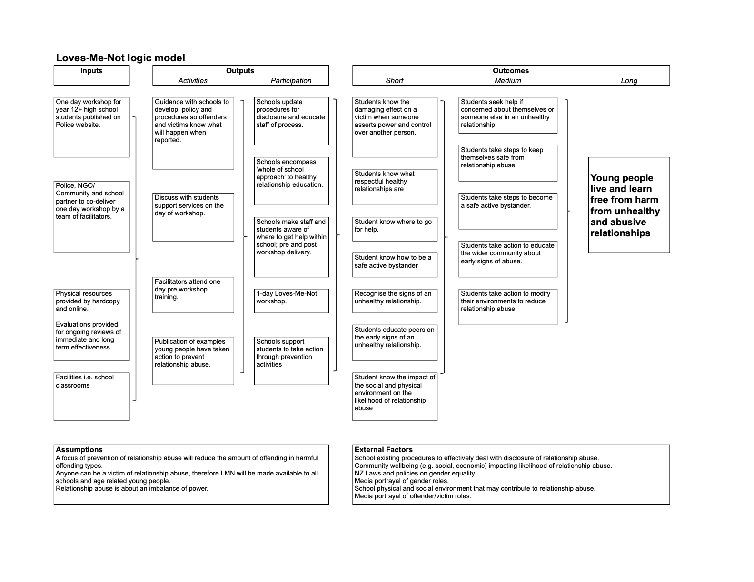

# Acknowledgements

The New Zealand Police would like to thank all those who were involved in the development of the Loves-Me-Not workshop and in particular:

Rape Prevention Education for permission to use The Bystander ... The Action Movie.

Lizzie Marvelly (‘Villainesse’) for permission to use The REAL Sex Talk.