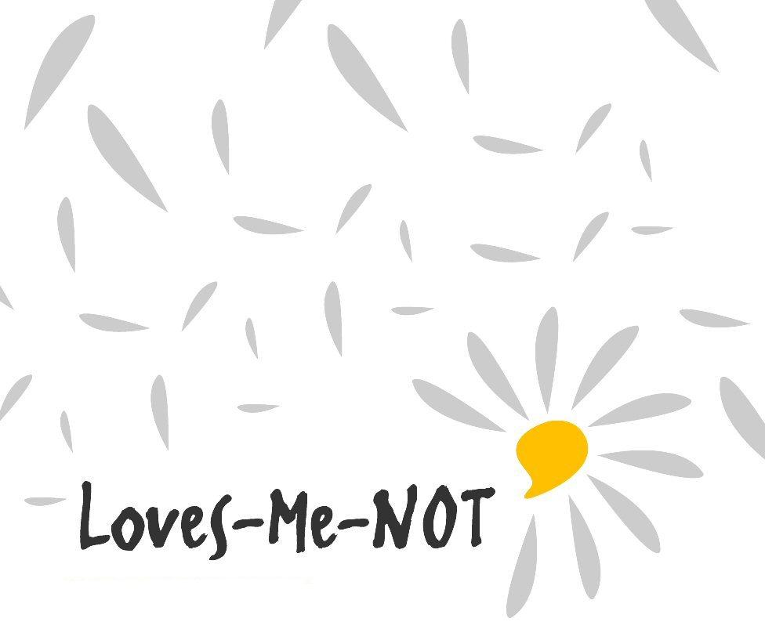

Implementation guide 2018

Supported by

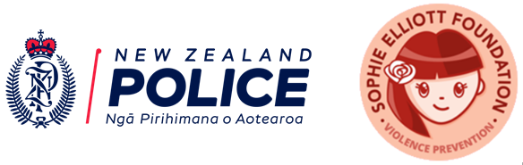

Loves-Me-Not: Implementation guide for schools

Contents

Foreword 3
Part A: Introduction 4
Who is this guide for? 4
What is Loves-Me-Not? 4
Aim of Loves-Me-Not 4
Key messages of Loves-Me-Not 4
Loves-Me-Not: A whole-school approach to healthy relationships 5
Loves-Me-Not: A student inquiry learning process 7
Part B: Implementing Loves-Me-Not 8
Detailed implementation tasks 11
Part C: Information and resources to implement Loves-Me-Not 14
National Administration Guideline 5 14
Loves-Me-Not in The New Zealand Curriculum 14
Loves-Me-Not and New Zealand qualifications 16
Guide for workshop facilitators 20
Loves-Me-Not workshop facilitator planning guide 21
Ensuring a safe classroom environment during the workshop 23
Facilitator scenarios – dealing with difficult situations 24
Free copies of Loves Me Not by Lesley Elliott 26
Evaluation of Loves-Me-Not workshop 27
Part D: Acknowledgements 32

Foreword
Having a great relationship is an awesome thing if it helps you to be bigger and better than you can be on your own.

Young people are on an educative journey to having great relationships. Part of learning is avoiding making mistakes. Some mistakes in relationships may be regretted and some may have a long-term negative impact on a person’s life.

Education about relationships involves:
- identifying and aspiring to great relationships
- recognising when things aren't going right
- identifying societal mores that perpetuate abusive behaviours in relationships
- understanding the law in relation to sexual consent
- having the skills and strategies to deal with negative, unhealthy and abusive behaviours in relationships as any combination of perpetrator, victim or bystander.

Relationship abuse is a pattern of abusive and coercive behaviours inflicted by a person who wants power and control over another person.

Over time abuse in relationships tends to escalate and erodes the victim's confidence to such a degree that getting help and/or getting out can be difficult and dangerous.

Abuse in relationships and sexual assault occurs in all communities, regardless of their ethnic, socio-economic, geographic, or religious make-up.

Part A: Introduction

Who is this guide for?
This guide is for:
- schools – to implement Loves-Me-Not in a whole-school approach
- Police – to provide community support and leadership for Loves-Me-Not
- facilitators – to ensure consistency of delivery of the workshop.

It provides a workshop planning process, a student inquiry learning process, and guidance on how to apply a whole-school approach.

What is Loves-Me-Not?
Loves-Me-Not is a whole-school approach to prevent abusive behaviour in relationships. It is based on a student inquiry learning process, where students take action (personal action, effective bystander action and community action) to prevent harm from relationship abuse

Loves-Me-Not includes a one-day workshop in which year 12 and/or 13 students discuss abusive behaviour in relationships. This workshop is designed to be held with groups of 25 students and a team of facilitators, who must include school staff, Police staff, and NGO/community sector specialists (with at least one facilitator being male). This composition is a fundamental principle of the Loves-Me-Not workshop.

Aim of Loves-Me-Not
Loves-Me-Not aims to:
- assist schools that are seeking to support student well-being through a whole-school approach
- encourage and empower young people to absolutely reject abuse in relationships
- encourage young people to be safe and active bystanders who take action against unhealthy relationships
- encourage young people to take a stand against myths in society that perpetuate relationship violence
- help young people know who they can go to in their community to seek advice and support if they need it as either victims or perpetrators
- encourage young people to contribute to, or create a wider community response so as to encourage others to accept only healthy relationships.

Key messages of Loves-Me-Not
- Abuse is never OK in our school or with our students.
- I can recognise signs of healthy and unhealthy relationships.
- As a bystander I can recognise the signs of an unhealthy relationship.
- As a bystander I can take action when I recognise signs of an unhealthy relationship.
- Only "yes" means “yes” for consenting to sexual acts.
- I have to be aware of the other person's state when asking for consent to sex and/or sexual acts.
- I can speak up and get help for others.
- It's not OK to be abusive in a relationship.
- It's OK to ask for help.

Loves-Me-Not: A whole-school approach to healthy relationships
Loves-Me-Not’s learning activities should operate within a whole-school approach. There are various models of whole-school approaches. This implementation guide uses the following model advocated by Police. However, a school may prefer to use their own or another whole-school approach model.

This model has three inter-related categories (shown in the coloured boxes and circles in the diagram) and nine components (shown in the grey boxes). A thorough implementation of Loves-Me-Not will include all nine components.

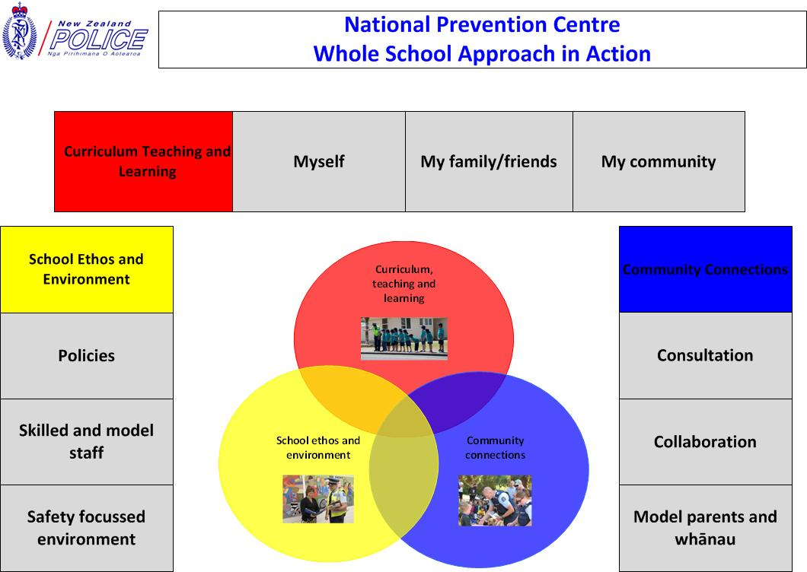

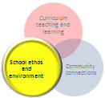
School ethos and environment

Policies
The school's procedures related to disclosure of relationship abuse, sexual violence, and sexual harassment are current and in place. These procedures may be incorporated within ‘NAG 5: safe physical and emotional environment’ policies, for example student behaviour management policies, student support policies.

Skilled staff
Staff members are provided with the opportunity through training to facilitate the Loves-Me-Not workshop. They are all aware of school policies related to ‘NAG5: safe physical and emotional environment’. All staff are provided with information about Loves-Me-Not, and are reminded about the school’s abuse disclosure policies and procedures.

Safety focused environment
The school reviews the physical and social environment for anything that provides opportunities for abuse. The schools put steps into place to minimise these opportunities, for example:
- increased natural surveillance, clear out-of-bounds areas, and clearly marked entrance and exits
- well maintained buildings and grounds
- effective peer mediation and peer support structures.

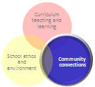
Community connections

Consultation
The school consults with family/whānau and students about the place of relationship education within the school curriculum. Note that Section 60B of the Education Act 1989, as amended by the Education Standards Act 2001, outlines the legal requirements for state schools to consult with their community over health education, which includes relationship education.

Collaboration
The school is aware of and partners with community organisations that are relevant and capable of supporting the school to achieve safe physical and emotional environments for their students. This should include the Police and NGOs involved in the Loves-Me-Not workshop.

Parents and whānau
Parents and whānau are informed about the Loves-Me-Not workshop within the school curriculum and their participation is encouraged, so that they can:
- know what the school is doing to promote confident, connected, lifelong learning for healthy relationships
- know how the school deals with disclosures of abusive behaviours
- reinforce the learning provided in the Loves-Me-Not workshop – for example, across other curriculum area and peer support programmes
- learn more about relationship abuse and sexual assault, its signs, and the myths that contribute to the perpetuation of abuse in our society
- know how to support their child if they raise alarms about relationship abuse and/or sexual assault, and where to get the necessary help
- learn about the community agencies that support victims, perpetrators, and bystanders to take action to stop relationship abuse.

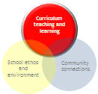
Curriculum teaching and learning
An outcome of the Loves-Me-Not workshop is for students to take action through a student inquiry learning process for:
- myself – how students can take action to prevent being affected by relationship abuse as a perpetrator or a victim
- my family/friends – how students can take action for the safety of their friends and family as effective bystanders
- my community – by empowering students to take action to influence the school community and/or wider community to prevent relationship abuse.

The school may also consider including learning activities related to promoting positive behaviours in relationships in different subjects/learning areas, for example:
- English lessons based on relevant stories such as My Leanne, by Patricia Grace
- mathematics and statistics, using analysis of victim or offender statistics to tell a story about abusive behaviour in relationships
- review of the school environment, using Crime Prevention Through Environmental Design (CPTED) principles
- training programmes for senior students for peer support and/or peer mediation
- art and media studies analysing portrayal of gender and relationship roles (e.g. see achievement standard 91250 assessment resource).

Loves-Me-Not: A student inquiry learning process
Student take action through a six-step process based on an action competence learning model

Step | Sample learning experiences to select from
Gather data | Students gather data and question personal assumptions through the Loves-Me-Not workshop. For example, students may ask:  - What is a healthy and an unhealthy relationship?  - Why do they want to be in a relationship?  - What are the different types of abuse that may occur in relationships?  - What are the main risks of being in an unhealthy relationship?
Develop options | Students brainstorm a range of actions they can take. For example:  - to ensure their friends and family are safe in their significant relationships  - to influence their school (school culture) so that relationship abuse does not occur.  For examples of actions, see Section 6.1 of the workshop manual.
Select options | Students compare the different brainstormed options by using different measures. For example, measures might consider which actions:  - are easiest to complete  - are the most effective  - are going to influence most people  - will have the most convincing message  - can be taken in the available timeframe  - can be taken with the available money.  Students decide on:  - the action(s) that they will take to achieve their goal of a community in which people can have healthy relationships free from abuse  - how they will know whether the actions they will take have made a difference.
Plan actions | Students decide and record (see Copysheet 6.1: ‘Be the Change’ planning template):  - how they will carry out the action  - what small sub-actions need to be taken  - who will do these sub-actions  - when they will be done.
Carry out actions | Students carry out the steps/tasks stated in the plan.
Reflect and transfer | Students reflect on how well the action achieved its goal (see Copysheet 6.1: ‘Be the Change’ planning template). For example, they could consider how well the action:  - encouraged people to think about the quality of their relationships  - encouraged people to think critically about ideas of gender and violence  - influenced people to communicate with honesty and consent in a relationship  - encouraged people to seek help when their relationship was not healthy  - encouraged people to become active bystanders.  Students may transfer the learning by identifying other issues that affect the safety of young people (for example, drug abuse, road crashes) and what actions they can take to address these issues.

Part B: Implementing Loves-Me-Not

Step one | Agree to partner
Step two | Register
Step three | Review policies and procedures
Step four | Coordinate range of supporting activities
Step five | Plan workshop
Step six | Prepare workshop material
Step seven | Train all facilitators
Step eight | Inform all staff and parents
Step nine | Deliver the Loves-Me-Not workshop
Step ten | Debrief the workshop
Step eleven | Support and promote student-led actions
Step twelve | Complete impact evaluation

Summarised implementation steps and timeframes

Steps | Actions | Summary of tasks | Timeframe
Step one | Agree to partner | - Meeting between school and Police to reduce harm from relationship abuse and future family violence.  - Consultation within Police, and confirm Police’s LMN coordinator.  - Consultation in the school, and confirm school’s LMN coordinator.  - Initial planning meeting to agree on how LMN will be delivered in a whole-school approach, and to set a date for the workshop. | At least 4 months before the LMN workshop
Step two | Register for workshop | - Complete Registration Form (download for the the School Portal) and email to schools@police.govt.nz.
Step three | Review school procedures  (whole-school approach in action) | - Review school policies and procedures related to disclosure of abuse and pastoral care.  - Progress through BOT for endorsement (if necessary). | At least 4 months before the LMN workshop
Step four | Coordinate supporting activities (whole- school approach in action) | Identify and plan supporting whole-school approach activities, such as:  - cross-curriculum lessons (see NCEA examples)  - curriculum for student well-being and relationship education (e.g. Health Education)  - PB4L-SW activities  - Mates and Dates  - Peer Support programme. | At least 3 months before the LMN workshop
Step five | Plan workshop | - Identify number of classes required.  - Identify number of facilitators (school staff, Police, NGO), and select them.  - Identify rooms and timetable.  - Identify AV technology in each room. | At least 2 months before the LMN workshop
Step six | Prepare workshop material | - Download and edit workshop manual from the School Portal to identify options to be used.  - Photocopy one edited manuals for each facilitator.  - Photocopy necessary handouts.  - Source flipcharts. | At least 1 month before the LMN workshop
Step seven | Train all facilitators | - Run a training workshop where facilitators:  - review guide for facilitators  - go through the full programme together  - identify parts each facilitator is responsible for  - complete the facilitator planning guide (see pages 21-22)  - clarify timekeeping responsibility  - clarify any skills training for facilitators, such as running continuums, role play, debriefing. | At least 1 week before the LMN workshop
Step eight | Inform all staff and parents  (whole-school approach in action) | - Explain purpose and process of the workshop and potential implications (e.g. disclosures to trusted staff) at a staff meeting.  - Communicate to parents through standard methods, e.g. website, newsletters.  - Share a link to the Loves-Me-Not parent video on the School Portal.  - Consider inviting parents to a consultation presentation. | At least 1 week before the LMN workshop
Step nine | Deliver the Loves-Me-Not workshop | - Plan welcome for visitors.  - Ensure rooms and technology operational.  - Ensure guidance staff available for students.  - Consider providing kai for facilitators and students.  - Collect student feedback on the workshop.
Step ten | Debrief the workshop | - Facilitators review the workshop.  - School and Police LMN coordinators collate students’ and facilitators’ process evaluations (see pages 28 and 29) onto the Collated Evaluations Form (available on the School Portal), and send to schools@police.govt.nz. | Within 1 week after the LMN workshop
Step eleven | Support and promote student-led action | - Encourage students to initiate the student-led actions they identified in Focus area 6.1.  - Support and promote the planned student-led actions. | 1 month after the LMN workshop
Step twelve | Complete impact evaluation | - Gather impact evaluations from a random sample of students and teachers (see page 30 and 31) and send collated evaluations to schools@police.govt.nz. | 4 months after the LMN workshop

Detailed implementation tasks

Step one
School consultation
School consultation would ideally occur toward the end of a school year or early in the new school year, but at least 4 months before the workshop.
- The school principal agrees to include Loves-Me-Not in the school timetable.
- A school Loves-Me-Not coordinator is allocated (e.g. HOD Health, guidance counselor, deputy/assistant principal, dean).
- The school accesses the following documentation from the Police School Portal:
  - FAQ guide
  - Loves-Me-Not implementation guide
  - Loves-Me-Not workshop manual.

Police consultation
When supporting Loves-Me-Not, Police consultation will usually take place between the Police Family Violence Coordinators (FVC), Child Protection Teams (CPT), Criminal Investigation Branch (CIB), and the School Community Officers (SCOs).
- District/Area Prevention Managers agree to deploy police staff to support LMN in a school.
- They agree on who will be the Police Loves-Me-Not coordinator in their area/district.
- The SCO will ideally be part of the Police team implementing the workshop, and will also work with the school to support the whole-school approach.
- FVC will ideally be part of the Police team implementing the workshop. They are aware of NGOs through the local Family Violence Network. The FVC will seek expressions of interest from NGOs to be LMN facilitators.
- CIB and CPT, as Police staff dealing with disclosures, should be called on for the training session to talk with the facilitators and discuss any current issues in the community.

Initial planning meeting
Police LMN coordinator and school LMN coordinator agree on:
- components of the whole-school approach that will be implemented to support the workshop
- the approach to planning the Loves-Me-Not workshop, including delivery date (consideration may be given to dividing the workshop into sessions on different days if facilitators are available, so teachers can follow up after each session - this will require re-focusing for each session).
Meeting topics include:
- deciding which students will take part, e.g. some smaller schools may include year 13 students
- a review of school policies, e.g. procedures for student disclosure abusive relationships to staff
- communication of revised policies and the Loves-Me-Not workshop to all staff
- communication about Loves-Me-Not to students and parents
- completion and submission of the Registration Form (available on the School Portal).

Step three
Review school policies
The school should review any school policy that relates to disclosure of relationship abuse. The procedures within these policies should be developed and communicated to all staff, as students may disclose to any staff member.

Specific advice is available from Relationship Education Programmes: Guide for Schools. Example of procedures are provided on page 24.

Step five
Allocate workshop venues and students
- Venues for the full day should all have access to the internet, a sound system, a projector, a computer, a whiteboard, flipchart paper, and pens.
- Class groups are divided into 25 students. Feedback from previous Loves-Me-Not workshops has provided two alternative ways of doing this:
  - Either consider different groupings from a normal school day. If possible, avoid having known relationships in the same group.
  - Or group students who are more familiar with each other, and aim to have teachers work with their own students where possible.

Select facilitators
- Selection of school staff is based on interest in the workshop topic, rapport with students, influence to empower students to change their environment, and function as positive role models relating to the kaupapa.
- Selection of Police staff is based on training, experience, and interest in the workshop.
- Selection of NGOs is based on recommendations by FVC and the school, as well as their training, experience, and interest in the workshop.

When choosing the team of facilitators, consider the demographics of the student population. This will include factors such as gender balance, age balance, confidence in delivering the material, and ethnicity. It is expected that each class will have a least one male facilitator.

Consider how to ensure the sustainability of NGO and other facilitator availability for future Loves-Me-Not workshops. The three-person delivery is the key feature of the Loves-Me-Not approach, as it combines the three different sets of competencies to ensure effective delivery.

Step six
Prepare workshop resources
Decide who will do this task (school, Police, NGO) based on who may have the capacity to do the job.

The workshop manual on the School Portal provides optional activities in some places. Schools may also choose to add in some icebreakers and energisers. You can download and edit the Word version of the manual to show the options the school has chosen, and to add any icebreakers and energisers.

Photocopy one manual for each facilitator. Also photocopy sufficient copysheets for the activities. The school may also wish to put together their own handout of local support agencies’ contact details.

Step seven
Facilitator training
This minimum half-day session is essential for consistency of delivery. It should occur about one week before the workshop date to:
- go though the full workshop and each activity
- allocate facilitators to different learning activities – see the facilitator planning guide
- ensure that all resources are prepared before the workshop.

Before the training session each facilitator should have received and read the Loves-Me-Not workshop manual, the LMN PowerPoint with the embedded videos, and this implementation guide.

Important: Evaluations in 2017 showed that the quality of the Loves-Me-Not decreased when insufficient emphasis was placed on the training. Shortening the training, not having all facilitators attend the training, or having the training too close to the workshop are all likely to have a detrimental effect on what students get out of the workshop.

Step eight
Inform all staff and parents
- Hold a whole-of-staff meeting where the school and Police LMN coordinators discuss:
  - the impact of relationship abuse on the school community
  - the structure of the LMN workshop using the video Loves-Me-Not for Parents
  - what the school currently does to build healthy relationships
  - the school policy and procedures for any staff member who receives a disclosure
  - how different subjects can include lessons about positive behaviours into their curriculum.
- Communicate to parents, for example via the website or newsletters, including a link to Loves-Me-Not for Parents from the School Portal or the Sophie Elliot Foundation.
- Consider running a whānau hui or parent consultation presentation and show them Loves-Me-Not for Parents.

Step nine
Workshop day
Steps to be considered include:
- ensuring venues are set up and all resources available
- providing a general introduction to students (e.g. class assembly, whakatau) to describe the day and timetable, Loves-Me-Not room allocation, expectations of the school, referral room
- availability of pastoral team to respond to any disclosures
- ensuring a clear closure for the day with next action steps for students
- consider providing kai for the students and facilitators during the day
- at the end of the day a facilitators’ debrief, sharing of experiences, and gathering of evaluations.

Step ten
After the workshop
The school LMN coordinator, senior manager, and Police LMN coordinator meet to:
- collate the Student Process Evaluations and Facilitator Process Evaluations, complete a Collated Evaluations Form (from School Portal) and email it to schools@police.govt.nz
- integrate evaluation findings with plans for operating Loves-me-Not again in the future.

Step eleven
In the weeks after the workshop
Encourage students to initiate the student-led actions they identified in Focus area 6.1. Provide opportunities for students to turn their planned activities into real-life actions. This could be done through a student inquiry process, as suggested on page 7 of this guide.

Step twelve
At least four months after the workshop
Have a random sample of students and teachers complete the Student Impact Evaluation and Teacher Impact Evaluation forms (see pages 29 and 30), and send them to schools@police.govt.nz.

Part C:
Information and resources to implement Loves-Me-Not

National Administration Guideline 5
Each Board of Trustees is required to provide a safe physical and emotional environment for students and comply in full with legislation currently in force or that may be developed to ensure the safety of students and employees.

Loves-Me-Not in The New Zealand Curriculum
This section describes Loves-Me-Not as it relates to the vision, principles, values, key competencies, learning areas and effective pedagogy in The New Zealand Curriculum (2007).

Vision
The vision of The New Zealand Curriculum is for young people to be confident, connected, actively involved and lifelong learners.
(The New Zealand Curriculum, p. 8)
The vision of The New Zealand Curriculum is incorporated throughout Loves-Me-Not by promoting: self-identity, resilience, communication skills, critical and creative thinking, informed decision making and active contribution to the well-being of New Zealand.

Principles
The principles of The New Zealand Curriculum embody beliefs about what is important and desirable in a school curriculum.
(The New Zealand Curriculum, p. 9)
The principles of The New Zealand Curriculum that are significantly promoted through Loves-Me-Not include:
- community engagement, through including wider community agencies
- inclusion, through accepting and promoting students' identity
- a future focus, through exploring citizenship and contributing to the well-being of New Zealand.

Values
Values are deeply held beliefs about what is important or desirable. They are expressed through the ways in which people think and act. Every decision relating to curriculum and every interaction that takes place in a school reflects the values of the individuals involved and the collective values of the institution.
(The New Zealand Curriculum, p. 10)
The key values of The New Zealand Curriculum that are most obviously promoted through Loves-Me-Not are:
- community and participation for the common good
- integrity, which involves being honest, responsible and accountable, and acting ethically
- students’ respect for themselves, others, and human rights.

Through learning experiences in Loves-Me-Not, students will learn about:
- their own values and those of others
- different kinds of values, such as moral, social, cultural, aesthetic, and economic values
- the values on which New Zealand’s cultural and institutional traditions and myths are based.

Through learning experiences in Loves-Me-Not, students will develop their ability to:
- express their own values
- explore, with empathy, the values of others
- discuss disagreements that arise from differences in values and negotiate solutions
- make ethical decisions and act on them.

Key competencies
People use the key competencies to live, learn, work, and contribute as active members of their communities … Opportunities to develop the competencies occur in social contexts. People adopt and adapt practices that they see used and valued by those closest to them, and they make these practices part of their own identity and expertise.
(The New Zealand Curriculum, p. 12)

The key competencies from The New Zealand Curriculum that are most obviously promoted through Loves-Me-Not are:
- Managing self: students who manage themselves are enterprising, resourceful, reliable, and resilient
- Relating to others: the ability to listen actively, recognise different points of view, negotiate, and share ideas - students who relate well to others ... are aware of how their words and actions affect others
- Participating and contributing: being actively involved in communities – these include family, whānau, and school and those based, for example, on a common interest or culture. Students who participate and contribute in communities have a sense of belonging and the confidence to participate within new contexts. They understand the importance of balancing rights, roles, and responsibilities and of contributing to the quality and sustainability of social, cultural, physical, and economic environments.

Learning areas
The learning associated with Loves-Me-Not is part of a broad, balanced, and general education. Loves-Me-Not aligns with the Health and Physical Education learning area from The New Zealand Curriculum. Achievement objectives can be best drawn from Levels 5–6 under:
- Strand A: safety management
- Strand C: relationships; identity, sensitivity and respect
- Strand D: societal attitudes and values; community resources; and rights, responsibilities, and laws.

Loves-Me-Not incorporates the four underlying concepts of the Health and Physical Education learning area – for example:
- well-being, hauora (all aspects): analysing own values and attitudes to relationship abuse
- health promotion: sharing ideas about a school and community that promote healthy relationships
- the socio-ecological perspective: identifying societal myths and media influences on attitudes towards relationship abuse and unhealthy relationships
- attitudes and values: developing positive attitudes to personal, peer and societal safety to promote healthy relationships.

Loves-Me-Not and New Zealand qualifications
The topic of healthy relationships and relationship abuse is a useful context for learning within a broad range of subjects/learning areas.

Assessment from the Health Education domain
A range of sample assessment material for Health are provided on TKI from: https://ncea.tki.org.nz/Resources-for-Internally-Assessed-Achievement-Standards/Health-and-physical-education/Health-education

Here are some examples of how the assessment tasks could be modified to focus on healthy relationships and relationship abuse.

Achievement standards NCEA Level 1
- AS90971 Take action to enhance an aspect of personal well-being.

Assessment task - Relationships take work
An assessment activity that requires students to take action to enhance an aspect of their well-being by planning, implementing, and evaluating a SMART health-related, action plan to strengthen a relationship they have with someone.
http://ncea.tki.org.nz/content/download/3392/10887/file/health1_1A_v2_nov12.docan aspect of personal well-being

Due to the sensitive nature of abusive relationship, this assessment task is likely to focus on healthy relationships and improving a relationship, rather than addressing an abusive relationship.

Assessment task - Enhancing my wellbeing
An assessment activity that requires students to take action to enhance an aspect of their personal well-being by planning, implementing, and evaluating a SMART action plan to achieve a personal health-related goal.
http://ncea.tki.org.nz/content/download/3393/10890/file/health1_1B_v2_nov12.doc

Due to the sensitive nature of abusive relationship, this assessment task is likely to focus on goals towards improving a relationship (e.g. boyfriend or girlfriend) rather than addressing an abusive relationship. The goal may be improving the use of effective interpersonal skills or increasing the use of assertive behaviours.

- AS91097: Demonstrate understanding of ways in which well-being can change and strategies to support well-being.

Assessment task - Onwards and upwards
An assessment activity that requires students to understand the effects of change on the well-being of the characters involved in the scenario, their consequent feelings (positive and negative) and possible responses; along with strategies to support their well-being during the change.
http://ncea.tki.org.nz/content/download/3394/10893/file/health1_3A_v2_nov12.doc

The scenario provided could be modified to a scenario that shows changes in a relationship that begins to include abusive behaviours.

- AS90973 Demonstrate understanding of interpersonal skills used to enhance relationships

Assessment task - Putting Things Right Again
An assessment activity that requires students to explain how interpersonal skills can enhance relationships, and how well the students are able to apply the use of effective listening and assertiveness skills. Critical explanations make explicit links between the components of skills and how these enhance relationships in one of the scenarios provided.
http://ncea.tki.org.nz/content/download/3396/10899/file/health1_4A_v2_nov12.doc

The scenarios could use the five scenarios in Loves-Me-Not rather than the examples provided in the assessment task.

Assessment task - Making a relationship work
An assessment activity that requires students to explain how interpersonal skills can enhance relationships, and how well the stduents are able to apply the use of effective listening and assertiveness skills. Critical explanations make explicit links between the components of skills and how these enhance relationships in the developed scenario/s.
http://ncea.tki.org.nz/content/download/3397/10902/file/health1_4B_v2_nov12.doc

Students could develop a scenario similar to those discussed during Loves-Me-Not.

Achievement standards NCEA Level 2
- AS91237 Take action to enhance an aspect of people’s well-being within the school or wider community 4 credits.

Assessment task - Our Mentally Healthy School
This assessment activity requires students to take action to promote an aspect of mental and emotional well-being in their school community by planning, implementing and evaluating a plan for health promoting action that aligns with the principles of, or implements aspects of, the Health Promoting Schools framework.
https://ncea.tki.org.nz/content/download/3402/10917/file/health2_3A_v2_jan15.docx

Students could plan, implement and evaluate a health promotion plan to enhance healthy relationships.

Sample of relationship abuse contexts in Level 1 achievement standards from other subjects

Subject |  | Std number |  | Standard title |  | Current task theme |  | Sample context to focus student learning on positive relationships
Drama |  | 90009 |  | Perform an acting role in a scripted production |  | Act in a scripted play |  | Provide specific examples of scripted play based on relationships – see examples from http://www.playmarket.org.nz/
English |  | 90052 |  | Produce creative writing |  | Writing about conflict and resolution |  | Students produce scenarios of conflict for example bullying, relationship abuse, family violence
English |  | 90052 |  | Produce creative writing |  | Personal news starters |  | Students produce news starters about dealing with conflict– e.g,. bullying, relationship abuse, family violence
English |  | 90053 |  | Produce formal writing |  | Opinion writing |  | Students write opinion pieces of relationship issues in New Zealand – e.g., date rape, bullying
Mathematics |  | 91030 |  | Apply measurement in solving problems |  | Measuring water |  | Students use crime statistics to identify implications of family violence in New Zealand
Media Studies |  | 90993 |  | Produce a design and plan for a media product using a specified range of conventions |  | Create an advertisement |  | Students create an advertisement based on promoting successful relationships or ethical bystanders behaviour
Media Studies |  | 90993 |  | Produce a design and plan for a media product using a specified range of conventions |  | Create an instructional video |  | Students create an instructional video of how to maintain successful relationships
Media Studies | 90996 |  | Write media texts for a specific target audience |  | Create a portfolio and media articles |  | Students create a portfolio and media articles focusing on safer communities
Social Studies | 91040 |  | Conduct a social inquiry |  | Explore an organisation with social justice focus |  | Students could explore New Zealand Police as a human rights organisation
Social Studies | 91043 |  | Describe a social justice and human rights action |  | Taking action generic |  | Student prepare examples of action they could take to promote successful relationships

Sample of relationship abuse contexts in Level 2 achievement standards from other subjects

Subject | Std number | Standard title | Current task theme | Sample context to focus student learning on positive relationships
Drama | 91220 | Script a scene suitable for drama performance | Ideas for creating a script | Students script a scene based on scenarios from the Loves-Me-Not workshop
Economics | 91227 | Analyse how government policies and contemporary economic issues interact | Comparing economic policies | Students develop economic rationalism for policies that reduce incarceration as a result of relationship/family violence
English | 91103 | Create a crafted and controlled visual and verbal text | From written text to visual text | Students create presentations (ppt, flash) that incorporate text based around themes of successful relationships
Mathematics | 91263 | Design a questionnaire | Caffeine | Students design a question about young people rights and responsibility towards successful relationships
Mathematics | 91266 | Evaluate a statistically based report | Statistics in the media | Students evaluate reports on family violence available from New Zealand Police.
Media Studies | 91255 | Write developed media text for a specific target audience | Writing a feature article for a magazine | Students write an article about relationship abuse for the school website or a youth publication
Media Studies | 91250 | Demonstrate understanding of representation in the media | What a girl wants (doc) – how teenage girls are represented in the media | Using media film from Loves-Me Not (1.5) students consider how this representation contributes to relationship abuse and what action they can take to prevent abuse.
Physical Education | 91334 | Consistently demonstrate social responsibility through applying a social responsibility model in physical activity | Applying Hellison’s social responsibility model | Students describe how this model can be developed from a physical activity context to a social context –e.g., bullying, family violence
Social Studies | 91280 | Conduct a reflective social inquiry | Social inquiry of community solution | Students conduct a social inquiry into relationship abuse in both face-to-face and online relationships
Social Studies | 91282 | Describe personal involvement in a social action related to rights and responsibilities | Support SurfAid | Students participate in support for Victim Support and explore rights and responsibilities
Technology | 91354 | Undertake brief development to address an issue | A brief of a product for around the home | Students develop a brief for a specific safety issue – e.g,. online safety, relationship abuse

Guide for workshop facilitators
The team of facilitators includes school staff, Police staff, and NGO/community sector specialists (with at least one facilitator being male). This composition is a fundamental principle of the Loves-Me-Not workshop.

Facilitators have an important role in modelling respect, integrity, accountability, and responsibility to the students.

Facilitators must:
- complete the facilitator training in full before running the workshop
- use the resource materials in the intended way, and without adding other material (changing the material can compromise Loves-Me-Not's effectiveness and integrity)
- not use personal experiences related to sexual violence to highlight a point – instead, reframe the point as a question directed back to the students
- demonstrate respect, tolerance, and a respect for diversity
- follow the prescribed script until they have completed the workshop at least three times (once this capability has been developed, facilitators may modify the script where changes reflect the identified needs/interests of the student participants)
- ensure personal values are not dominant, for example ensuring that they:
- use language that embraces healthy relationships in a variety of sexual orientations, not just heterosexual
- avoid gender stereotypes - focus different behaviour traits on masculinity and femininity, rather than on male and female gender
- avoid blame and labeling - perpetrators as well as victims (both actual or potential) may gain a lot out of the day to prevent re-offending and re-victimisation.

Facilitators’ code of ethics
- I will behave in a manner consistent with my position as a professional, and be a positive role model in the Loves-Me-Not workshop.
- I will respect young people's differences, including their rights, culture, language, and beliefs.
- I will not engage and collude in behaviour that may be disrespectful, degrading, exploitive, intimidating, emotionally damaging or harmful to participants in this workshop.
- I will not allow my personal beliefs and world-views to influence students' opinions.
- I will have an open mind to new learning.
- I will use all course material provided, and not introduce new material into the Loves-Me-Not workshop, or use parts of the Loves-Me-Not workshop in other primary prevention programmes without consent from Police National Headquarters (email schools@police.govt.nz).
- I will follow and support the approved school disclosure procedures.

Loves-Me-Not workshop facilitator planning guide
Members of my facilitating team are:
Police Rep: ___________________ Phone: __________ Email: _________________________
Teacher: _____________________ Phone: __________ Email: _________________________
NGO Rep: ____________________ Phone: __________ Email: _________________________

Table 4: Workshop timetable
Focus area | Timetable
1. Your future relationship
2. Barriers to a healthy relationship
Interval
3. Consent - only “yes” means “yes”
4. Stepping up
Lunch
5. Lashing out
6. Be the change!

Activity-specific timetable

Focus area 1: Your future relationship (Suggested time 85 min)
In this focus area students will develop a trusted picture of an excellent relationship, and a sense of personal journey towards it.
1.1 Introduction Facilitator: ________________________ (20 min)
1.2 Ground rules Facilitator: ________________________ (5 min)
1.3 A healthy relationship Facilitator: ________________________ (15 min)
1.4 Features of a healthy relationship Facilitator: ________________________ (25 min)
1.5 What influences my thinking? Facilitator: ________________________ (10 min)
1.6 Personal experience Facilitator: ________________________ (10 min)

Focus area 2: Barriers to a healthy relationship (Suggested time 45 min)
In this focus area students will learn about negative behaviours that demonstrate increasing power and control in a relationship.
2.1 Grouping behaviour Facilitator: ________________________ (25 min)
2.2 Is that right? Facilitator: ________________________ (20 min)

Focus area 3: Consent - only “yes” means “yes” (Suggested time 35 min)
In this focus area students will learn what active sexual consent is, the damage caused by sexual assault, and how they can help their friends stay safe.
3.1 What is consent? Facilitator: ________________________ (15 min)
3.2 Consent scenarios Facilitator: ________________________ (20 min)

Focus area 4: Stepping up (Suggested time 60 mins)
In this focus area students will learn to appreciate the important role they have to help their friends to be aware and safe in their relationships.
4.1 Healthy behaviours Facilitator: ________________________ (15 min)
4.2 Should I step in? Facilitator: ________________________ (20 min)
4.3 Stepping in Facilitator: ________________________ (20 min)
4.4 Who can help? Facilitator: ________________________ (5 min)

Focus area 5: Lashing out (Suggested time 50 min)
In this focus area students will explore the reality of partner violence towards men and women in New Zealand, and how they can help themselves and others safely if it happens.
5.1 Statistics, statistics Facilitator: ________________________ (5 min)
5.2 Real scenario Facilitator: ________________________ (45 min)

Focus area 6: Be the change! (Suggested time 35 min)
In this focus area students will explore positive actions they can take right now in their relationships, their friend's relationships, their families/whānau, schools and communities to resist unhealthy relationships and promote excellent relationships
6.1 Taking action Facilitator: ________________________ (25 min)
6.2 Summation and evaluation Facilitator: ________________________ (10 min)

Important!

If it is not possible to complete all activities from the workshop during the allocated time, be careful not to miss Focus area 6.1: Taking action, where students plan actions they can take to reduce relationship abuse in their community.

Student-led action as a result of the workshop is crucial to the success of Loves-Me-Not as a behaviour change programme.

Ensuring a safe classroom environment during the workshop
Learning activities will be effective only when they take place in a safe physical and emotional environment in which all students feel that their contributions and experiences are accepted.

Create a safe physical environment
- Set up the room with:
  - desks and chairs set into groups of five
  - sufficient space for interactive activities.
- Ensure there are few interruptions – arrange to switch off cell phones and other devices.
- Allow students to be up and active in the activities by doing as much as possible with them standing and walking, e.g. do continuum exercises outside if there is an appropriate space.

Create a safe emotional environment
- Give students the opportunity during Focus area 1 to brainstorm guidelines (ground rules) for the day.
- Have all students, all facilitators, and any visitors agree to abide by the guidelines.
- Display these guidelines so they can be viewed throughout the day.
- Demonstrate to the students that the guidelines are important, e.g. direct every person who enters the room throughout the day to read the guidelines.

Maintain a safe environment

Student behavior
- Be sensitive in your handling of disruptive, disrespectful, or difficult behaviours – you don't know the reasons why someone is acting up, and Loves-Me-Not could be a difficult topic for some people.
- Do not embarrass students who act up.
- Approach them quietly about their behaviour.
- Direct their attention to ground rules (Focus area 1) and give them the opportunity to correct themselves or to go to a referral room.

Student views
- Avoid making negative responses, such as “That's incorrect” or “You're wrong”.
- Consider and respect all young people's views - the opinions of the students with opposing views may increase student engagement in an activity.
- Allow the discussion as young people come to their own learning, but just ensure that the interactions remain respectful.

Vocabulary
- Set aside a place on the whiteboard for new words that may be new for some students to be displayed, so they can be explained. Examples of possible new words are: victim, assault, sexual violation, conviction, bystander, escalation, consent, and offender.

Extend the learning beyond the Loves-Me-Not workshop
As a facilitator, your goal is not just about the workshop, but that students take action as a result.
- Encourage students during Focus Area 6 to take action to stop abuse.
- Have a facilitator, preferably a member of school staff, encourage and facilitate student-led action afterwards so as to further embed the messages of this workshop.

Facilitator scenarios – dealing with difficult situations
Following are some situations you may face, with suggestions for dealing with each situation.

Situation 1 – disrespectful classroom behaviour
A student is acting inappropriately – they are disrespectful towards other students' feedback or actively opposing or challenging the intent of the workshop.

Possible responses
- Refer the student to the ground rules and confirm whether they are willing to abide by them.
- Listen actively. Active listening is a technique that ensures that you are not putting your own interpretation on what is being said. In some cultures it can involve maintaining eye contact with the speaker, showing with nods and brief comments that you are actually hearing what is being said, not interrupting or giving advice, and paraphrasing what the speaker is saying in order to clarify your own understanding.
- Find out more about the situation.
- Ask if the student is finding the information difficult, if they able to contribute their views in a more respectful way, or if they would like to step out for a break and come back a bit later.
- Refer the matter to the guidance counsellor or equivalent.

Note: We are often unaware of why students show disapproval toward other students and their ideas. Friendship dynamics may also be involved.

Situation 2 – student personal disclosure
After one of the learning activities, a girl approaches you. She wants you to promise not to tell anyone what she is going to say.

Possible responses
- Before the student discloses anything, be sure to tell her that you cannot promise not to tell someone if she or someone else is in danger. Reassure the student that you will support her regardless of what happens, if that is what she would like, or that you'll help her find someone else she can talk to.
- If the student discloses harm and there is immediate danger, follow the school procedures and advise the student of your obligation to report the danger immediately – whenever possible, this needs to be done with the student as part of the process.
- If the student discloses harm and there is no immediate danger:
  - affirm her by expressing approval, warmth, support and acceptance, both verbally and by using body language. Reassure her that the abuse is not her fault.
  - ensure that she knows you must follow some compulsory school procedures about abuse, and let her know you have to refer the case to the appropriate person.
  - explain to her the steps will be taken to help her. If you don't know, tell her you are not sure but you will find out and get back to her. Don't make it up.
- If the student is 17 years or older and she does not wish to involve the designated person (e.g. guidance counsellor) in the school, the student’s wish will stand. However to assist the school to support her through the challenging times ahead, please encourage the student by offering to accompany her if she tells the guidance counsellor. If the student would prefer you to do it, ask her what she would like you to tell the counsellor.

Situation 3 – student bystander disclosure
After Loves-Me-Not has been in the school, students tell you (a school teacher) about a young boy who is the victim of assault from his girlfriend, but who won't tell anyone.

Possible responses
- Advise the students that they have done the right thing in telling you.
- Follow the school's disclosure policy.

Procedure for disclosures
The school should have procedures for dealing with disclosures of relationship abuse. During the Loves-Me-Not training, all facilitators must be:
- made aware of these school procedures
- advised that the school's procedures for disclosures will be discussed with the students
- given guidance on how to act when a student discloses and what records to keep.
A typical school disclosure procedure may look like this flowchart
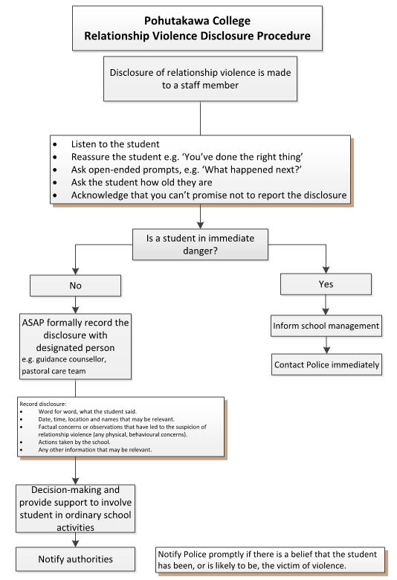

Free copies of Loves Me Not by Lesley Elliott
The Sophie Elliott Foundation has reprinted the paperback book Loves Me Not: How to Keep Relationships Safe (by Lesley Elliott with Bill O’Brien, 160 pages, published by Random House, 2014)

This book normally retails at about $25, but (courtesy of Zonta) while stocks last it can be given free to students who attend the Loves-Me-Not workshop.

Your Police LMN facilitator can order copies for the students, using the Police ordering system (code PUBL1065).

Evaluation of Loves-Me-Not workshop

For effectiveness, Loves-Me-Not must be evaluated for:
- process (did the workshop go well, and did the students believe they learnt anything relevant)
- impact (did the workshop actually lead to students making different decisions in their relationship behavior, or take any action to prevent relationship abuse).

Process evaluations consist of Student Process Evaluations (page 28) and Facilitator Process Evaluations (page 29), which are filled in at the end of the workshop. Once these are filled in, collate the responses into the Collated Evaluations Form (available on the School Portal), and submit this form to Police National Headquarters (email schools@police.govt.nz) within one month of the workshop.

Impact evaluations consist of Student Impact Evaluations (page 30) and Teacher Impact Evaluations (page 31) completed by a random selection of students and teachers at least four months after the workshop. Collate and submit the responses to Police HQ (email schools@police.govt.nz).

The result of these evaluations will:
- influence how Loves-Me-Not is implemented in the future
- provide evidence as to the value of Loves-Me-Not as a tool to affect young people’s lives.

Student Process Evaluation

1. How easy was it for you to participate in the Loves-Me-Not workshop?
Very easy 1 2 3 4 5 Very hard
2. How actively were you involved in the learning activities?
Very active 1 2 3 4 5 Not very active
3. Having participated in Loves-Me-Not, would you be more or less likely to act or speak up if someone you knew was in an unhealthy/abusive relationship?
Much more likely 1 2 3 4 5 Much less likely
4. How well do you now know the early signs of abuse in a relationship?
Very well 1 2 3 4 5 Not at all
5. Having learnt about sexual consent, how well are you now able to ensure the person you are with is saying "yes"?
Very well 1 2 3 4 5 Not at all
6. How useful was today's workshop to help you decide whether your relationships are healthy or unhealthy?
Very useful 1 2 3 4 5 Not at all
7. How well was the workshop facilitated/led?
Very well 1 2 3 4 5 Not very well
8. What was the best part of the workshop for you?

9. What was the least favourite part of the workshop for you?

10. Do you want a free copy of the book Loves Me Not by Lesley Elliot? Yes / No

- Tick here if you want to talk to someone further about anything you’ve heard today, and provide a contact phone number and/or email address:

Facilitator Process Evaluation – Loves-Me-Not workshop
 | Yes | No | Partly
1. Do you think your facilitation team established a safe environment for young people to share their views?
2. Did your students contribute actively in Loves-Me-Not?
3. Did you feel adequately prepared to facilitate Loves-Me-Not?
4. Were your resources appropriate and well prepared and organised?
5. Did you feel the Loves-Me-Not topics were relevant to the lives of young people in New Zealand?
6. Did you feel you were adequately supported to take disclosures from students?
- If you answered “no” or “partly” to some of the above questions, why not:

8. What were the most effective aspects of the Loves-Me-Not workshop?

9. What inspired you the most from the day?

10. What should be changed to enable you to better deliver the workshop?

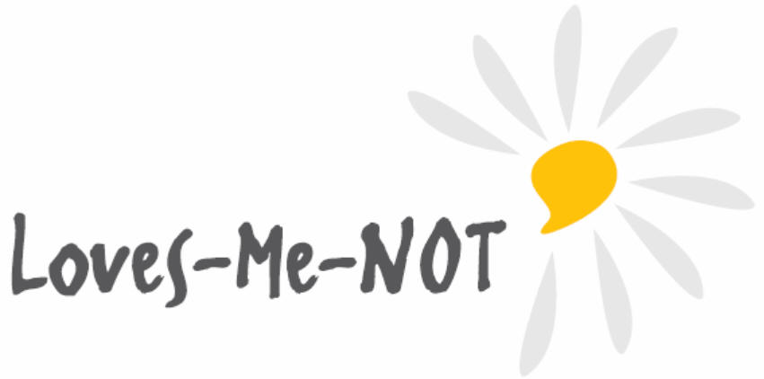

Student Impact Evaluation

(completed by randomly selected students about 4 months after the workshop)
- What school are you from?

- What term did your school run the Loves-Me-Not workshop in 2017?

- What were the main things you learned in the workshop?

- As a result of doing the workshop, did you have the opportunity to plan and take action to influence your school or wider community to prevent relationship abuse (eg a booth at a school fair, a production, producing posters etc)?

If so, what actions and how did they go?

- As a result of doing the workshop, have you used anything you learnt in real life (eg in your own relationship, or with friends or family)?

If so (and if you are happy to say), what knowledge and skill did you use?

- Tick here if you want to talk to someone further if you have any questions or concerns arising from Loves-Me-Not, and provide a contact phone number and/or email address:

Teacher Impact Evaluation

(Completed by randomly selected teachers about 4 months after the workshop)
- What school are you from?

- What term did your school run the Loves-Me-Not workshop?

- Besides the workshop day itself, are you aware if your school undertook any of these activities from the Loves-Me-Not Implementation Guide:

Did the school develop or review its procedures related to disclosure of relationship abuse, sexual violence, and sexual harassment? Yes/No Comment (if applicable):

Were staff up-skilled about the school’s disclosure policies and procedures? Yes/No Comment (if applicable):

Did the school review its physical or social environment for anything that provided opportunities for abuse (eg unclear out-of-bounds areas, ineffective peer mediation or lack of peer support structures). Yes/No Comment (if applicable):

Did the school consult with family/whānau and students about the place of relationship education within the school curriculum (eg as part of the health consultation)? Yes/No Comment (if applicable):

Did the school collaborate with community organisations to support safe physical and emotional environments for their students? Yes/No Comment (if applicable):
- Did the school engage with parents and whānau to inform them about the Loves-Me-Not workshop, and what they can do to prevent about relationship violence? Yes/No Comment (if applicable):
- Did the school extend on the workshop by subsequently using the topic of healthy relationships and relationship abuse as a context for learning in other learning areas? Yes/No Comment (if applicable):
- Did any students take action to influence the school or wider community to prevent relationship abuse (eg stall at school fair, a production, setting up blog, posters)? Yes/No Comment (if applicable):
- As far as you are aware, has any of the learning from Loves-Me-Not been put into effect? Yes/No Comment (if applicable):

- Overall, the two main aspects that take Loves-Me-Not from being just a one-off event are:
- Incorporating the workshop into a whole school approach. Do you think this occurred with fidelity?
(If not, what prevented this from happening, or what could we do to ensure it occurs in future?)
- Providing opportunities for the students to take action themselves to influence their school and wider community to prevent abuse. Do you think this occurred with fidelity?
(If not, what prevented this from happening, or what could we do to ensure it occurs in future?)

Part D: Acknowledgements
The New Zealand Police would like to thank all those who were involved in the development of the Loves-Me-Not workshop.

In particular, we thank the following people:

Lawrie Stewart (principal writer) | Coordinator: Schools | New Zealand Police
Roly Hermans | Advisor: Schools | New Zealand Police
Inspector Brigitte Nimmo | Senior Policy Advisor | New Zealand Police
Sylvia Powell | Child Case Manager | New Zealand Police
Lesley Elliott | Trustee | Sophie Elliott Foundation
Bill O'Brien | Trustee | Sophie Elliott Foundation
Tony Sutorius | Director/Producer | Unreal Films
Stephanie Edmond | Project Manager | It’s Not OK Campaign
Jerusha King | Area Manager | Family Planning New Zealand
Melanie Beres | Senior Lecturer | Otago University
All schools, staff, NGOs and Police who have provided valuable feedback to improve this workshop every year since its pilot in 2013.
Rape Prevention Education for permission to use The Bystander ... The Action Movie.

