Keeping Ourselves Safe

Years 9–10 Focus area 6
This section of the KOS programme contains one of the following focus areas for students at years 9–10 (ages 13–14):
- Identifying abuse
- Recognising and avoiding risk
- Knowing what to do
- Getting help
- Safety in cyberspace
- Anger and violence
- Breaking the silence about family violence
- What I think, what you think
Note: Research suggests that an effective KOS programme should include learning experiences from each of the focus areas.

Focus area 6: Anger and violence

Contents
Focus area 6: Anger and violence 2
Explanation 2
Notes for the teacher 2
Curriculum links 2
Resources 2
Learning intentions 2
Activities 3
Anger versus violence 3
Anger Feelings Scale 3
Anger Action Scale 3
Anger management talk 4
Learning journal 4
Optional activity 4
Copysheet: My Anger Scales 5

Focus area 6: Anger and violence

Notes for the teacher
- Ensure that safety guidelines are in place. All school staff (not just the teachers concerned) must know what to do if a student discloses abuse to them during or after Keeping Ourselves Safe. Parents should also be made aware of what to do. See the Child Protection Guidelines available on the School Portal.
- Ensure that the resource person is sent a guide for speakers before their visit.
The guide should include such things as:
- who the speaker is and their experience with anger management
- why they work in the anger management area
- what are the causes of anger and violence and the short and long-term consequences
- discussion of different types of anger and violence
- talk about the cycle of violence and how to break it
- real-life examples from people of different ages, backgrounds and cultures.

Curriculum links
Key Competencies: Managing self; Relating to others; Participating and contributing
Learning areas: Levels 5–6 Health and Physical Education – Strand A: Personal growth and development, Strand C: Interpersonal skills
Underlying concepts:
- Well-being, Hauora (all aspects) – expressing thoughts and feelings and responding constructively
- Attitudes and values – understanding that anger is acceptable but violence is not

Resources
A guest speaker – a professional who deals with anger management, such as someone from Men for Non-Violence or a counsellor
Copysheet: My Anger Scales

Learning intentions
At the end of this focus area students will be able to:
- explain the difference between anger and violence.
- learn to cope with their anger in non-violent ways.
- identify the cyclic trends of violence and understand how these can be broken.

Activities

Anger versus violence
Write Violence at the top of one side of the board. Students call out any words they can think of that relate to violence. Record all words as students express them. No discussion is necessary.
Write Anger at the top of the other side of the board. Students call out any words they can think of that relate to anger. Record all the words as students express them. No discussion is necessary.
Ask: What is the difference between anger and violence?
Why is anger acceptable while violence is not?
Establish that anger is a feeling and violence is an action or behaviour. Move any action words from the Anger side to the Violence side. Move any feeling words from the Violence side to the Anger side.
Write Choice between anger and violence.
Ask: Who chooses whether anger turns to violence?

Anger Feelings Scale
On the board, draw a scale from 0–10. Label it the Anger Feelings Scale.
Ask the students to think of a time when they were the angriest they have ever been.
Ask: How did you feel at this time?
Record some of the responses at 10 on the scale.
Now ask them to think of times when they were not angry at all.
Ask: How did you feel at these times?
Record the responses at 0 on the scale. Now repeat the process for different points on the scale, such as 0–2, 3–5, 6–8, 9–10. See the Anger Feelings Scale diagram on the following page.
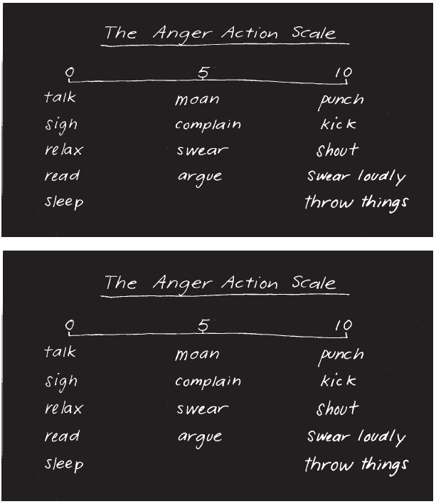

Anger Action Scale
On the board, draw another scale under the first, labelled the Anger Action Scale.
Ask: What do you do when you are feeling very angry?
Record these action words at the 10 end of the scale. Now repeat the process with other points on the scale, as was done with the Anger Feelings Scale. The finished scale will look something like the one in the diagram.
Ask: Where on the scale would you be most of the time?
Are the actions at 10 on the Anger Action Scale acceptable?

Anger management talk
Invite a resource person to class to talk about how anger can be managed. Leave time at the end of the session for students to ask questions.

Learning journal
Ask students, in pairs, to talk about things that a person could do to stop their anger turning into violence. Ideas can be shared with the class. Suggestions would include such things as taking timeout, going for a walk, listening to music, talking to someone about it. Each student makes a personal journal entry with the ideas that they think would be most successful for them.

Optional activity
Give students Copysheet: My Anger Scales. For five days they mark on the scale the position that marks their angriest time each day. Under the scale they explain what they did to stop their anger from turning to violence.

Copysheet: My Anger Scales
Day 1 ____________________________________________________________________
0 5 10
I stopped my anger from turning to violence by:

Day 2 ____________________________________________________________________
0 5 10

I stopped my anger from turning to violence by:

Day 3 ____________________________________________________________________
0 5 10

I stopped my anger from turning to violence by:

Day 4 ____________________________________________________________________
0 5 10

I stopped my anger from turning to violence by:

Day 5 ____________________________________________________________________
0 5 10

I stopped my anger from turning to violence by:

