Keeping Ourselves Safe – Senior primary

Focus area 4 – Families working together

The six focus areas in the Keeping Ourselves Safe (KOS) senior primary programme are:

1. Keeping one step ahead
2. I’m responsible for others, too
3. Finding out about abuse
4. Families working together
5. Reporting abuse
6. What happens now?

Research suggests that an effective programme should include learning experiences from each of the six focus areas.

## 

**Contents**

Focus area 4 – Families working together 3

Notes for the teacher: preparation 3

Explanation 3

Curriculum links 3

Success criteria 4

Learning intentions 4

Resources 4

Activities 5

The Hedgehog 9

The Last Straw 14

Copysheet: Family contract 17

Copysheet: My stress scale 18

Copysheet: Stress scale for parents 19

# Focus area 4 – Families working together

## Notes for the teacher: preparation

* Ensure that safety guidelines are in place.
* All school staff, not just the teachers concerned, must know what to do if a student discloses abuse to them during or after Keeping Ourselves Safe.
* Parents should also be made aware of what to do. See the Child Protection Guidelines available on the NZ Police School Portal at <https://www.police.govt.nz/advice-services/personal-community-safety/school-portal/information-and-guidelines/child-protection>

## Explanation

Sometimes abuse occurs within the family. This can be directed at any family member and can include all forms of abuse. Children are particularly vulnerable and yet they should be able to expect care and protection within their family.

In this focus area, students consider abuse within the family, reasons why it may occur, and what should be done about it. They discuss family discipline and stress. They learn that they should feel safe, cared for and protected within their family.

**Note:** Because this activity requires that parents write down family rules and discuss stress, teachers should prepare them for this in communications about the programme, so they know what to expect.

## Curriculum links

Key competencies: Managing self, Relating to others, Participating and contributing

Learning area:

Level 3 Health and Physical Education, Strand C: Interpersonal skills

* Identify the pressures that can influence interactions with other people and demonstrate basic assertiveness strategies to manage these.

Level 4 Health and Physical Education, Strand C: Interpersonal skills

* Describe and demonstrate a range of assertive communication skills and processes that enable them to interact appropriately with other people.

## 

## Success criteria

Students can:

* describe stress within the family and suggest ways of handling this
* distinguish between family discipline and abuse
* Use assertive strategies to explain that they have the right to proper care and protection and that they should be safe within their family.

## Learning intentions

Students are learning to:

* support family members
* identify positive behaviour management techniques
* communicate their needs.

## Resources

Story: The Hedgehog

Story: The Last Straw

Copysheet: Family contract

Copysheet: My stress scale

Copysheet: Stress scale for parents

## 

## Activities

### 1 – Family discipline

**Read The Hedgehog**

Using the reading approach best suited to your class, introduce the story The Hedgehog to the class. Then discuss the story in small groups, using the following questions as discussion points:

* What angered Dad?
* How did he show it?
* Why did he beat Tony? (Ensure students understand how being beaten as a child has affected Dad)
* How did Mum try to protect the children?
* What else could she have done?
* How did Tony try to help?
* What else could he have done?
* Where could the family have gone for help?

### 2 – Family behaviour management

Discuss what an effective consequence is with the class. Focus on the Three Rs and H of logical consequences:

* **related** to the action – for example if a child draws on the wall, a related consequence could be cleaning the wall
* **respectful** – it doesn’t shame or hurt the child
* **reasonable** – for example it would be reasonable to ask the child to clean the wall, but not the whole house
* **helpful** – it helps a child let go of guilt and change in the future.

Ask students to write down types of consequences that they know about or have experienced.

* These could be ‘posted’ in a post box.
* Open the post box and read out one consequence at a time.
* In small groups, students decide which side of a chart, like the one below, to place each consequence should be placed.
* The groups’ charts can then be compared and a class chart created.

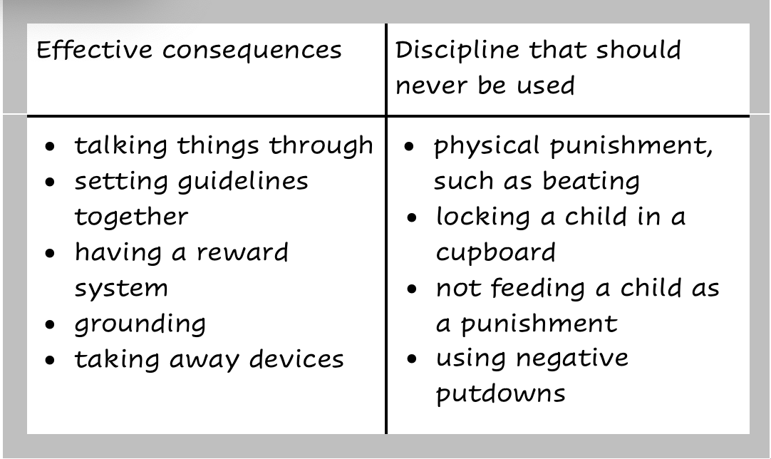

Ask:

* When do you think consequences become abuse?
* What should you do if this is happening to you?

**Note:**

Section 59 of the Crimes Act 1961 has removed a defence that had been available to parents charged with assaulting children. Parents are no longer permitted to use force against their children for the purpose of correction.

Some use of force against children is not unlawful, for example, where a parent throws a child out of the path of a vehicle.

The police have the discretion to decide whether to prosecute a case of an assault against a child, where force is used for corrective purposes, if they decide that the force was inconsequential and there is no public interest in prosecuting the parent.

A lawyer or Police prosecutor could be invited into the classroom to comment on this.

**Noticing good behaviour**

Talk about how it is important that family members acknowledge when someone in the family has behaved well. Brainstorm with the class some ways in which this could be done.

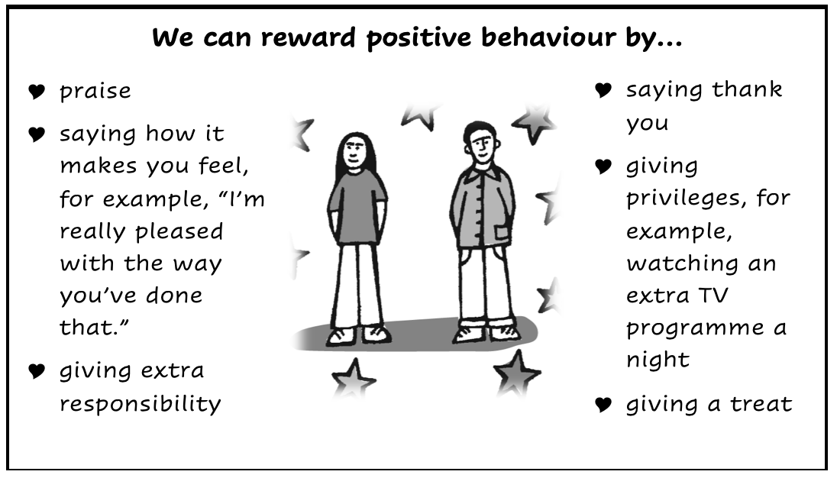

Students take home Copysheet: **Family contract**. Their family uses this to work out together ways of rewarding positive behaviour and discouraging misbehaviour.

### 3 – Family stress

**Read The Last Straw**

* Read the story The Last Straw, using a reading approach that suits your class. In small groups, discuss the story, using the following questions as a guide.
* What pressures or stress were making it hard for Mum to cope?
* What were the signs that Mum was not coping?
* Why do you think he did not recognise the signs?
* How do you think a baby that kept on crying might affect you?
* What effect can a baby’s crying have on different people?
* What did Sophia’s crying lead Mum to do? Why?
* In this story, help did not arrive until the baby had been hurt. How might Sarah have got help before this happened?
* Where else could she have gone for help?
* Who can help adults and young people with stress?

### 4 – What is stress?

**Hot potato activity**

Discuss the meaning of the word stress. Ask students to identify the kinds of negative emotions we might feel when we are stressed: tension, anxiety, anger, distress, etc.

Divide students into six groups. Give each group a sheet of paper with one of the categories: work, school, money, health, family, personal.

Ask each group to think of triggers for stress in a family, for all family members, for their category.

* They write down as many triggers as they can think of in five minutes, then pass the papers clockwise.
* With their new paper, they tick the ones they agree with, then write down as many new triggers they can think of in three minutes.
* Repeat the swapping until they have written on each of the categories.
* With their original category, the groups number each trigger from 1-3 for most likely to occur and give them a star rating to show how big an impact they would have, 1 star is low impact, 3 stars is high impact.

These charts could be displayed on the wall. Each group then reports back to the class.

**Stress scale**

Talk about how different people react to stress, and to different types of stress, in different ways. Explain that sometimes parents and children have a great deal of pressure and stress.

Give each student Copysheet: **My stress scale**. Invite them to reflect on their emotions for either a typical day or for yesterday.

Ask:

* What sort of things make people of your age stressed?
* What can you do if you feel like this?

Talk about some stress relievers, such as talking to someone, going for a walk or run, listening to music, having a shower.

In pairs, students discuss the best stress relievers for them.

Give students the Copysheet: **Stress scale for parents**. They read the situations given and mark the emotions they think a parent would experience.

Ask:

* What sort of things do you think cause parents the most stress? Why?
* What sort of unexpected things could cause extra stress?
* What could happen if the stress is not dealt with?
* What can you do to help minimise your parents’ stress?

Students could take home their completed **Stress scale** copysheets to discuss with their parents.

# The Hedgehog

by Kathleen Crayford

Our Dad was big and strong and quiet. When we all went out together, it felt good. He was in charge. Knew how to handle things. Bus timetables; which platform the train went from; ordering a meal when we ate out to celebrate someone’s birthday. Changed a wheel once without any fuss when we had a puncture going along the motorway. My younger brother and sister watched, while I helped our Dad with the jack.

So most of the time, things were pretty good. Most of the time. So long as we didn’t get into arguments or fights. Dad couldn’t bear it if people started to raise their voices. Even a normal sort of quarrel would bring him to his feet, fists clenched, eyes blazing. Usually when this happened, Mum would get there first. “Outside,” she’d say. And out we’d scramble, quickly. We learned to recognise her warning expression, the merest movement of head and eyes, the slight frown, the downward curve of her mouth. We learned to play quietly when Dad was in the house, and saved our disagreements for the times when he wasn’t around.

Only sometimes, we forgot.

I was twelve and it wasn’t so difficult for me. Sandra was eight, and Johnny was nine. Sometimes, we just couldn’t help getting into squabbles, especially over things like whose turn it was on the computer. Johnny was in the middle of yelling, “It’s not fair!” when Dad came striding into the room. He hit Johnny hard around the head and sent him spinning across the room. Johnny knocked over a vase of flowers. The crash brought Mum into the room.

“Out!” she said to us.

Sandra rushed out with her mouth clamped shut to keep in the sobs. I took Johnny’s hand, and we joined Sandra at the end of the garden. I tried to comfort Johnny, and to reassure Sandra. I took them to the park and played on the roundabout with them, and pushed them on the swings, and larked around the slide until they cheered up and it was time to go home for tea.

There was a coldness between Mum and Dad for a long time after that. I felt it, though the younger ones didn’t seem to notice. We really did try very hard to save our arguments till Dad was out of the house. Things gradually eased and we all began to relax again.

The quarrel that erupted between Johnny and Sandra several weeks later was one of those silly, “Yes you did - No I didn’t”, kind of arguments. It was a Saturday, and Dad was in the kitchen fixing a new cord for the electric jug. He came into the dining room just as I was getting between Johnny and Sandra to stop them from fighting. “Leave them alone,” Dad roared at me, and took a swipe at me with the jug cord he still held in his hand. Sandra and Johnny fled from the room. “Get Mum!” I screamed. Because it seemed that once Dad started hitting, he didn’t know how to stop. The cord came down across my face, shoulders, my bare arms, the tops of my legs. And then, suddenly, Mum was there and the hitting stopped, and I ran up to my room and lay on my bed and didn’t think I’d ever be able to stop crying.

Later that night, at tea time, Dad didn’t, couldn’t, look at me. Or even at Mum or the younger ones. We all ate in silence, and Dad left the table as soon as he’d finished, and hurried away. Mum said, “It may be hard for you to understand, Tony, but Dad is suffering over this just as much as you are. Maybe even more than you. All the same, it can’t go on.”

And that evening, when we were all in the lounge watching television, Mum got up and turned the switch off and said, “I want to say something that you’ve all got to hear.” And she turned to Dad and said, “From now on, I am in charge of the children’s discipline. If you feel angry, I want you to walk away. If you so much as touch them, I shall leave you, and take them with me. Now I’ve said all I’ve got to say. You can talk it over between you if you like.” And she left the room.

We didn’t talk it over. Dad went out, and the two younger ones sat and looked frightened, and I didn’t know what to do. So I switched the television over to a comedy show for them, and stayed with them, and tried not to think about the stinging on my arms and legs.

Next day at school, we had sport. I didn’t want to get changed. The marks of the jug cord criss-crossed my arms and legs, red and swollen. I’d put on jeans and a sweat-shirt to hide them. The one across my face I couldn’t hide, so I just said I’d fallen over and told people to mind their own business when they asked what had happened. One of my class-mates started going on about it and my fists clenched. I felt really wild and angry. The bell went and the moment passed. I was left feeling weak and frightened.

When it was time to go on to the playing field, everyone had changed except me. My silent refusal puzzled the sports teacher. He said if I wasn’t prepared to get changed and wasn’t prepared to say why, I’d better go and see the principal. He was about to take the rest of the class outside when he seemed to have second thoughts. “Hang on a minute, I think I’d better come with you,” he said and took me to the office. He said to the principal, “I think we’ve got a problem here. Tony won’t get changed. Over to you.” I was surprised to hear the concern in his voice.

“Why won’t you get changed, Tony?” asked the principal.

I couldn’t say anything. I just stood there. The principal reached out and turned my face towards the light.

“What’s this?” he said.

And still I couldn’t tell him.

“You’ve been hit,” the principal said.

I nodded.

“And you don’t want to get changed because you don’t want anyone to see the rest of the marks. Is that it?”

Silently, I nodded again.

“Your father?”

Another nod.

The principal said that he’d met our parents and liked them. He said that though Mum did most of the talking on meet-the-teacher evenings and at PTA meetings, at least Dad came, which was more than a lot of fathers did.

The principal stood gazing out the window for a moment.

Then he seemed to come to a decision.

“Tony,” he said, “it’s quite likely that your father was ill-treated when he was a child. He’s probably just doing what his father did. It’s important we do something about it now, for your sake, and your dad’s. We even have to think about the children you’ll have yourself when you grow up. If it happens again, will you come and tell me?”

“Mum says we’ll all have to leave him if he does it again,” I said. My voice was thick because I was trying not to cry.

“Perhaps your mother will come and see me. Could you ask her, or do you want a note?”

“I’ll ask her,” I said.

I was let off sport for the rest of that week. I spent the sports period in the library, pretending to read, but I was thinking. Dad had hardly spoken to me all week. He hadn’t even looked at me. When I looked at Dad, I saw deep shame on his face. There was pain in the lines around his mouth.

“It’s true what Mum said,” I thought. “He is suffering about it more than I am.”

We were all sitting in the dining room. Sandra was colouring-in with her crayons, and Johnny was doing his spelling list. Mum was just sitting, gazing into space. She’d been doing a lot of that lately. Quite suddenly she asked Dad:

“Did you ever get into trouble when you were at school?”

I wanted to ask if Dad was ever hit when he was a boy, but I didn’t dare.

Dad put down the paper.

“Oh yes,” he said. “Lots of times.”

“What for?” Mum asked.

“Oh talking mostly,” he said.

“How old were you then?”

“About Johnny’s age, I think,” said his father.

I got the feeling that something was happening in the room. Sandra concentrated very hard on her colouring book. Johnny’s eyes were glued to his spelling. I could almost hear them listening.

“Did you mind?” I asked.

“Oh no, I don’t think so. Mind you, I’d learned to behave myself by the time I was your age.”

I felt embarrassed when he said that. I didn’t know what else to say. I felt as if he was blaming me for something. Did he think that I hadn’t learned to behave myself yet? Very quietly, Mum came to the rescue.

“Did you get into trouble at home as well as at school?” she asked.

“Oh, I don’t know,” said Dad. “It’s hard to remember. I did get a hiding once for coming home late from school.” As he spoke, his hands came up and made fists, and his big knuckles rubbed into his eyes as though he were suddenly a very small child.

“Why were you late?” she asked.

The hand came down and thumb and forefinger began to pull at the upper lip. Dad’s eyes looked back into his own past.

“Funny thing to remember after all this time,” he said. “I found an old potato lying in the gutter, and there was a matchstick near it. And the potato had three spots at one end. Looked like two eyes and a nose. And I stuck this match into it, and then I looked for more matches and bits and pieces, and stuck them in and made a hedgehog. Took me ages, finding enough matches. I forgot the time. It was nearly dark when I got home. Mum hit the roof, and I could tell they’d been rowing again. My Dad was waiting for me. Took his belt off to me. It was one of the worst thrashings I ever got from him. I couldn’t sit down for a week!”

Johnny abandoned all pretence of learning his spelling. “You mean he actually used his belt on you?” he wanted to know.

“Yeah,” said Dad. “It wasn’t so bad if he didn’t use the buckle end.”

“You mean your father hit you with the buckle end of a belt?” Mum asked incredulously.

“Well, not till I was a bit bigger,” he said. “About Tony’s age, I suppose.”

Sandra put down her crayon.

“What happened to the hedgehog, Daddy?” she said.

“That? Oh I guess it got broken up. I don’t remember.”

Sandra left the table and went out into the kitchen. She came back with a potato in her hand, and a packet of toothpicks.

“Show me, Daddy,” she said. “Show me how to make a hedgehog out of an old potato.”

And she went and stood by him, close, while he undid the toothpicks and showed her how to push them into the potato to make the spines for a make-believe hedgehog.

When they’d finished, Johnny cleared his throat with a funny little cough. He took his list over to Dad and said in a tight little voice, “I’ve got a test at school tomorrow, Dad. Can you test me on my words?”

I could see that it was a difficult thing for Johnny to do, to go and stand close to Dad as Sandra had done, and ask for something, and risk getting it wrong. He spelled every word correctly and without hesitation.

“Good,” said Dad. “Everyone a winner!”

He looked round the room at us all. He looked directly at me for the first time since he’d hit me. The mark from the jug cord was still on my face. I felt that every one of us had done something risky and difficult that evening. But what Dad did was the most difficult thing of all. “I’m sorry I hit you, son,” he said.

In spite of all the feelings pushing and shoving inside me, I managed a lop-sided sort of smile.

“It’s O.K., Dad,” I said.

Mum came over and picked up the hedgehog very gently and examined it carefully. Then she put it on the shelf where we kept our small collected treasures.

“I wonder if we could have a day out tomorrow,” she said. “That’s something we always enjoy.”

# The Last Straw

by Beverley Dunlop

My three-month-old baby sister, Sophia, was always crying. Once, she cried all night. At breakfast, Mum looked awful. She had nasty black rings under her eyes. She snapped at Dad. She was horrible to me.

“You’ve got dirt on your face and arms, Sarah,” she yelled, “Go and clean yourself up. You can’t go to school looking like that.”

I got up, feeling miserable. I looked at Dad. He was going away on a business trip that morning and I knew I would miss him. It would be ghastly spending two evenings alone with Mum in her present mood. I hugged Dad goodbye on my way past.

Dad hugged me back. “Try and help your mother with the baby,” he whispered. “Remember, we’re new in town and Mum hasn’t any friends to turn to.”

I nodded. But I knew that Mum wouldn’t let me help. Even though I was twelve, she thought I was still a kid!

Mum had been really strange since she’d had the baby. The house was a mess. Once our house was spotless. Mum was always crying. Sometimes she looked at the baby as if she hated it.

I thought about Mum as I walked to school. Last week I’d seen her smack Sophia hard on the legs. Then she snatched Sophia up and hugged her. Mum sat on the bed rocking the baby backwards and forwards. She kissed Sophia and said she was “a bad mummy” and wouldn’t do it again. The next day I saw an ugly bruise on Sophia’s leg.

The more I thought about the bruise, the more I worried. I thought about Mum all day. When my new friend, Tayla, asked me to go to her house after school, I said I had to go home and look after Mum.

Tayla looked surprised. “Is your mother sick?”

I hesitated. “It’s our new baby. She cries all the time. Mum smacked her the other day and left a bruise.”

Tayla looked wise. My aunt is a social worker,” she said. “Sometimes she helps mothers who hurt their babies.” I felt angry that Tayla should think such a thing about my mother. I also felt mad with myself for telling her. “My mother didn’t mean to hurt the baby,” I snapped. “She loves Sophia. Mum’s always wanted another baby. She’s the kindest mother in the world.”

“Bruising is hurting a baby,” sniffed Tayla. “And you needn’t be so touchy.” Tayla walked off in a huff.

I ran home. Even though I was angry at Tayla’s words, I felt scared. I knew some women bashed their babies. I knew sometimes the babies died. Surely Mum wouldn’t hurt Sophia. The bruise was just an accident. Sophia was a lovely, pale, little doll and I couldn’t wait until she was old enough to play with.

When I reached home, Mum was sitting by the phone. A big pile of dirty nappies had been dropped in the rubbish by the kitchen door, and the breakfast dishes were still in the sink. Mum looked worse than she had that morning. She hadn’t combed her hair, and her face was streaky with dirt.

Mum put her hands over her face when she saw me. “Your grandmother’s broken her hip,” Mum’s voice was muffled. “She’s in hospital.”

I bit my lip – poor Grandma. Suddenly I wished we lived nearer to Grandma so that we could visit her in hospital.

“Will she be all right?” I asked.

Mum nodded. “Yes, but what will she do when she gets out?” Mum’s voice rose. “I should have her to stay with me because your grandpa is too frail to cope, but how can I look after my mother and a screaming baby?”

“I can do more in the house,” I offered. “And so can Dad.”

Mum wasn’t listening. She jumped up and tore over to the kitchen sink. “Oh, the jug!” she cried. “It’s boiled dry and the element’s burnt out. That’s the second accident today – I dented the car this morning. It’s the last straw.” Mum began to cry.

I’d never seen Mum cry quite like that. She clutched the burnt-out jug to her chest and rocked it backwards and forwards.

I felt frightened for Mum. What could I do? How could I help her? Before I could move, Sophia started screaming loudly in the bedroom. Mum shook her head as if she were in pain. “My head’s bursting, it’s bursting!” Mum shrieked.

I didn’t recognise Mum. Her face was twisted up. She was a wild-looking stranger.

Suddenly, Mum crashed the jug through the closed kitchen window. Glass splintered everywhere. Mum tore down the passage to the bedroom. I raced after her and was just in time to se her whack Sophia hard across the face. Sophia stopped screaming. She lay quiet and still.

“You’ve hurt the baby!” I shrieked. “You’ve killed her!”

Mum seemed to realise what she’d done. She picked up Sophia and held her limp body against her face. She made a high moaning sound.

I remembered 111 was for emergencies. I ran to the phone, dialled the number, and asked for an ambulance.

Things happened fast after that. The ambulance officers came and rushed Mum and the baby to hospital. A lady came to stay with me until Dad could get the next flight home.

Dad explained everything to me later.

“Sophia has concussion but there may be no permanent damage,” he said. Dad’s face was white. He put his head in his hands. “I didn’t realise your mother needed help so badly. I should have helped her more.”

When I look back, it’s hard to remember that awful day. Mum’s almost her old self now. She still has visits from the social worker, and they’ve become good friends. Mum’s made friends with the neighbours, and she’s joined a group of mothers who’ve hurt their babies. Dad and I take it in turns to do the dishes and vacuuming. I play a lot with Sophia. She’s bouncy and beautiful and extra special to us all because we so nearly lost her.

# Copysheet: Family contract

Every family needs to find ways to reward positive behaviour and to discourage misbehaviour.

Have a family discussion to decide how your family will do this and put your ideas below. All family members should agree to this.

Positive behaviour that we reward Ways we will do this

1

2

3

Misbehaviour that we discourage Ways we will do this

1

2

3

Signed by all family members:

# 

# Copysheet: My stress scale

Write or draw the main things you did during the day, in order.

Decide how you felt during each of the activities you have recorded above. Mark this level with a cross on the scale below. Join up all the crosses to show your emotions for the whole day.

|  |  |  |  |  |  |  |  |  |  |  |
| --- | --- | --- | --- | --- | --- | --- | --- | --- | --- | --- |
| **10**  **Feeling stressed** |  |  |  |  |  |  |  |  |  |  |
| **5**  **Feeling tense** |  |  |  |  |  |  |  |  |  |  |
| **0**  **Feeling relaxed** |  |  |  |  |  |  |  |  |  |  |
|  | **6** | **8** | **10** | **12** | **2** | **4** | **6** | **8** | **10** | **12** |
|  | **am** | | | | **pm** | | | | | |

# Copysheet: Stress scale for parents

Decide how a parent might feel during each of the following activities. Mark this with a cross on the scale below. Join all the crosses up to show their emotions for the day.

|  |  |
| --- | --- |
| 6 am | Asleep |
| 7 a.m. | Gets children up, checks email, organises breakfast, homework, and school lunches |
| 8.15 am | Drinks a cup of coffee on own and scrolls through social media |
| 8.50 am | Drives Matiu to school because he missed the bus |
| 9–11 am | At work |
| 11 am | Picks up Holly from school because she has been sick. Takes her to Grandma’s |
| 11.45 am | Back at work, but late for a meeting |
| 1 pm | Quiet lunch with a friend |
| 2–3 pm | Goes on a school outing |
| 3.30 pm | Takes Matiu to sports practice |
| 4 pm | Goes to Grandma’s to pick up Holly and has a cup of tea there |
| 5 pm | Back home, prepares dinner, puts on a load of washing, does chores |
| 5.30 pm | Picks Matiu up |
| 6 pm | Family eats dinner and watches some TV together |
| 8 pm | Playing on phone |
| 10.30 pm | Asleep |

|  |  |  |  |  |  |  |  |  |  |  |
| --- | --- | --- | --- | --- | --- | --- | --- | --- | --- | --- |
| **10**  **Feeling stressed** |  |  |  |  |  |  |  |  |  |  |
| **5**  **Feeling**  **tense** |  |  |  |  |  |  |  |  |  |  |
| **0**  **Feeling relaxed** |  |  |  |  |  |  |  |  |  |  |
|  | **6** | **8** | **10** | **12** | **2** | **4** | **6** | **8** | **10** | **12** |
|  | **am** | | | | **pm** | | | | | |