Keeping Ourselves Safe – Senior primary

Focus area 3 – Finding out about abuse

The six focus areas in the Keeping Ourselves Safe (KOS) senior primary programme are:

1. Keeping one step ahead
2. I’m responsible for others, too
3. Finding out about abuse
4. Families working together
5. Reporting abuse
6. What happens now?

Research suggests that an effective programme should include learning experiences from each of the six focus areas.

**Contents**

Focus area 3 – Finding out about abuse 3

Notes for the teacher: preparation 3

Explanation 3

Curriculum links 3

Success criteria 4

Learning Intentions 4

Resources 4

Activities 5

Copysheet: A definition of abuse 9

Copysheet: Signposts of abuse 10

Copysheet: Examples of abuse 11

Copysheet: Home alone 13

Copysheet: Summary Offences Act 1981, Section 10B 14

The Swimming Pool 15

# Focus area 3 – Finding out about abuse

## Notes for the teacher: preparation

* Ensure that safety guidelines are in place.
* All school staff, not just the teachers concerned, must know what to do if a student discloses abuse to them during or after Keeping Ourselves Safe.
* Parents should also be made aware of what to do. See the Child Protection Guidelines available on the NZ Police School Portal at <https://www.police.govt.nz/advice-services/personal-community-safety/school-portal/information-and-guidelines/child-protection>

## Explanation

Students need to be aware of what constitutes abuse so that they can recognise if they are being abused. They need to know that abusers can be anyone and that abuse can happen to anyone.

* This focus area provides activities that allow students to explore these issues, consider peer harassment in depth, and look at ways of creating a safe classroom.

This is sensitive material and teachers will need to watch for reactions it may cause in some children. It is imperative that you have put support networks in place and clearly explained these to children. Remind students about the post box (see focus area 1).

**Note:** It is misleading to assume that sexual touching always feels uncomfortable and unwanted.

* Children often don’t report it at the fondling stage, because they find it enjoyable, although it may be confusing.
* It is often presented to boys as something that males do together. When serious abuse occurs they want to opt out, but are often trapped and told it is their fault.

## Curriculum links

Key competencies: Managing self, Relating to others, Participating and contributing

Learning area:

Level 3 Health and Physical Education

* Strand A: Safety management: Identify risks and their causes and describe safe practices to manage these.
* Strand C: Identity, sensitivity and respect: Identify ways in which people discriminate and ways to act responsibly to support themselves and other people.

Level 4 Health and Physical Education

* Strand A: Safety management: Access and use information to make and action safe choices in a range of contexts.
* Strand C: Interpersonal skills: Describe and demonstrate a range of assertive communication skills and processes that enable them to interact appropriately with other people.

## Success criteria

Students can:

* identify different types of abuse
* describe how victims can be anybody and that offenders can be peers, authority figures, and people they know and love
* use assertive communication skills to support themselves or others experiencing abuse.

## Learning Intentions

Students are learning to:

* identify what is abuse
* be assertive when they communicate
* support others who are experiencing abuse.

## Resources

|  |  |
| --- | --- |
| Copysheet: A definition of abuse  Copysheet: Signposts of abuse  Copysheet: Examples of abuse  Copysheet: Home alone  Copysheet: Summary Offences Act  Story: The Swimming Pool |  |

## 

## Activities

### 1 – What is abuse?

Divide students into groups of four and ask each group to work through the following steps of 1:4:PCR ([1])

1. Write down your own idea of what you think abuse is. **1**
2. Share your idea with the rest of the group. **4**
3. **P**ublish a synthesised/combined idea.
4. **C**ircle the room and consider other groups’ ideas.
5. Review and **R**efine your group idea.

Display each group’s refined idea of what abuse is.

Display an A3 definition of abuse taken from **Copysheet: A definition of abuse** for comparison.

**Signposts**

Place the signposts from **Copysheet: Signposts of abuse** around the room, preferably in clear spaces on the floor.

Explain to the class that you are going to read out some examples of different types of abuse – see **Copysheet: Examples of abuse**.

* Select examples for all the signposts. It is important that you give children the opportunity to discuss all these types of abuse, because they need to be able to recognise each type.

After you read each example, each student moves to the signpost they think best describes that example of abuse. Ask some students to give a reason for their choice.

Take away the Not Abuse signpost.

* Ask students to stand next to the signpost that they think is the worst type of abuse.
* Ask some students to give a reason for their choice.

Write the following two statements on a large piece of chart paper headed: Important facts about abuse, and discuss it with the class.

* All forms of abuse can be equally damaging to the victim.
* Abuse is never the victim’s fault.

Ask students to stand next to the type of abuse that they think is against the law. Ask some students to give a reason for their choice.

Write the following two statements on the chart and discuss them with the class:

* All abuse is wrong and is against the law.
* All abuse should be reported.

Display the completed chart on the wall.

**Follow up discussion**

Look at each of the signposts again and discuss the following questions:

* Who might the offenders be in these cases of abuse?
* Who might the victims be?
* Who can suffer from abuse?
* Who is to blame in these situations?
* Does anyone deserve abuse?
* If any of these things happened to you, how might you feel?
* What could you do?
* If any of these things have already happened to you, what could you do now?

Help the young people to remember these points:

* Abuse is wrong and it must be stopped.
* Abuse is never the victim’s fault.
* Victims can be anyone – babies, toddlers, children, young people, teenagers, adults.
* Offenders can be anyone – peers, authority figures, people you know and love.
* Nobody deserves to be abused.

### 2 – Feelings about abuse

Brainstorm with the class the feelings that they may have when they talk about hassling from peers and about other forms of abuse. Record them in a diagram like the one below. Explain that it is important to talk about our feelings. 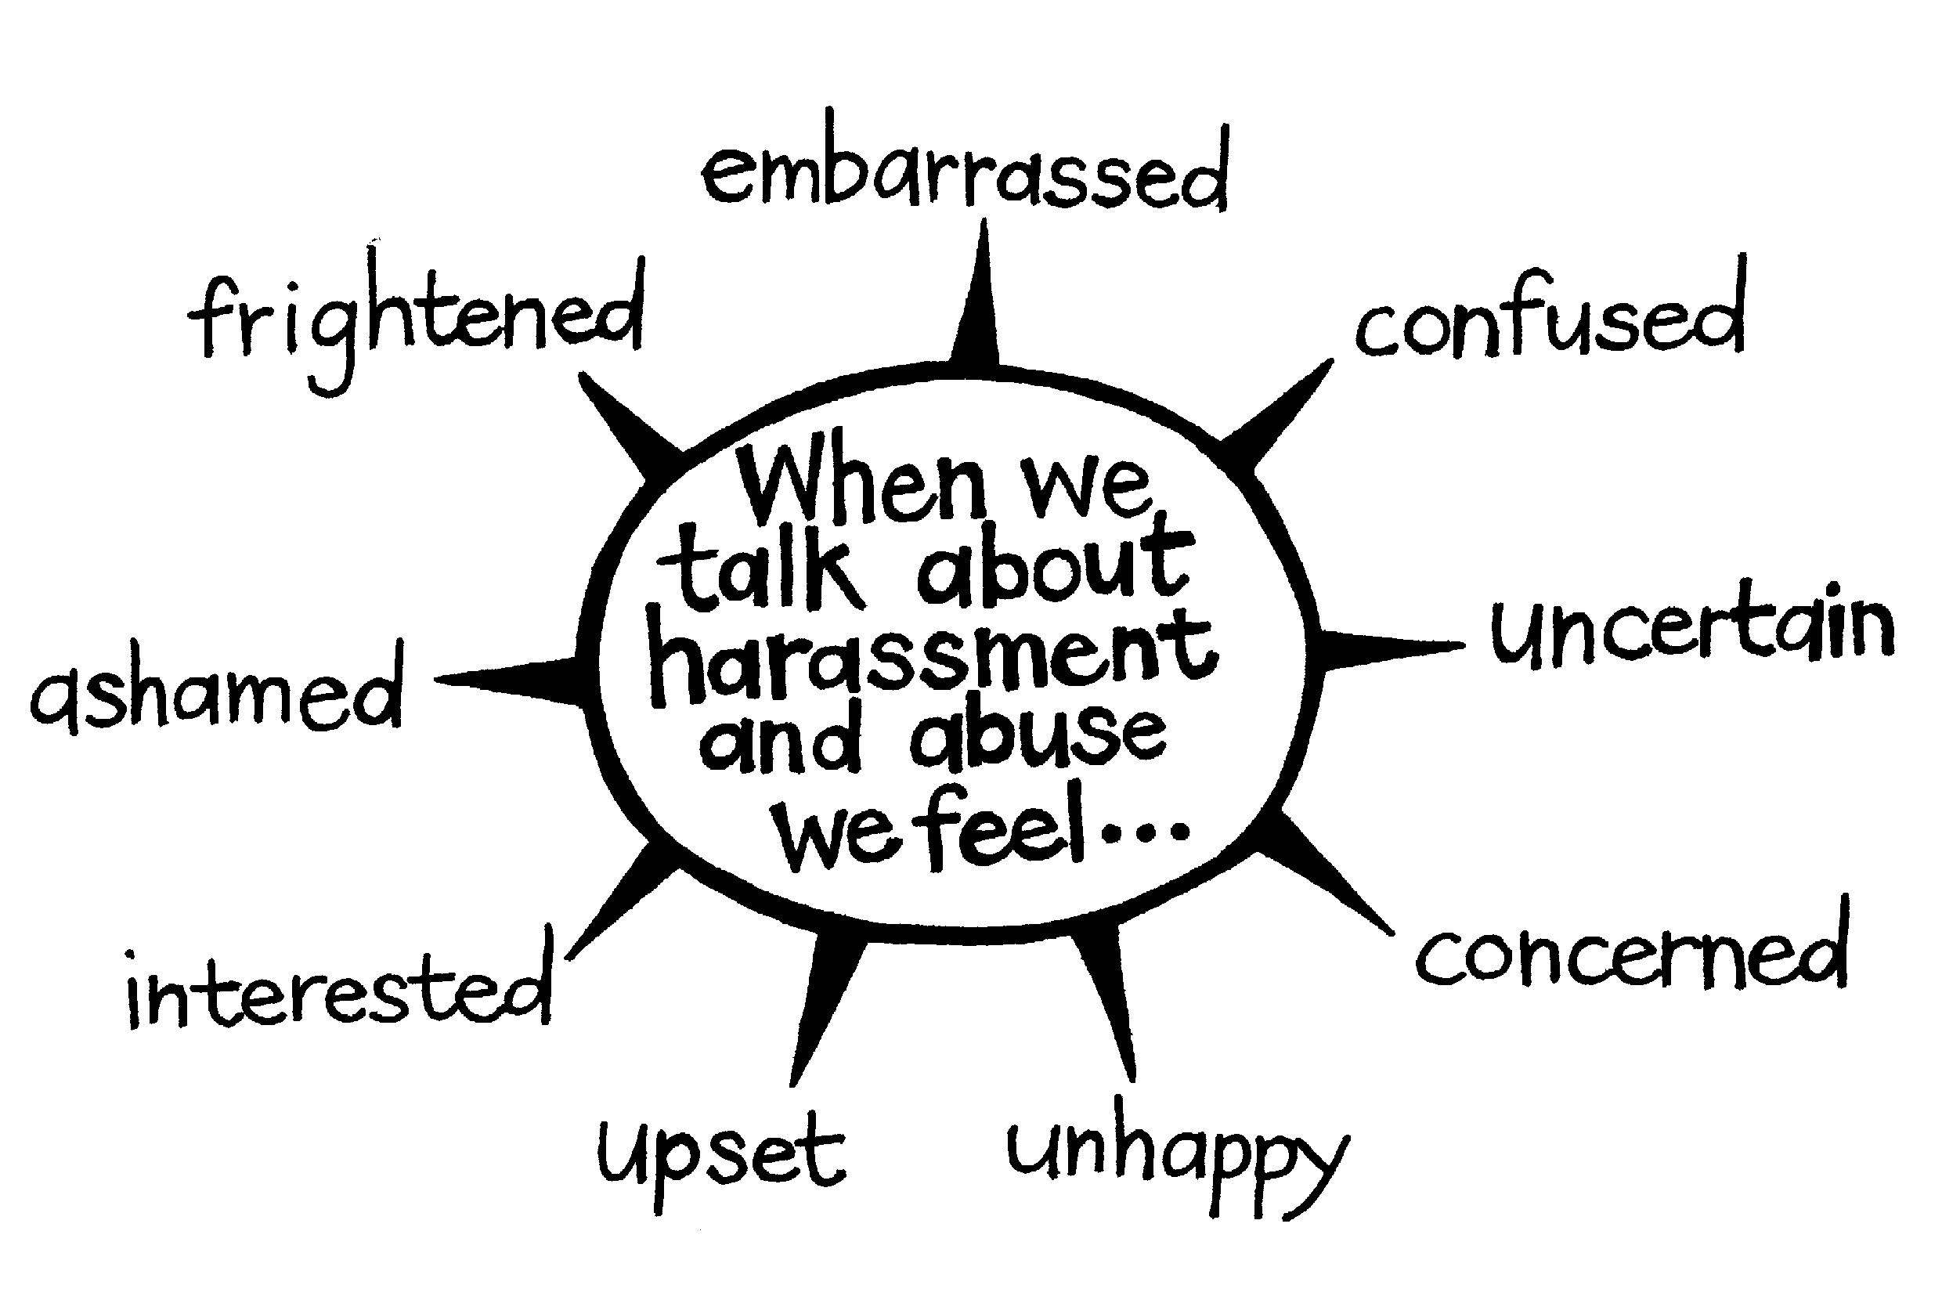

Remind the class about the support network in the school and reinforce the use of the post box.

The diagram could be displayed on the classroom wall.

### 3 – Home alone

Read the newspaper article on **Copysheet: Home alone**, or children could read it in groups.

Ask:

* Were these children at risk?
* If yes, what were the risks?
* Was it the 11-year-old boy’s fault that the baby got stuck? Why or why not?
* Who is really responsible for these children?
* Were they being responsible on this occasion?

Explain to the class that the parents were actually breaking the law by leaving these children alone without reasonable supervision.

* See **Copysheet: Summary Offences Act**.
* Talk about what reasonable supervision means and the implications of this for young people of their age who are asked to look after younger children.

Introduce the term abuse.

* Explain that it is anything one person does to another that harms them physically, emotionally or sexually. It includes neglect, and can occur as part of family harm, or in online situations.

Anyone can be a victim of abuse – babies, toddlers, children, young people, teenagers, adults – and abuse is never the victim’s fault.

* The abuser can be anyone, too – they can be the same age as the victim, someone in authority, or someone the victim knows and loves. It may be someone that the child’s family trusts.

Ask:

* Do you think the children in the newspaper article were being abused?
* If so, what sort of abuse do you think it was?

### 4 – The Swimming Pool

This story shows peer abuse and harassment in a school setting. Most of this is directed towards Tayla. The main culprits are Sam and his group of friends, which includes Ella and Sophia. The harassment culminates in Tayla being touched sexually in the swimming pool by Sam. Tayla is supported by Tama and eventually they both report Sam’s behaviour.

Ask students to read the story up to the discussion break.

Help students to identify the main characters in the story – Tayla, Sam, Huia, Ben, Ella, and Sophia.

Use the following questions as a basis for discussion. Ask:

* Why do you think Sam and his friends are targeting Tayla and Huia?
* How would you describe the comments he and the others make – funny, clever, unkind, cruel, pathetic … Why?
* How do you think the comments make Tayla feel?
* How does Huia feel about the comments? What does she do about it?
* What do you think about the incident in the pool?
* Is what has been happening in the class abuse? If so, what sort?
* What do you think will happen next?

Ask students to read the second part of the story.

At the end, discuss the story with the class using the following questions as a guide:

* Do you think Tayla and Huia should have told about what Sam did in the pool? Why or why not?
* Do you think Sam’s punishment is fair? Why or why not?
* How do you think the class might change now?
* Do you think Ben and Ella have changed at all? Why or why not?
* How is Tayla feeling now?
* Does this sort of harassment take place in our school (our class)?
* What do you think should happen if it does?
* What advice would you give someone who was being harassed?
* What would you say to someone who was harassing someone else?
* What does it mean to be an ally? (Someone who acts with and for others to end oppression or abuse.) Who in this story was an ally? How could you be an ally when you see this kind of harassment?

### 5 - Taking action

In small groups, ask students to note down types of peer abuse and harassment they have seen or heard about in their school.

Some common types of abuse and harassment include:

* put downs
* sexual comments
* unwanted touching
* physical abuse
* bullying
* sexual texts or messages
* mean texts or messages
* comments about appearance.

Cyber abuse is very common. Discuss the examples of cyber abuse the students have seen. Students could then prepare a policy and plan of action to reduce cyber abuse at school. This could be discussed with the principal.

# Copysheet: A definition of abuse

Abuse is when anybody uses power over another person and causes them harm.

This could include:

* hurting them physically
* ill-treating them
* not taking care of their everyday needs
* touching them in sexual ways
* showing them sexual materials
* hurting their feelings and their sense of wellbeing.

It also includes violence that happens in families.

Abuse can harm a child’s health and dignity and may make it hard for them to learn and develop.

# 

# Copysheet: Signposts of abuse

**Physical**

**Emotional**

**Sexual**

**Neglect**

**Cyber**

**Not Abuse**

# Copysheet: Examples of abuse

Burning a child with a cigarette

Waiting in a public toilet to watch boys urinating

Smacking a child on the legs and leaving a mark

Using put downs

Sharing someone else’s nude photos

Not taking a sick child to the doctor

Punching someone and making their nose bleed

Exposing genitals in public

Shaking a baby hard

Sending someone nasty texts

Telling a child they are no good

Leaving preschool children at home alone

Hitting someone hard on the head with a shoe

Making a child touch your genitals

Grounding a child

Never letting a child go out except to school

Leaving someone out of a group

Making nasty personal comments

Not giving a child enough to eat

Giving someone a hiding

Bullying

Failing to provide clean, warm clothing for a child

Using a chat room to arrange a face to face meeting with a young person for sex

Watching your parents fight

Sending someone a dick pic

Shouting at someone all the time

Showing nude photos to a child

Putting a hand up somebody’s pants or skirt

Encouraging a young person to undress while using a webcam to film them

Being frightened in case you or your brother get a hiding from your stepfather

# 

# Copysheet: Home alone

Home alone

Yet another home-alone case came to the notice of Police yesterday.

Police were called to a house in Lombard Street on Saturday evening after a 111 call from an eleven-year-old boy. On arrival they found three children at the address, aged 11, 8 and 2.

The eldest boy said they had been alone since early that morning when their parents had gone out for the day. They had expected them home about 8pm but had heard nothing.

The eldest boy made the 111 call when the toddler had got her head stuck between the bars of the cot. All efforts by her brothers had failed to release her and she was in a very distressed state.

Ambulance officers at the scene soon had the baby free.

Police praised the boy for making the call. He also appeared to have looked after the younger children well, although there was little food in the house. The children were taken into care while the parents were located.

This article follows a spate of such cases over the last few months. Under the Summary Offences Act it is illegal to leave children under the age of 14 without reasonable supervision and care. In this case there were no other relatives or friends that the boy could contact. Police are considering what action should be taken.

# Copysheet: Summary Offences Act 1981, Section 10B

In New Zealand it is an offence for a parent, guardian or caregiver to leave a child under the age of 14 years alone without making reasonable arrangements for that child's care and supervision.

What are reasonable arrangements for care and supervision will depend on factors such as the child's age, the duration of the absence of the adult and where the child is left.

A person may be liable to a fine not exceeding $2000 if found in breach of this law.

# The Swimming Pool

Mr Wilson took a group of us to the swimming pool to train for the inter-school competition. I was pretty pumped because I came second last year and Huia reckoned if I trained hard, this year I could win.

Then I realised Sam and his mates were coming. Sigh. I used to be friends with Ella and Ben, but since I started going around with Huia, they never even talk to me anymore. Yesterday at the library they were all talking about people’s boobs and guessing what size bra they wear. Such dicks. And Sam always teases Huia about having short hair..

On the walk to the pool, Ben grabbed my bag! He’s such a butthole. Sam grabbed my togs out of my bag and put his hands in the chest area. Huia snatched them back for me. They’re lucky Mr Wilson didn’t see! He’s really strict about harassment. I wanted to tell him, but Huia said it wasn’t worth it.

In the changing rooms, Huia and I changed under our towels so Ella and Sophia couldn’t see our boobs and tell the boys what size we are. I still heard them whispering about me though.

It felt so good to dive under the water! The pool is my happy place. I can zone out all the crap from Sam and those guys and just focus on zooming through the water.

I was just about at the end of the pool and focused on my turn, when something grabbed my tits! I spluttered up and saw Sam splashing off laughing. What a creeper! Then Sophia looked over and told me I better keep my mouth shut. I started to cry and Mr Wilson came over and asked me what was wrong.

**Discussion point**

I had to tell him what was wrong, didn’t I? I’m not gonna be touched like that. Huia backed me up. She saw everything that went on before. Ella and Ben told Mr Wilson too, so I guess maybe we’re friends again.

Sam was stood down and had to go to counselling. His dad made him come over and apologise in front of my parents. He looked pretty whakamā - like he kind of meant it too.

1. 1:4:PCR is one of the Co-operative Thinking Skills developed by Eric Frangenheim. http://www.rodineducation.com.au (accessed 3 December 2013)